# Inseption Testing

## Login Screen credentials

Valid Username:

“username”

Valid Password:

“password”

Invalid Username entered.

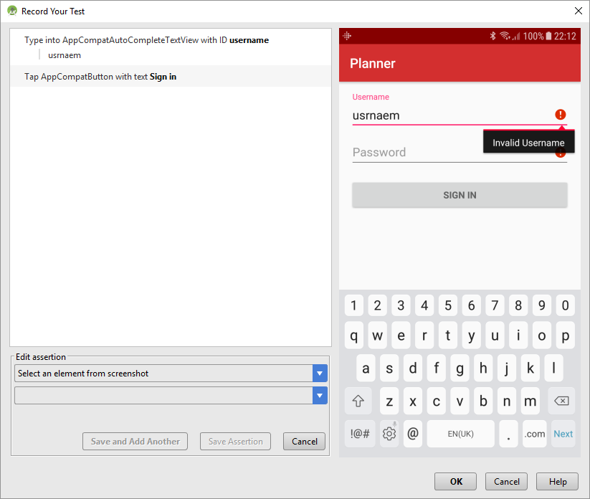

Valid username entered with no password entered.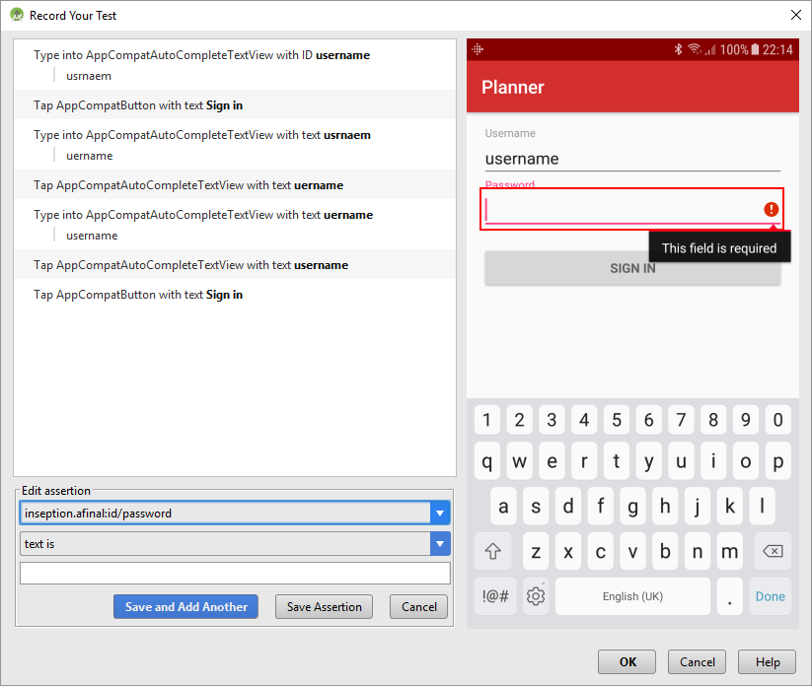

Valid username and invalid password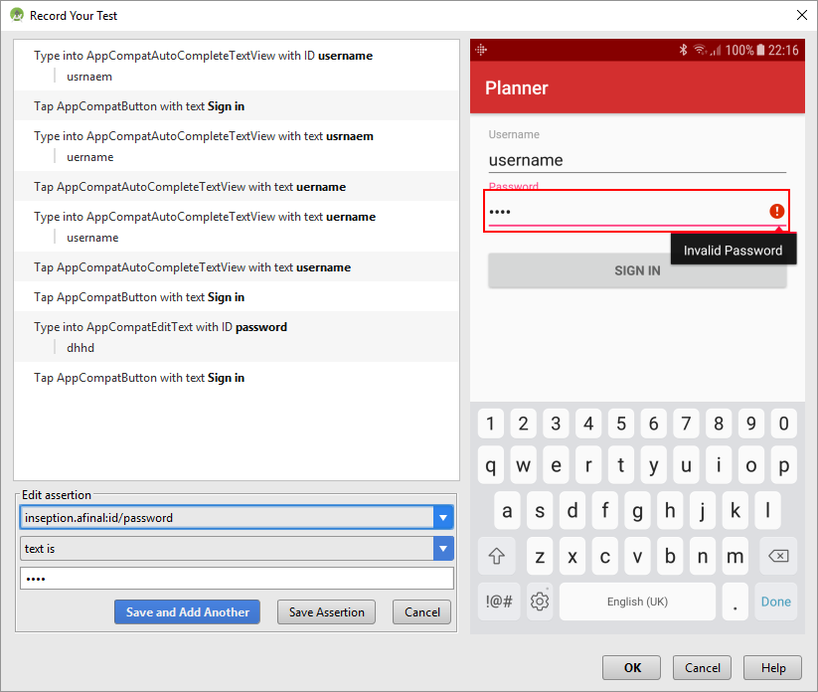

Valid username and valid password: Opens Main screen.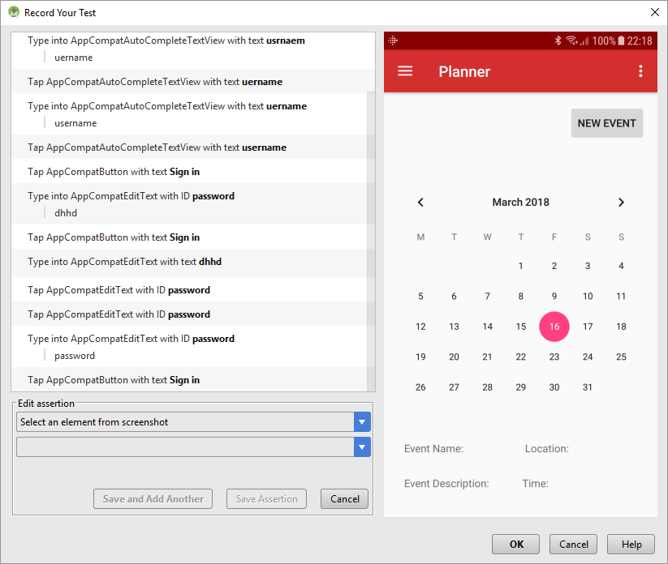

Navigation bar button: Opens nav bar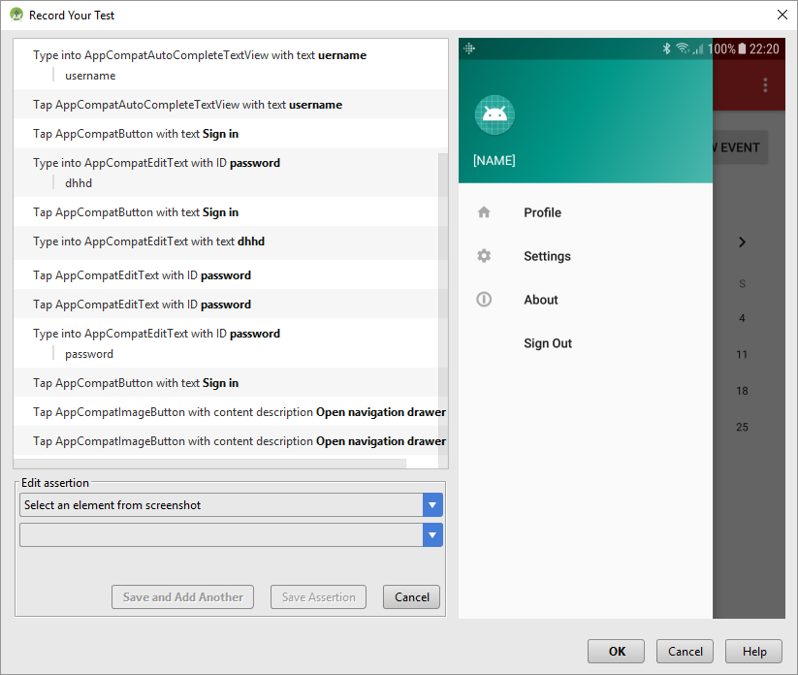

First navbar button (Profile): Opens Edit Profile screen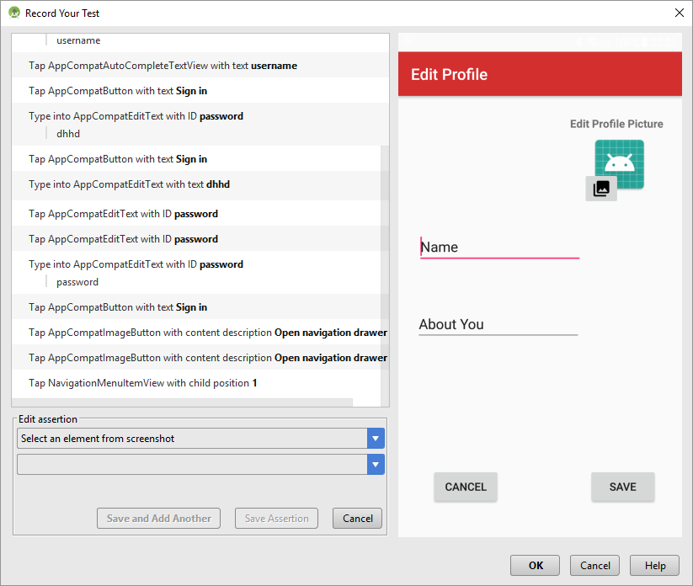

Save or Cancel button: Returns to Main screen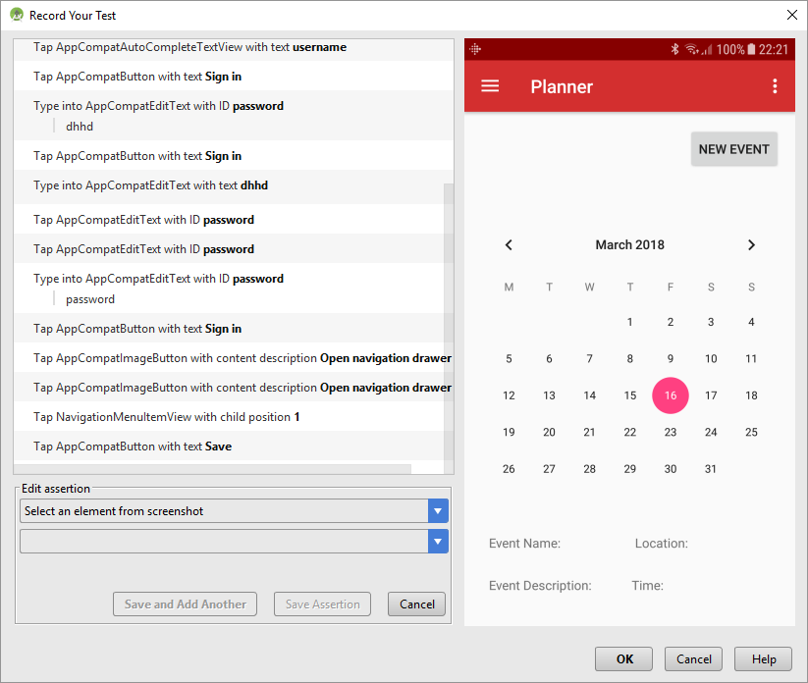

New Event Button: Opens New Event screen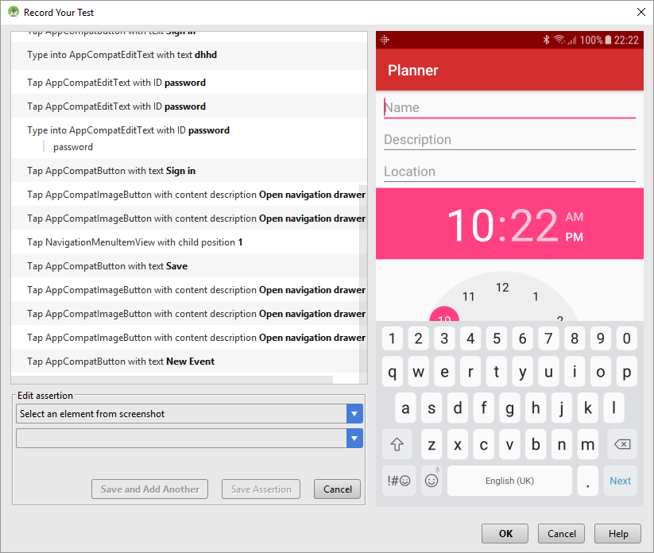

Third nav bar button (About): Opens about screen

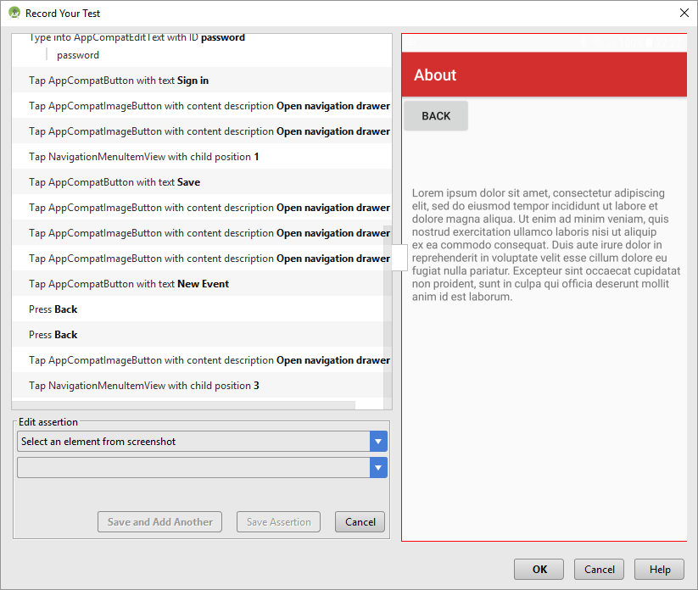

Back button: returns to main screen

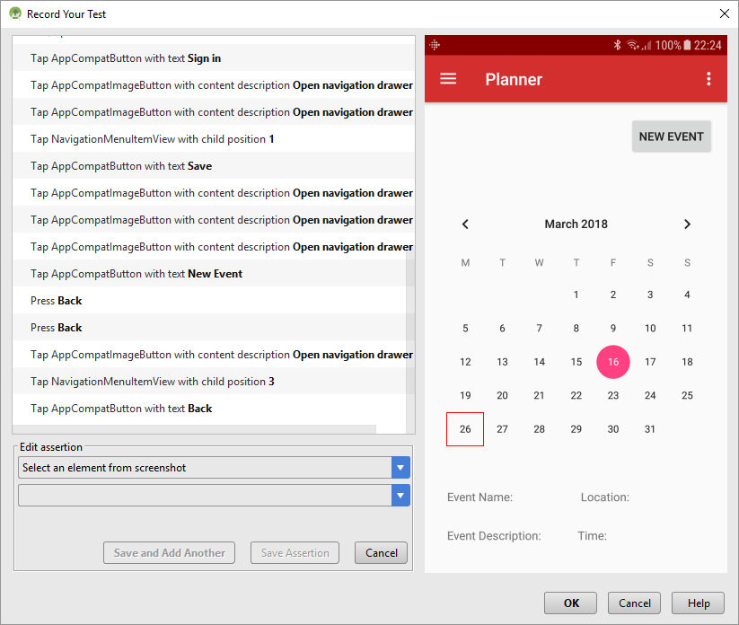

Fourth nav bar button (Sign Out): Returns to Login screen

