ML Flow

screenshot of all the experiments (highlighting the lead_scoring_experiment)

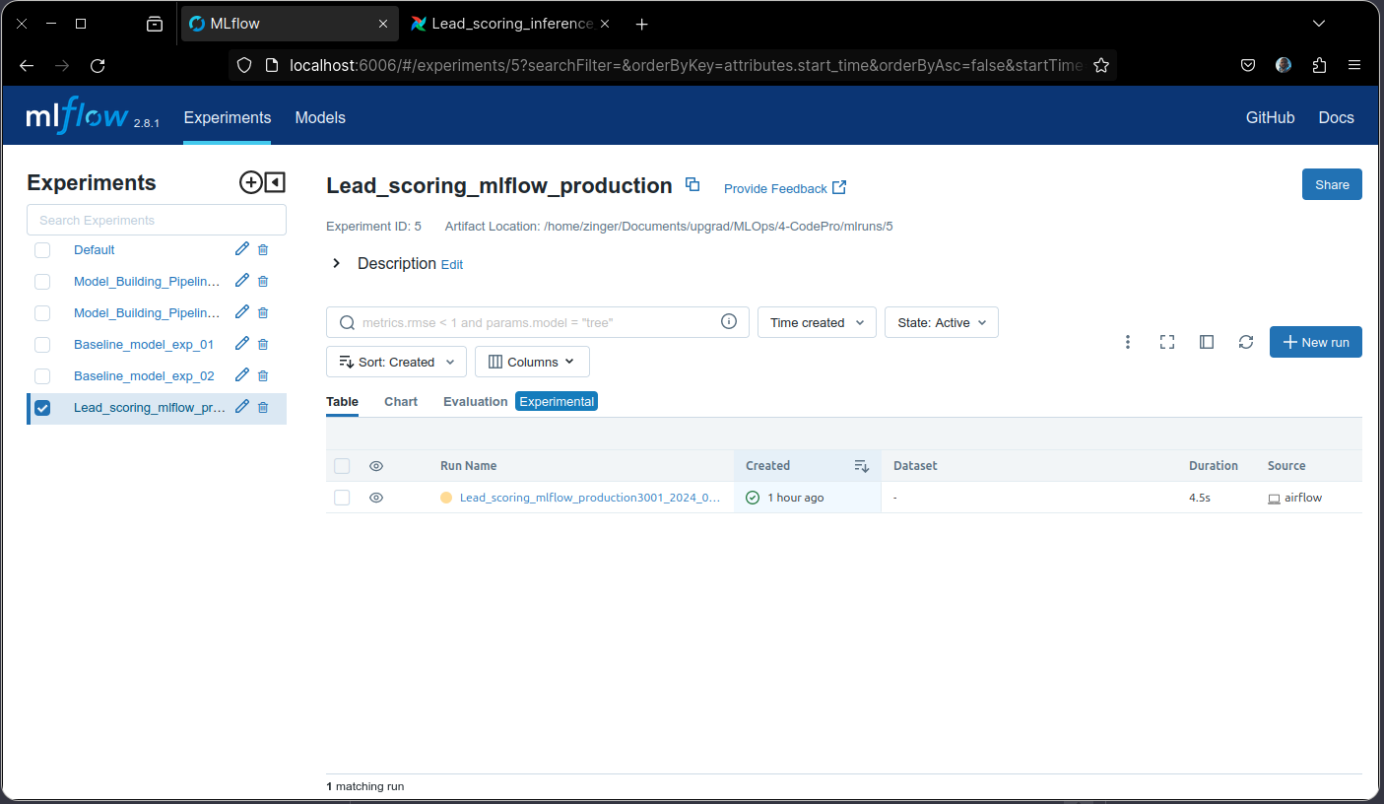

screenshot of lead_scoring_experiment with all the artifacts visible

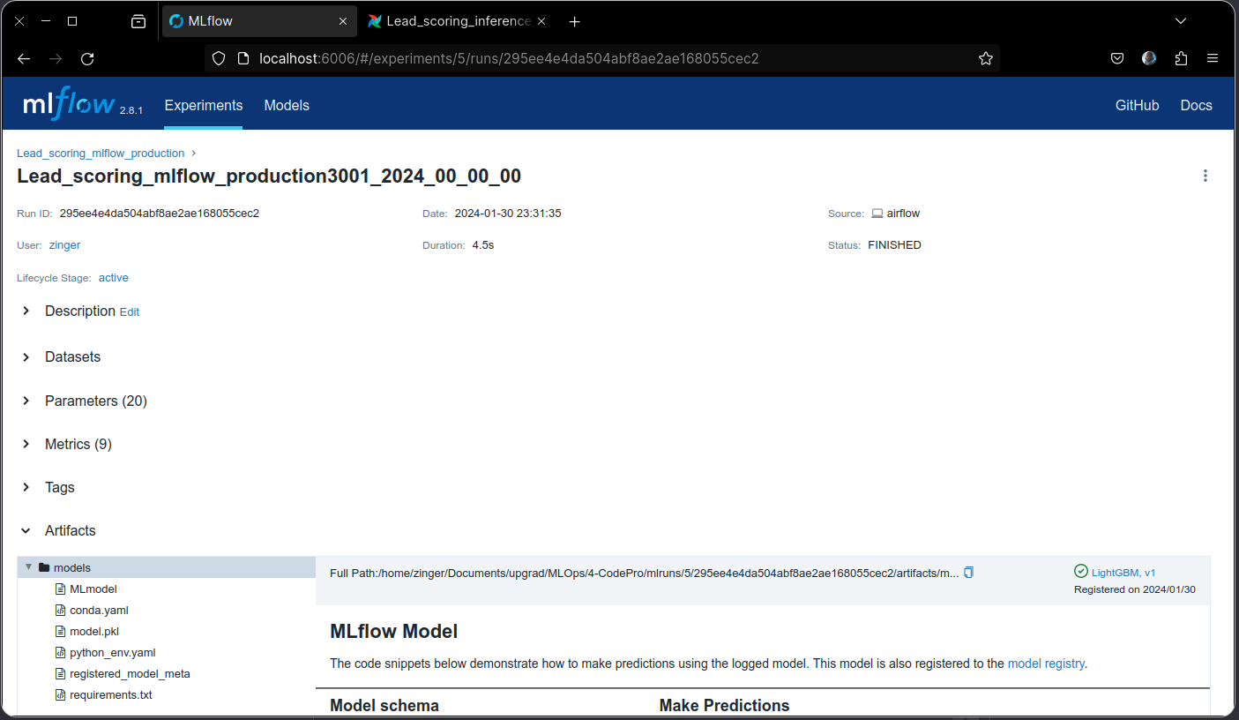

screenshot of registered models under lead_scoring_experiment

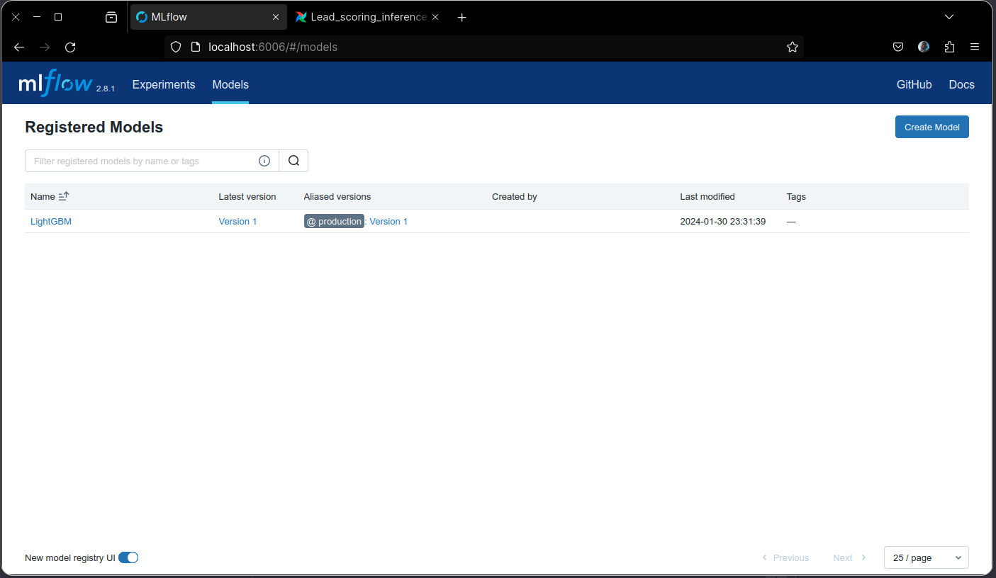

screenshot of production version of lgbm under registered models

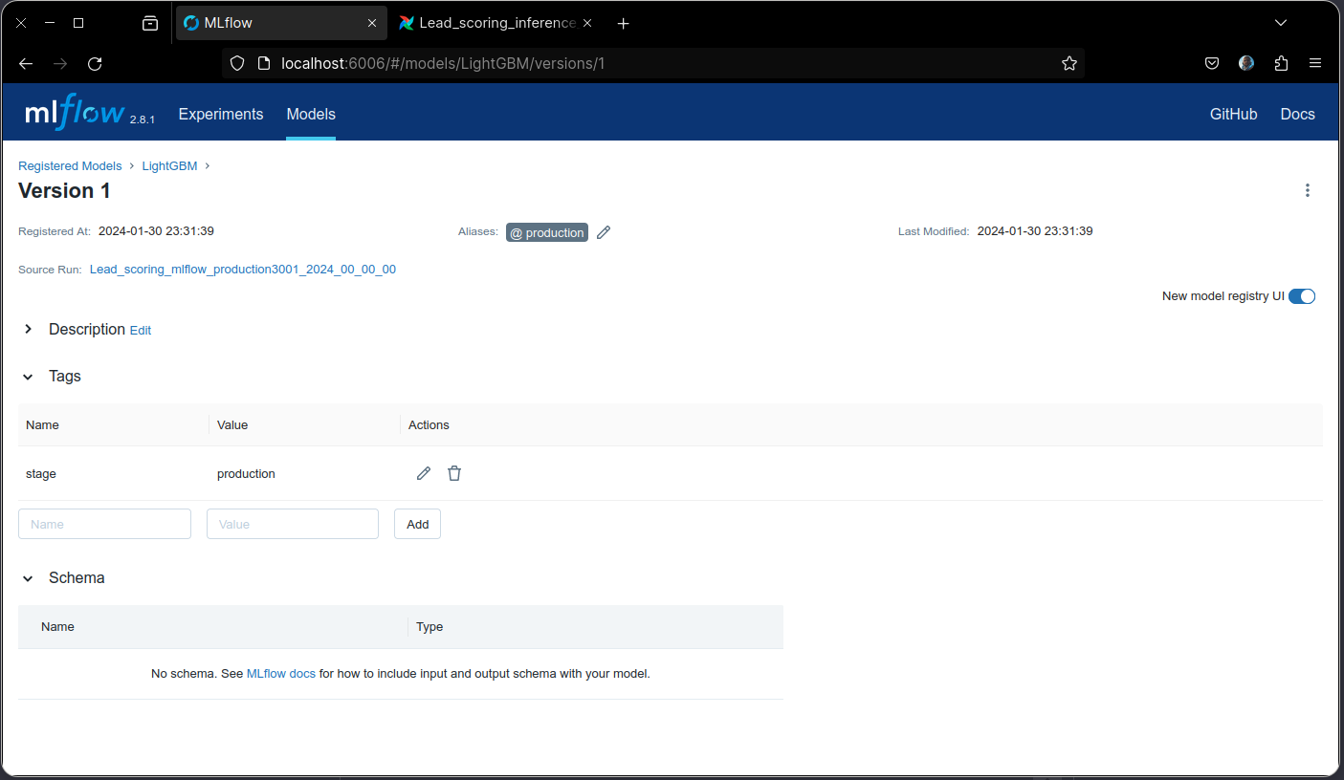

AirFlow

screenshot of all dags after successful execution

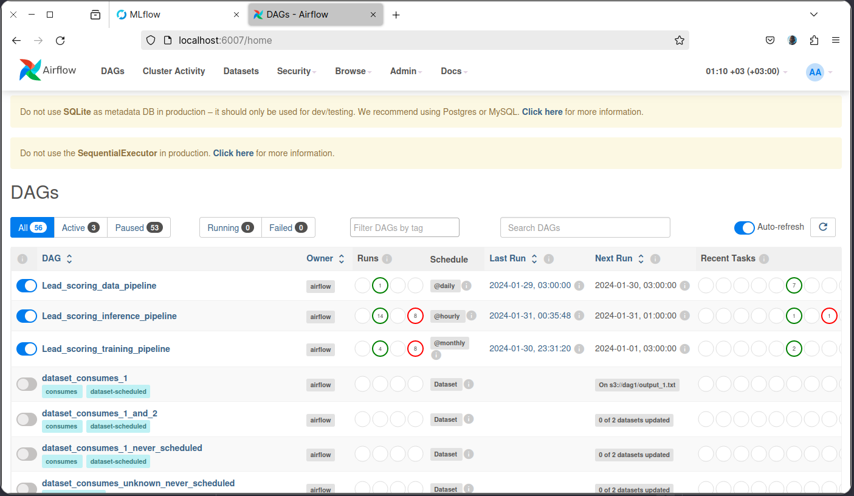

screenshot of data pipeline (lead_scoring_**data**_pipeline)

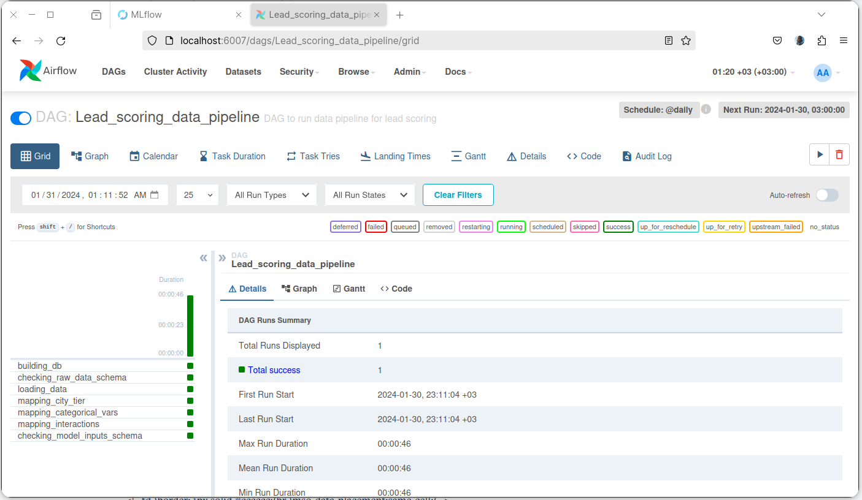

screenshot of training pipeline (lead_scoring_**training**_pipeline)

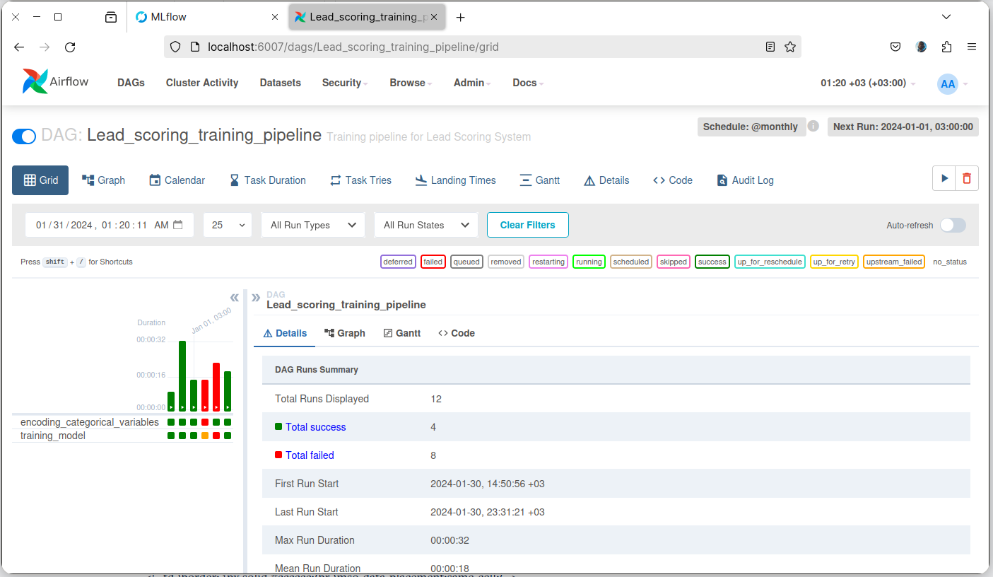

screenshot of inference pipeline (lead_scoring_**inference**_pipeline)

