Step 1 : start zookeeper in windows
Get inside bin folder of kafka and run
zookeeper-server-start.bat zookeeper.properties
in Ubuntu
./zookeeper-server-start.sh ./zookeeper.properties

Step 2 : start kafka server in windows
Get inside bin folder of kafka and run
kafka-server-start.bat server.properties
in Ubuntu
./kafka-server-start.sh ./server.properties

Step 3 : create topic in windows
Get inside bin folder of kafka and run
kafka-topics.bat --create --topic npcibatch_afternoon --bootstrap-server localhost:9092 --partitions 3 --replication-factor 1
in Ubuntu
./kafka-topics.sh --create --topic npcibatch_afternoon --bootstrap-server localhost:9092 --partitions 3 --replication-factor 1
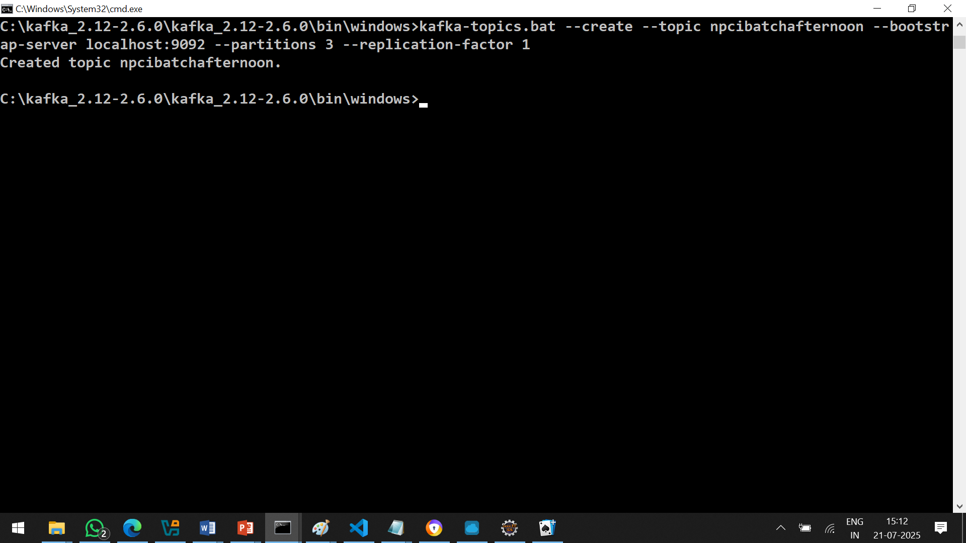

Step 4 : display topic details
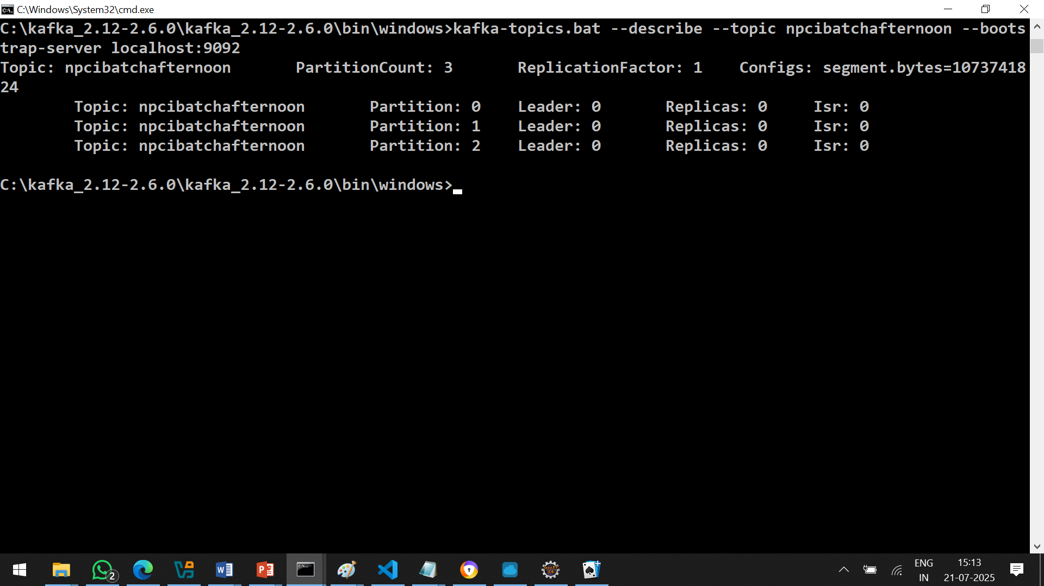

Total topics in kafka server available
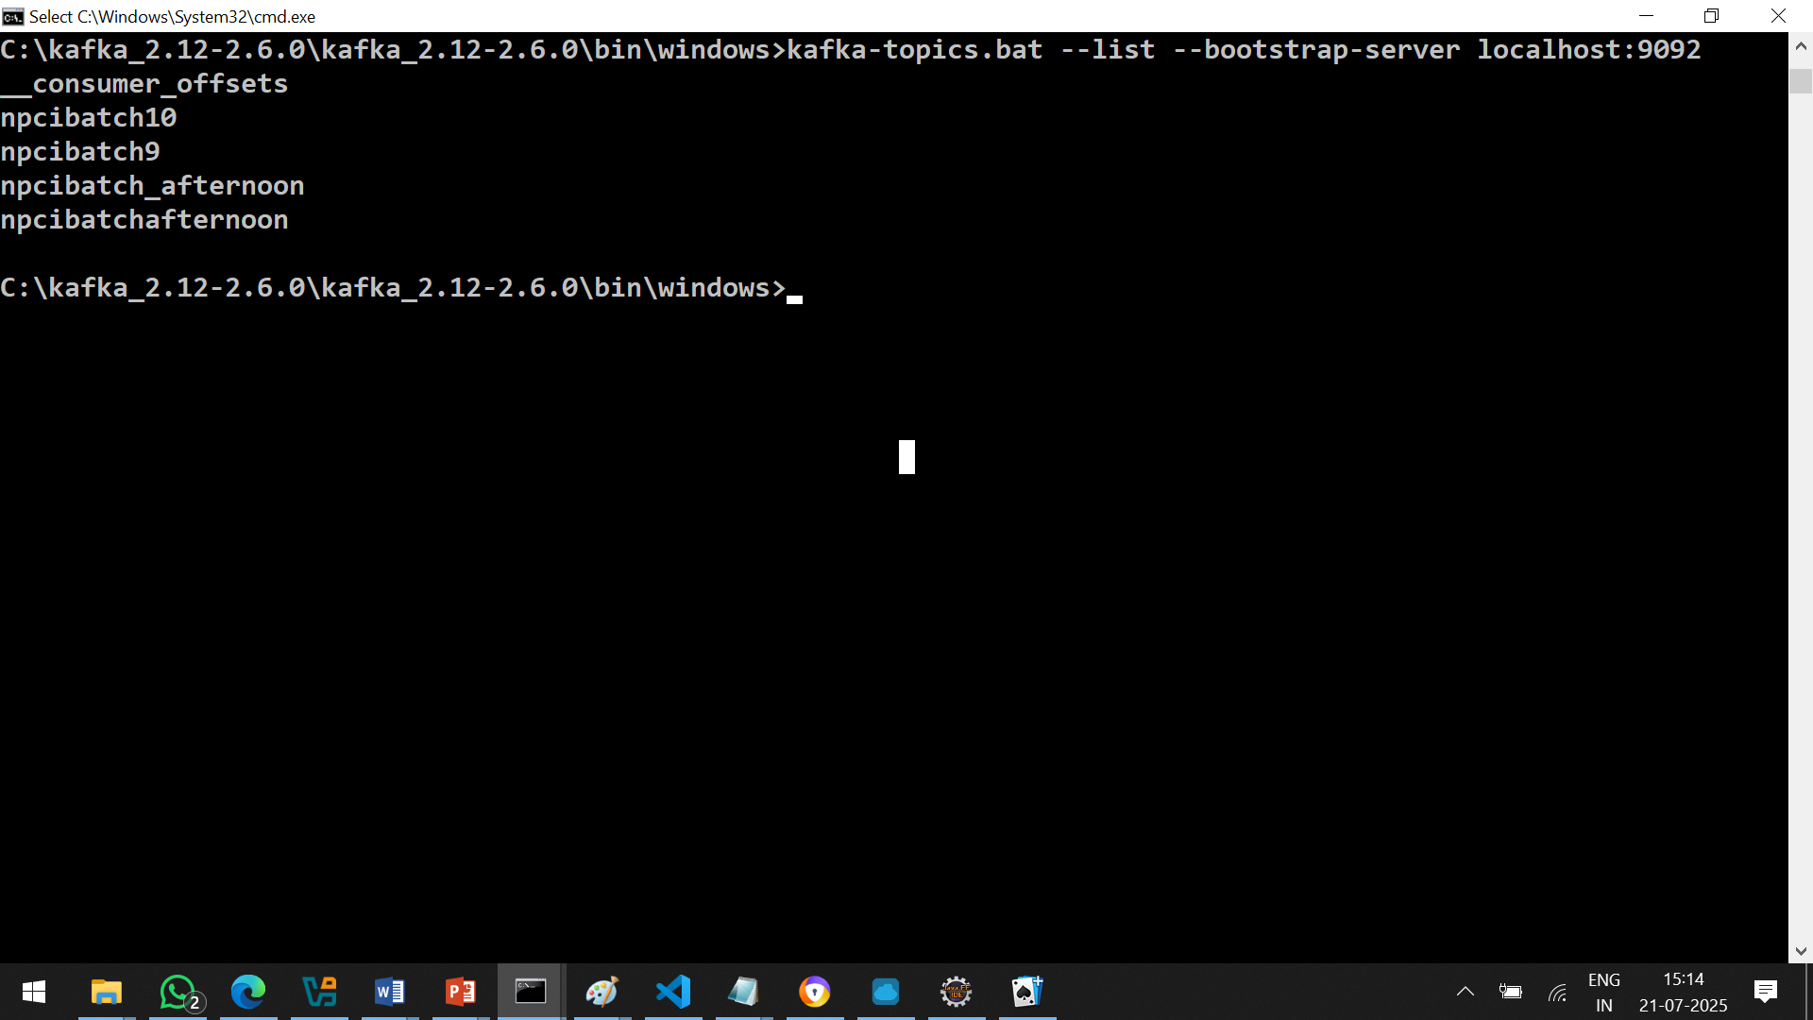

Step 4 how to produce message inside topic
kafka-console-producer.bat --topic npcibatchafternoon --bootstrap-server localhost:9092

in Ubuntu
./kafka-console-producer.sh --topic npcibatchafternoon --bootstrap-server localhost:9092

step 5 : how to consume message
kafka-console-consumer.bat --topic npcibatchafternoon --bootstrap-server localhost:9092
in Ubuntu
./kafka-console-consumer.sh --topic npcibatchafternoon --bootstrap-server localhost:9092

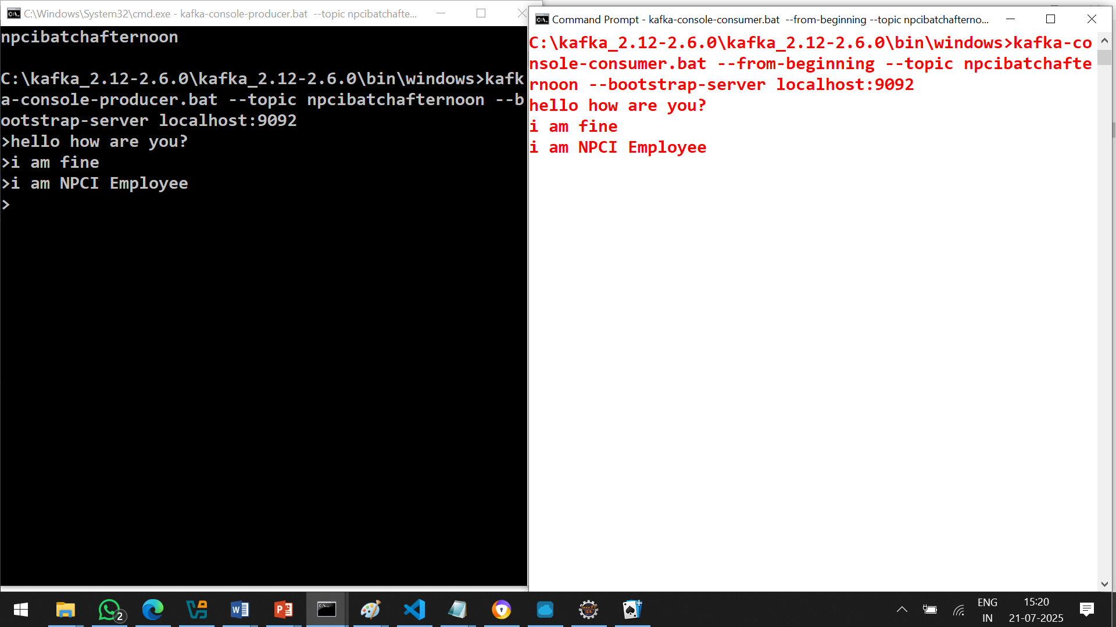

How to use kafka in api
Api
Config
Kafkaconfig.go
Router
Router+controller+model
Producer
Producer.go
Consumer
Consumer.go
Main.go

