Power pivot:

1.Yearly product margin analysis:

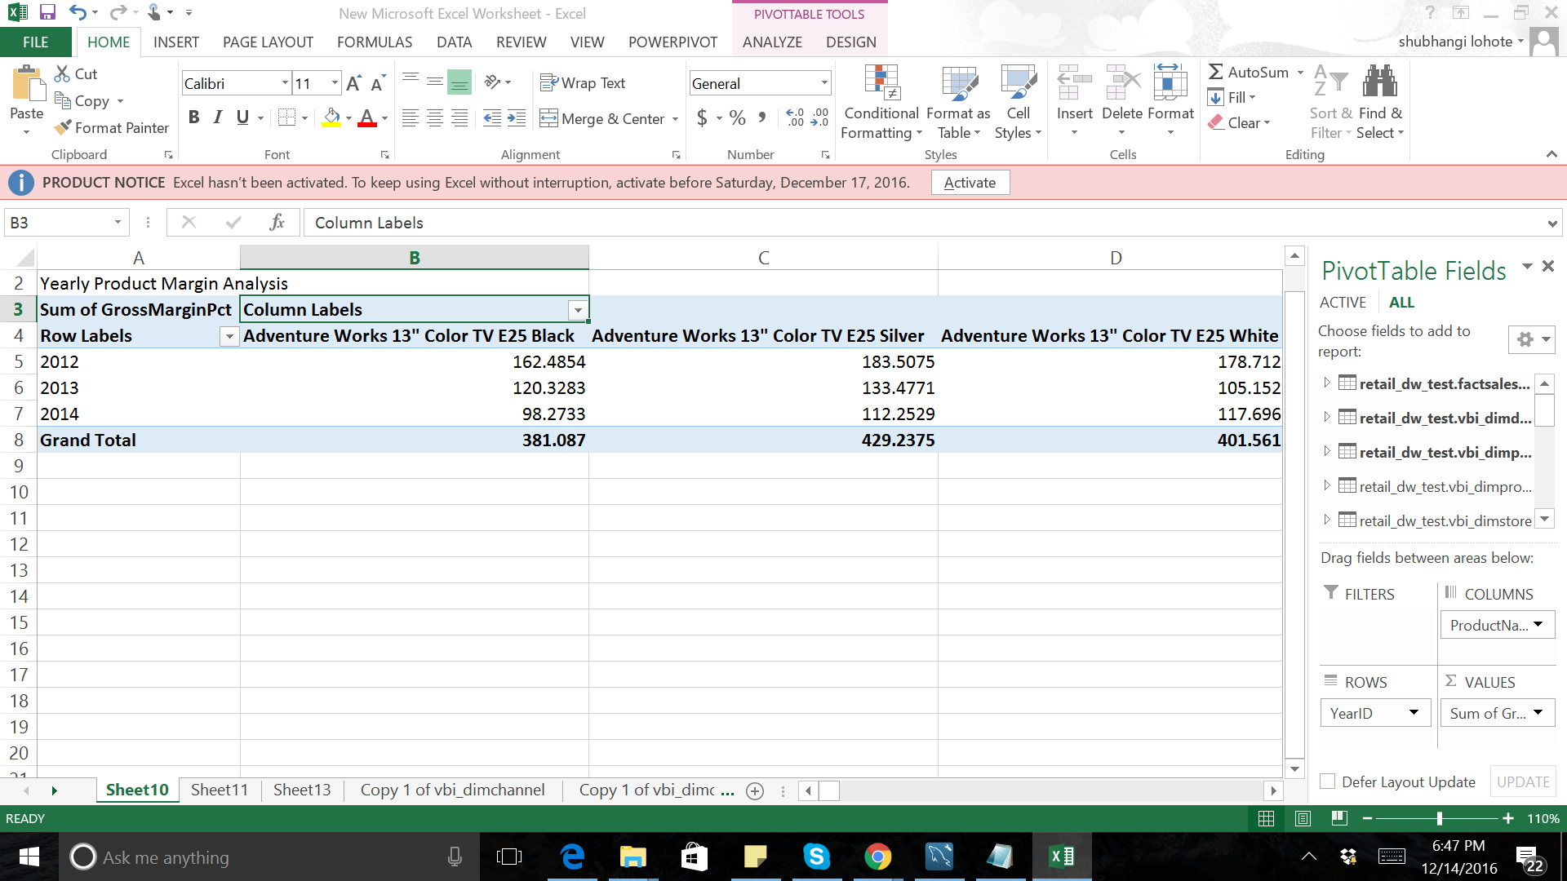

2.Store profit analysis:

