SVKM'S NMIM’S Nilkamal School of Mathematics, Applied Statistics & Analytics

Master of Science (Data Science)

Practical-7 **Web Feed**

**Name : Upasana Yadav Roll no : A015**

**Date:-26/03/2024 Submission Date:- 02/04/2024**

**Writeup:-**

* **Web Feed**
* **RSS and Atom**
* **Benefits of web feed**

**Write a program for Web Feed.**

[**https://www.carronmedia.com/create-an-rss-feed-with-php/**](https://www.carronmedia.com/create-an-rss-feed-with-php/)

**Step 1**

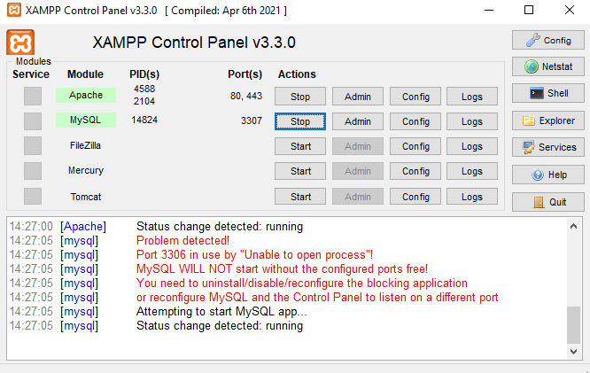

**Step 2**

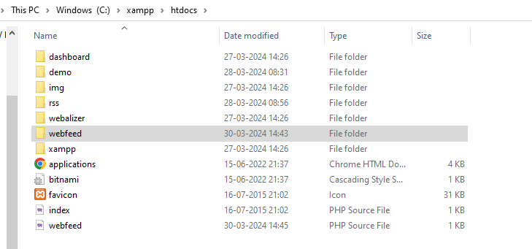

**Step 3**

**fetch**

<?php

$url="https://timesofindia.indiatimes.com/rssfeeds/913168846.cms";

$feedArr=json_decode(json_encode(simplexml_load_file($url)),true);

if(isset($feedArr['channel'])){

    if(isset($feedArr['channel']['item'])){

        echo "<div class='container'>";

        foreach($feedArr['channel']['item'] as $list){

            echo "<div class='item'>";

                echo "<a href='".$list['link']."' target='_blank'><h2>".$list['title']."</h2></a>";

                echo "<div class='desc'>".$list['description']."</div>";

            echo "</div>";

        }

        echo "</div>";

    }else{

        echo "Invalid Feed Link";

    }

}else{

    echo "Invalid Feed";

}

?>

<style>

.container{

    width: 80%;

    margin: auto;

}

.item{

    width:300px;

    float:left;

    height:500px;

    padding:10px;

}

.desc img{

    width:100%;

}

</style>

**create**

<?php

$con=mysqli_connect('localhost','root', '' , 'mscds');

$res=mysqli_query($con,"select * from product order by date desc");

$link='http://google.com';

header('Content-Type: text/xml');

$feed="<?xml version='1.0' encoding='UTF-8' ?>";

$feed.='<rss xmlns:atom="http://www.w3.org/2005/Atom" version="2.0">';

$feed.='<channel>';

$feed.='<title>My Website Feed</title>';

$feed.='<link>'.$link.'</link>';

$feed.='<description>My Website Feed Description</description>';

if(mysqli_num_rows($res)>0){

    while($row=mysqli_fetch_assoc($res)){

        $feed.='<item>';

            $feed.='<title>'.$row['title'].'</title>';

            $feed.='<description>'.$row['description'].'</description>';

            $feed.='<link>'.$row['link'].'</link>';

            $feed.='<guid>'.$row['id'].'</guid>';

            $feed.='<pubDate>'.$row['date'].'</pubDate>';

        $feed.='</item>';

    }

}

$feed.='</channel>';

$feed.='</rss>';

echo $feed;

?>

**product sql file**



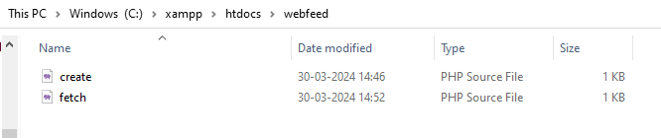

**Step 4**

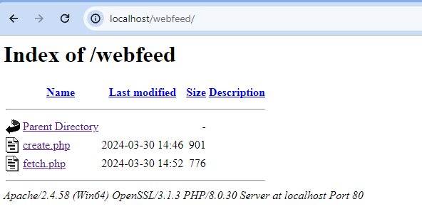

**Step 5**

