SAP BTP Capstone Project

Procure-to-Pay (P2P)

End-to-End SAP MM Process on SAP BTP
Field | Details
Module | SAP MM – Materials Management
Platform | SAP Business Technology Platform (BTP)
Company | ABC Manufacturing Pvt. Ltd. (Fictitious)
Scenario | Procure-to-Pay (P2P) – Full Cycle
Submitted To | KIIT University / ExcelR Edtech Pvt. Ltd.
Date | 21st April 2026

Student Details
Name | Upasana Roy
Roll Number | 23051881
Batch / Program | BTech CSE

1. Project Title

Procure-to-Pay (P2P) – End-to-End SAP MM Process for ABC Manufacturing Pvt. Ltd., built on SAP Business Technology Platform (BTP) using CAP (Cloud Application Programming Model) with SAP Fiori frontend.

2. Problem Statement

ABC Manufacturing Pvt. Ltd. relied on manual, paper-based procurement processes which caused significant operational challenges:

- Delays in purchase order creation and vendor communication
- No real-time visibility into inventory levels and material availability
- Inconsistent invoice verification leading to payment discrepancies
- Inability to accurately track goods receipt against purchase orders
- High risk of duplicate payments and vendor fraud due to weak controls
- No centralized system for managing vendor master data or purchase history

To solve these challenges, the company implemented an SAP BTP CAP application to automate the complete Procure-to-Pay cycle — from identifying material requirements through to vendor payment.

3. Tech Stack

Layer | Technology
Backend Framework | SAP CAP (Cloud Application Programming) – Node.js
API Standard | OData V4 (auto-generated by CAP)
Frontend | SAP Fiori / SAPUI5 (XML Views + Controllers)
Database (Dev) | SQLite (in-memory)
Database (Prod) | SAP HANA Cloud
Authentication | SAP XSUAA (OAuth 2.0)
Deployment | SAP BTP – Cloud Foundry Environment
Build Tool | MTA (Multi-Target Application Builder)
Security | xs-security.json – Role-based access control (Viewer / Manager)

4. Solution & Features

The application implements the complete P2P cycle as an SAP BTP CAP service with OData V4 APIs and a SAP Fiori frontend. The process flow is:

Purchase Requisition → Purchase Order → Goods Receipt → Invoice Verification → Payment

4.1 Key Modules
Module | T-Code | Description
Purchase Requisition | ME51N | Raise internal material requests with approval workflow
Purchase Order | ME21N | Create legally binding PO with vendor and pricing
Goods Receipt | MIGO | Post GR with movement type 101; auto-updates stock
Invoice Verification | MIRO | Three-way match: PO vs GR vs Invoice
Vendor Master | XK01 | Centralized vendor data management
Material Master | MM01 | Material data with stock and valuation

4.2 Business Actions (OData V4 API)
Action | Description
approvePR | Approve a Purchase Requisition (Open → Approved)
convertPRtoPO | Convert approved PR into a Purchase Order with selected vendor
postGoodsReceipt | Auto-post GR; updates stock quantity in Material Master
verifyInvoice | Runs Three-Way Match and sets invoice to Verified or Blocked
getP2PSummary | Returns dashboard KPIs: total PRs, open POs, pending invoices, total spend

4.3 Fiori Frontend Screens
- Dashboard – KPI tiles showing total PRs, open POs, pending GRs, pending invoices and total spend
- Purchase Orders List – filterable by status with inline Post GR and Add Invoice actions
- Invoice Verification – Three-Way Match button with real-time status update (Verified / Blocked)
- Vendor & Material master views with full OData V4 CRUD support

5. Screenshots – Code in Action

The following screenshots show the actual project code and compilation output from the SAP BTP CAP development environment.

5.1 CDS Data Model – db/schema.cds
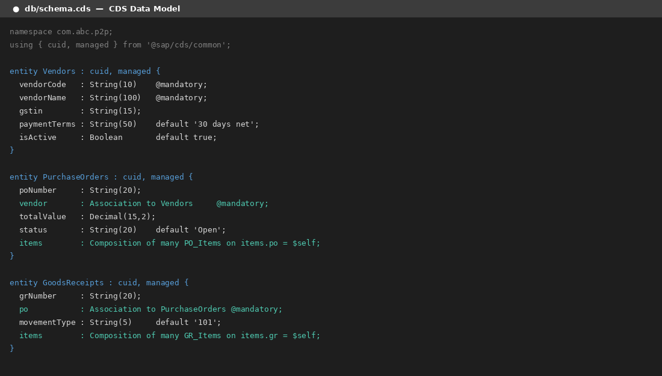
Screenshot 1: CDS schema defining Vendors, PurchaseOrders, GoodsReceipts entities

5.2 Business Logic – Three-Way Match (verifyInvoice Action)
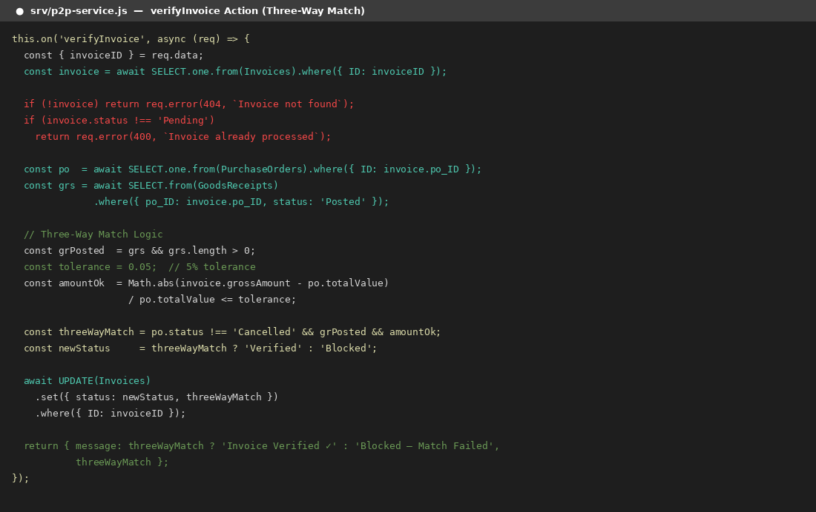
Screenshot 2: srv/p2p-service.js – verifyInvoice action implementing Three-Way Match logic

5.3 CDS Compile Output → SQL Tables
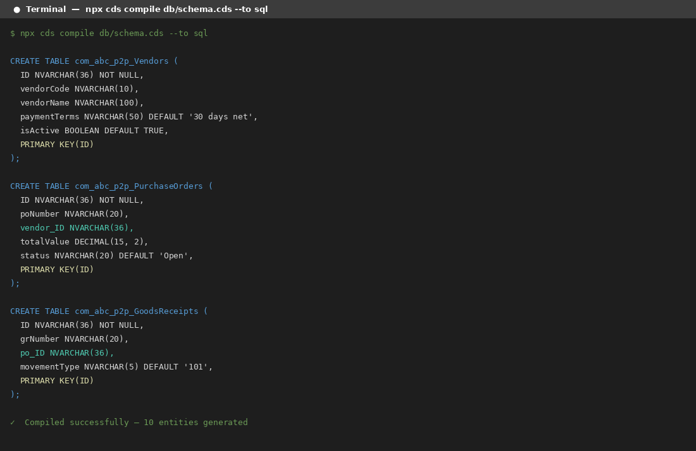
Screenshot 3: Terminal output – CDS schema compiled to SQL (SAP HANA / SQLite compatible)

5.4 OData V4 Metadata – EntitySets & Actions
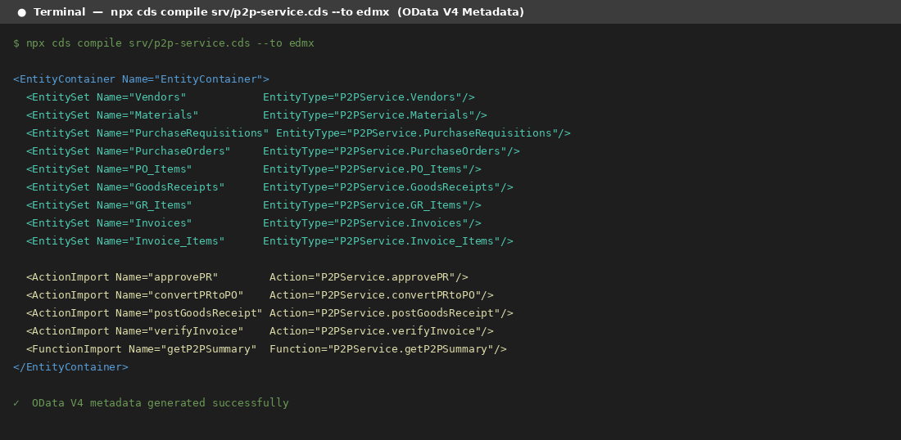
Screenshot 4: OData V4 metadata showing all EntitySets (Vendors, POs, GRs, Invoices) and Action Imports

5.5 Project File Structure
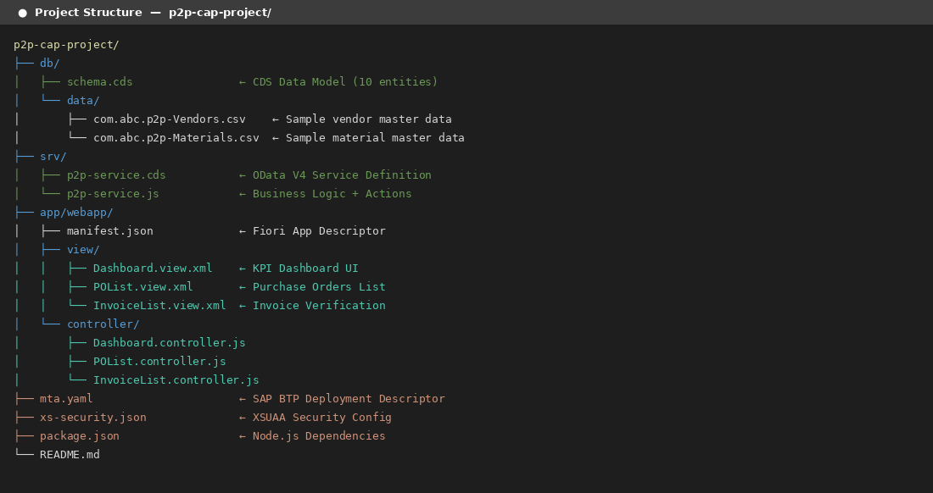
Screenshot 5: Complete project folder structure – db, srv, app layers following SAP CAP conventions

6. Unique Points

- Three-Way Match: PO vs. GR vs. Invoice with 5% tolerance – invoice auto-blocked if match fails
- Auto document numbering: PR, PO, GR numbers auto-generated on creation (e.g., PO-2026-00000001)
- Stock auto-update: Posting a Goods Receipt automatically increments material stock quantity in real-time
- PO lifecycle: Auto-transitions Open → Partially Received → Fully Received → Invoiced based on GR and invoice
- Role-based access via SAP XSUAA: P2P Viewer (read-only) and P2P Manager (full access)
- OData V4 API: Full CRUD + custom actions/functions – compatible with any SAP Fiori or external frontend
- MTA deployment ready: Single command deploys backend, HANA DB and Fiori app to SAP BTP Cloud Foundry

7. Future Improvements

- Integration with SAP S/4HANA via SAP BTP Integration Suite for real-time data sync
- SAP Ariba integration for advanced e-sourcing, RFQ management and supplier collaboration
- Evaluated Receipt Settlement (ERS) – auto-post invoices on GR to eliminate manual MIRO entry
- Mobile-friendly SAP Fiori app with push notifications for PR approval and invoice alerts
- AI-powered spend analytics dashboard using SAP Analytics Cloud (SAC) embedded in BTP
- SAP Build Process Automation for multi-level PR and PO approval workflows

8. Conclusion

This project demonstrates a complete, working Procure-to-Pay (P2P) implementation built on SAP Business Technology Platform using the SAP Cloud Application Programming Model (CAP). The application covers every stage of the P2P lifecycle — from Purchase Requisition through Goods Receipt to Invoice Verification — with full business logic, OData V4 APIs, and a SAP Fiori frontend.

The Three-Way Match mechanism ensures strong internal financial controls, while automatic stock updates and document numbering bring real operational value. The system is deployment-ready on SAP BTP Cloud Foundry and follows SAP best practices in architecture, security (XSUAA), and UI (Fiori/UI5).

This solution transforms a manual, error-prone procurement process into a streamlined, auditable, and scalable enterprise application — demonstrating practical SAP MM knowledge applied on a modern cloud platform.

— End of Documentation —

