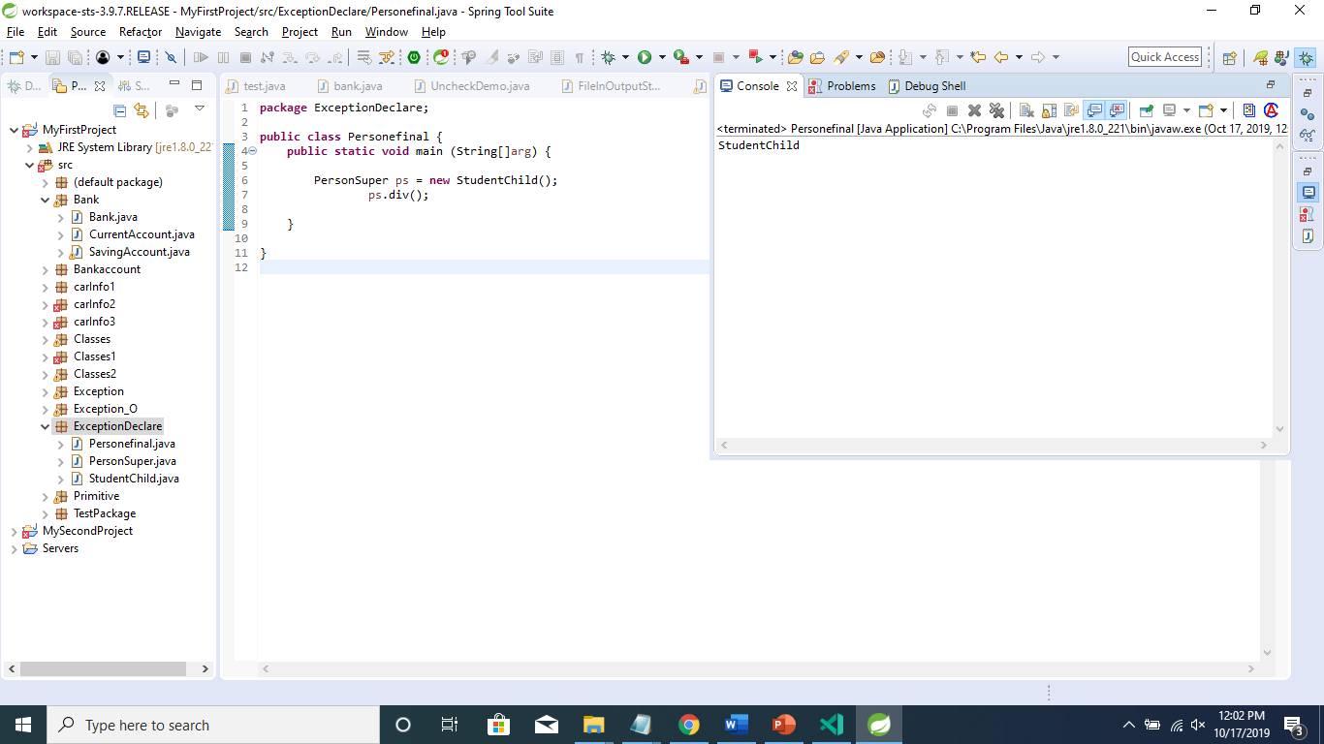

This is non-static method so, it will be called during runtime and decided which value to print, in this case it will print left-side of the value.

For instance methods, the method is called according to the type of object being referred, not according to the type of reference, which means method calls is decided at run time.

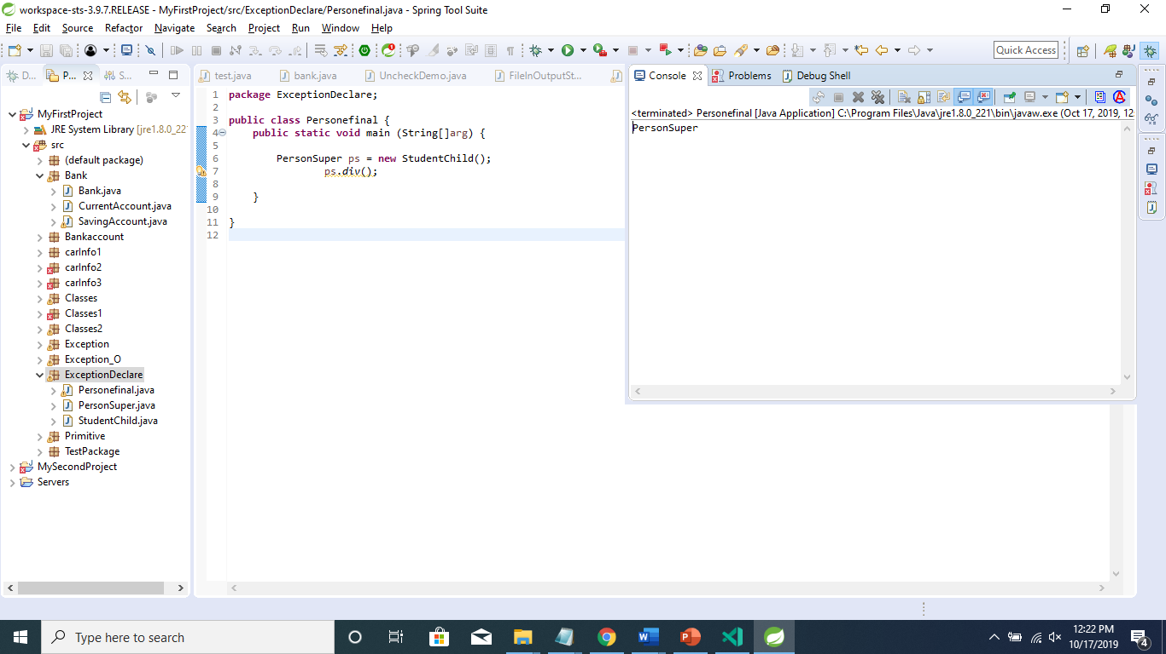

The static method called during the compile time, so it will print right-side of the object.

For ex: - “PersonSuper”.

For static methods, the method according to the type of reference is called, not according to the object being referred, which means method call is decided at compile time.

1. You cannot override static method to non-static and non-static to Static method it will give you compile time error.

1) Rule: If the superclass method does not declare an exception, subclass overridden method can declare the checked exception.

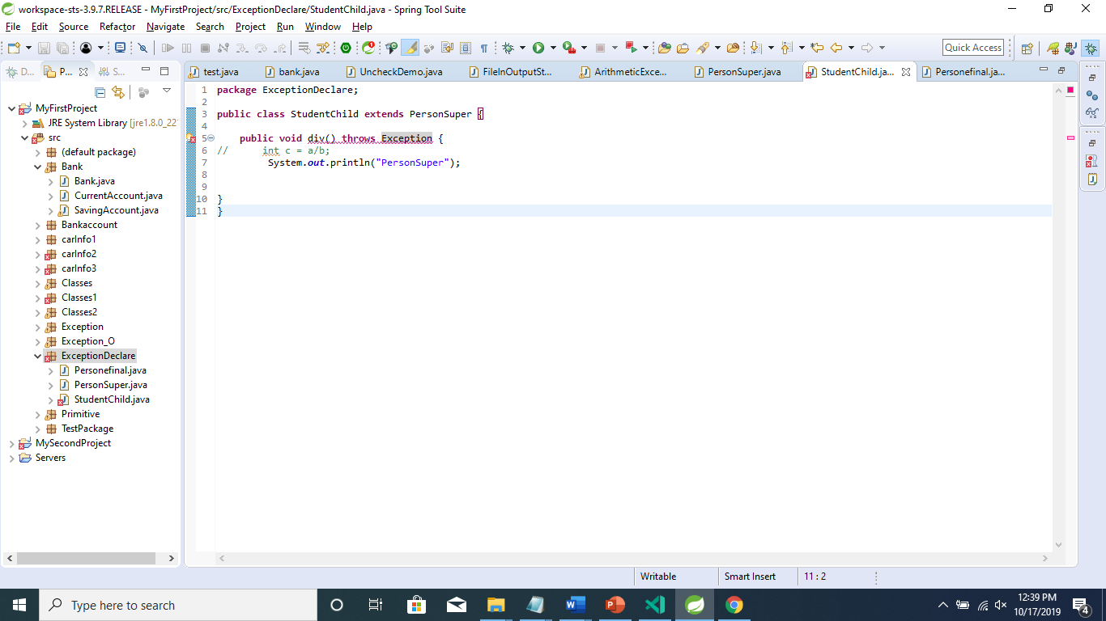

It will show the compile time error.

2) Rule: If the superclass method does not declare an exception, subclass overridden method cannot declare the checked exception but can declare unchecked exception.

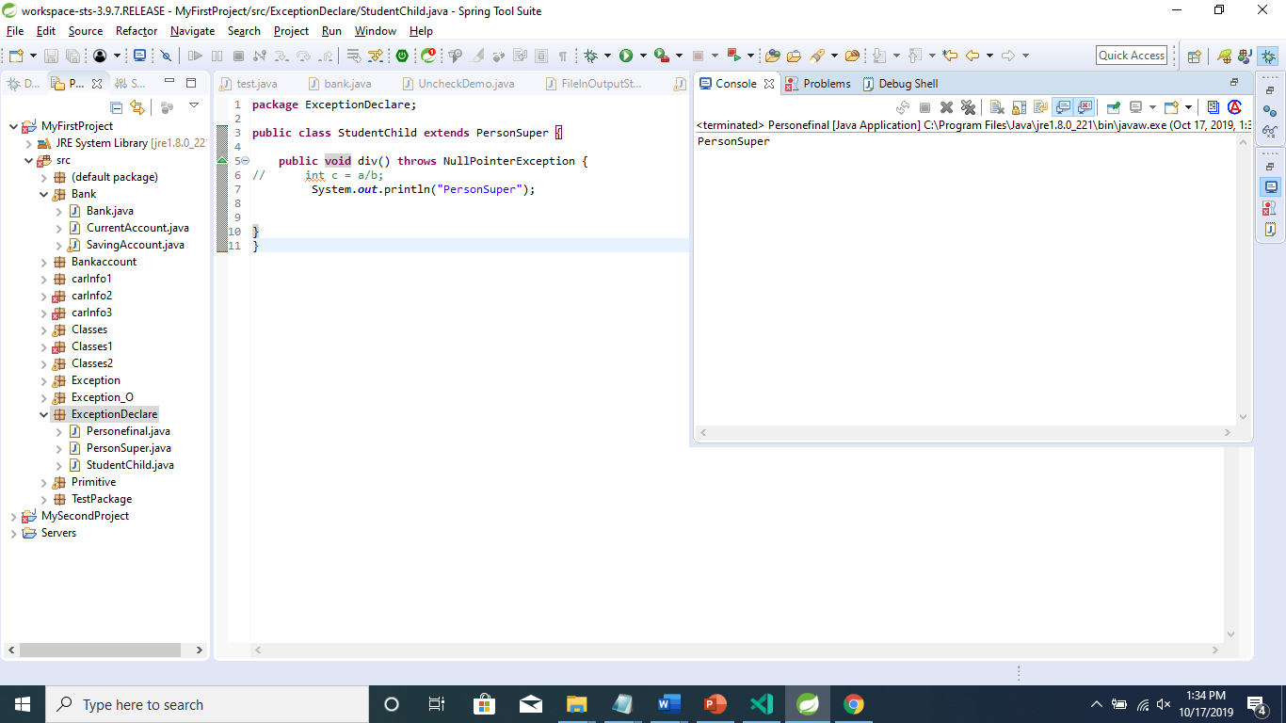

It will show the output, so if you are overring the method with unchecked exception it will execute.

3) Rules: If we declare exception in both parent and child class.

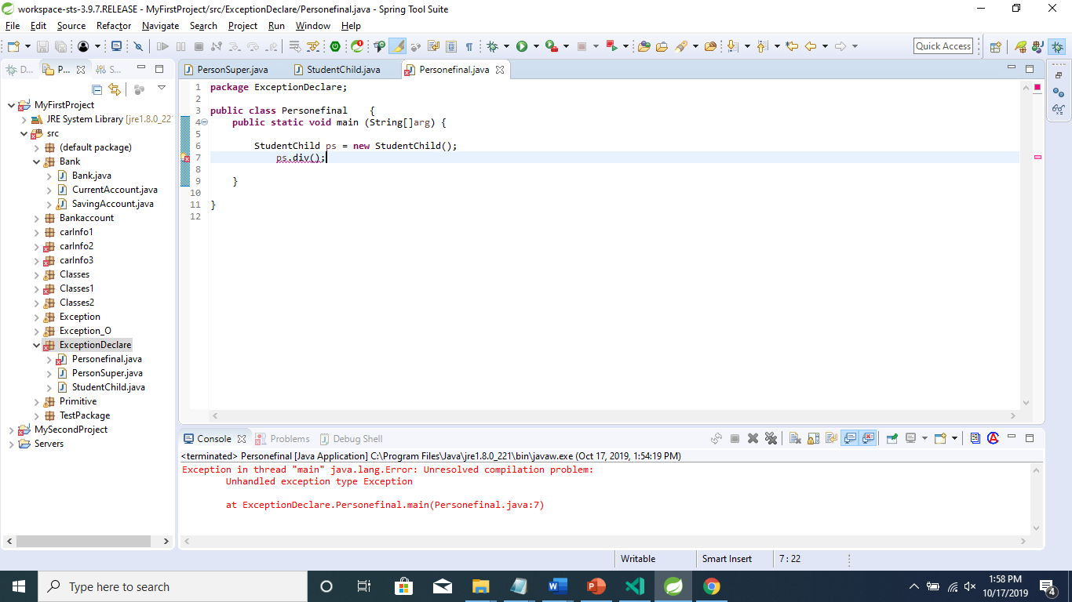

It will give you compile error to handle the exception.

4) rules: If Superclass declares an exception and Subclass declares an child exception of the superclass declared Exception.

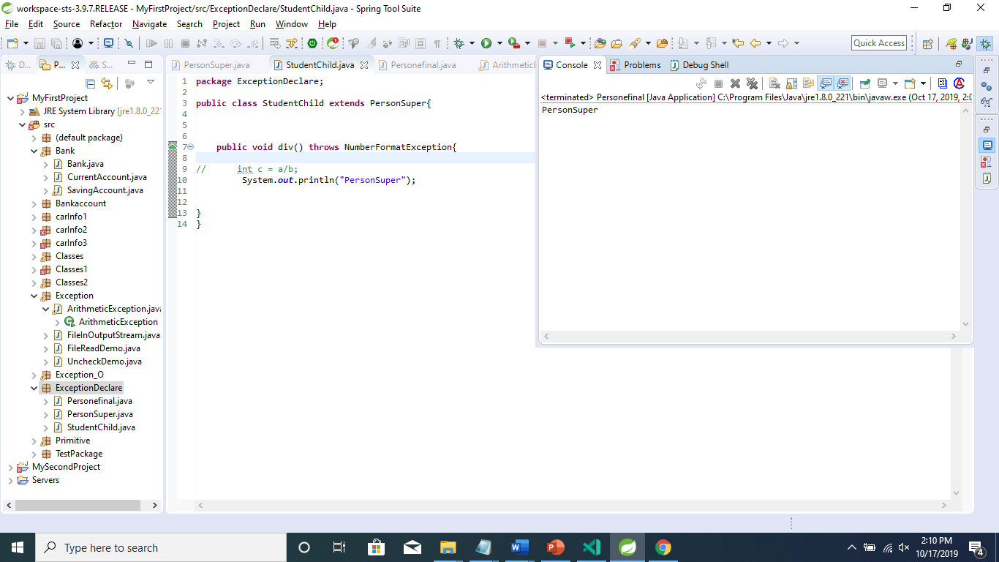

If both super class and child class declare different type of unchecked exception, in that case program will execute properly.

5) Rules: If Super Class declares an exception and Sub Class declares without exception.

