WEEK 1 INTERNSHIP PROJECT PLAN
Customer Churn Prediction Using Python
and Machine Learning
A Strategic Data Science Project Blueprint

Internship Deliverable | Week 1 – Project Planning & Strategy
Project Domain | Data Science / Machine Learning
Proposed Technology | Python
Planned Effort | 33 Hours
Status | Conceptual Planning – No Dataset Required

Prepared as a Week 1 internship submission

1. Executive Summary
This Week 1 project plan proposes a hypothetical Customer Churn Prediction system using Python and machine learning. The purpose is to establish a complete, practical strategy for solving a business problem through the data science lifecycle before technical implementation begins. The project will conceptually use customer demographic information, subscription details, service usage, transaction history, and interaction records to identify patterns associated with customer churn.
The plan covers problem definition, project scope, data requirements, preprocessing, exploratory analysis, feature engineering, model development, evaluation, interpretation, tools, timeline, expected outcomes, and risk mitigation. No real dataset is required during Week 1; the emphasis is on strategic thinking, architecture, and methodological justification.

2. Project Background

2.1 Problem Context
Customer retention is an important concern for subscription-based and service-oriented organizations. A customer may discontinue a service because of price, poor experience, low engagement, service issues, changing needs, or competitive alternatives. If an organization can identify customers who show a higher likelihood of leaving, it can investigate the underlying factors and design appropriate retention strategies.

2.2 Proposed Data Science Problem
The proposed project will formulate customer churn as a supervised classification problem. The target variable will represent whether a customer leaves within a defined future period. The model will use historical customer information available before that period to estimate churn risk.

2.3 Motivation
The motivation is to transform historical customer data into actionable information. Instead of relying only on broad assumptions about why customers leave, a data-driven approach can systematically examine relationships among customer characteristics, usage behavior, service interactions, and churn outcomes. The resulting analysis can support data-informed retention planning while recognizing that model predictions are probabilistic and should be interpreted alongside business context.

3. Project Objectives
- Define a clear and measurable customer churn prediction problem.
- Identify the types of customer data required for analysis.
- Design a structured data cleaning and preprocessing strategy.
- Plan exploratory data analysis to identify distributions, trends, relationships, and potential churn drivers.
- Define an appropriate feature engineering approach for categorical, numerical, and behavioral variables.
- Plan the development and comparison of suitable classification models.
- Define evaluation metrics that reflect both predictive performance and the business context.
- Design a workflow that can be implemented using Python and commonly available data science libraries.
- Document expected benefits, limitations, risks, and mitigation strategies.

4. Project Scope

4.1 In Scope
- Customer-level structured data analysis.
- Data quality assessment and preprocessing.
- Exploratory data analysis and visualization.
- Feature engineering and preparation of model-ready data.
- Binary classification for churn prediction.
- Comparison of multiple candidate machine learning models.
- Evaluation using appropriate classification metrics.
- Interpretation of important variables and model behavior.
- Documentation of findings and recommendations for future implementation.

4.2 Out of Scope
- Real-time production deployment during Week 1.
- Automated customer communication or marketing campaigns.
- Direct financial transactions or changes to customer accounts.
- Guaranteeing that a predicted customer will actually churn.
- Collection of personally identifiable information beyond what is necessary for the hypothetical analysis.
- Building a complete enterprise data warehouse or cloud infrastructure.
- Production monitoring and model retraining, which would be addressed in a later implementation phase.

5. Methodology & Strategy
The proposed methodology follows an iterative data science lifecycle. Each stage produces outputs that inform the next stage, while evaluation and validation may require revisiting earlier assumptions.

5.1 Stage 1 – Problem Definition
Define churn precisely, including the observation period, prediction window, target variable, and acceptable prediction use. Establish the business question: which customer attributes and behaviors are associated with a higher probability of future churn?

5.2 Stage 2 – Data Collection Strategy
Potential data sources may include:
- Customer profile information: age group, region, customer tenure, and account type.
- Subscription information: plan, contract type, renewal frequency, and pricing.
- Usage information: login frequency, service usage, session activity, or product engagement.
- Transaction information: billing amount, payment method, payment delays, and purchase history.
- Customer support information: number of complaints, tickets, response times, and resolution outcomes.
- Historical churn labels indicating whether customers discontinued the service within the defined prediction period.
Before modeling, data sources would be checked for consistency, privacy requirements, duplicate records, missing fields, and whether each feature would genuinely be available at prediction time.

5.3 Stage 3 – Data Cleaning & Preprocessing
- Inspect dataset dimensions, data types, missing values, duplicate records, and invalid entries.
- Handle missing values using strategies appropriate to the variable and missingness pattern.
- Identify and investigate extreme or implausible values rather than automatically deleting them.
- Remove duplicate or inconsistent records where justified.
- Encode categorical variables using suitable techniques.
- Scale numerical variables when required by the selected model.
- Check class imbalance in the churn target.
- Separate training and testing information carefully to prevent data leakage.

5.4 Stage 4 – Exploratory Data Analysis
- Analyze the distribution of churn and non-churn classes.
- Compare churn rates across subscription and customer segments.
- Examine tenure, usage, spending, support interactions, and other numerical variables.
- Use histograms, box plots, bar charts, correlation analysis, and grouped summaries where appropriate.
- Investigate relationships between variables and identify potential data quality problems.
- Generate hypotheses that can guide feature engineering and modeling.

5.5 Stage 5 – Feature Engineering
Potential derived features include:
- Customer tenure bands.
- Average monthly usage or spending.
- Recent change in usage compared with historical usage.
- Support-contact frequency.
- Payment delay indicators.
- Engagement ratios such as active days relative to subscription duration.
- Aggregated behavioral measures over a defined observation window.
Feature engineering will be guided by business meaning and temporal availability. Features that use information occurring after the prediction point will be excluded to avoid leakage.

5.6 Stage 6 – Model Selection
The initial modeling strategy will establish a simple baseline and then compare several classification algorithms. Candidate models may include Logistic Regression, Decision Tree, Random Forest, and a gradient-boosting model such as HistGradientBoostingClassifier. The final choice will depend on validation performance, interpretability, computational requirements, and the intended use.

5.7 Stage 7 – Model Evaluation
Evaluation will not rely on accuracy alone, particularly if churn is an imbalanced target. Candidate metrics include precision, recall, F1-score, ROC-AUC, and the confusion matrix. Where appropriate, Precision-Recall analysis may also be considered. Cross-validation on the training data will be used for model comparison, followed by final testing on a held-out test set.
Business interpretation will consider the consequences of false positives and false negatives. For example, incorrectly flagging a loyal customer may create unnecessary retention effort, while failing to identify a customer at risk may reduce the opportunity for intervention.

6. Strategic Project Workflow
The following workflow represents the proposed end-to-end process. It is intentionally designed as an iterative process: evaluation results may lead to revised preprocessing, features, or model choices.
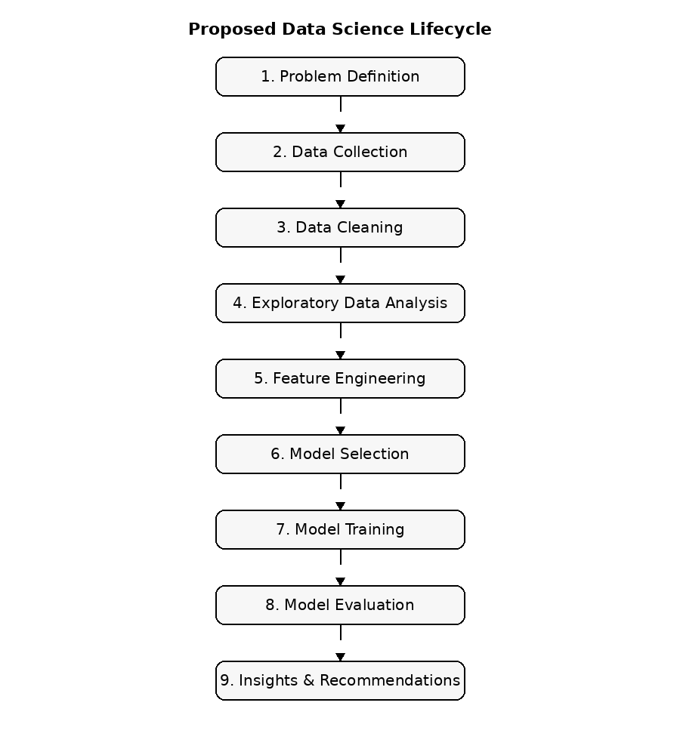
Figure 1. Proposed end-to-end data science lifecycle.

7. Proposed Project Architecture
The architecture separates data preparation, analysis, modeling, and interpretation. In a future implementation, these components could be organized into reusable Python scripts or notebooks and eventually converted into a reproducible pipeline.
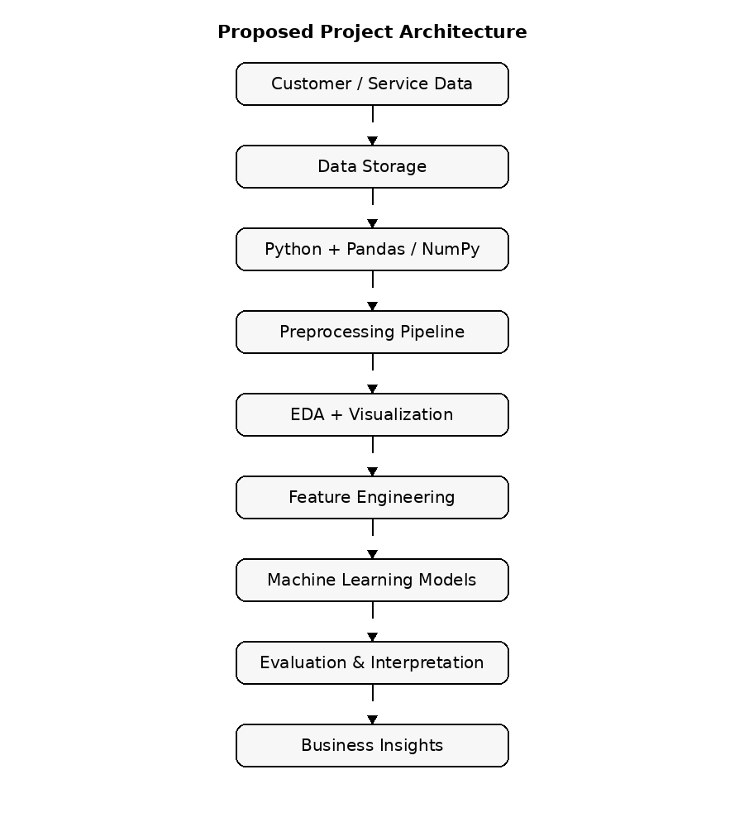
Figure 2. Conceptual project architecture.

8. Tools, Technologies & Libraries
Category | Tool / Library | Purpose
Programming | Python | Core programming language
Data handling | Pandas | Tabular data manipulation and preprocessing
Numerical computing | NumPy | Numerical operations and arrays
Visualization | Matplotlib | Charts and exploratory visualizations
Visualization | Seaborn | Statistical visualizations
Machine learning | Scikit-learn | Preprocessing, models, validation, and metrics
Development | Jupyter Notebook / Google Colab | Interactive experimentation and documentation
Code management | Git / GitHub | Version control and collaboration
Documentation | Microsoft Word | Final Week 1 project plan
Diagrams | Draw.io / diagrams.net | Professional flowcharts and architecture diagrams

9. Model Evaluation Strategy
The evaluation plan is designed to balance statistical performance with practical interpretability. The proposed process starts with a baseline model, compares candidate algorithms using validation data, examines multiple metrics, and then evaluates the selected approach on an untouched test set.
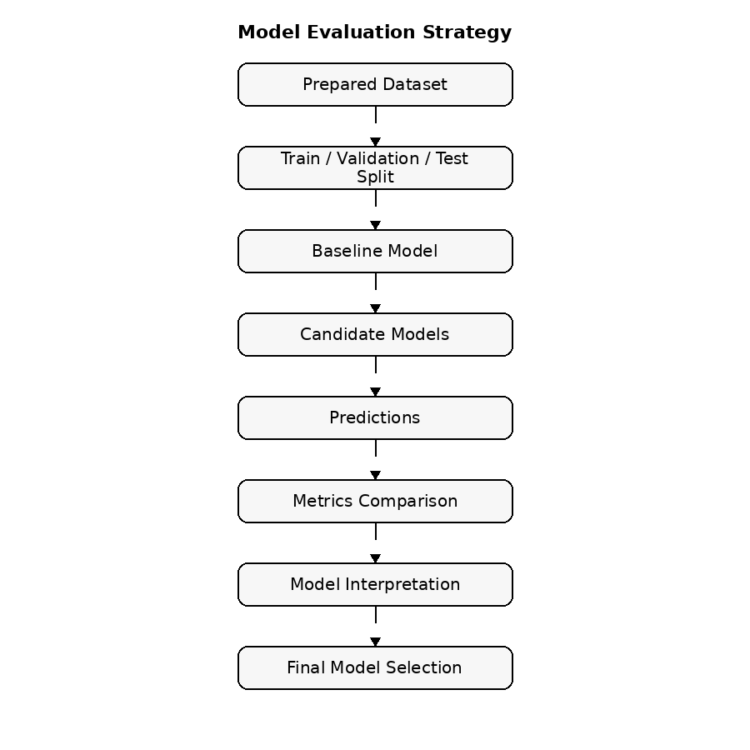
Figure 3. Planned model evaluation flow.

10. Timeline & Work Allocation
Week 1 is planned as approximately 33 hours of focused work. The allocation is conceptual and can be adjusted if the internship schedule changes.
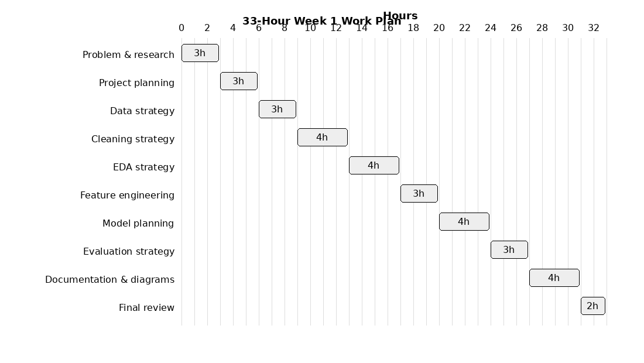
Task | Hours | Planned Output
Problem understanding & research | 3 | Problem statement and motivation
Project planning | 3 | Objectives, scope, assumptions
Data collection strategy | 3 | Data-source and variable plan
Cleaning strategy | 4 | Preprocessing framework
EDA strategy | 4 | Exploration and visualization plan
Feature engineering | 3 | Candidate feature plan
Model selection & planning | 4 | Candidate algorithms and rationale
Evaluation strategy | 3 | Metrics and validation plan
Documentation & diagrams | 4 | Report and strategic visuals
Final review | 2 | Quality check and submission

11. Expected Outcomes
- A complete and reproducible conceptual workflow for customer churn prediction.
- A clearly defined target variable and data requirement specification.
- A structured preprocessing and exploratory analysis strategy.
- A justified shortlist of machine learning algorithms.
- A multi-metric evaluation framework.
- Identification of potentially important churn-related factors for later investigation.
- A professional project blueprint that can be converted into technical implementation in subsequent internship weeks.
The expected result at the end of Week 1 is not a trained model or a numerical accuracy score. It is a well-justified technical plan that defines how those outputs will be produced once an appropriate dataset is available.

12. Anticipated Challenges & Mitigation Strategies
Challenge | Potential Impact | Mitigation Strategy
Missing or inconsistent data | Reduced reliability of analysis | Profile missingness, validate values, and document assumptions.
Class imbalance | Accuracy may hide poor minority-class detection | Use suitable metrics, stratification, class weighting or resampling where justified.
Data leakage | Unrealistically high validation performance | Use time-aware feature definitions and isolate test data.
Overfitting | Poor generalization to unseen customers | Use cross-validation, regularization, pruning, and controlled model complexity.
High-dimensional categorical data | Complex preprocessing and sparse representations | Use appropriate encoding and feature selection.
Interpretability requirements | Difficult business adoption | Compare interpretable baselines and use model-interpretation methods.
Changing customer behavior | Performance may degrade over time | Plan for periodic monitoring and retraining in future phases.
Privacy and security | Risk of inappropriate data use | Minimize personal data, apply access controls, and follow organizational policies.

13. Evaluation Criteria for the Week 1 Plan
- Completeness: all required project-planning sections are present.
- Clarity: the problem, objectives, scope, and methodology are easy to understand.
- Technical understanding: the proposed workflow demonstrates knowledge of the data science process.
- Logical strategy: each stage has a clear purpose and feeds logically into the next stage.
- Tool justification: proposed Python libraries are aligned with the project tasks.
- Time feasibility: the planned work fits within approximately 30–35 hours.
- Visual communication: diagrams clearly represent the workflow, architecture, evaluation strategy, and schedule.
- Professional presentation: the report is structured, readable, consistent, and suitable for internship submission.

14. Key Assumptions
- A suitable historical customer dataset will be available during the technical implementation phase.
- Each record can be linked to a defined observation period and churn outcome.
- Features used for prediction are available before the churn prediction window closes.
- The organization permits the proposed analytical use of the data.
- The objective is decision support rather than automatic decision-making about individual customers.
- Model performance will be assessed on unseen data rather than only on training performance.

15. Conclusion
This Week 1 plan establishes a structured foundation for a hypothetical Customer Churn Prediction project using Python. The proposed strategy covers the complete data science lifecycle from problem formulation and data planning to preprocessing, exploratory analysis, feature engineering, model development, evaluation, and interpretation.
The plan deliberately separates conceptual strategy from technical implementation. This makes it possible to begin the next stage with clear objectives, defined data requirements, selected tools, evaluation criteria, and an achievable work schedule. If implemented carefully, the project could provide useful evidence about customer behavior and support data-informed retention analysis, while its limitations, uncertainty, privacy considerations, and potential model drift would need to be monitored.

Appendix A – Proposed Dataset Schema
The following is a hypothetical schema to guide future dataset selection; it is not a dataset required for Week 1.
Feature | Type | Example Meaning | Role
customer_id | Identifier | Unique customer reference | Identifier
tenure_months | Numeric | Months as a customer | Predictor
contract_type | Categorical | Monthly / annual contract | Predictor
monthly_charge | Numeric | Recurring charge | Predictor
usage_frequency | Numeric | Usage or activity measure | Predictor
support_tickets | Numeric | Support contacts in period | Predictor
payment_delays | Numeric | Count of delayed payments | Predictor
engagement_change | Numeric | Recent change in engagement | Predictor
churn | Binary | Left service or remained | Target

Appendix B – Suggested Next-Phase Deliverables
- Acquire or select a suitable anonymized dataset.
- Create a Python/Jupyter project structure.
- Perform data profiling and cleaning.
- Conduct EDA and generate documented visualizations.
- Engineer and validate features.
- Train baseline and candidate classification models.
- Compare models using cross-validation and held-out testing.
- Interpret the selected model and document limitations.
- Prepare a final technical report and presentation.
End of Week 1 Project Plan

