WEEK 4 INTERNSHIP REPORT
Comprehensive Data Science Report
and Insights Presentation Plan
Hypothetical Project: Customer Churn Prediction
A professional framework for consolidating analysis, translating findings into business insights,
and communicating recommendations to non-technical stakeholders.
Document Information | Details
Internship Week
 | Week 4
Report Type
 | Comprehensive Data Science Report & Presentation Plan
Project Type
 | Supervised Machine Learning – Binary Classification
Business Theme
 | Customer Retention / Churn Prediction
Status
 | Hypothetical / Mock Analysis

Prepared as an internship portfolio deliverable

Table of Contents
1. Executive Summary
2. Project Context and Business Objective
3. Methodology Overview
4. Data Understanding and Preparation
5. Insights and Analysis
6. Mock Visualizations and Their Rationale
7. Translating Technical Results into Business Insights
8. Presentation Strategy for Non-Technical Stakeholders
9. Actionable Recommendations
10. Future Work and Further Research
11. Risks, Limitations, and Responsible Communication
12. Proposed Executive Presentation Flow
13. Reporting and Documentation Standards
14. Expected Outcomes
15. Conclusion
References
Appendix A – Mock KPI Dashboard
Appendix B – Final Quality Checklist

1. Executive Summary
This report presents a complete communication plan for a hypothetical customer churn prediction project. The objective is to identify patterns associated with customer attrition, estimate which customers are at elevated risk of leaving, and translate analytical results into practical retention actions.
The analysis is assumed to combine exploratory data analysis, statistical reasoning, feature engineering, and supervised machine learning. Mock findings indicate that contract structure, customer tenure, monthly charges, and customer-service interactions are important signals associated with churn.
Executive message
The central business story is not simply “who may churn?” but “where can the organization intervene early, and what evidence should guide those interventions?” The presentation should therefore move from business problem → evidence → customer segments → actions → measurement.

Hypothetical headline findings
- Month-to-month customers show substantially higher mock churn than customers on longer contracts.
- Short-tenure customers form an important early-retention opportunity, with estimated churn decreasing as tenure increases.
- Higher recurring charges and repeated support interactions are treated as additional risk signals requiring investigation.
- A classification model can prioritize customers for review, but intervention decisions should also consider customer context, cost, fairness, and business rules.
- The recommended operating model is a monitored retention workflow in which predictions trigger human-reviewed, measurable interventions.

2. Project Context and Business Objective
Customer churn occurs when an existing customer stops using or paying for a service. Retaining an existing customer can be strategically important because acquisition and onboarding may require substantial marketing, sales, and service resources. A data science approach can help identify patterns that are difficult to monitor manually across a large customer base.

2.1 Business questions
- Which customer characteristics and behaviors are associated with churn?
- Which customer segments appear to have elevated churn risk?
- How accurately can a model distinguish customers likely to churn from those likely to stay?
- How should model outputs be communicated so business teams can act on them?
- How will the organization measure whether retention actions actually improve outcomes?

2.2 Success criteria
Dimension | Illustrative success criterion
Analytical
 | Reliable data-quality checks and reproducible analysis.
Predictive
 | Useful discrimination between higher- and lower-risk customers.
Business
 | Risk segments can be connected to feasible retention actions.
Communication
 | Executives can understand the main findings without reading technical details.
Operational
 | Predictions can be monitored and evaluated after deployment.

3. Methodology Overview
The hypothetical methodology follows a structured data science lifecycle. Each stage has a specific purpose and produces evidence needed for the next stage.
Stage | Methods / Techniques | Primary Output
Problem definition
 | Business objective, target definition, success metrics
 |  | Problem statement
Data acquisition
 | Customer profile, billing, contract, service-interaction data
 |  | Analytical dataset
Data quality
 | Missingness, duplicates, inconsistent categories, outliers
 |  | Quality assessment
EDA
 | Univariate, bivariate, multivariate analysis
 |  | Patterns and hypotheses
Feature preparation
 | Encoding, scaling where appropriate, feature engineering
 |  | Model-ready features
Model development
 | Baseline + tree/ensemble classification models
 |  | Candidate models
Validation
 | Stratified cross-validation and holdout testing
 |  | Generalization estimate
Evaluation
 | Confusion matrix, precision, recall, F1, ROC AUC, PR AUC
 |  | Performance profile
Interpretation
 | Feature importance / explainability analysis
 |  | Drivers and caveats
Communication
 | Charts, narrative, recommendations, executive summary
 |  | Decision-ready report

3.1 Analytical principle
The workflow separates descriptive findings from predictive claims. A variable being associated with churn does not by itself prove that changing the variable will cause churn to decrease. This distinction is essential when turning model outputs into recommendations.

4. Data Understanding and Preparation

4.1 Potential data structure
Data Category | Example Variables | Purpose
Customer profile
 | Age band, region, segment
 |  | Segmentation and context
Contract
 | Contract type, renewal period
 |  | Relationship structure
Billing
 | Monthly charges, payment method
 |  | Financial behavior
Usage
 | Login frequency, service usage
 |  | Engagement
Support
 | Tickets, complaint count, resolution time
 |  | Service experience
Target
 | Churn: Yes/No
 |  | Supervised learning label

4.2 Data preparation plan
- Remove or investigate duplicate customer records.
- Check impossible values, inconsistent categories, invalid dates, and extreme numerical observations.
- Quantify missing values by variable and customer segment before selecting an imputation strategy.
- Encode categorical variables using appropriate methods such as one-hot encoding.
- Scale numerical features for algorithms that are sensitive to feature magnitude.
- Engineer useful variables such as tenure bands, recent support-contact frequency, and change in monthly charges where valid.
- Separate training and testing data before fitting transformations to prevent information leakage.

4.3 Quality assurance
Every transformation should be reproducible and documented. Data dictionaries, validation checks, preprocessing pipelines, and versioned model artifacts should be maintained so the final analysis can be audited and updated.

5. Insights and Analysis
The following findings are intentionally presented as mock results for a hypothetical project. They demonstrate how a final data science report can translate analytical outputs into understandable business insights without claiming that real customer data was analyzed.

5.1 Contract type is a major segmentation signal
The mock analysis estimates churn at approximately 42% for month-to-month customers, compared with 11% for one-year contracts and 3% for two-year contracts. This pattern suggests that contract structure and customer commitment are strongly associated with observed churn in the hypothetical dataset.
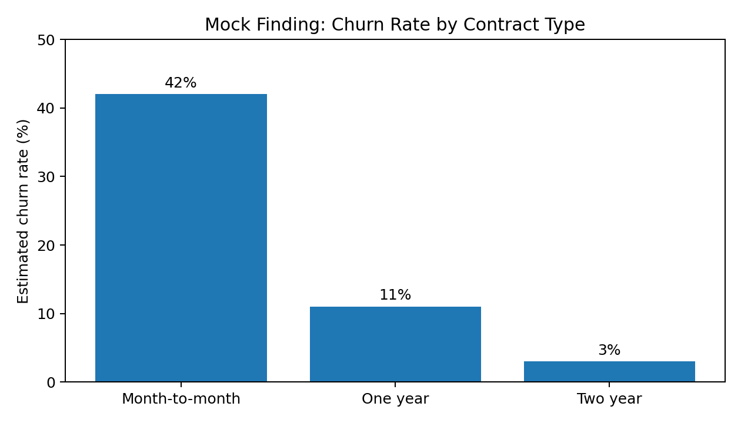
Figure 1. Mock churn rate by contract type.

5.2 Early-tenure customers represent a retention opportunity
The mock trend shows a higher churn rate among customers with short tenure, followed by a gradual decline as tenure increases. This supports an early life-cycle retention strategy: onboarding quality, first-value achievement, education, and proactive service could be evaluated.
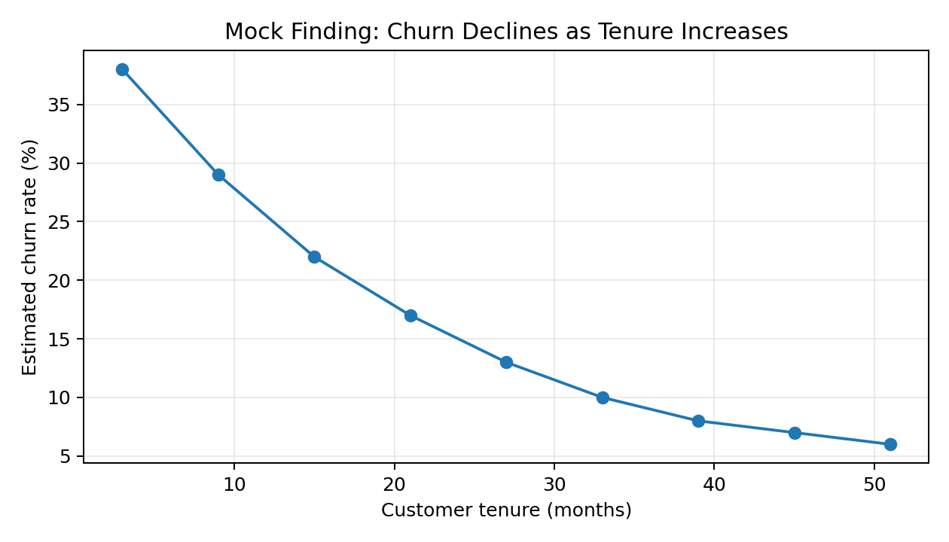
Figure 2. Mock relationship between tenure and churn.

5.3 Model performance should be interpreted through multiple metrics
For an imbalanced churn problem, accuracy alone can be misleading. The mock confusion matrix below illustrates the need to examine false positives and false negatives. Recall is particularly relevant when missing a genuinely high-risk customer is considered costly; precision becomes important when retention interventions are expensive.
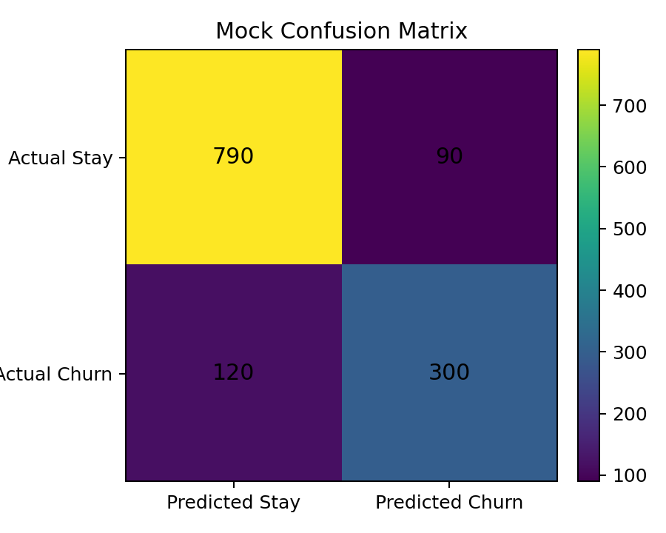
Metric | Purpose in this project | Communication wording
Accuracy
 | Overall proportion classified correctly
 |  | “How often was the classification correct?”
Precision
 | Share of predicted churners who actually churn
 |  | “How targeted are the alerts?”
Recall
 | Share of actual churners detected
 |  | “How many churners did we identify?”
F1 score
 | Balance between precision and recall
 |  | “How balanced is the detection performance?”
ROC AUC
 | Ranking/discrimination ability across thresholds
 |  | “How well can the model separate risk levels?”
PR AUC
 | Useful when the positive class is relatively uncommon
 |  | “How well does the model identify the relevant class?”

5.4 Model interpretation highlights key drivers
A model-interpretation view can help stakeholders understand which variables contribute to predictions. The mock chart below intentionally uses relative contribution rather than causal language. These variables should be investigated further before operational decisions are made.
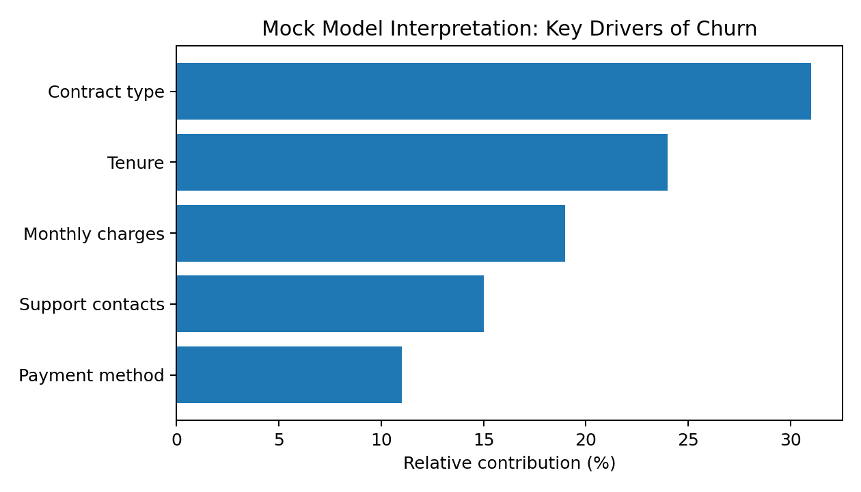
Figure 4. Mock relative contribution of selected features.

6. Mock Visualizations and Their Rationale
Visualization | Question answered | Why it is useful | Audience
Bar chart: churn by contract
 | Which contract groups differ?
 |  | Direct comparison of categories
 |  |  | Executives / sales
Line chart: churn vs tenure
 | How does risk vary across customer age?
 |  | Shows trend and intervention window
 |  |  | Retention teams
Confusion matrix
 | Where does the classifier make errors?
 |  | Makes false positives/negatives visible
 |  |  | Analytics / managers
Feature-importance chart
 | Which variables contribute most to predictions?
 |  | Supports interpretation and hypothesis generation
 |  |  | Managers / analysts
Segment table
 | Which groups deserve attention?
 |  | Combines size, risk and action
 |  |  | Executives
KPI dashboard
 | Are interventions working?
 |  | Connects analysis to business outcomes
 |  |  | Leadership

6.1 Visualization design principles
- Use one clear message per chart.
- Prefer simple comparisons over decorative graphics.
- Label axes, units, categories, and time periods explicitly.
- Show denominators or sample sizes where they materially affect interpretation.
- Avoid implying causation from association-only charts.
- Use consistent terminology across charts and narrative.
- Use annotations to highlight the decision-relevant point rather than forcing the audience to decode the graph.

7. Translating Technical Results into Business Insights
A strong data science report does not stop at model metrics. It connects evidence to decisions while clearly stating uncertainty and assumptions.
Technical observation | Business translation | Potential action | Measurement
Higher churn among month-to-month customers
 | This segment has greater observed retention risk.
 |  | Test tailored renewal/retention offers.
 |  |  | Churn rate and incremental retention.
Short-tenure customers show higher churn
 | The first months may be a critical experience window.
 |  | Strengthen onboarding and early check-ins.
 |  |  | 90/180-day retention.
Support interactions are associated with risk
 | Repeated service friction may signal dissatisfaction.
 |  | Prioritize unresolved/repeated issues.
 |  |  | Resolution time and subsequent churn.
Model detects a subset of churners
 | Risk scoring can prioritize limited outreach capacity.
 |  | Use threshold based on intervention cost.
 |  |  | Precision, recall, ROI.

Important distinction
A predictive model identifies patterns that help prioritize attention. It does not establish that a customer will churn or that changing a feature will cause retention. Recommendations should therefore be validated through experiments, controlled rollouts, or longitudinal analysis where feasible.

8. Presentation Strategy for Non-Technical Stakeholders
The presentation should use a story-first structure. Technical detail remains available in backup slides or an appendix, while the main narrative focuses on the business problem, evidence, implications, decisions, and measurement.

8.1 Recommended storytelling sequence
- Start with the business problem: customer attrition creates avoidable revenue and service pressure.
- Establish the baseline: describe the customer population and the scale of the hypothetical problem.
- Reveal the evidence: show two or three high-value patterns rather than every exploratory chart.
- Explain the model simply: “The model assigns a risk score using historical customer patterns.”
- Show what the model can and cannot do: explain performance and uncertainty using plain language.
- Move to action: identify which customer segments should receive attention and why.
- Close the loop: define how retention actions will be measured and improved.

8.2 Technical-to-business translation examples
Technical phrase | Stakeholder-friendly phrasing
Feature importance
 | “These are the customer characteristics most associated with the model’s risk estimates.”
Recall
 | “Of customers who actually left, this is the share the model successfully flagged.”
Precision
 | “Of customers flagged as high risk, this is the share who actually left.”
Cross-validation
 | “We repeatedly tested the approach on different portions of the historical data to check consistency.”
Data leakage
 | “We prevented future information from accidentally influencing past predictions.”
Threshold
 | “We choose how sensitive the alert system should be based on the cost of acting versus missing a customer.”

8.3 Presentation delivery principles
- Keep the executive presentation focused on decisions rather than algorithms.
- Use a small number of consistent visuals and repeat the central message.
- Explain uncertainty openly instead of presenting estimates as guarantees.
- Anticipate questions about cost, fairness, false alarms, and operational feasibility.
- Keep technical appendices available for analysts who want methodology details.

9. Actionable Recommendations

9.1 Immediate actions
- Create a monitored early-tenure customer segment and review onboarding performance.
- Investigate service-contact patterns, particularly repeated or unresolved issues.
- Develop retention experiments for month-to-month customers rather than assuming one universal intervention will work.
- Define a risk threshold using intervention capacity and the relative costs of false positives and false negatives.

9.2 Medium-term actions
- Integrate churn scoring into a customer relationship management workflow with human review.
- Build segment-specific playbooks so alerts trigger appropriate actions rather than generic messaging.
- Measure incremental retention through controlled experiments wherever practical.
- Create a dashboard showing model performance and business outcomes together.

9.3 Long-term actions
- Refresh the model periodically as customer behavior and products change.
- Evaluate fairness and performance across relevant customer segments.
- Introduce cost-sensitive decision rules so model outputs reflect real intervention economics.
- Explore causal or uplift modeling to estimate which intervention is most likely to help a particular customer.

10. Future Work and Further Research
Area | Proposed future work | Expected value
Data enrichment
 | Add product usage, customer journey, and service-quality signals.
 |  | Richer behavioral context.
Modeling
 | Compare calibrated ensembles and alternative algorithms.
 |  | Potentially stronger ranking/calibration.
Explainability
 | Use local explanations for individual risk alerts.
 |  | Better human review.
Causal analysis
 | Use experiments or causal methods to test interventions.
 |  | Move from correlation toward action evidence.
Uplift modeling
 | Estimate which customers may respond to an intervention.
 |  | More efficient retention spending.
Monitoring
 | Track drift, calibration, precision/recall and business KPIs.
 |  | Sustained reliability.

11. Risks, Limitations, and Responsible Communication
- The findings in this document are mock findings and are not claims about a real customer population.
- Historical data may reflect existing business practices and therefore encode historical biases.
- A model can be accurate on historical data while performing poorly after customer behavior or business conditions change.
- Prediction does not establish causality; retention actions need independent evaluation.
- Personal or sensitive information should be governed under applicable privacy, security, and organizational policies.
- Automated scores should support accountable human decision-making rather than become unquestioned decisions.
- Model thresholds should be selected based on business costs, operational capacity, and risk tolerance.

12. Proposed Executive Presentation Flow
Slide | Title | Core message | Suggested visual
1
 | The retention challenge
 |  | Why the business should care.
 |  |  | Single KPI / headline
2
 | What we analyzed
 |  | What data and approach were used.
 |  |  | Simple workflow
3
 | Where churn is concentrated
 |  | Some customer groups show higher observed risk.
 |  |  | Contract bar chart
4
 | When risk is highest
 |  | Early tenure is an important window.
 |  |  | Tenure trend
5
 | How the model performs
 |  | The model has useful but imperfect detection.
 |  |  | Confusion matrix + metrics
6
 | What drives the risk score
 |  | Several variables contribute to predictions.
 |  |  | Feature contribution chart
7
 | What we should do
 |  | Convert evidence into prioritized interventions.
 |  |  | Action matrix
8
 | How we will measure impact
 |  | Retention actions must be evaluated.
 |  |  | KPI dashboard
9
 | Risks and limitations
 |  | What the model cannot prove.
 |  |  | Short risk checklist
10
 | Next steps
 |  | Pilot, measure, learn, improve.
 |  |  | Roadmap

12.1 Suggested presentation timing
Segment | Approx. time
Problem and executive summary
 | 2 minutes
Methodology and data
 | 2 minutes
Key findings and visuals
 | 5 minutes
Model performance and limitations
 | 3 minutes
Recommendations and action plan
 | 4 minutes
Questions / discussion
 | 4 minutes
Total
 | 20 minutes

13. Reporting and Documentation Standards
- Maintain a clear distinction between observed facts, model estimates, assumptions, and recommendations.
- Record dataset version, preprocessing decisions, model version, evaluation period, and key parameters.
- Give every chart a descriptive title, labeled axes, source/context note, and concise interpretation.
- Use reproducible code and preserve the analytical environment where possible.
- Document rejected approaches and explain why the final method was selected.
- Maintain a glossary so non-technical stakeholders can understand recurring terms.

13.1 Suggested report structure for final submission
- Executive summary
- Business context and objectives
- Data and methodology
- Findings and visual evidence
- Model evaluation
- Actionable insights
- Recommendations
- Limitations and responsible-use considerations
- Future work
- Appendices and technical details

14. Expected Outcomes
- A coherent end-to-end narrative from business problem to recommended action.
- A set of mock visualizations that demonstrate professional data storytelling.
- A clear explanation of analytical and model results for non-technical decision-makers.
- A prioritized set of recommendations linked to measurable outcomes.
- A reusable structure for future data science reports and executive presentations.

15. Conclusion
This Week 4 report demonstrates how data science work can be consolidated into an executive-ready communication package. The hypothetical churn project illustrates the complete transition from data and methodology to findings, visual evidence, business interpretation, recommendations, and future research.
The key professional skill demonstrated is not only building an analytical solution, but communicating what the evidence means, what it does not mean, and how an organization can responsibly use it. A strong final presentation should leave stakeholders with a small number of memorable findings, clear actions, and a measurement plan for learning whether those actions create meaningful improvement.

References
- McKinney, W. – Python for Data Analysis. O’Reilly Media.
- Hunter, J. D. – Matplotlib: A 2D Graphics Environment. Computing in Science & Engineering.
- Waskom, M. – Seaborn: Statistical Data Visualization.
- Pedregosa, F. et al. – Scikit-learn: Machine Learning in Python. Journal of Machine Learning Research.
- Provost, F. & Fawcett, T. – Data Science for Business. O’Reilly Media.
- Knaflic, C. N. – Storytelling with Data. Wiley.

Appendix A – Mock KPI Dashboard
KPI | Mock value | Interpretation / use
Overall churn rate
 | 18.4%
 |  | Baseline business outcome.
Month-to-month churn
 | 42%
 |  | Priority segment for investigation.
One-year churn
 | 11%
 |  | Comparison segment.
Two-year churn
 | 3%
 |  | Lower observed churn segment.
Model precision
 | 77%
 |  | Targeting quality at selected threshold.
Model recall
 | 71%
 |  | Share of churners detected.
ROC AUC
 | 0.86
 |  | Illustrative discrimination measure.
Retention experiment lift
 | To be measured
 |  | Must be established after intervention testing.

Dashboard principle
Model metrics and business KPIs should appear together. A model can improve technically while failing to create business value, and business outcomes can change for reasons unrelated to the model.

Appendix B – Final Quality Checklist
- ☐ Executive summary clearly states the purpose, major findings, and business relevance.
- ☐ Methodology is understandable without requiring code-level knowledge.
- ☐ Every major finding has supporting evidence or a clearly labeled mock visualization.
- ☐ Charts have titles, axes, units, and interpretation.
- ☐ Technical metrics are translated into plain language.
- ☐ Recommendations are linked to specific findings.
- ☐ Recommendations are measurable and realistically actionable.
- ☐ Limitations and uncertainty are stated.
- ☐ Predictive findings are not presented as causal proof.
- ☐ Presentation follows a coherent story rather than a list of disconnected charts.
- ☐ Technical details are available in appendices for deeper review.
- ☐ Document formatting is consistent and suitable for executive-level review.

