NAME:- UPASNA

ROLL NO:- 24csu225

ASSIGNMENT-4

QUES- Rock Paper Scissor (which is also called Stone Paper Scissor) is a hand game and played between two people, in which each player simultaneously forms one of three shapes.

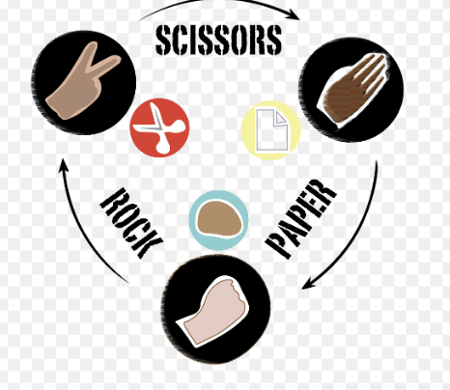The winner of the game is decided as per the below rules:

Rock vs Paper -> Paper wins.

Rock vs Scissor -> Rock wins.

Paper vs Scissor -> Scissor wins.

In this game, the user will be asked to make choice and according to the choice of user and computer and then the result will be displayed along with the choices of both computer and user.

Note: This random number will decide the choice of computer as:

If the number is between 0-33 then the choice will be Stone.

If the number is between 33-66 then the choice will be Paper.

If the number is between 66-100 then the choice will be Scissors.

SOL:- #include <stdio.h>

#include <stdlib.h>

#include <time.h>

void play_game();

int main() {

play_game();

return 0;

}

void play_game() {

int user_choice;

int computer_choice_number;

char *computer_choice;

srand(time(0));

printf("Enter your choice:\n");

printf("1. Rock\n2. Paper\n3. Scissors\n");

printf("Choice: ");

scanf("%d", &user_choice);

if (user_choice < 1 || user_choice > 3) {

printf("Invalid choice! Please choose 1 (Rock), 2 (Paper), or 3 (Scissors).\n");

return;

}

computer_choice_number = rand() % 100 + 1;

if (computer_choice_number <= 33) {

computer_choice = "Rock";

} else if (computer_choice_number <= 66) {

computer_choice = "Paper";

} else {

computer_choice = "Scissors";

}

printf("You chose: %s\n", user_choice == 1 ? "Rock" : user_choice == 2 ? "Paper" : "Scissors");

printf("Computer chose: %s\n", computer_choice);

if ((user_choice == 1 && computer_choice_number <= 33) ||

(user_choice == 2 && (computer_choice_number > 33 && computer_choice_number <= 66)) ||

(user_choice == 3 && computer_choice_number > 66)) {

printf("It's a tie!\n");

} else if ((user_choice == 1 && computer_choice_number > 66) ||

(user_choice == 2 && computer_choice_number <= 33) ||

(user_choice == 3 && (computer_choice_number > 33 && computer_choice_number <= 66))) {

printf("You win!\n");

} else {

printf("Computer wins!\n");

    }

}