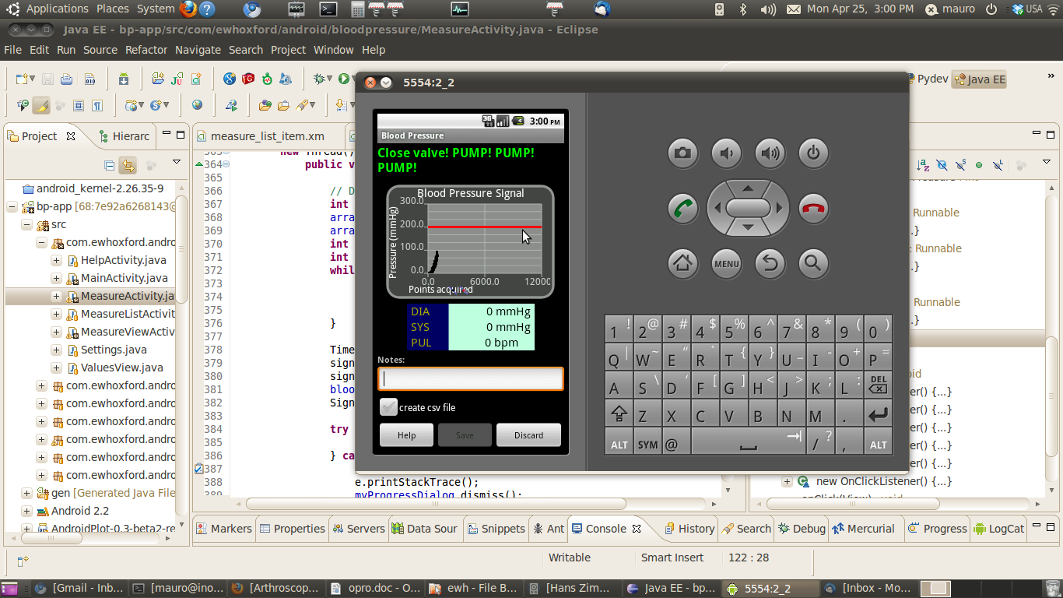
1 - Real Time Pressure Chart
2 - Blood Pressure Display
3 – Notes Field
4 – Save/Discard Buttons

