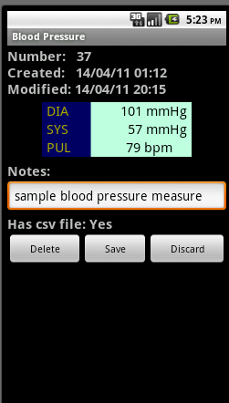
1 - Measure Number/Date
2 - Blood Pressure Display
3 - Notes Field (Edit)
4 - Save/Delete Buttons

