PROJECT REVIEW 3
AuxFlow: Static Analysis for Multi-Pass Document Compilation
1. Title Page
Project title | AuxFlow: Static Analysis for Multi-Pass Document Compilation
Student name | Upayan Mazumder
Register number | 24BDS0367
Programme | B.Tech CSE (Data Science)
Department | School of Computer Science and Engineering (SCOPE)
College | Vellore Institute of Technology, Vellore, Tamil Nadu, India
Academic year | 2026-2027
Project guide | Banupriya R

2. Abstract
Cross-references, contents pages, and bibliographies can require more than one LaTeX run. Each run reads auxiliary files from the preceding run. Build tools usually repeat the engine until those files appear stable or a run limit is reached. A document with feedback between page references and layout may not settle.
AuxFlow is a static analysis tool and compiler front end for a declared subset of LaTeX. The parser identifies references and generated lists, then the Auxiliary Reference Graph (ARG) records individual facts and their dependencies. Taint analysis checks whether a reference value controls the amount of content. AuxFlow reports CERTIFIED, BENIGN_CYCLIC, AMPLIFYING, or UNKNOWN before compilation. The planner selects engine runs, and the runtime verifier compares the resulting auxiliary files.
The evaluation used 15 documents and 7 baselines, with 10 repetitions per document and baseline (1,050 trials, not 1,050 engine runs). Over an eight-pass ground-truth horizon, the predicted bound met or exceeded the measured requirement for all 7 currently certified documents. Two unstable documents were AMPLIFYING and four were UNKNOWN. UNKNOWN does not establish non-convergence. Analysis took 1.3 ms at the median and 10.4 ms at most in this corpus. Guards added after the first measurements changed three declared false negatives from CERTIFIED to UNKNOWN.
3. Introduction
Background
LaTeX writes labels to an auxiliary file during one run. A reference can read those labels on the next run. Contents pages and bibliographies add further dependencies. The tools examined here use different stopping tests: latexmk limits itself to 5 runs, Tectonic to 6, ConTeXt to 9, and Typst to 5 iterations. latexrun documents no limit.
Problem statement
The stopping tests examined in this report do not derive a pass bound from the document's source. A fixed schedule can end before references settle. An engine warning can miss changes to a generated list. Reference text can also change line breaks and page numbers, so a document may alter the dependencies that the analysis tries to describe. Static pass numbering assumes a fixed graph. AuxFlow therefore verifies its predicted plan against an engine run.
Objectives
- Classify a document before an engine run and show the source locations of potentially amplifying cycles.
- Calculate a pass bound for certified documents, then compare it with measured run counts.
- Build from that classification and compare auxiliary files after each engine run.
- Compare a fixed schedule and four dynamic stopping tests with AuxFlow on a 15-document corpus, including cases that expose limitations.
4. Literature Review
Related work | Main finding | Relation to AuxFlow
Alblas (1981) | Distinguishes simple from pure multi-pass attribute evaluation. The pure setting considers individual attribute instances. | AuxFlow numbers individual auxiliary facts. It does not claim to invent instance-level pass numbering.
Hecht and Ullman (1975) | Relate iterative data-flow rounds to graph depth. | AuxFlow uses a similar propagation bound, followed by a confirmation run.
Magnusson and Hedin (2007) | State finite-height and monotonicity conditions for circular attribute convergence. Their evaluator does not check them. | AuxFlow detects content-generation feedback in its declared subset, but it does not test every convergence condition.
Erdweg, Lichter, and Weiel (2015) | Their Pluto build system handles LaTeX dependencies dynamically. They explain why general static dependency detection is not sound. | AuxFlow restricts the source language and reports UNKNOWN for unsupported constructs.
Gaspar (2014) | Shows a LaTeX loop whose page reference causes repeated page growth. | The example informs corpus document b08_cycle, which AuxFlow reports as AMPLIFYING.

These five works cover pass scheduling, iteration bounds, cyclic evaluation, dynamic build dependencies, and a non-convergent LaTeX example. AuxFlow applies their ideas to a restricted document model.
5. Methodology
Proposed system and architecture
Parsing, graph construction, classification, and planning use only source files. The auxflow run command executes the plan and checks the files TeX writes.
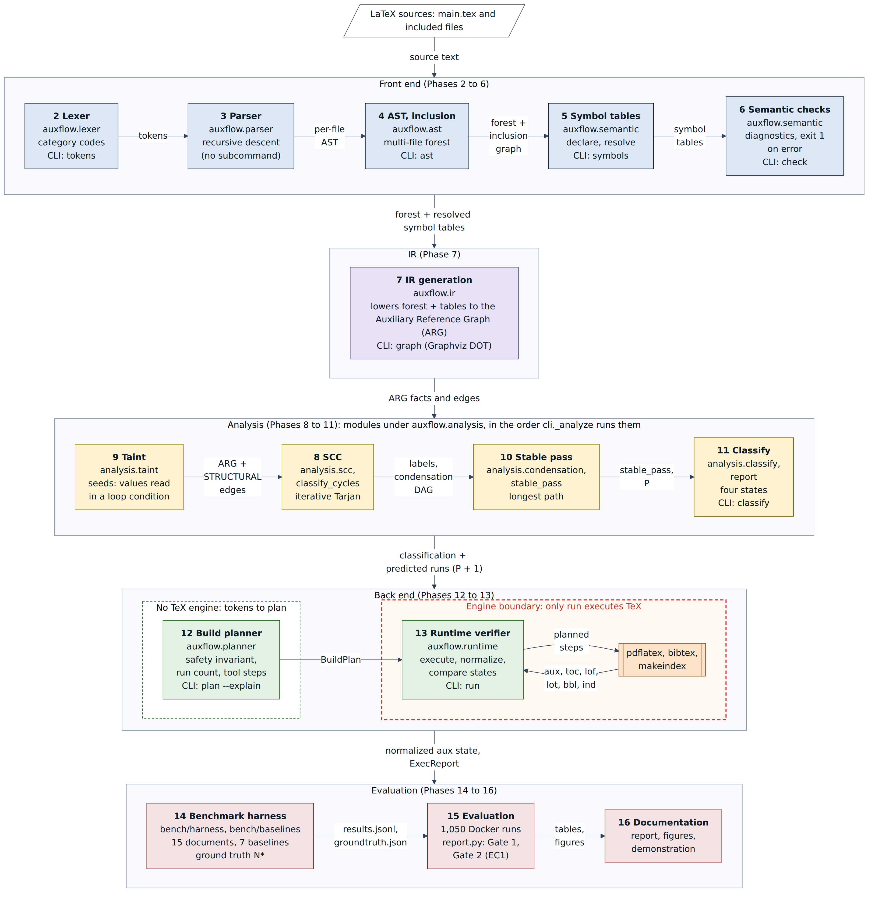
Figure 1. AuxFlow compiler pipeline
Data model
The Auxiliary Reference Graph (ARG) has a node for each label, reference, or other fact instance. Each node records its kind, key, component (exists or value), and source span. Edges record the dependency, pass lag, reason, and type: AUX_ROUNDTRIP, TOOL, LAYOUT, or STRUCTURAL.
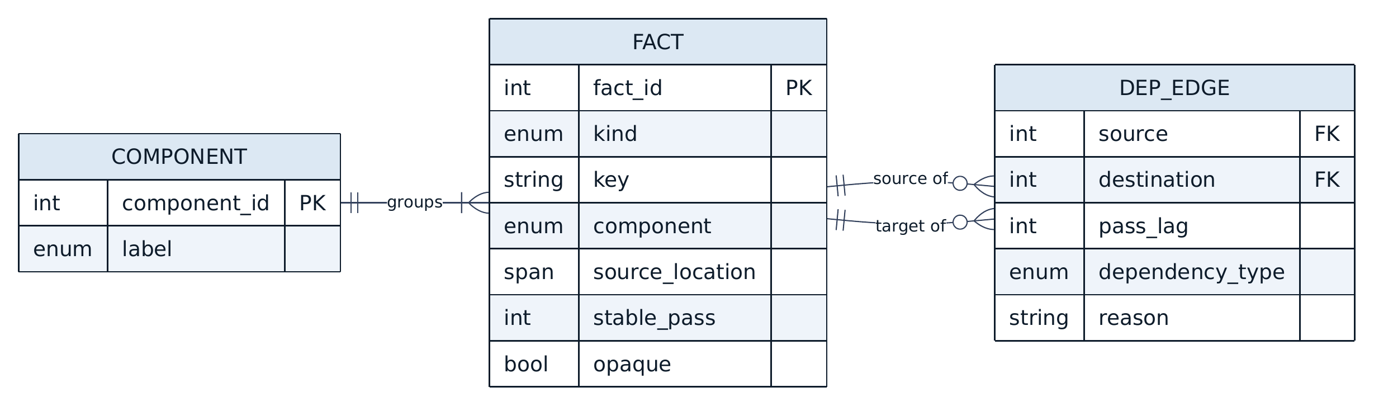
Figure 2. Entity-relationship model of the ARG
Analysis workflow
- Taint analysis begins with values read in loop bounds or conditions. It follows value edges to find facts that may influence generated content. For each such fact, it adds a STRUCTURAL edge to content volume. The cost is O(V + E).
- Iterative Tarjan analysis finds strongly connected components. An internal STRUCTURAL edge marks an AMPLIFYING cycle. An opaque fact marks UNKNOWN_CYCLE. The other cycles are BENIGN within the model.
- After cycle analysis, stable-pass numbering follows the longest path between components. For a fact f, s(f) = 1 when f has no dependencies. Otherwise, s(f) = 1 + max(s(g) + lag(g to f) - 1) over dependencies g. P is the largest s(f) for facts stored in auxiliary files. The planned bound is N = P + 1.
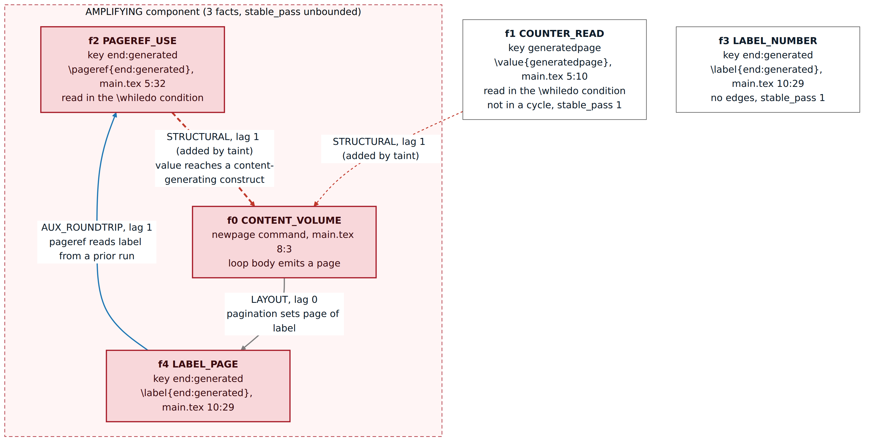
Figure 3. ARG of b08_cycle. Taint analysis adds the STRUCTURAL edge that closes the AMPLIFYING cycle.
Classification and planning
The classifier selects one of four states from the graph. A CERTIFIED plan uses the derived count. Every other executable plan starts with at least three engine runs, as enforced by a planner assertion. AMPLIFYING has no plan unless the user supplies --force. Forced runs stop at a cap of six. UNKNOWN has a conservative executable plan by default. The --strict option refuses UNKNOWN before execution.
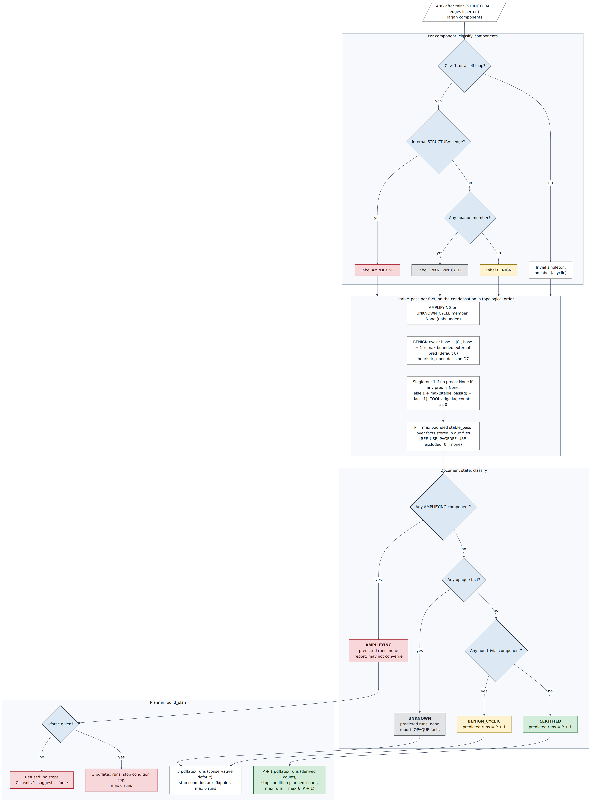
Figure 4. Four-state classifier and the plan for each state
Runtime verification
After each engine run, the verifier reads auxiliary files and compares canonical records with the previous run. If they still change after the planned runs, it repeats the last engine step up to the cap. It records a prediction miss if verification exceeds a certified bound. It does not use engine rerun warnings.
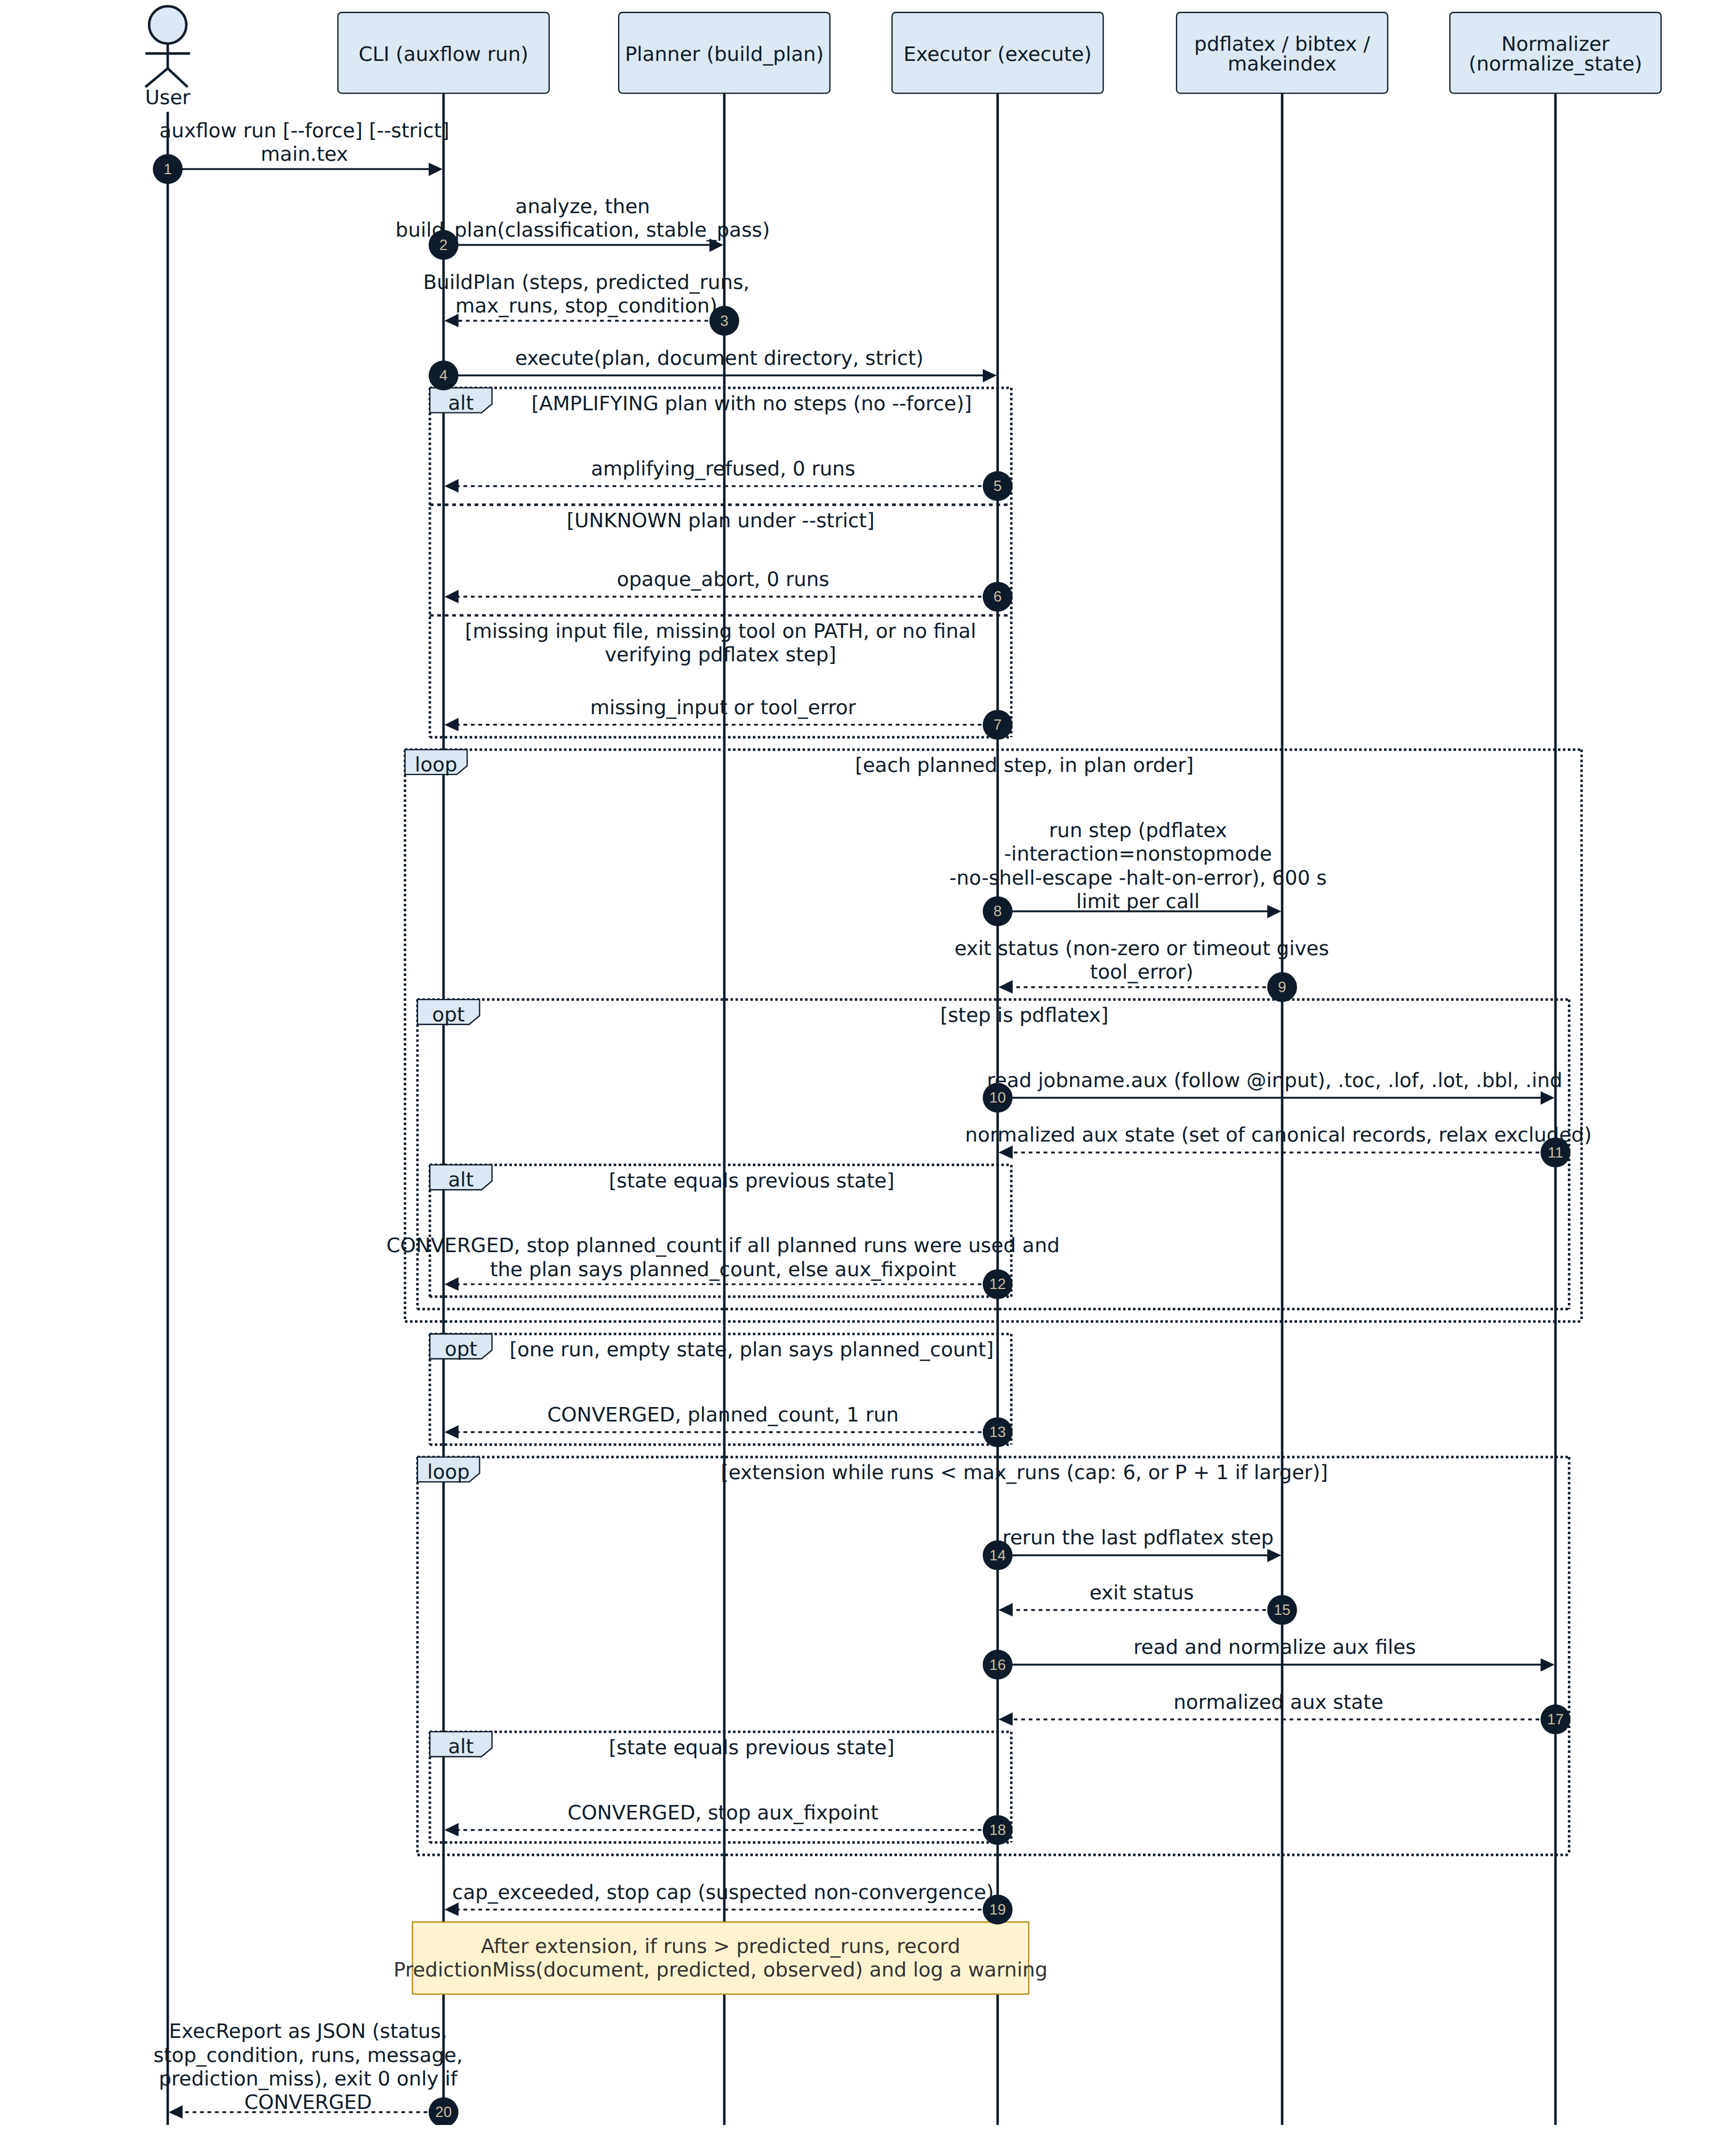
Figure 5. auxflow run: plan execution with runtime verification
Tools
The compiler core uses Python 3.12 without third-party runtime dependencies. I used pytest and Hypothesis for tests, ruff and mypy --strict for checks, Docker for the pinned benchmark image, and hatch-vcs for tag-based versions.
6. Implementation
Review 2 covered phases 1 to 7, from lexical analysis through ARG construction. Phases 8 to 16 add graph analysis, planning, runtime checks, and evaluation.
Phase | Module | Function
8 | auxflow.analysis.scc | Iterative Tarjan SCC and cycle labels
9 | auxflow.analysis.taint | Seed and propagate taint, add STRUCTURAL edges
10 | auxflow.analysis.stable_pass | Stable-pass number per fact, N = P + 1
11 | auxflow.analysis.classify | Four-state classifier and diagnostics
12 | auxflow.planner | Build plan with the safety rule and the --force cap
13 | auxflow.runtime | State normalisation, fixpoint check, auxflow run
14 to 16 | bench/ | Corpus, 7 baselines, ground truth, evaluation report

Changes after the first measurement
- After the first measurements, I added a guard for page references under roman, Roman, alph, or Alph numbering. These numeral forms can change width as their values change. The guard also marks \vref and \vpageref UNKNOWN.
- An explicit list treats certain packages and commands as inert. This lets ordinary front matter pass without treating an arbitrary package as safe.
- The auxflow run command limits each tool call to 600 seconds. It passes -no-shell-escape and rejects auxiliary files outside the work directory.
- The auxflow update command uses pipx when that environment has no pip.
Code and quality figures
- The current tree has 5,657 lines of Python source in 47 modules, excluding the generated version file. Tests contain 6,021 lines in 58 Python files. The compiler core has no third-party runtime dependencies. In the local non-engine test run, 403 tests passed, 1 skipped, and 3 engine or slow tests were deselected. These counts describe the current tree.
7. Results and Discussion
Experimental setup
The 15 documents, b01_plain through b15_ibid, include a multi-chapter thesis and cases for mechanisms M1 to M9. Each of seven baselines used ten repetitions per document, in separate containers with one CPU and no network. This produced 1,050 trials, including static-only D trials with no engine runs. A is a fixed three-run schedule, B uses engine warnings, C compares outputs, C' compares inputs, and C'' compares files read and rewritten within a run. D is static AuxFlow analysis. E adds runtime verification with --strict for UNKNOWN. Ground truth N* uses eight unconditional engine passes rather than a baseline's stopping decision. I recorded expected classes before implementing the analyzer.
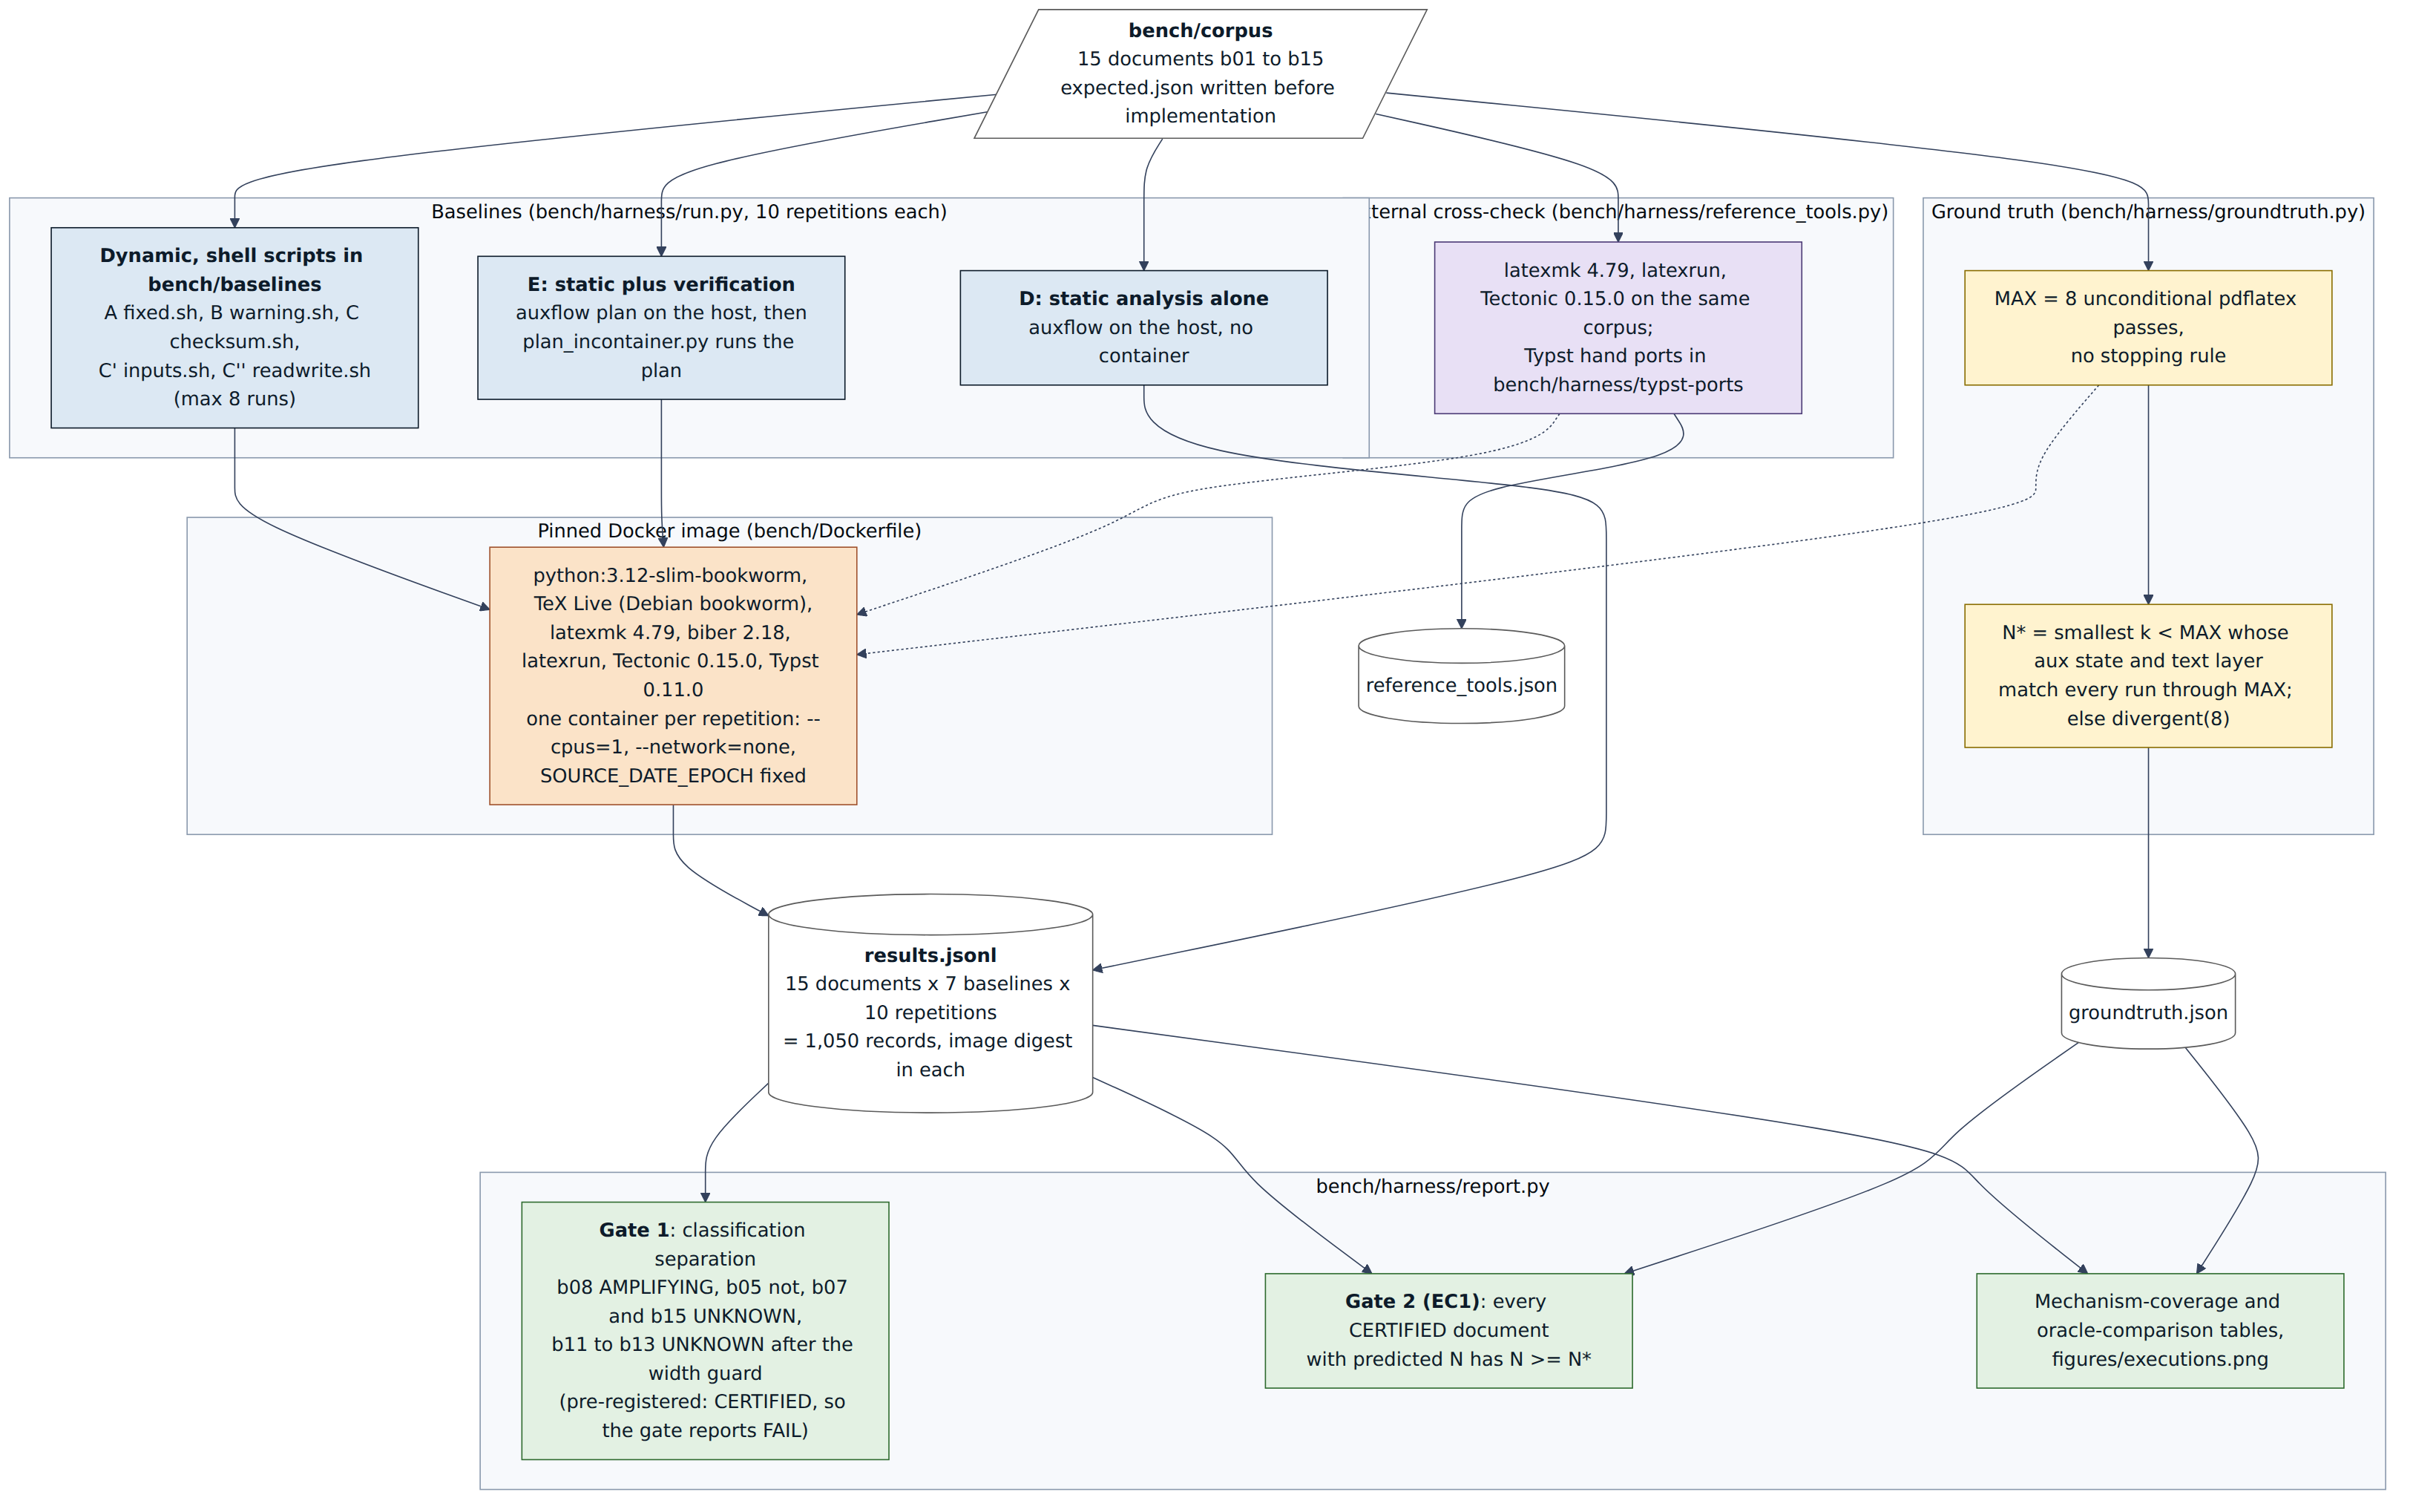
Figure 6. Evaluation setup: corpus, baselines, ground truth, and gates
Screenshots of classification and execution
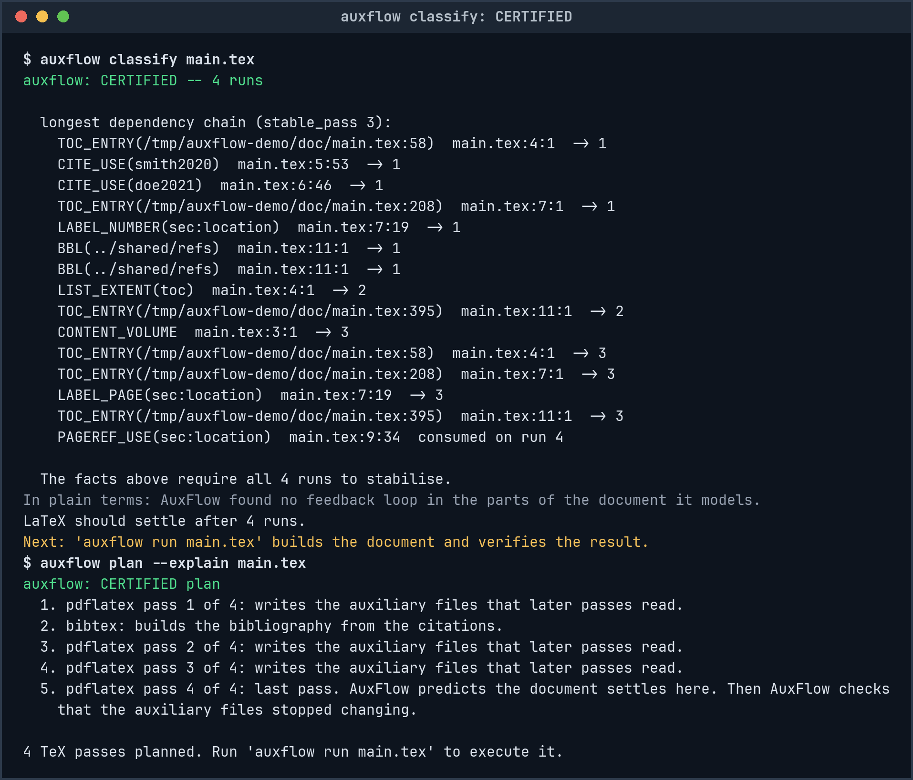
Figure 7. auxflow classify and plan on a CERTIFIED document
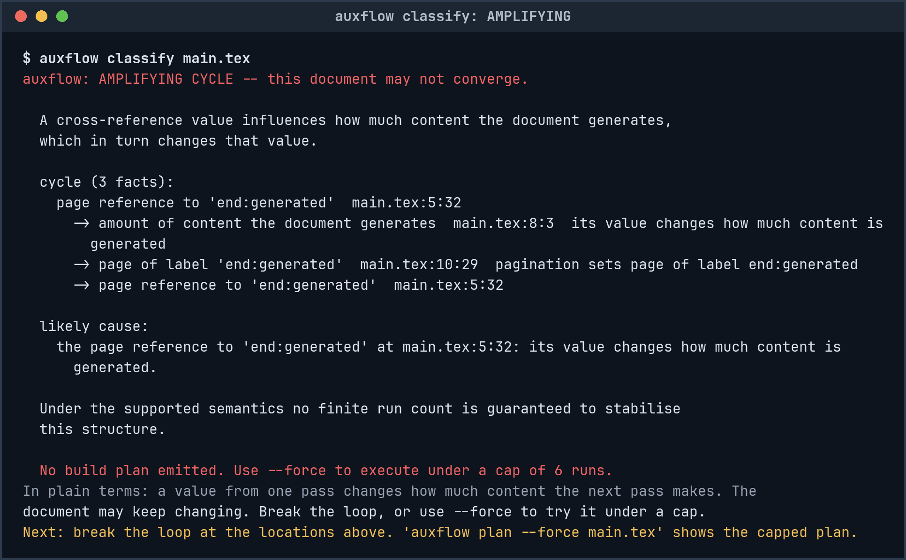
Figure 8. auxflow classify on an AMPLIFYING document
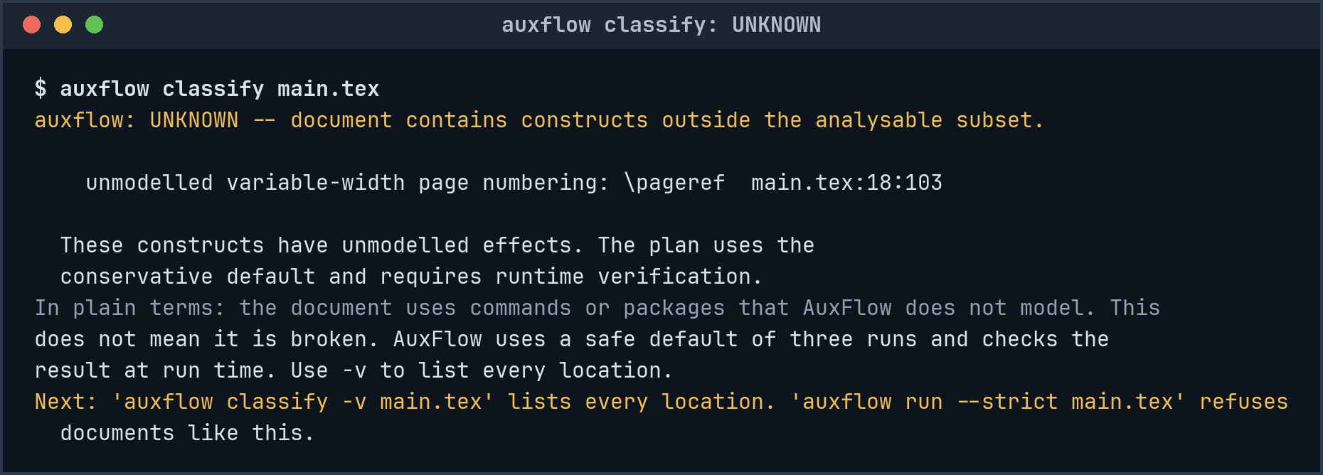
Figure 9. auxflow classify on an UNKNOWN document
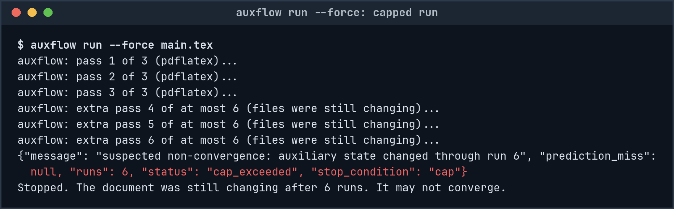
Figure 10. auxflow run --force stops at the cap of six runs
Classification and run-count bound
Document | N* | Before the guard | Current class | Predicted N
b01_plain | 1 | CERTIFIED | CERTIFIED | 1
b02_backref | 2 | CERTIFIED | CERTIFIED | 2
b03_fwdref | 2 | CERTIFIED | CERTIFIED | 2
b04_chain | 2 | CERTIFIED | CERTIFIED | 3
b05_toc | 3 | CERTIFIED | CERTIFIED | 3
b06_bib | 3 | CERTIFIED | CERTIFIED | 4
b07_footnote | 2 | UNKNOWN | UNKNOWN | none
b08_cycle | divergent | AMPLIFYING | AMPLIFYING | none
b09_thesis | 3 | CERTIFIED | CERTIFIED | 4
b10_random | divergent | UNKNOWN | UNKNOWN | none
b11_width | oscillating | CERTIFIED | UNKNOWN | none
b12_float | oscillating | CERTIFIED | UNKNOWN | none
b13_varioref | oscillating | CERTIFIED | UNKNOWN | none
b14_ifthen | oscillating | AMPLIFYING | AMPLIFYING | none
b15_ibid | 3 | UNKNOWN | UNKNOWN | none

- For the 7 currently certified documents, N >= N* over the measured eight-pass horizon. The bound is exact for 4 and exceeds ground truth by one for b04, b06, and b09. This does not prove a universal bound.
- The classifier marks b08 AMPLIFYING and b05 CERTIFIED. The former has a content-generating cycle, while the latter has a generated list without that cycle.
- Among the 6 non-convergent corpus documents, 2 are AMPLIFYING and 4 are UNKNOWN before execution. UNKNOWN reports insufficient static knowledge, not proof of non-convergence. Ground truth supplies the latter finding.
- The analysis marks b14 AMPLIFYING because it may affect content quantity. This case changes content size instead. A hand port compiled under Typst without an error.
Gate 1 is reported as FAIL
The original test specification expected CERTIFIED for b11, b12, and b13, although it identified them as false negatives. After initial measurements, the phase 16 syntactic guards changed all three to UNKNOWN. The automated report therefore marks Gate 1 FAIL against that original specification. Gate 2 checks N >= N* for certified documents and reports zero violations. These three cases cannot independently validate a guard designed after their failures. The guard checks numeral syntax, not font metrics.
Stopping tests compared
Outcome | A | B | C | C' | C'' | E | D
Correct stop, of 9 convergent documents | 9 | 7 | 9 | 9 | 9 | 7 | 7
Premature stop on a convergent document | 0 | 2 | 0 | 0 | 0 | 0 | 0
Withheld by static refusal | 0 | 0 | 0 | 0 | 0 | 2 | 2
Non-convergence flagged, of 6 | 0 | 5 | 6 | 6 | 6 | 6 | 6
Non-convergence accepted as converged | 6 | 1 | 0 | 0 | 0 | 0 | 0
Engine runs on the 9 convergent documents | 27 | 17 | 22 | 22 | 22 | 17 | 0

- The fixed three-run schedule A accepts all 6 non-convergent cases as converged.
- The warning test B accepts b10 after one run in every repetition, although its auxiliary state never settles. B also stops at one run on b05 and b15, where N* is 3.
- C, C', and C'' produced the same outcomes for each document. The expected one-run difference between output and input comparisons did not appear in this corpus.
- E made 17 engine runs across the 7 convergent documents it executed. A made 21 on those same documents. The benchmark's strict policy refused the 6 non-convergent cases and the convergent but opaque b07 and b15 before execution. Without --strict, UNKNOWN can run with verification.
- For b01_plain, N* and the predicted N are both 1, but E runs twice. pdfTeX writes a page-count record to the .aux file, so the verifier needs two observed states to confirm equality. It records a prediction miss in all 10 repetitions because the executed count exceeds N. That operational miss does not show a pass-bound violation.
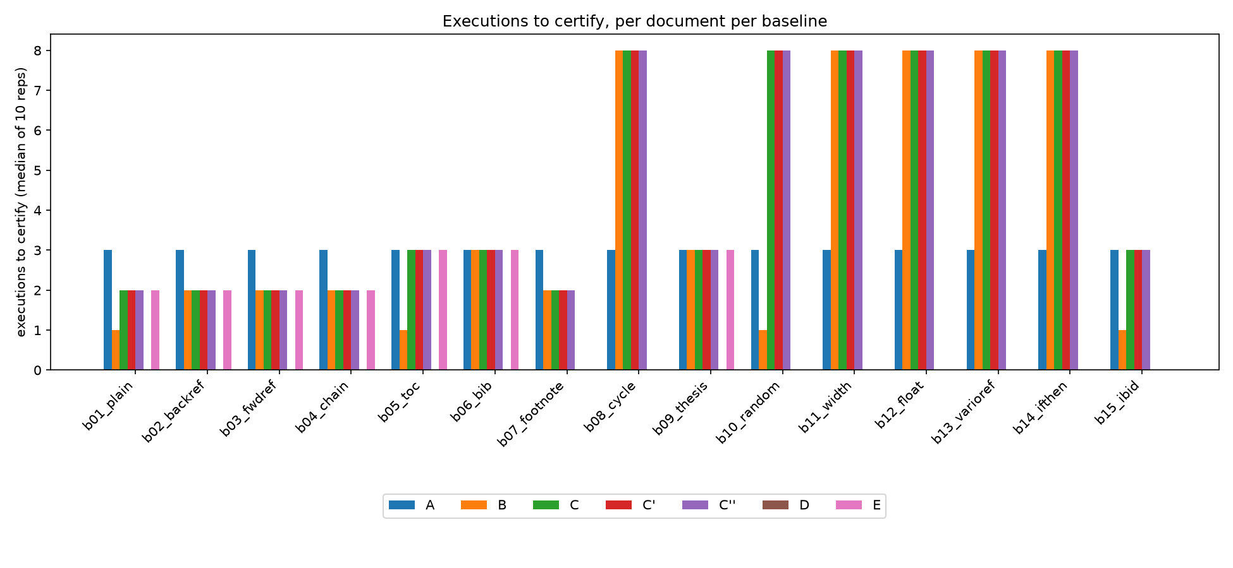
Figure 11. Engine runs until a verdict, per document and baseline (generated by bench/harness/report.py)
External tools
latexmk and latexrun did not converge on the 6 non-convergent documents within their tested limits. latexrun also failed on b15, which latexmk accepted. Offline Tectonic ran only b01 and b08. It reached its six-pass limit on b08. Typst rejected a hand port of b08 with 'loop seems to be infinite'.
Cost
The analysis took 1.3 ms at the median and 10.4 ms at most across the measured corpus. The largest graph, b09_thesis, had 91 facts and 73 edges and took 7.5 ms. These timings are analysis overhead. The run counts above do not subtract that time.
Threats to validity
- The corpus contains 15 documents, mostly synthetic, and all benchmark runs used one machine. This limits how far the findings generalize.
- I wrote the corpus, expectations, and analyzer. I recorded the expectations first, but their author and the implementer were the same person.
- The model assumes a resolved reference does not change pagination. Text width can violate that assumption, so the analysis remains unsound for extent-driven feedback.
- The container uses TeX Live 2022. Other releases may require different run counts. A leftover .aux file once caused three baselines to stop early on b05. I removed those records and repeated the runs.
8. Conclusion and Future Work
Outcomes
- On the 7 currently certified documents, AuxFlow's predicted count was never below measured N* within eight passes. Non-certified plans use at least three runs when execution is allowed.
- Static analysis took 1.3 ms at the median in this 15-document corpus. Diagnostics include source locations.
- In this corpus, a fixed three-run schedule accepted all 6 unstable documents, while the engine-warning test stopped early on b05 and b15. It also accepted b10 as converged.
- The IEEE conference-style research paper is in paper/.
Limitations
- The analysis handles a declared subset. Unsupported constructs make the result UNKNOWN, which is not a non-convergence finding. The benchmark refused UNKNOWN under --strict, while normal execution permits it.
- The syntactic width guard does not capture every change to text extent. Extent-driven feedback can still defeat the analysis.
- AMPLIFYING covers both divergence and oscillation. The bound for BENIGN_CYCLIC is heuristic, and this corpus has no benign cyclic case.
- Ground truth observes eight passes. A longer run could reveal later changes.
Improvements
- Test more documents from independent, real projects.
- Develop a width analysis that does not rely only on numeral syntax.
- Distinguish divergent cycles from oscillating cycles where evidence permits.
- Model additional package behavior and study whether benign cycles admit a justified pass bound.
9. References
- G. V. Bochmann, Semantic evaluation from left to right, Communications of the ACM 19(2):55-62, 1976.
- H. Alblas, A characterization of attribute evaluation in passes, Acta Informatica 16(4):427-464, 1981.
- K.-J. Raiha and E. Ukkonen, Minimizing the number of evaluation passes for attribute grammars, SIAM Journal on Computing 10(4):772-786, 1981.
- R. Farrow, Automatic generation of fixed-point-finding evaluators for circular, but well-defined, attribute grammars, SIGPLAN Notices 21(7):85-98, 1986.
- L. G. Jones, Efficient evaluation of circular attribute grammars, ACM TOPLAS 12(3):429-462, 1990.
- E. Magnusson and G. Hedin, Circular reference attributed grammars: their evaluation and applications, Science of Computer Programming 68(1):21-37, 2007.
- M. S. Hecht and J. D. Ullman, A simple algorithm for global data flow analysis problems, SIAM Journal on Computing 4(4):519-532, 1975.
- J. B. Kam and J. D. Ullman, Global data flow analysis and iterative algorithms, Journal of the ACM 23(1):158-171, 1976.
- A. Mokhov, N. Mitchell, and S. Peyton Jones, Build systems a la carte, Proceedings of the ACM on Programming Languages 2(ICFP), 2018.
- S. Erdweg, M. Lichter, and M. Weiel, A sound and optimal incremental build system with dynamic dependencies, OOPSLA 2015.
- R. Tarjan, Depth-first search and linear graph algorithms, SIAM Journal on Computing 1(2):146-160, 1972.
- Gaspar, Does not suffice to run LaTeX a finite number of times to get cross-references right, TUGboat 35(1):16, 2014.
- L. Madje, A Programmable Markup Language for Typesetting, MSc thesis, Technische Universitat Berlin, 2022.
- J. Collins, latexmk, https://ctan.org/pkg/latexmk (version 4.88).
- A. Clements, latexrun, https://github.com/aclements/latexrun.
- Tectonic, https://github.com/tectonic-typesetting/tectonic (version 0.15.0).
- Typst, https://github.com/typst/typst (version 0.11.0).
- AuxFlow source, corpus, harness, and results, https://github.com/upayanmazumder/auxflow, and PyPI package auxflow.
- U. Mazumder and B. R., AuxFlow: A static applicability test for fixpoint convergence in multi-pass LaTeX builds, 2026, paper/main.pdf in the repository.

