Great work 117B, you are asking really good questions and I'm pleased you are working ahead and putting the required time, thought and effort into this assignment. I have had lots of questions about reputable sources, I know this is hard. We recognize that many of you are thinking about this for the first time, we are bombarded with information however quality, reputable sources require more effort.  I thought one final post may help! Make sure you read all the prior posts related to reputable sources.

* *Please note that you will research and read more than you will include your papers. Be discerning about what you include as a reference (don't include the first few articles that you find, read several and determine which are the most appropriate). You may have to read several chapters or papers before you find ones that are relevant and appropriate for your paper. Include only the articles you cite in your paper as references.*

**Question to ask yourself when deciding if this is a reputable source (note this relates to what we consider acceptable for this class):**

* *Is this from an academic text?*  **Yes – this is considered a reputable source** for this class, make sure content is relevant and appropriate to update your issue.
* *Is this from an academic article?***Yes – this is considered a reputable source** for this class, make sure content is relevant and appropriate to update your issue.
* *Is the author a Professor or academic?* **Yes – this is considered a reputable source** for this class, make sure content is relevant and appropriate to update your issue.
* *Is this from a magazine?* If Yes, this is **not** considered a reputable source for this class. You will loose points if you use this.
* *Is this from a newspaper?* If Yes, this is **not** considered a reputable source for this class. You will loose points if you use this.
* I*s this a blog/ anecdote?* If Yes, this is **not** considered a reputable source for this class. You will loose points if you use this.
* *Did you google the issue and use the first websites that popped up?* If Yes, this is **not** considered a reputable source for this class. You will loose points if you use this.

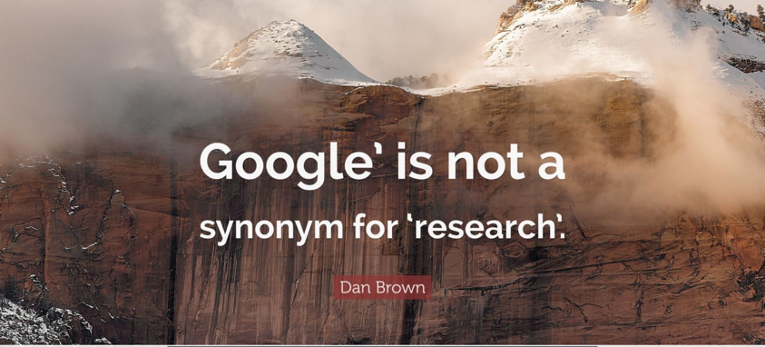

**UsingWebsites:** Finding reputable sources online is difficult. Google is an endless ocean of information but it is not always useful for writing academic research papers.  Go to the University of Illinois Social Sciences library in person or online <https://www.library.illinois.edu/sshel/>

If you are searching online at the library read this information from the site I uploaded in the “what is a reputable sources document” a few weeks ago and ask your self these questions:

Does the site author list qualifications? Is the author an authority? **Government (.gov) and university (.edu) websites are considered reputable for this class assignment.**

Other things that will help you determine if this is a reputable site are:

* Does the author cite sources? Are those sources referenced?
* Is the database article from a **peer-reviewed** source? This lends credibility. you can check to see if the article is peer reviewed as you search in the library.
* Is the article written to inform rather than persuade?

**Plagiarism Reminder:**We are aware of the assignment papers that are uploaded to course sites such as CourseHero, Unstuck, Essay edge etc. as I check about 40 of these sites when assignments are due.  If our course content is present I share it with graders. Students who upload or download papers are subject to disciplinary action by the University under Academic Integrity Policies. In addition students receive a zero on their assignments if plagiarism is confirmed. Sadly, we encounter instances of plagiarism each semester. In an attempt to avoid cheating we change the rubrics slightly each class session. Thankfully,  it's a very small minority of students who access these sites.