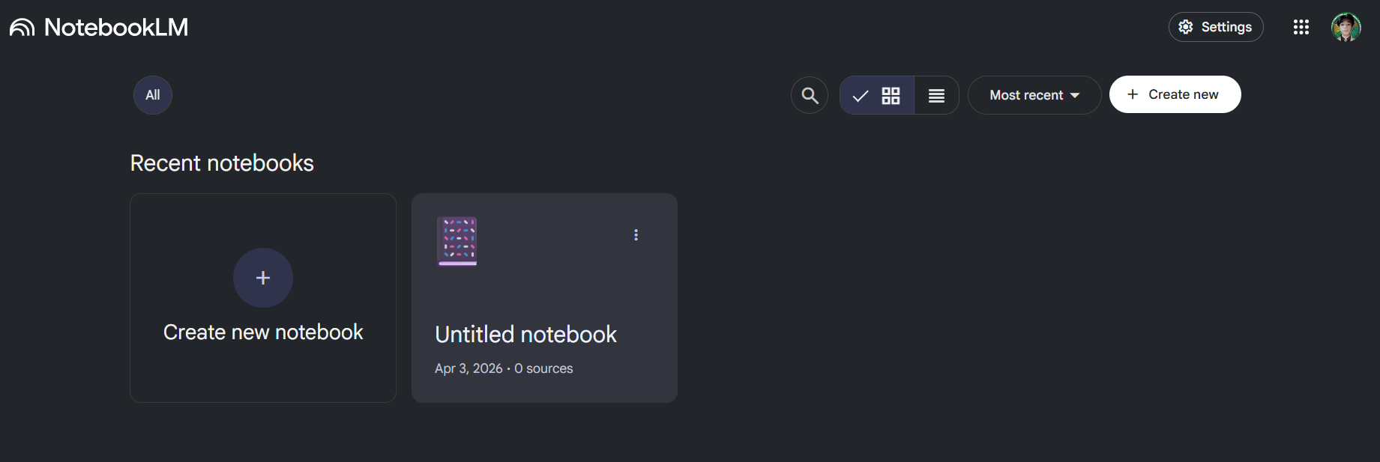
1. Learning: https://notebooklm.google.com/?icid=home_maincta
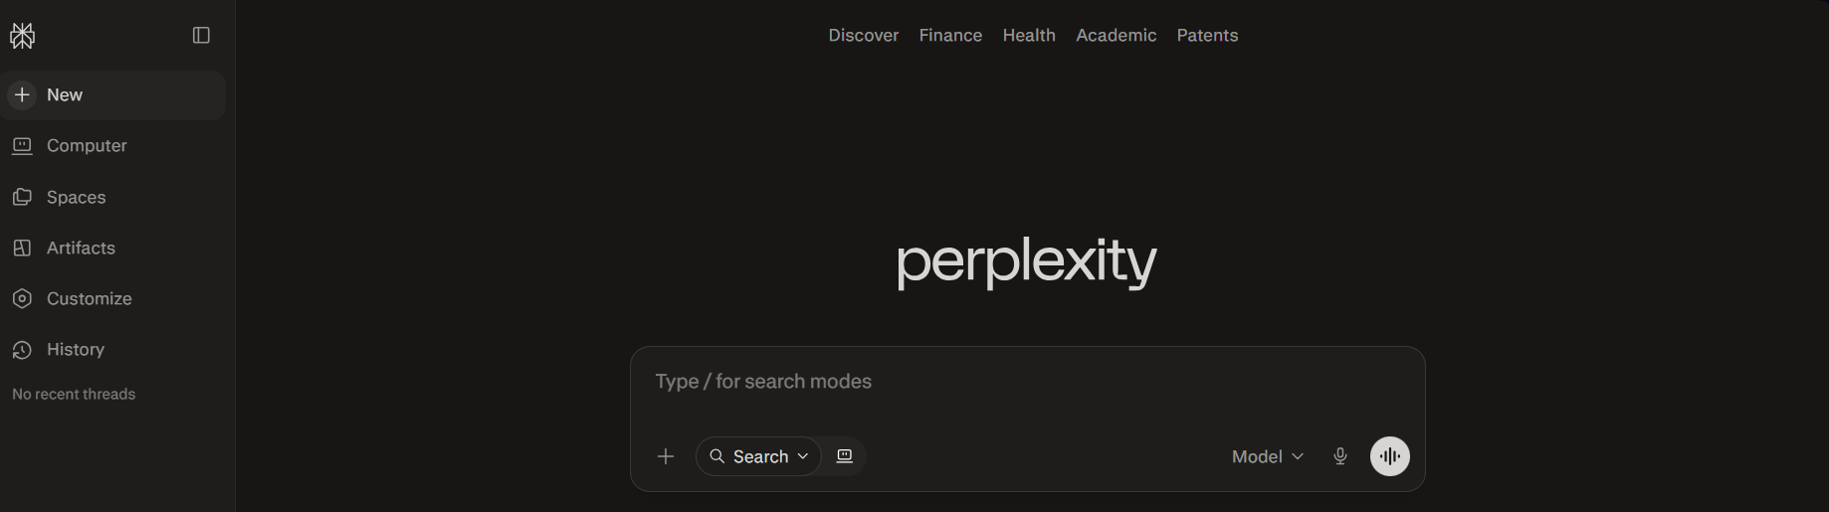
2. Search : https://www.perplexity.ai

* APP/WEBSITE BUILDING FULL STACKS
3. https://lovable.dev/dashboard
4. https://bolt.new
5. https://replit.com
6. https://blink.new
7. https://aistudio.google.com/prompts/new_chat
8. Figma make, working frontend with code
https://www.figma.com/make/LOrDPcHp96aQ5NTzMR7Uvj/Untitled?t=w24llhNSQHPDl1oq-0
9. Automatically generates professional diagrams, mind maps, and infographics.
https://app.napkin.ai/page/CgoiCHByb2Qtb25lEiwKBFBhZ2UaJDY5M2M5YjY0LTYzNjgtNDY4Ny1hNGExLTExN2E4MTZlODdiNQ
10. https://aistudio.google.com/prompts/new_chat (just like claude, gpt, gemini)

