User Type | Epic/Feature | User Stories |  | Priority | Complexity | Estimate/Story Points | Status
Customer | Registration | C_R1 | As a customer, I can register for the application by entering my email, password and confirming my password so that I can receive confirmation of my registration via email. |  |  |  | DONE
 | Login | C_L1 | As a customer, I can log into the application by entering my email and password so that I can use the system. |  |  |  | DONE
 |  | C_L2 | As a customer I can reset my password by entering my email so that the reset instruction will be sent via email. |  |  |  | NOT DONE
 | My Account | C_M1 | As a customer I can upload photo in my profile so that I can be easily recognized by the admin. |  |  |  | DONE
 |  | C_M2 | As a customer, I can modify my personal details such as address and contact number so that it will be updated in the database. |  |  |  | DONE
 |  | C_M3 | As a customer, I can view my previous transactions so that I can easily monitor them. |  |  |  | NOT DONE

Legend: Estimate/Story Points:
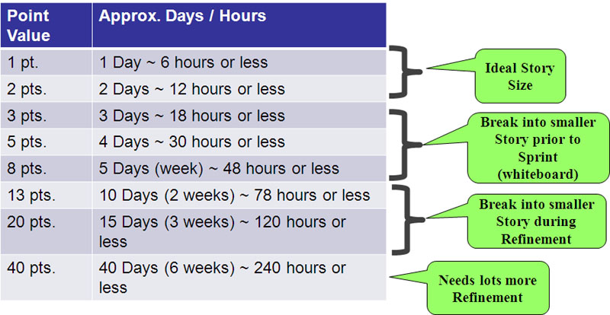
Priority: Must/Critical, Should/High, Could/Medium, Wont/Low
Complexity: High, Medium, Low
Status: Done/Not Done

