Technical Specification for Updraft

Application Description
The application will provide flight planning functions and will be capable of visualizing recorded flights.
There will be some module/plug-in management which will make the application extendable for future purposes, because its development will probably continue after school project will have ended. (possible extensions are e.g. weather forecasting module or communication with flight recorder device)

Environment
Our target platform is PC with MS Windows or Mac OS X. Connection to the Internet will not be required to use the application, but some features may be unavailable in that case.

Localization
Application will be distributed with Czech and English localizations.

Negative Specification
The software is not intended to be used by competition directors or referees or for judging the achievements of any official goals.
Application will not be focused on detailed flight planning like calculating optimal speed, water ballast, final glide etc.
The application will not run on mobile devices and will not serve as an on-board computer.

Features

Terrain and Map Visualization
- Central point of the application is 2D / 3D map view.
- Additional data relevant to glider flying can be shown on the map, for example airspace divisions, turn-points or airfields.

Flight Planning
- The application allows the user to plan a flight in advance by selecting from a set of turn-points, which are pre-declared or specified by the user.
- Flight plans can be saved to a file or loaded from it.

Flight Visualization
- Flight paths from on-board GPS flight recorder can be visualized over the map using different color schemes to illustrate ground speed, vertical speed, etc.
- Various flight statistics will be displayed in a plot.

User Interface
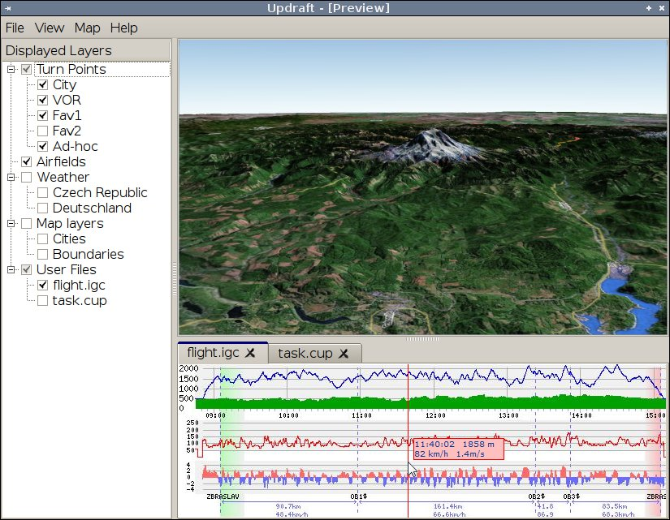
Application window consists of the following areas:
- Map view
- Left pane with list for selecting visible map features
- Bottom pane with various tool panels
- Menu bar

Map View
Map view shows the 2D or 3D terrain with:
- Height map
- Airspace division
- In 3D view airspaces are drawn as transparent boxes, detailed info is accessible through context menu.
- Airfields
- Can be used as a turning point, context menu shows additional details.
- Turn points
- Declared tasks
- Opened IGC files
- Drawn as a 3D path or as trace on the ground
- Colored using a selectable value (groundspeed, height, vertical speed, ...)
- Other data from plugins (weather, …)
Each of these features can be individually shown or hidden from the left pane.

Camera Control
Camera control is similar to Google Earth.
Panning | Drag & Drop |  | Arrow Keys
Zooming | Mouse Scroll |  | +/- Keys
Rotation | Drag & Drop + Shift | Middle Mouse Button | Arrow Keys + Shift
Looking around | Drag & Drop + Ctrl |  | Arrow Keys + Ctrl

Panning is technically done as a rotation around globe center.
Mouse rotation modes use the clicked point (in 3D) as a center of rotation. It can be for example a point on the terrain or a point on IGC visualization curve.
Key rotation is always around point on terrain which is in the middle of view.
Angle of rotation is bounded, user can never look above given fixed angle (e.g. 20° below horizon).
Camera control in 2D mode is limited only to panning and zooming.

Left pane
Left pane is used to control the main map view. It contains:
- Buttons controlling the map
- Switch between 2D and 3D view
- Tree of map features.
- Turn points, divided into categories
- Airfields database
- Map layers from other plug-ins (weather …)
- Other layers of the base map
- Files opened by the user
Each item in this tree can be individually displayed or hidden.

Bottom Pane
Bottom pane has tabbed windows of files opened by the user.
- IGC files and its associated graphs.
- Planned flights with editing tools.

Menu Bar
Most of the application functionalities should be accessible through the main menu bar.

Keyboard Control
The basic functions should be accessible as keyboard shortcuts

IGC Visualization
Each opened IGC file adds a new tab to the bottom pane. It contains a graph of the flight data.
Hovering mouse over this graph displays a marker on a corresponding position on the flight path rendered in a map and vice versa.
Closing the tab with IGC file means the file is closed and it disappears both from a map and from the left pane.
Where to put settings for IGC viewing? (what color to render the line in a map, what values to plot in a graph, if a track on a ground should be displayed, …) My two favorite ideas are a small area in the left part of the igc file tab that could be opened /closed on one click, or just a little button that opens a dialog. If the dialog is modal and can be closed with simple Esc press, then it shouldn't be too annoying.

Flight Planning
TODO

Preferences Window
There is a common preferences window shared by the application core and plug-ins. It is divided into pages. Both application core and plug-ins add pages with any content.

Packages
User can download packages of data. These contain maps and any other type of data usable by the application. A package can be automatically installed from the application (not from a file association), so that all its data are added to the application.
The intended use of packages is simplifying installation of data specific to a country, example is Czech package with czech maps, airspace, airfield and turn point databases and with a weather plugin for czech republic.

Application Design
The application is written in Qt flavored C++ and uses Qt widget toolkit.
The application is separated into core, plug-ins and data access libraries.

Core
Core contains basic GUI, map rendering, plug-in management and plug-in interface. No features related to flying gliders exist in a core.
Map rendering is based on OpenSceneGraph and osgEarth.

Plug-ins
Plug-ins provide most of the functionality visible to the user.
They may be loaded either dynamically or statically, but both types will be implementing the same interface.
Dependencies between plug-ins are supported by allowing each of them to find another loaded plug-in by name and use anything of its interface.
Plug-ins communicate with the core using a relatively narrow interface allowing it to modify the map, listen to map events, create windows and modify main window:
- Items in the left pane
- Tabbed windows in the bottom pane
- Menu items
- Context menus

Available Plug-ins
- IGC visualization plug-in
- Flight planning plug-in
- Airspaces plug-in
- Airfields plug-in
Later extensions might include:
- Weather forecasting plug-in
- Plug-in for communication with flight-recorder

Plug-in Interface
Interface between the application core and plug-ins consists of two interfaces CoreInterface,that is implmented by the core and PluginInterface that is implemented by plug-ins.

Map rendering
Part of CoreInterface are methods for obtaining pointers to OpenSceneGraph nodes representing the map and callbacks on
TODO

Settings
Probably something using Qt settings support
TODO

File Open
Files are divided into persistent and one time. Persistent files are copied to a configured directory when they are opened.
Each loaded plug-in registers extensions of file types it can open. These are used in Open File dialogs and for choosing a plug-in to actually open a file.
Plug-in that has the extension registered is asked to identify the file. Results of this identification include user-friendly name, date and whether the file should be persistent The plug-in may open a window and ask the user about any details of the file. When identification succeeds, it is asked to open the file.

Data Access Libraries
TODO

