
HORN OF AFRICA UNIVERSITY
FACULTY OF COMPUTER SCIENCE
DEPARTMENT OF INFORMATION TECHNOLOGY

JOB HUNTING MANAGEMENT SYSTEM

By:
ABDISHAKUUR YUUSUF MOHAMED
ID: 7563

And

ABDIHAKIN MUUSE HASSAN
ID: 7581

SUPERVISOR:
Muhammad Kadar Abdulaziz

January, 2026

DECLARATION A

We, Abdishakuur Yuusuf Mohamed (ID No: 7563) and Abdihakiin Muuse Hassan (ID No: 7581), declare that this is our own original work and has not been presented
for a degree or any other academic award in any other university or
institution of learning.

Name of Candidate: _____________
Signature: ________________
Date: _/_/2026

Name of Candidate: _____________
Signature: ________________
Date: _/_/2026

DECLARATION B

We confirm that the work presented in this thesis was carried out by the
candidates under our supervision.

Supervisor Name: ______________
Signature: _________________
Date: _/_/2026

APPROVAL SHEET

This thesis entitled: AN ONLINE LOAN TRACKING SYSTEM
prepared and submitted by: Abdishakuur Yuusuf Mohamed and Abdihakiin Muuse Hassan
in partial fulfilment of the requirements for the degree of
Bachelor of Science in Information Technology
has been examined and approved by the panel on oral examination.

Name of Chairman: _______________
Signature: ________ Date: __/_/2026

Name of Supervisor: ______________
Signature: ________ Date: __/_/2026

Name of Panel Member: _____________
Signature: ________ Date: __/_/2026

Name of Panel Member: _____________
Signature: ________ Date: __/_/2026

Name of Dean, Faculty of Computer Science: ______
Signature: ________ Date: __/_/2026

DEDICATION
This thesis is dedicated to my parents for their continuous support, encouragement, and sacrifices throughout my academic journey.
I also dedicate this work to my lecturers, friends, and all those who inspired and motivated me to pursue knowledge and excellence in the field of Information Technology.

ACKNOWLEDGEMENT
First and foremost, I thank Allah (SWT) for granting me strength, patience, and wisdom to successfully complete this thesis.
I would like to express my sincere gratitude to my supervisor for his valuable guidance, constructive criticism, and continuous support throughout this research. My appreciation also goes to the lecturers and staff of the Faculty of Computing and Information Technology at Horn of Africa University for providing the necessary knowledge and academic foundation.
Special thanks go to my parents, family members, and friends for their moral support, encouragement, and understanding during the course of this study. I also acknowledge all respondents who contributed information and feedback essential for the success of this project.

ABSTRACT
The Online Job Hunting Management System is a web-based platform designed to improve the efficiency, transparency, and accessibility of job searching and recruitment processes. Traditional recruitment methods in Somalia are largely manual, time-consuming, and prone to errors, limiting access to employment opportunities for job seekers and increasing administrative burdens for employers.
This project aims to develop an online system that allows job seekers to search, apply for, and track job applications, while enabling employers to post vacancies, manage applications, and communicate with candidates efficiently. The system also provides administrators with tools for monitoring activities, managing users, and generating reports.
The study employs requirement analysis, literature review, and feasibility analysis to design a system that meets both academic and practical needs. The proposed system enhances transparency, reduces recruitment costs, and improves access to employment opportunities, particularly for students and fresh graduates. Overall, the Online Job Hunting Management System contributes to workforce development and supports economic growth in Somalia.

Contents
DECLARATION A 2
DECLARATION B 3
APPROVAL SHEET 4
DEDICATION 5
ACKNOWLEDGEMENT 6
ABSTRACT 7
CHAPTER ONE 10
INTRODUCTION 10
1.0 Background of the study 10
1.1 Statement of the Problem 12
1.2 The Purpose of the Project 12
1.3 Project Objectives 12
1.4 Research Questions 13
1.5 Scope of the System 13
1.6 Significance of the Project 13
1.7 Project Organization 14
CHAPTER TWO 15
REVIEW OF RELATED LITERATURE 15
2.0 Overview 15
2.1 Concepts, Opinions, or Ideas from Authors/Experts 15
2.2 Previous Work / Existing Systems 17
2.3 Gap Analysis and Direction 18
2.4 Chapter Summary 19
CHAPTER THREE 20
REQUIREMENT ANALYSIS 20
3.1 Introduction 20
3.2 User Requirement Analysis 20
3.3 Preliminary Investigation 21
3.3.1 Organizational Profile 21
3.3.2 Current System 22
3.3.3 Limitations of the Current System 22
3.4 Data Gathering 22
3.4.1 Data Flow Diagram 23
Unified Modeling Language (UML) 24
3.5 Problem Statement 24
3.6 Feasibility Study 25
3.6.1 Technical Feasibility 25
3.6.2 Operational Feasibility 26
3.6.3 Schedule Feasibility 26
3.6.4 Feasibility Report 27
3.7 User Requirement Specification 27
3.7.1 New Proposed System 27
3.7.2 Solution Strategy 28
3.7.3 System Requirements Specification 28
3.7.3.1 List of Events 30
3.7.3.2 Converting Events into Processes 33
3.7.3.3 Regrouping 34
3.8 Chapter Summary 35

CHAPTER ONE

INTRODUCTION
Online Job Hunting Management System is a web-based system developed to improve the process of job searching and recruitment. It allows job seekers to search, view, and apply for jobs through the internet. Employers can post job vacancies and manage applications online. The system reduces manual work and saves time for both job seekers and employers. It enhances efficiency, accuracy, and accessibility of job-related information. This project is prepared by a Computer IT student at Horn of Africa University.

1.0 Background of the study
Online Job Hunting Management System has emerged as an essential innovation in the modern labor market. Traditionally, job seeking involved visiting companies in person, consulting newspapers, and relying on personal networks or word-of-mouth recommendations. This conventional approach was time-consuming, inefficient, and often limited to localized opportunities. The emergence of online job management systems has dramatically changed the way job seekers and employers interact, enabling a faster, more transparent, and accessible recruitment process.
Globally, online recruitment platforms such as LinkedIn, Indeed, Glassdoor, and Monster have transformed the job market by connecting millions of job seekers with potential employers (Kumar & Sharma, 2019). These platforms allow users to create professional profiles, submit applications online, and track application status. Employers benefit from streamlined processes, including applicant tracking, automated shortlisting, and communication with candidates. Online systems reduce the cost and time associated with traditional recruitment methods, making it possible to manage a larger pool of candidates efficiently. The adoption of these systems has contributed significantly to improving employment access, especially for young professionals and recent graduates (Smith, 2020).
In Africa, the use of online job hunting systems is expanding rapidly. Platforms such as Jobberman in Nigeria, Brighter Monday in Kenya, and Careers24 in South Africa have become central to employment processes (Adepoju, 2018). These systems address major challenges faced by traditional recruitment methods, such as limited access to information, time delays, and biased hiring practices. Online platforms provide African youth with opportunities that were previously difficult to access, promoting inclusivity and equal employment chances. Furthermore, online systems enhance transparency and accountability in recruitment, reducing favoritism and nepotism (Njoroge & Otieno, 2021).
The history of online job hunting systems dates back to the 1990s, beginning with simple web- based job listings. Over the years, platforms have evolved to include features such as resume parsing, AI-based candidate matching, skill assessments, and automated interview scheduling. Globally, these advancements have improved the efficiency, speed, and accuracy of recruitment processes, benefiting both job seekers and employers (Kumar & Sharma, 2019). In Africa, despite initial challenges like limited internet access and digital literacy, online job systems are becoming increasingly accessible and valuable for economic growth (Adepoju, 2018).
The importance of Online Job Hunting Management Systems is significant. They save time and resources for both job seekers and employers by centralizing vacancies and applications digitally. Job seekers gain access to a broader range of opportunities and can apply to multiple positions simultaneously. Employers benefit from efficient candidate management, improved hiring decisions, and reduced administrative workload. Additionally, online systems provide a platform for students and fresh graduates to build professional networks, enhance employability skills, and understand market demands (Johnson, 2020). By offering a reliable, efficient, and accessible recruitment process, online job systems play a critical role in supporting both employment and economic development globally and in Africa.
In conclusion, Online Job Hunting Management Systems are vital in bridging the gap between job seekers and employers. They provide a digital, transparent, and efficient platform that improves employment opportunities and supports economic growth. By understanding their history and significance, this project seeks to design a system that maximizes the benefits of online recruitment for both employers and job seekers.
1.1 Statement of the Problem
Online Job Hunting Management System addresses the challenges faced by traditional recruitment methods. Previously, job seekers depended on newspapers, personal networks, and manual applications, which were inefficient and often limited to local opportunities. Employers faced difficulties in managing applications, shortlisting candidates, and maintaining records. Online systems solve these problems by providing a centralized platform for applications and communication. The importance of this system lies in reducing time, cost, and errors in recruitment. Additionally, it ensures fairness, transparency, and better access to information for both employers and job seekers. This problem statement highlights the need for a modern online solution in Somalia and globally.
1.2 The Purpose of the Project
The purpose of this project is to develop an Online Job Hunting Management System that improves the recruitment and job application process. It aims to provide an efficient and accessible platform for job seekers to find employment opportunities. Employers can post vacancies and manage applications effectively. The system reduces administrative workload and ensures transparency in recruitment. Overall, it enhances access to jobs and improves workforce efficiency.
1.3 Project Objectives
the objectives of this Online Job Hunting Management System are:
- To provide an online platform for job seekers to search and apply for jobs easily.
- To enable employers to post job vacancies and manage applications efficiently.
- To reduce the time and cost associated with traditional recruitment methods.
- To promote transparency and fairness in hiring processes.
- To improve access to employment opportunities for students and fresh graduates.
- To centralize job and applicant information for better management.
- To enhance professional networking and skill development for job seekers.
- To contribute to economic growth by supporting workforce development.

1.4 Research Questions
The research questions guiding this study are:
- How can the online system improve the efficiency of job applications?
- How can employers manage applications effectively using the online platform?
- What features are essential for job seekers in an online recruitment system?
- How does the system ensure transparency in the recruitment process?
- How can the system reduce time and cost compared to traditional methods?
- How does the system improve access to employment opportunities?
- What impact does the system have on students and fresh graduates?
- How can the system support overall workforce and economic development?

1.5 Scope of the System
The scope of this Online Job Hunting Management System is defined as follows:
- Time Scope: The project will be carried out from July 2025 to April 2026.
- Geographical Scope: The study will focus on businesses and employers operating within Somalia, particularly those offering opportunities to students and graduates.
- Content Scope: The system will cover job registration, vacancy posting, application tracking, candidate management, reporting, and user account management.
1.6 Significance of the Project
This Online Job Hunting Management System is significant because it addresses inefficiencies in traditional job searching methods. It saves time and reduces administrative workload for employers. Job seekers benefit from wider access to opportunities and simplified application processes. The system promotes fairness and transparency in recruitment, reducing bias. It supports professional growth and networking for students and graduates. By centralizing job and applicant information, it enhances record management and reporting. The project also contributes to the development of an efficient workforce, supporting Somalia’s economic growth.
1.7 Project Organization
The project is organized into six chapters as follows:
Chapter One: Provides the introduction, background of the study, statement of the problem, purpose, objectives, scope, significance, and research questions of the study.
Chapter Two: Presents the review of related literature, focusing on existing Job Hunting Systems and previous studies relevant to this project.
Chapter Three: Describes the system requirement analysis and preliminary investigation conducted to identify the needs and feasibility of the proposed system.
Chapter Four: Focuses on the system design, including database structure, data flow diagrams, and user interface design.
Chapter Five: Discusses the system development process, coding phase, testing procedures, and implementation stages.
Chapter Six: Presents the conclusion, project achievements, limitations, and recommendations for future system enhancement.

CHAPTER TWO

REVIEW OF RELATED LITERATURE

2.0 Overview
Online Job Hunting Management System review of related literature focuses on concepts, opinions, and ideas from experts, previous work, and gap analysis. The chapter highlights the importance of understanding prior knowledge and existing systems to design an efficient online recruitment platform. It examines how online systems function globally and in Africa, emphasizing their role in improving access to employment opportunities. This chapter also identifies gaps in current systems, providing direction for the proposed system. Literature review ensures the proposed system aligns with academic standards and practical needs. Overall, it sets a foundation for system design and development, supporting the objectives of this study.

2.1 Concepts, Opinions, or Ideas from Authors/Experts
Online Job Hunting Management System is a digital platform designed to facilitate the connection between job seekers and employers efficiently. The concept of online recruitment has evolved significantly with advancements in information technology, enabling users to access and submit job applications remotely. According to Kumar & Sharma (2019), online systems reduce the time and cost associated with traditional recruitment methods while enhancing transparency and accessibility. The importance of this concept lies in providing equitable access to job opportunities regardless of geographic location, which is especially critical in countries with limited physical job networks.
Experts argue that the opinions and experiences of users significantly influence the design of online job platforms. Johnson (2020) emphasizes that online recruitment platforms not only improve employability but also enhance professional networking, skill development, and understanding of labor market trends. The significance of expert opinion is that it guides the integration of essential features, such as candidate tracking, automated notifications, and application status updates, ensuring that the system meets user expectations effectively.
Authors such as Adepoju (2018) and Njoroge & Otieno (2021) note that online job systems in Africa are vital for promoting transparency and reducing nepotism in recruitment. These systems provide equal opportunities for young job seekers, enhancing social inclusion and economic participation. The importance of these ideas is that they support the development of a fair and accountable recruitment environment. By examining such expert insights, system designers can identify which features maximize efficiency, fairness, and user satisfaction.
From a conceptual standpoint, online job systems must include functionalities such as resume uploading, automated application sorting, real-time notifications, and candidate evaluation tools. Kumar & Sharma (2019) highlight that centralizing recruitment processes within an online platform improves decision-making for employers while giving job seekers accurate and timely feedback. The significance of this concept is that it ensures recruitment processes are streamlined, reducing errors and improving outcomes for both employers and candidates.
In addition to concepts, expert opinions underline the importance of user experience and interface design. Johnson (2020) suggests that intuitive design and clear navigation increase engagement, reduce dropout rates during application processes, and improve overall satisfaction. This is particularly important for young job seekers who are accustomed to digital platforms. The implication for this project is the integration of a user-friendly interface that meets local needs while following global best practices.
Ideas from authors and experts also emphasize the economic and social impact of online recruitment. Adepoju (2018) argues that such systems contribute to workforce development by connecting qualified candidates to employment opportunities more efficiently. Njoroge & Otieno (2021) add that by providing transparent processes, these platforms strengthen employer credibility and support equitable labor markets. The importance of these ideas is evident in their potential to enhance employment access, reduce unemployment, and support economic growth at both local and national levels.
Furthermore, experts highlight that online systems must be adaptable to regional challenges, such as limited internet access or varying levels of digital literacy. Solutions include simplified interfaces, offline application options, and educational resources to support first-time users. This reflects the importance of designing a system that is inclusive, practical, and scalable, ensuring that no user is disadvantaged. By incorporating these expert ideas, the proposed system will be tailored to Somalia’s context while aligning with international standards.

2.2 Previous Work / Existing Systems
Online Job Hunting Management Systems have been widely implemented globally to improve recruitment efficiency and accessibility. Platforms such as LinkedIn, Indeed, Glassdoor, and Monster provide centralized digital portals where job seekers can create profiles, upload resumes, apply for multiple vacancies, and track application status online. Employers benefit from automated candidate shortlisting, analytics, and real-time notifications (Smith, 2020). The significance of these systems is that they reduce administrative workload, increase transparency, and enable faster recruitment processes.
In Africa, the adoption of online job platforms has grown significantly over the past decade. Platforms such as Jobberman in Nigeria, BrighterMonday in Kenya, and Careers24 in South Africa provide localized services, connecting employers to candidates more efficiently (Adepoju, 2018). These systems reduce recruitment bias, increase access to opportunities, and support social inclusion for youth and marginalized groups. The importance lies in bridging the gap between available skills and employment opportunities, which enhances national economic development.
Previous systems generally include core features such as job posting, resume submission, candidate tracking, notifications, and report generation. More advanced systems integrate automated shortlisting, AI-based candidate matching, and interview scheduling. The significance of these functionalities is that they improve hiring accuracy, reduce human errors, and ensure that both employers and job seekers benefit from streamlined processes.
Despite their advantages, existing systems have limitations. Many platforms do not fully adapt to local contexts, such as Somalia, where SMEs may lack access to digital resources or sufficient training to use complex online platforms. Some systems have limited analytics or reporting capabilities, which restricts employers’ ability to make informed decisions. The importance of recognizing these gaps is that it informs the design of a system tailored to local needs while adopting global best practices.
Figure 2.1 – Previous System Overview
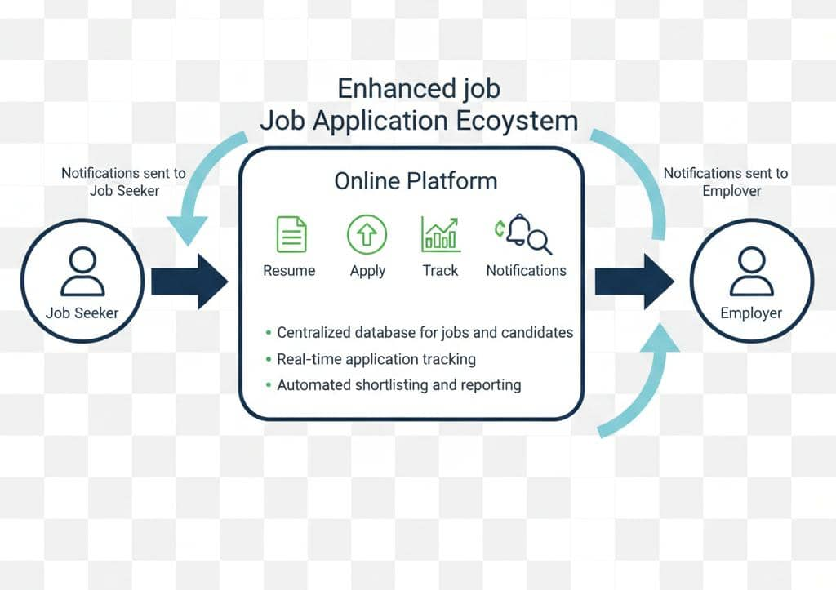

2.3 Gap Analysis and Direction
Despite the success of online systems, gaps remain, particularly in adapting systems for local contexts, small and medium enterprises, and user training. Addressing these gaps is essential for maximizing efficiency, transparency, and accessibility in Somalia. The proposed system focuses on bridging these gaps by customizing features for local needs and enhancing usability.

Table 2.1 – Gap Analysis
Aspect | Existing System | Gap Identified | Direction
Local Context | Partial | Not fully adapted to Somalia | Customize UI
SME Access | Limited | Hard for small enterprises | Add SME Module
Candidate Tracking | Basic | Lack of detailed analytics | Advanced Tracking
Transparency | Moderate | Some bias remains | Full transparency

2.4 Chapter Summary
Online Job Hunting Management Systems have evolved globally and in Africa, providing efficient recruitment platforms. Concepts, expert opinions, and ideas emphasize the importance of digital systems in improving transparency, access, and workforce efficiency. Previous systems reveal strengths and weaknesses, guiding the design of the proposed system. Gap analysis shows local adaptation, SME accessibility, and advanced tracking are needed. Overall, this chapter establishes a foundation for developing a system that is user-friendly, transparent, and effective for Somalia.

CHAPTER THREE

REQUIREMENT ANALYSIS

3.1 Introduction
Online Job Hunting Management System requires careful analysis to ensure that it meets the needs of all users. This chapter focuses on identifying functional and non-functional requirements. It examines the needs of job seekers, employers, and administrators. Preliminary investigation methods and data gathering techniques are discussed. The chapter highlights challenges in current recruitment processes. Organizational context and existing system limitations are reviewed. The importance of understanding requirements is emphasized. Requirements ensure efficiency, transparency, and fairness in job recruitment. The system design is based on this detailed analysis. Horn of Africa University supports rigorous methodology for academic and practical relevance. This chapter sets the foundation for building a robust online recruitment system.

3.2 User Requirement Analysis
The Online Job Hunting System requires clearly defined user requirements. Job seekers need easy access to search and apply for jobs. Employers require efficient management of applications and candidate tracking. Administrators need control over system operations, user accounts, and reporting. Security, accessibility, and usability are important functional requirements. Non-functional requirements include system performance, reliability, and scalability. The system must provide timely notifications and updates to users. User-friendly interfaces are critical to ensure engagement. The analysis ensures that the system meets practical and academic standards. Requirements help to prevent errors and inefficiencies in recruitment. By understanding user needs, the system becomes efficient and relevant for Somalia.

3.3 Preliminary Investigation
Preliminary investigation identifies the feasibility and scope of the Online Job Hunting System. It examines existing practices and system performance. Challenges and gaps in current recruitment methods are highlighted. This investigation ensures the proposed system addresses real-world needs. The significance lies in guiding design and development effectively.
A. Project Level
At the project level, investigation focuses on system functionality and deliverables. It examines how the system will improve recruitment efficiency. Objectives, timelines, and expected outcomes are defined. The system must reduce time and cost for users. Functional requirements are assessed. The importance is to ensure project success and stakeholder satisfaction.
B. Thesis Level
At the thesis level, investigation emphasizes research methodology and academic rigor. Literature review and expert opinions are analyzed. Data collection methods and system specifications are examined. Ethical and operational considerations are reviewed. Importance is to align the project with Horn of Africa University standards. Research ensures the system is academically credible and practically useful.

3.3.1 Organizational Profile
The proposed Online Job Hunting Management System is designed to serve businesses and educational institutions across Somalia. Its primary importance lies in creating an efficient and reliable connection between employers and job seekers. The system targets key stakeholders such as students, fresh graduates, and employers by providing equal access to employment opportunities. It offers a centralized digital platform that simplifies recruitment processes and reduces dependency on manual methods. Core processes include job posting, application submission, application tracking, and report generation, all of which improve transparency and efficiency. The system enhances communication between employers and applicants, reducing recruitment time and operational costs. By supporting fair and accessible hiring practices, the organization contributes to workforce development and economic growth in Somalia.
Our Mission
to provide a transparent, reliable, and efficient online recruitment system that supports equal employment opportunities.
Our Vision
to become the leading digital platform for connecting job seekers and employers in Somalia, fostering sustainable workforce development.

3.3.2 Current System
Currently, recruitment is done manually through newspapers and personal networks. Employers manage applications manually, which is time-consuming and prone to errors. Job seekers have limited access to information. Tracking applications is inefficient. Communication delays affect timely hiring. Existing systems lack digital integration and transparency. The importance is to justify the need for an online, centralized platform.

3.3.3 Limitations of the Current System
Manual recruitment is slow and costly. Data management is inefficient and error-prone. There is limited access to opportunities for remote job seekers. Transparency is lacking, increasing bias. Reporting is inadequate for decision-making. Highlighting these limitations emphasizes the importance of an online system.

3.4 Data Gathering
Data for the Online Job Hunting System will be collected using questionnaires, interviews, and observation. Job seekers, employers, and administrators will provide input. Requirements will be validated through surveys and feedback sessions. Data will include user needs, functional expectations, and system preferences. Analysis will focus on improving accessibility, efficiency, and transparency. Historical recruitment data will be reviewed to understand existing workflows. Metrics such as application processing time and user engagement will be gathered. Both qualitative and quantitative methods will be used. Data accuracy and completeness are prioritized. Feedback will guide system design and features. The importance is to ensure the system aligns with real user needs. Data-driven decisions will enhance system usability. Collected information will inform technical specifications and interface design. Results will help in defining user roles, permissions, and workflows. This approach ensures practicality, efficiency, and user satisfaction.

3.4.1 Data Flow Diagram
DFD illustrates the flow of data within the Online Job Hunting System. It shows how users interact with the system, how applications are processed, and how reports are generated. The diagram ensures clarity in system processes and highlights information flow. DFD helps identify redundancies and inefficiencies in the process. Its importance is to guide accurate system design and prevent errors.
Figure 3.1 Data Follow Diagram
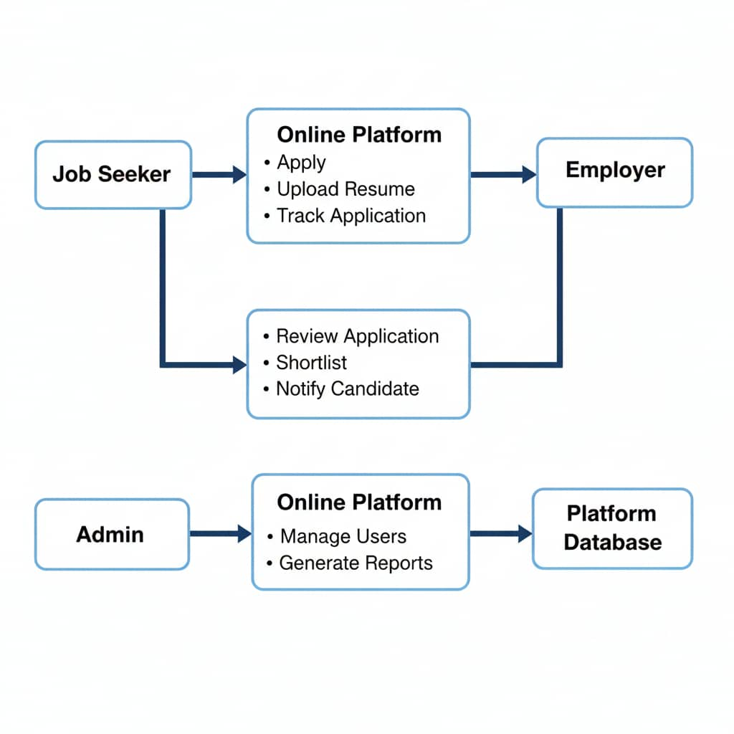

Unified Modeling Language (UML)
Online Job Hunting Management System uses UML to model system structure and behavior. UML diagrams illustrate how users interact with the system, define system components, and show workflows. These diagrams are critical for developers and stakeholders to understand processes clearly. The importance of UML is in reducing errors, improving communication, and ensuring correct implementation of the system.
Figure 3.2 UML
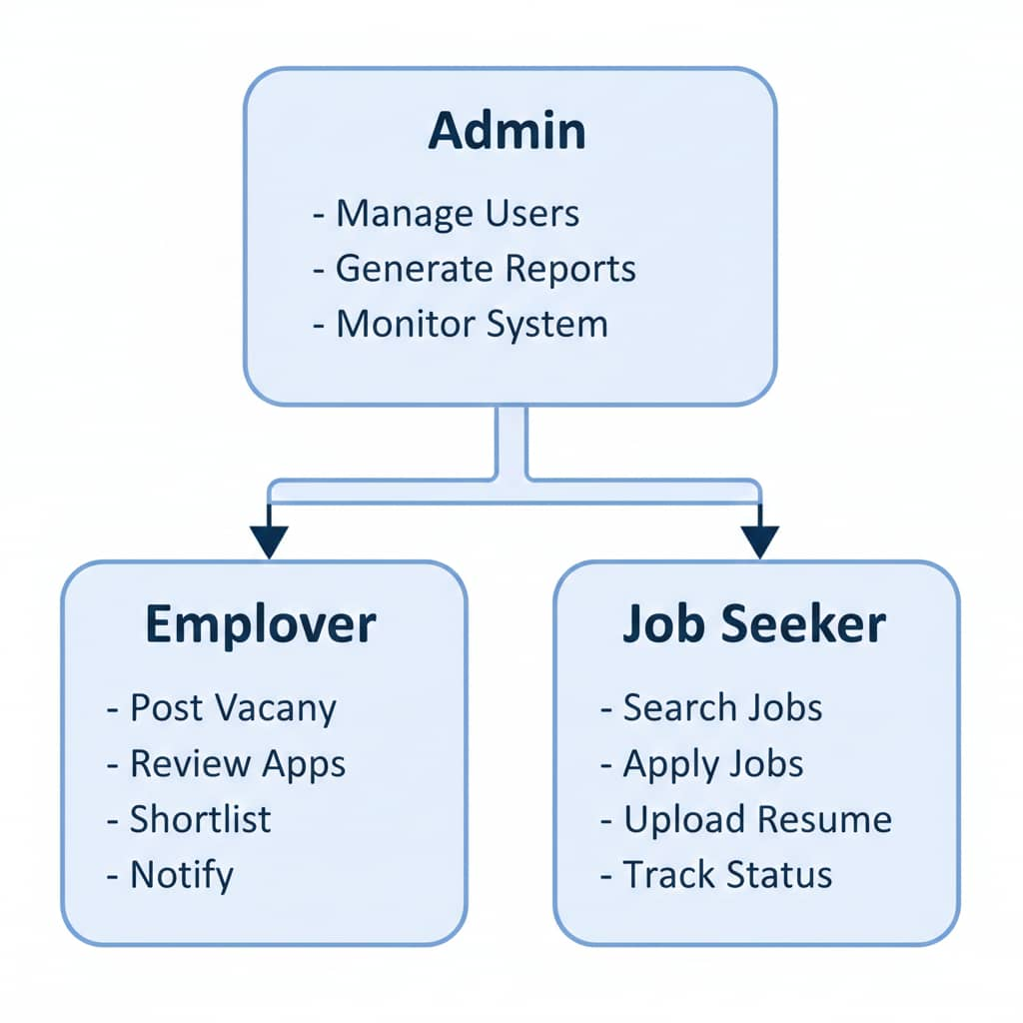

3.5 Problem Statement
The current recruitment process in Somalia is inefficient, manual, and error-prone. Job seekers have limited access to job information. Employers face delays in candidate evaluation. Communication is slow and lacks transparency. Records are poorly maintained, reducing decision accuracy. Online systems are underutilized in local contexts.
Key Problems:
- Limited accessibility and transparency in recruitment.
- Inefficient manual processes increasing time and cost.

3.6 Feasibility Study
The feasibility study evaluates the practicality of the proposed system. It considers technical, operational, and schedule aspects. The study ensures that the system can be implemented effectively. Resources, time, and cost requirements are analyzed. Feasibility ensures the system is realistic and achievable. The importance is to confirm that the project meets both academic and practical standards. Horn of Africa University emphasizes this structured assessment.

3.6.1 Technical Feasibility
The system requires hardware, software, and network infrastructure. It will run on web servers and support multiple user devices. Software requirements include a web application framework, database management system, and security protocols. Technical feasibility ensures compatibility, reliability, and scalability. Resources such as servers, computers, and software licenses are planned. The importance is to prevent technical failure and ensure smooth operation.
Table 3.1 – Technical feasibility
No | Item Description | Quantity | Cost per Unit | Amount
1 | Web Server | 1 | $500 | $500
2 | Laptop/PC | 3 | $600 | $1800
3 | Database Software | 1 | $400 | $400
4 | Internet Connection | 1 | $100 | $100

3.6.2 Operational Feasibility
Operational feasibility assesses system usability and impact on users. It ensures the system meets user expectations and improves efficiency. Training, support, and documentation are included. The importance is to ensure smooth adoption and minimal disruption to current processes.

Table 3.2 – Operational Feasibility
Activity | Duration | Expected Outcome | Total
User Training | 2 weeks | Efficient system usage | 2 weeks
System Testing | 1 week | Bug-free operation | 1 week
Feedback & Adjustments | 1 week | User satisfaction | 1 week

3.6.3 Schedule Feasibility
Schedule feasibility ensures the project can be completed on time. Tasks are divided into phases with clear timelines. Monitoring and control mechanisms are included. The importance is to deliver the system within academic deadlines and operational requirements.
Table 3.3 – Schedule Feasibility
Level | Phase Name | Duration
Phase 1 | Requirement Analysis | 1 month
Phase 2 | System Design | 1 month
Phase 3 | Development & Testing | 2 months

3.6.4 Feasibility Report
The feasibility report summarizes technical, operational, and schedule assessments. Technical feasibility confirms system compatibility and reliability. Operational feasibility ensures usability and adoption by users. Schedule feasibility guarantees timely completion. The importance is to validate the project’s practicality. The report supports decision-making for development. Horn of Africa University requires this to align academic and real-world implementation.

3.7 User Requirement Specification
The User Requirement Specification defines the features and functions that the Online Job Hunting Management System must provide. These requirements ensure the system meets user needs and operational goals.
Key Requirements:
- The system must allow job seekers to search, apply, and track job applications efficiently.
- Employers must be able to post vacancies, review applications, and communicate with candidates effectively.

3.7.1 New Proposed System
The proposed system is an Online Job Hunting Management System designed to streamline recruitment processes in Somalia. It provides a centralized platform connecting job seekers, employers, and administrators. The system automates application management, candidate tracking, and reporting. It reduces time, cost, and human errors compared to manual systems. The platform supports multiple devices and ensures data security. Notifications and alerts keep users updated on application status. Employers can efficiently shortlist candidates and schedule interviews. Job seekers benefit from accessible job listings and progress tracking. Administrators monitor user activity, manage accounts, and generate reports. The system is scalable to accommodate future growth. Online accessibility ensures real-time interactions. Local adaptation allows support for small and medium enterprises. Integration with existing databases ensures data consistency. User-friendly interfaces enhance engagement and satisfaction. Reporting and analytics support informed decision-making.
Key Features:
- Job posting and application management
- Candidate tracking and notifications
- Admin user management and reporting
- Multi-device support
- Security and data privacy
- Analytics and performance monitoring

3.7.2 Solution Strategy
The solution strategy focuses on delivering an efficient, reliable, and user-friendly online system. It involves requirement gathering, system design, development, and testing. Agile methodology is adopted for iterative improvements. Data validation and user feedback ensure system accuracy. Integration with databases allows seamless information flow. Security protocols protect sensitive data. Training and support will ensure smooth adoption. The importance of this strategy is to guarantee effective implementation and user satisfaction.

3.7.3 System Requirements Specification
The system requirements specification defines interfaces, hardware, software, and user requirements. It ensures that the system functions correctly across devices. Specifications are designed to support usability, performance, and scalability.
A. System Interface
The system interface allows users to interact with the Online Job Hunting System effectively. It includes dashboards, forms, notifications, and menus. Job seekers access search, application, and tracking functions. Employers access posting, shortlisting, and reporting tools. Administrators have management and monitoring capabilities.
B. Hardware Interface
The system requires standard hardware to operate efficiently. Minimum requirements include:
- Hard Disk: 512 GB
- RAM: 16 GB
- Processor: Intel i5 or equivalent

C. User Interface
The system is accessible on various devices, including smartphones, tablets, and desktops/laptops. It is designed to be responsive and intuitive for all user types.
D. Software Interface
Component | Specification
Operating System | Windows 10, 11
Front End | PHP
Back End | MySQL

3.7.3.1 List of Events
Figure 3.3 Admin Login Event Diagram
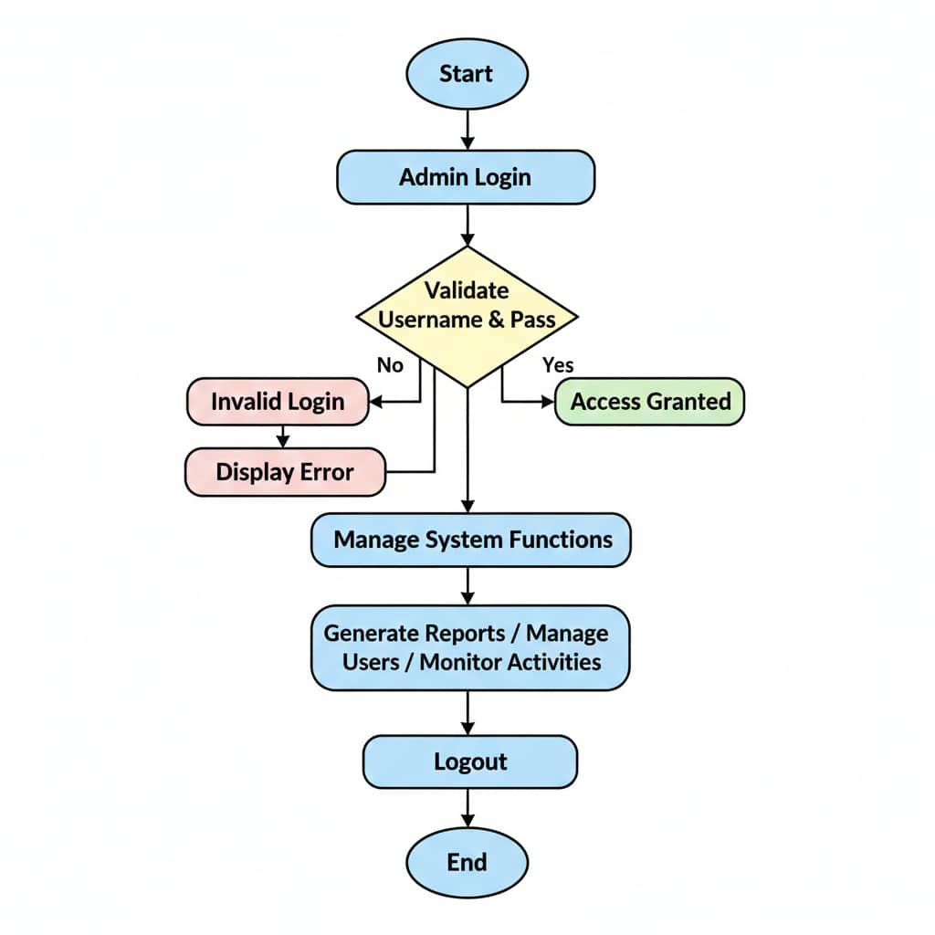
Figure 3.4 list Process Diagram Events
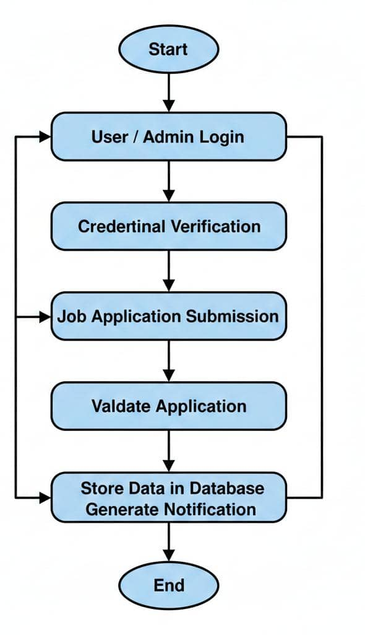

3.7.3.2 Converting Events into Processes
Figure 3.5 convert events
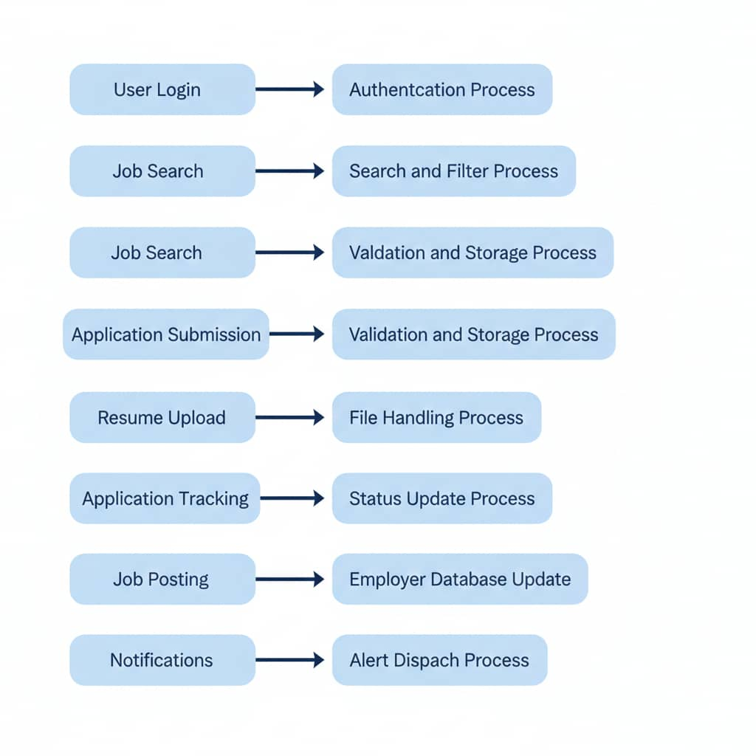

3.7.3.3 Regrouping
Figure 3.6 regrouping
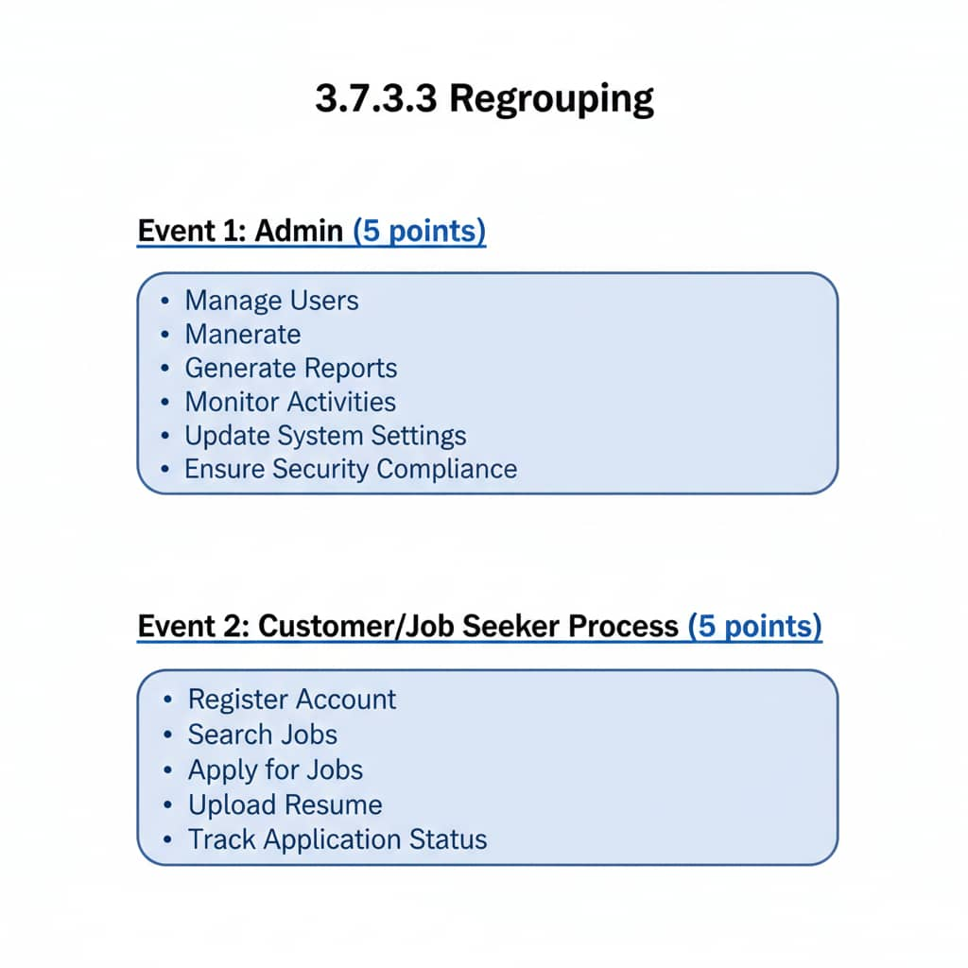

3.8 Chapter Summary
Chapter Three provides a detailed analysis of system requirements for the Online Job Hunting Management System. It covers user requirements, preliminary investigation, data gathering, and feasibility study. System specifications, interfaces, events, and processes are defined. Tables and diagrams illustrate technical and operational aspects. The chapter ensures that the system will be user-friendly, efficient, and aligned with Horn of Africa University academic standards.

