  - Analysis between “Monthly fuel usage SLT vehicels by fuel cards” and “Fuel card payments”. (Included “04.Fuel Usage data” from Mobitel as well)
- We grouped “Monthly fuel usage SLT vehicels by fuel cards” based on “card_number”, “vehicle_no” and “station_name”, but we couldn’t link up with any relevant data with “Fuel card payments” Invoice amount.
- Invoice Amount
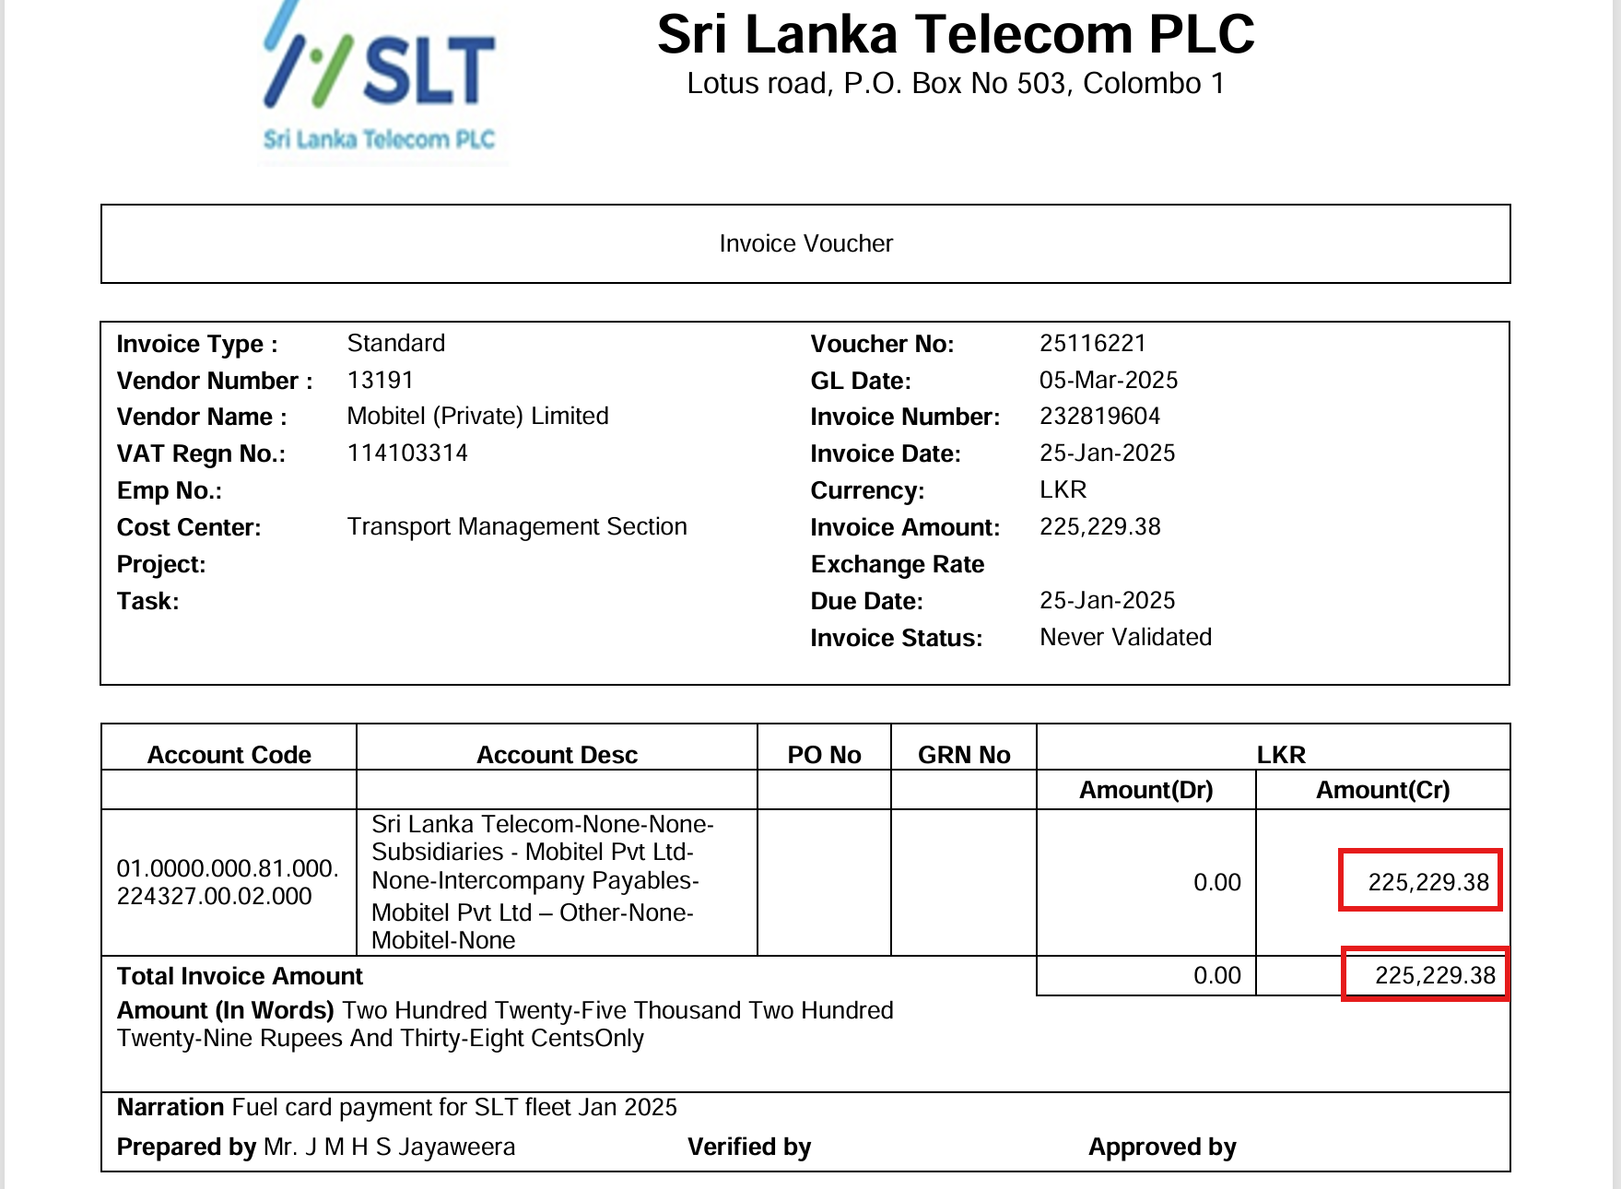
- “card_number”
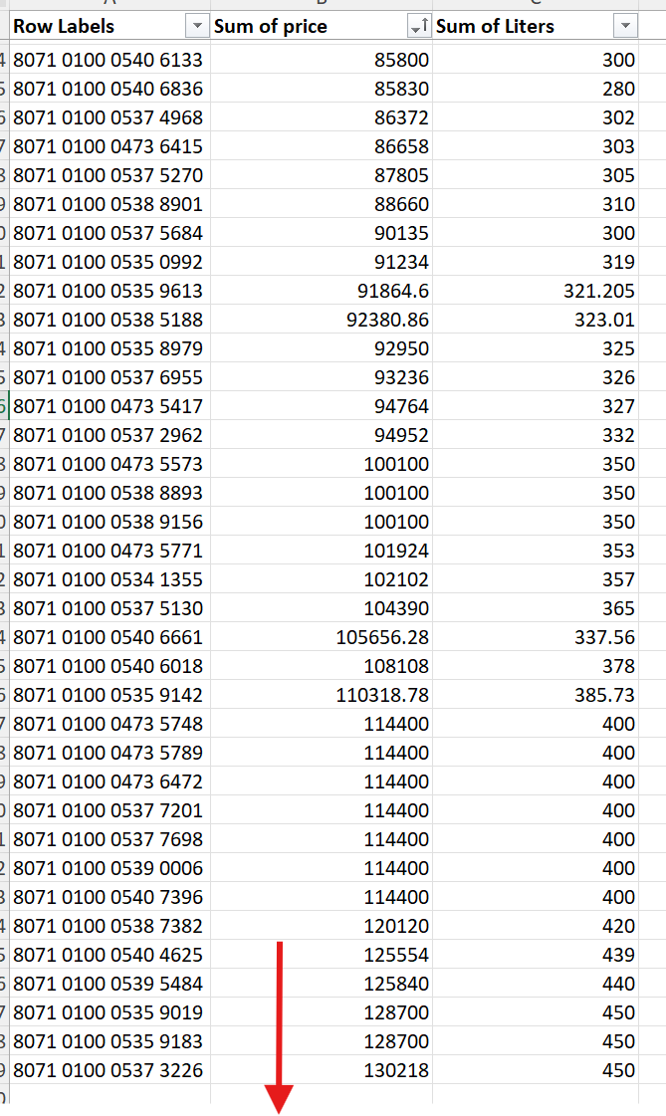

- “vehicle_no”

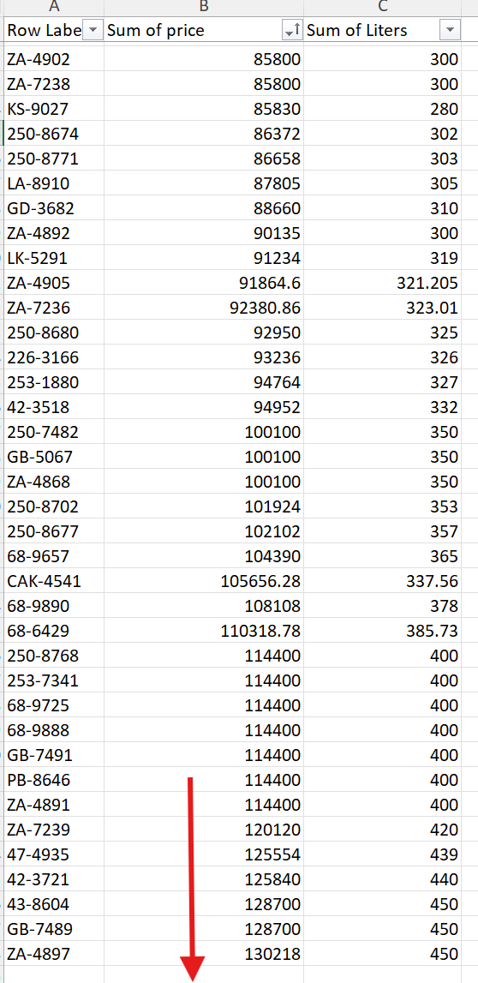

- “station_name”

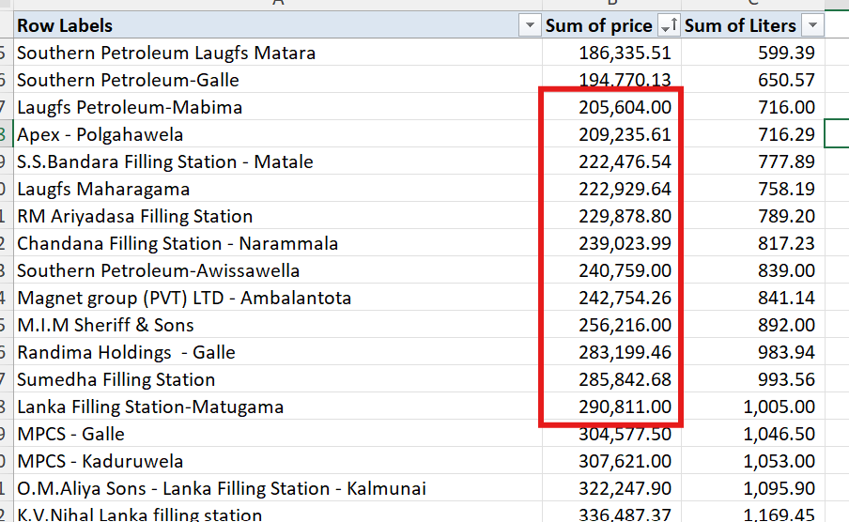

- Couldn’t link up “04.Fuel Usage data” as well.
