DATA ANALYTICS PROJECT
Tesla Stock Market
Performance Analysis
EDA & Unsupervised Learning
K-Means • Gaussian Mixture Model • DBSCAN
Prepared by: Prince Kumar Singh
Role: Data Analyst
Analysis period: 2010-06-30 to 2022-09-19
Observations: 3,077 daily records
Project Report | EDA, Feature Engineering, Clustering & Statistical Validation

Document Overview
This report documents the complete Tesla stock analysis workflow performed in the supplied Jupyter Notebook and presentation. It follows the project task sheet, covering data understanding, cleaning, feature engineering, exploratory analysis, time-series analysis, feature scaling, K-Means, GMM, DBSCAN, cluster interpretation, model evaluation and statistical validation.
Item | Details
Project | Tesla Stock Market Performance Analysis
Approach | Exploratory Data Analysis + Unsupervised Learning
Dataset | Daily Tesla OHLCV market data
Raw size | 3,077 rows × 7 columns
Clustering sample | 3,047 rows after engineered-feature NaN removal
Algorithms | K-Means, Gaussian Mixture Model, DBSCAN
Primary evaluation | Silhouette Score
Statistical test | One-way ANOVA on Close price across K-Means clusters
Prepared for | Project / Academic Submission
Author | Prince Kumar Singh

Contents
- 1. Executive Summary
- 2. Project Objective & Problem Statement
- 3. Dataset Description & Data Dictionary
- 4. Data Understanding & Quality Checks
- 5. Data Cleaning & Preparation
- 6. Feature Engineering
- 7. Distribution Analysis
- 8. Time Trend Analysis
- 9. Seasonal Decomposition
- 10. Rolling Statistics & Volatility
- 11. Feature Scaling
- 12. K-Means Clustering
- 13. Gaussian Mixture Model
- 14. DBSCAN Clustering & Outlier Detection
- 15. Model Comparison
- 16. Statistical Validation — ANOVA
- 17. Cluster Summary & Interpretation
- 18. Findings, Recommendations & Business Interpretation
- 19. Limitations
- 20. Conclusion
- Appendix A — Task-by-Task Answers
- Appendix B — Key Formulas & Methodology

1. Executive Summary
The project analyzes Tesla's historical daily stock data using exploratory data analysis and unsupervised learning. The objective is not to predict a future stock price, but to identify historical periods that share similar combinations of price level, daily movement, trading range, percentage movement, volatility and trading volume.
The raw dataset contains 3,077 daily observations and 7 original variables. The supplied notebook reports no missing values and no duplicate rows. Dates were converted to datetime and sorted chronologically, covering 2010-06-30 through 2022-09-19.
Key model results
K-Means selected K=2 with a Silhouette Score of 0.501; GMM with 2 components achieved 0.465; DBSCAN achieved 0.576 when the Silhouette Score was calculated on non-noise observations. DBSCAN labeled 86 observations as noise (2.82% of the clustering sample).

Metric | Result | Interpretation
Raw observations | 3,077 | Complete daily OHLCV sample
Clustering observations | 3,047 | Rows remaining after difference/rolling NaNs
Selected K | 2 | Highest tested K-Means Silhouette
K-Means Silhouette | 0.501 | Moderate cluster separation
GMM Silhouette | 0.465 | Alternative probabilistic segmentation
DBSCAN Silhouette | 0.576* | Calculated excluding DBSCAN noise
DBSCAN noise | 86 (2.82%) | Low-density observations
ANOVA F-statistic | 12,947.665 | Large between-cluster difference in Close means
ANOVA p-value | < 0.001 | Evidence against equal cluster mean Close

*The DBSCAN Silhouette value is not directly comparable to the other scores without considering that the noise observations were excluded from its calculation.

2. Project Objective & Problem Statement

2.1 Problem Statement
The project focuses on analyzing historical Tesla stock data to uncover meaningful patterns in stock price behavior. The supplied project brief defines the core data as daily trading information including Open, High, Low, Close, Adjusted Close and Volume. The intended outcome is to group similar historical periods using clustering techniques.
Additional features such as daily Price Change and Price Range are created to represent short-term movement and volatility. K-Means, Gaussian Mixture Models and DBSCAN are then applied to create different views of market behavior.

2.2 Objectives
- Understand the structure, variables and statistical characteristics of the Tesla dataset.
- Check and prepare the date and market fields for reliable analysis.
- Engineer features that capture daily movement, intraday range and recent volatility.
- Study distributions, skewness and potential outliers in price and volume.
- Visualize the long-term closing-price trend.
- Decompose the Close series into observed, trend, seasonal and residual components.
- Use rolling statistics to understand changing short-term variability.
- Standardize clustering features so scale differences do not dominate distance calculations.
- Identify historical market segments using K-Means, GMM and DBSCAN.
- Evaluate cluster separation using Silhouette Score and validate differences with ANOVA.
Important methodological note
The supplied project brief asks for an accuracy above 85%, but the implemented task is unsupervised clustering and has no ground-truth class labels. Therefore, the notebook evaluates clustering with Silhouette Score, cluster summaries and ANOVA rather than inventing a classification-accuracy figure.

3. Dataset Description & Data Dictionary
The supplied dataset is a daily OHLCV series with 3,077 records and seven original variables. The notebook reports a date range from 2010-06-30 to 2022-09-19.
Field | Type / Role | Description
Date | Date | Trading date of the observation.
Open | Numeric | Opening stock price for the trading day.
High | Numeric | Highest stock price reached during the day.
Low | Numeric | Lowest stock price reached during the day.
Close | Numeric | Closing stock price for the trading day.
Adj Close | Numeric | Adjusted closing price in the supplied dataset.
Volume | Integer | Number of shares traded during the day.

3.1 Original Dataset Summary Statistics
Variable | Mean | Std. Dev. | Min | Median | 75th % | Max
Open | 55.502 | 93.913 | 1.076 | 15.983 | 23.587 | 411.470
High | 56.748 | 96.085 | 1.109 | 16.242 | 23.917 | 414.497
Low | 54.161 | 91.517 | 0.999 | 15.687 | 23.229 | 405.667
Close | 55.496 | 93.851 | 1.053 | 16.001 | 23.523 | 409.970
Adj Close | 55.496 | 93.851 | 1.053 | 16.001 | 23.523 | 409.970
Volume | 93,403,920 | 82,358,160 | 1,777,500 | 75,415,500 | 117,303,000 | 914,082,000

The statistics show why scaling is important. Price variables and Volume operate on very different numerical scales, while the wide gap between mean and standard deviation also indicates substantial variation over the historical sample.

4. Data Understanding & Quality Checks

4.1 Dataset Shape and Types
Check | Result
Rows | 3,077
Columns | 7
Date type before conversion | object
Open / High / Low / Close / Adj Close | float64
Volume | int64
Missing values | 0 across all columns
Duplicate rows | 0
Invalid dates after parsing | 0
Final shape after cleaning | 3,077 × 7

4.2 Data Cleaning & Preparation
- Load the Tesla daily stock dataset into a pandas DataFrame.
- Inspect column names, data types, missing values and duplicate records.
- Convert Date from object/string representation into datetime format.
- Sort records chronologically by Date.
- Verify the parsed date range and confirm there are no invalid dates.
- Create derived features required for EDA and clustering.
- Remove rows created as NaN by differencing and the 30-day rolling volatility calculation before modeling.
Data quality conclusion
The raw file is structurally clean: there are no missing values or duplicate rows. The only modeling-row reduction comes from mathematically expected NaNs introduced by Price Change, Pct Change and the 30-day rolling calculation.

5. Feature Engineering
The original OHLCV fields describe market prices and trading activity, but clustering directly on those fields does not fully capture short-term market dynamics. Four derived features were created in the notebook.
Feature | Formula / Construction | Purpose
Price Change | Close − previous Close | Absolute daily movement and direction.
Price Range | High − Low | Intraday trading range.
Pct Change | Close.pct_change() × 100 | Relative daily movement, comparable across price levels.
Volatility | 30-day rolling standard deviation of Pct Change | Recent variability in daily returns.

5.1 Why These Features Matter
- Price Change identifies whether the closing price moved up or down and by how much in absolute terms.
- Price Range captures the distance between the day's highest and lowest traded prices.
- Pct Change expresses movement relative to the previous close, which is more scale-aware than raw price change.
- The 30-day rolling standard deviation summarizes recent dispersion in percentage movements and provides a local volatility signal.

5.2 Modeling Sample
After removing rows with missing values in the engineered clustering fields, 3,047 observations remained. This reduction is expected because the first difference-based observations cannot have a prior close and the 30-day volatility calculation requires an initial rolling window.

6. Distribution Analysis
The project task sheet asks for distribution analysis of Open, Close, High, Low and Volume, including skewness, potential outliers and visual interpretation. The notebook calculates skewness for the five variables.
Variable | Skewness
Volume | 2.3772
Open | 1.9852
High | 1.9847
Low | 1.9826
Close | 1.9823

All five distributions are positively skewed. Volume has the largest skewness in the notebook output, while the price variables have skewness close to 1.98. The closing-price histogram in the presentation shows a large concentration at lower historical prices with a long right tail extending into later high-price periods.
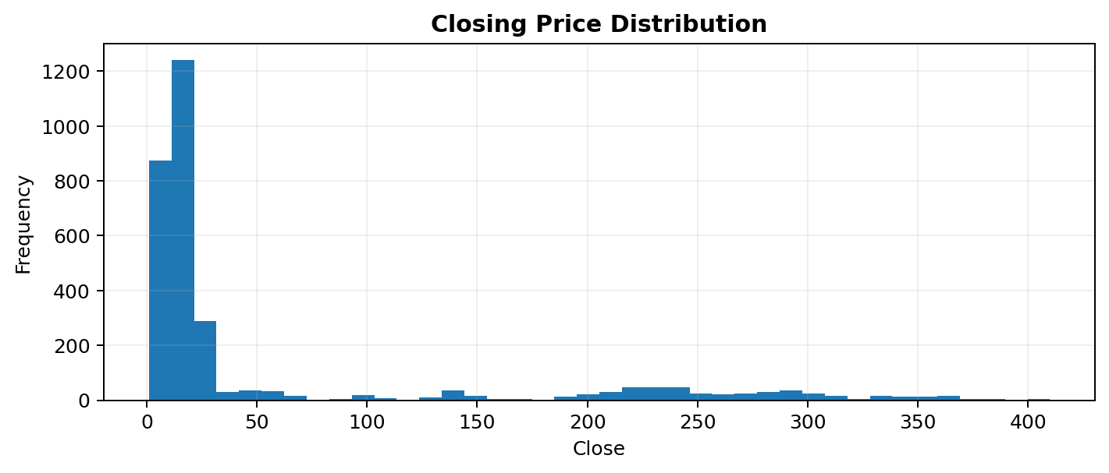
Figure 1. Closing-price distribution from the project presentation.

6.1 Outlier Interpretation
The project treats unusual financial observations cautiously. A high or low price/volume observation may represent a genuine market event rather than a data error. Therefore, the analysis does not automatically remove statistical outliers before clustering.

7. Time Trend Analysis
The closing-price time series is used to understand long-term movement and identify visible shifts in historical market regimes. The project presentation shows a comparatively low-price period during the earlier years followed by much larger price levels and variability in the later part of the sample.
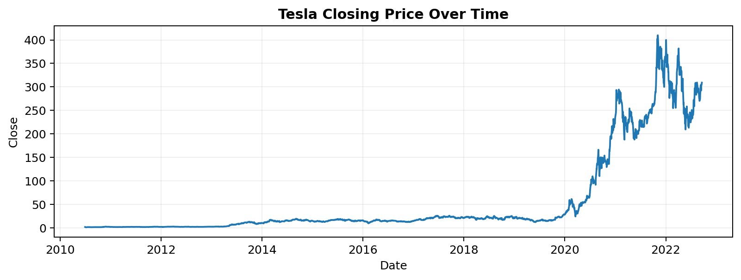
Figure 2. Tesla closing price over time.

7.1 Interpretation
- The time series is highly non-stationary in its price level across the sample.
- Later observations operate at substantially higher price levels than earlier observations.
- Large movements become more visible in the later years, supporting the use of engineered movement and volatility features.
- The changing price scale is one reason clustering on raw values alone would be difficult to interpret.

8. Seasonal Decomposition
The notebook applies additive seasonal decomposition to the Close series after setting Date as the index, converting to business-day frequency and interpolating missing business-day observations. A period of 252 business days is used as an approximate trading-year cycle.

8.1 Components
Component | Meaning in this analysis
Observed | Actual Close series used as the input time series.
Trend | Long-term movement extracted by the decomposition model.
Seasonal | Repeating annual-cycle component under the 252-business-day assumption.
Residual | Remaining variation not explained by the trend and seasonal components.

Interpretation caution
The seasonal component is exploratory. A decomposition can expose repeating structure under its model assumptions, but it does not establish that a stable trading-seasonality effect will persist in future periods.

9. Rolling Statistics & Volatility
The project uses a 30-day rolling mean and 30-day rolling standard deviation. The rolling mean smooths short-term noise in Close, while the rolling standard deviation captures recent dispersion.
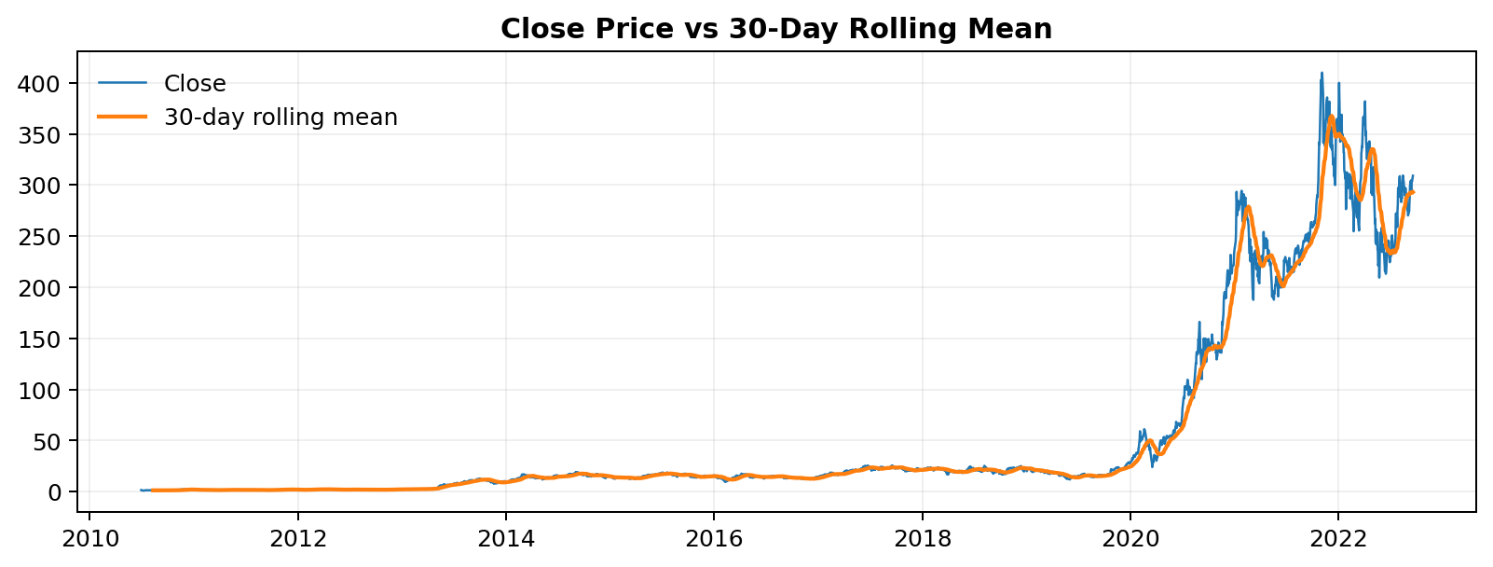
Figure 3. Tesla Close price compared with the 30-day rolling mean.

9.1 Practical Interpretation
- When the rolling mean follows Close closely, short-term price movement is relatively contained around the local trend.
- Wider gaps between Close and the rolling mean indicate stronger short-term movement relative to the recent baseline.
- A rising rolling standard deviation indicates greater recent variability and therefore a more volatile local regime.
- These rolling features complement the clustering variables by adding context about recent market behavior.

10. Feature Scaling
Six variables were selected for clustering: Close, Price Change, Price Range, Pct Change, Volatility and Volume. The notebook applies StandardScaler before K-Means, GMM and DBSCAN.
Step | Implementation | Reason
Feature selection | 6 engineered/raw clustering fields | Capture level, movement, range, volatility and activity.
Scaling | StandardScaler | Put variables on comparable standardized scales.
Result | Approximately mean 0 and standard deviation 1 | Reduce dominance from large-magnitude variables.

Conceptually, StandardScaler transforms a feature using z = (x − μ) / σ. This is particularly important because Close and Volume have much larger numerical magnitudes than percentage changes or daily ranges.
Why scaling affects clustering
K-Means and DBSCAN rely on distances/density in feature space, while GMM estimates distributions in that space. Without scaling, high-magnitude variables could disproportionately influence the segmentation.

11. K-Means Clustering
K-Means partitions observations into K groups by assigning each observation to the nearest centroid and iteratively updating the centroids. The notebook tests K values from 2 through 8.
K | Silhouette Score
2 | 0.501
3 | 0.470
4 | 0.481
5 | 0.467
6 | 0.429
7 | 0.255
8 | 0.268

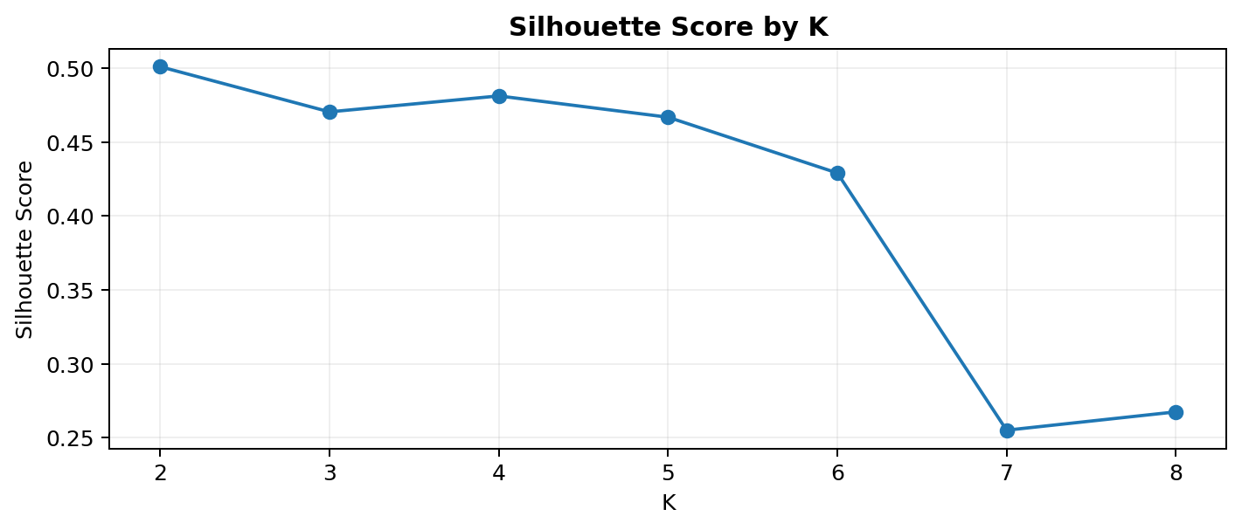
Figure 4. Silhouette Score across tested K values.
The highest tested score is 0.501 at K=2, so K=2 is selected for the K-Means segmentation.
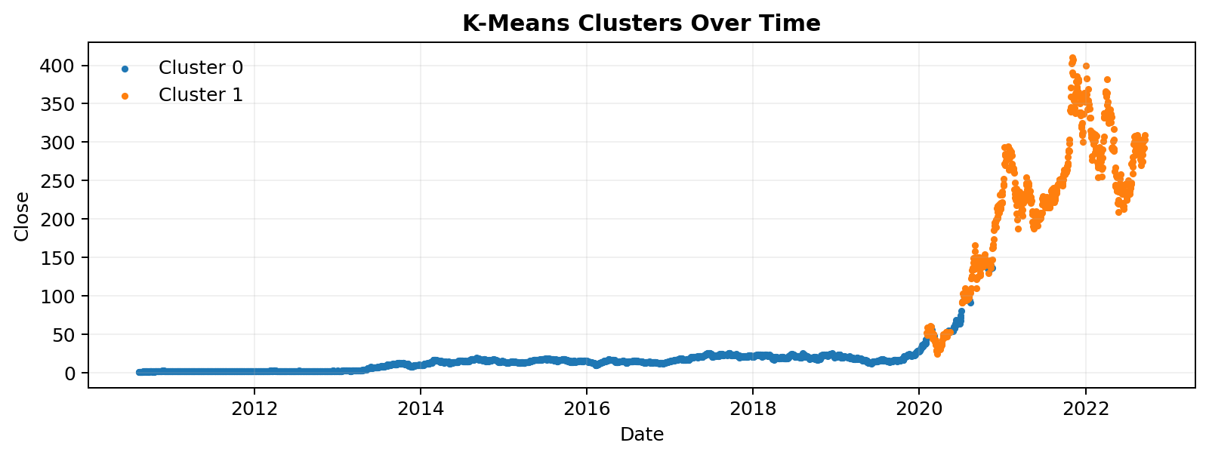
Figure 5. K-Means clusters mapped back to the Tesla closing-price timeline.

11.1 Cluster Profile
Cluster | Records | Avg Close | Median Close | Avg Price Change | Avg Price Range | Avg % Change | Avg Volatility | Avg Volume
0 | 2,454 | 14.389 | 14.521 | 0.0244 | 0.5107 | 0.2105 | 3.0884 | 85,896,110
1 | 593 | 228.346 | 236.603 | 0.4182 | 11.3034 | 0.3881 | 4.2813 | 126,946,000

Cluster 0 contains 2,454 observations and has a much lower average Close and average intraday range than Cluster 1. Cluster 1 contains 593 observations and shows substantially higher average Close, Price Change, Price Range, percentage change, volatility and volume. The clusters therefore represent materially different combinations of price level and market activity.

12. Gaussian Mixture Model
GMM models the standardized feature space as a mixture of Gaussian distributions. Unlike K-Means' hard assignments, GMM produces probabilistic membership, which is useful when an observation may sit near a boundary between regimes.
Setting | Result
Components | 2
Silhouette Score | 0.465
Membership output | Probability for each component

12.1 Interpretation
- GMM provides a soft-clustering perspective rather than forcing every observation into a purely distance-based centroid interpretation.
- The two-component GMM achieved a Silhouette Score of 0.465 on the same standardized feature framework.
- Membership probabilities provide an additional signal about how strongly an observation belongs to each component.
- The GMM result is directionally consistent with the existence of different historical market regimes, while using a different modeling assumption from K-Means.

13. DBSCAN Clustering & Outlier Detection
DBSCAN is a density-based algorithm. It does not require the number of clusters to be specified in advance and can explicitly label low-density observations as noise.
Parameter / Result | Value
eps | 1.5
min_samples | 10
Noise observations | 86
Noise percentage | 2.82%
Silhouette excluding noise | 0.576
Cluster labels | -1, 0, 1
Largest cluster | 2,951 observations
Second cluster | 10 observations

13.1 Outlier Interpretation
DBSCAN identifies 86 observations as noise under the selected parameters. In this project, noise is a density-based designation rather than a statement that the records are incorrect. A market observation can be unusual and still be valid.

14. Model Comparison
Algorithm | Configuration | Silhouette | Core Assumption | Notable Output
K-Means | K=2 | 0.501 | Centroid-based hard assignment | 2 historical segments
GMM | 2 components | 0.465 | Probabilistic mixture | Soft membership probabilities
DBSCAN | eps=1.5; min_samples=10 | 0.576* | Density-based | 2 clusters + 86 noise observations

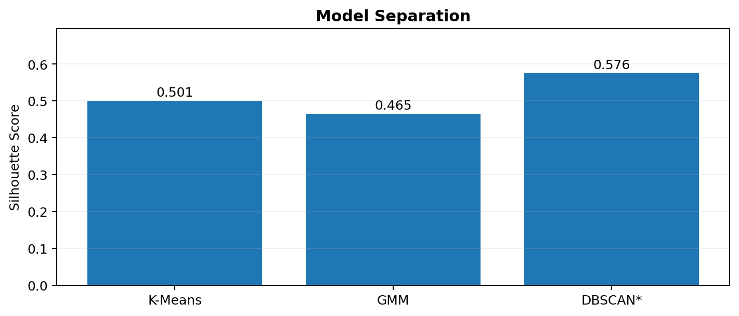
Figure 8. Silhouette Score comparison from the project presentation.
The scores show that the three methods provide complementary segmentation views. DBSCAN's score is highest in the notebook, but it is calculated after excluding noise observations, so it should not be interpreted as a simple one-to-one ranking of model quality. The purpose of the comparison is to understand how different clustering assumptions partition the data.

15. Statistical Validation — ANOVA
A one-way ANOVA test is performed on Close price across the two K-Means clusters. The hypotheses are:
Hypothesis | Statement
H0 | Mean Close price is equal across K-Means clusters.
H1 | At least one cluster has a different mean Close price.

Statistic | Value
F-statistic | 12,947.665
p-value | < 0.001 (reported as 0.000000 in notebook output)
Significance level | α = 0.05
Decision | Reject H0

The extremely small p-value provides evidence that the mean Close price differs between the K-Means clusters for this dataset. The test supports the observation that the clusters are materially different in Close price.
Statistical interpretation
ANOVA establishes evidence of a difference in group means; it does not establish causality and does not by itself explain why the clusters formed.

16. Cluster Summary & Interpretation
The final cluster summary combines the number of observations with central tendency and activity measures. This makes the unsupervised output easier to interpret as descriptive historical regimes.
Metric | Cluster 0 | Cluster 1
Records | 2,454 | 593
Average Close | 14.389 | 228.346
Median Close | 14.521 | 236.603
Average Price Change | 0.0244 | 0.4182
Average Price Range | 0.5107 | 11.3034
Average Pct Change | 0.2105% | 0.3881%
Average Volatility | 3.0884 | 4.2813
Average Volume | 85.90M | 126.95M

16.1 Regime-Level Interpretation
- Cluster 0 is characterized by lower average Close, smaller absolute daily movement and a much smaller intraday range.
- Cluster 1 is characterized by higher average Close, larger price movement, wider daily range, higher volatility and higher average trading volume.
- The cluster distinction is therefore multidimensional: it is not solely a division by closing price.
- The historical time plot shows that cluster membership is associated with different periods of the Tesla price history.

17. Findings, Recommendations & Business Interpretation

17.1 Key Findings
- The Tesla series changes scale substantially over the sample, so feature scaling is essential for distance- and density-based methods.
- The engineered features add short-term market context beyond raw OHLCV variables.
- The closing-price distribution is positively skewed, and Volume is the most strongly skewed variable among those tested.
- K-Means selects two clusters based on the highest tested Silhouette Score.
- The two K-Means clusters differ strongly in Close price and also differ in range, volatility and volume.
- GMM provides a probabilistic alternative with a Silhouette Score of 0.465.
- DBSCAN identifies 86 low-density observations and provides a density-based segmentation with a non-noise Silhouette Score of 0.576.
- ANOVA provides statistical evidence that mean Close differs across the K-Means clusters.

17.2 Practical Recommendations
- Use cluster labels as descriptive historical-regime indicators rather than as guaranteed future trading signals.
- Track rolling volatility alongside cluster membership when interpreting changing market conditions.
- Use cluster summaries to compare price level, movement and trading activity together rather than relying on a single metric.
- For future iterations, test whether the same clusters remain stable across different time windows.
- Add carefully selected technical or market-context features and prevent look-ahead leakage when evaluating any future predictive extension.
- If the project is extended toward prediction, define a clear target variable and use an appropriate supervised-learning evaluation framework.

18. Limitations
- The analysis is descriptive and historical; clustering does not establish future price direction.
- The 252-business-day seasonal decomposition is an approximate annual cycle and should be interpreted cautiously.
- DBSCAN results depend on eps and min_samples; different settings can materially change cluster density and noise labels.
- Silhouette Score depends on the feature representation and scaling approach.
- The K-Means segmentation uses a fixed set of six features and may change if additional market variables are introduced.
- ANOVA tests mean Close differences but does not explain causal drivers of the observed differences.
- The dataset ends on 2022-09-19 according to the supplied notebook, so the report does not represent later Tesla market behavior.

19. Conclusion
This project demonstrates a complete unsupervised-learning workflow for Tesla historical stock data. The analysis begins with data validation and exploratory analysis, then adds features for daily movement, intraday range, percentage movement and rolling volatility. Standardization creates a common feature scale before applying three clustering approaches.
K-Means identifies two broad historical segments with a Silhouette Score of 0.501. GMM offers a probabilistic alternative with a score of 0.465, while DBSCAN identifies density-based structure and 86 noise observations, with a non-noise Silhouette Score of 0.576. The ANOVA result (F=12,947.665, p<0.001) provides statistical evidence that the K-Means groups differ in mean Close price.
Overall, the project provides a structured way to describe historical Tesla market regimes. Its strongest value is in organizing complex historical observations into interpretable segments while explicitly acknowledging the assumptions and limitations of unsupervised clustering.
Final takeaway
The clustering output should be used as an analytical segmentation of historical behavior, not as a guaranteed trading signal.

Appendix A — Task-by-Task Answers

1. Data Understanding and Exploration
The dataset contains 3,077 rows and 7 original variables: Date, Open, High, Low, Close, Adj Close and Volume. Date is initially an object field; the price fields are float64 and Volume is int64. There are 0 missing values and 0 duplicate rows. The price variables have large variation across the historical sample, while Volume operates at a much larger numerical scale.

2. Data Cleaning and Preparation
Date was converted to datetime, the observations were sorted chronologically, and invalid dates were checked. The notebook reports 0 invalid dates, 0 missing values and 0 duplicates. The final raw dataset remains 3,077 × 7. Expected NaNs introduced by difference and rolling calculations are removed only before clustering.

3. Feature Engineering
Four derived variables were created: Price Change = Close − previous Close; Price Range = High − Low; Pct Change = daily percentage change in Close; and Volatility = 30-day rolling standard deviation of Pct Change.

4. Distribution Analysis of Stock Metrics
Open, High, Low, Close and Volume are positively skewed. Skewness is approximately 1.98 for the price variables and 2.38 for Volume. The closing-price histogram shows a long right tail. Financial outliers are treated as potentially genuine observations.

5. Time Trend Visualization
The closing-price time series shows a major change in price scale across the historical period. Later years contain much higher prices and more visible large movements than the early part of the sample.

6. Seasonal Decomposition of Close Price
An additive decomposition was applied using a 252-business-day period. The output separates observed Close into trend, seasonal and residual components. The seasonal component is exploratory and depends on the chosen model period.

7. Rolling Statistics for Volatility Analysis
A 30-day rolling mean is used to smooth Close and a 30-day rolling standard deviation is used to measure recent dispersion. These statistics help identify periods with changing local variability.

8. Feature Scaling for Clustering
Six clustering variables were standardized with StandardScaler: Close, Price Change, Price Range, Pct Change, Volatility and Volume. Scaling prevents high-magnitude variables from dominating distance calculations.

9. K-Means Clustering Application
K-Means was tested from K=2 to K=8. K=2 produced the highest Silhouette Score and was selected. The two clusters differ substantially in average Close, Price Range, Volatility and Volume.

10. K-Means Evaluation Using Silhouette Score
The K=2 Silhouette Score is 0.501. The tested scores range from 0.255 at K=7 to 0.501 at K=2. The score is used to assess how compact and separated the clusters are.

11. Gaussian Mixture Model Clustering
GMM was fitted with two components and produced a Silhouette Score of 0.465. Its key distinction is probabilistic membership, which can be useful for observations near regime boundaries.

12. DBSCAN Clustering and Outlier Detection
DBSCAN used eps=1.5 and min_samples=10. It produced labels -1, 0 and 1, with 86 observations labeled as noise. The noise rate is 2.82%, and the Silhouette Score excluding noise is 0.576.

13. Cluster Summary and Interpretation
K-Means Cluster 0 contains 2,454 records with average Close 14.389, while Cluster 1 contains 593 records with average Close 228.346. ANOVA gives F=12,947.665 and p<0.001, providing evidence that mean Close differs across the clusters.

14. Insights and Recommendations
The project indicates that Tesla's historical market behavior can be segmented into materially different regimes when price level, movement, range, volatility and volume are considered together. Future work should test cluster stability across time windows and incorporate additional market or technical variables without look-ahead leakage.

Appendix B — Key Formulas & Methodology

B.1 Feature Formulas
Metric | Formula
Price Change | Close_t − Close_(t−1)
Price Range | High_t − Low_t
Percentage Change | ((Close_t / Close_(t−1)) − 1) × 100
30-Day Volatility | Std. Dev. of Pct Change over the last 30 observations
Standardization | z = (x − μ) / σ

B.2 Clustering Workflow
- Load and inspect the daily Tesla dataset.
- Validate dates, missing values and duplicates.
- Create movement and volatility features.
- Drop rows with expected engineered-feature NaNs for modeling.
- Select six clustering variables.
- Standardize the feature matrix with StandardScaler.
- Evaluate K-Means for K=2 through K=8 using Silhouette Score.
- Fit K-Means using the selected K.
- Fit a two-component GMM.
- Fit DBSCAN with eps=1.5 and min_samples=10.
- Compare Silhouette Scores and inspect cluster assignments.
- Use one-way ANOVA to test whether mean Close differs across K-Means clusters.

B.3 Key Reproducibility Settings
Component | Setting
K-Means | n_clusters=2; random_state=42; n_init=20
GMM | n_components=2; random_state=42
DBSCAN | eps=1.5; min_samples=10
Scaling | StandardScaler
Seasonal decomposition | Additive; period=252
Rolling window | 30 observations
Significance level | α=0.05

B.4 Deliverables Covered
- EDA and statistical analysis presentation
- Jupyter Notebook with the implemented analysis and clustering workflow
- Detailed written report answering the task-sheet questions
- Visual evidence through distribution, trend, rolling, clustering and model-comparison charts
— End of Report —

