PROJECT REPORT ON
HUMAN ACTIVITY RECOGNITION,
FINDING INDOOR LOCATION USING WLAN
AND
CLASSIFICATION OF PHISHING WEBSITES



GUIDED BY:
Dr. Ankush Mittal
Guarav Bhatt

SUBMITTED BY:
SHUBHAM DOBHAL(B.TECH(CSE),4TH YEAR)
SHUBHAM RANA(B.TECH(CSE),4TH YEAR)
UPENDRA SINGH BARTWAL(B.TECH(CSE),4TH YEAR)

PROJECT 1

HUMAN ACTIVITY RECOGNITION

Introduction
Human Activity Recognition is one of the active research areas in computer vision for various contexts like security surveillance, health-care and human computer interaction. In this paper, a total of thirty-two recent research papers on sensing technologies used in HAR are reviewed. The review covers three area of sensing technologies namely RGB cameras, depth sensors and wearable devices. It also discusses on the pros and cons of the mentioned sensing technologies. The findings showed that RGB cameras have lower popularity when compared to depth sensors and wearable devices in HAR research.

Data Set Information:
The experiments have been carried out with a group of 30 volunteers within an age bracket of 19-48 years. Each person performed six activities (WALKING, WALKING_UPSTAIRS, WALKING_DOWNSTAIRS, SITTING, STANDING, LAYING) wearing a smart phone (Samsung Galaxy S II) on the waist. Using its embedded accelerometer and gyroscope, we captured 3-axial linear acceleration and 3-axial angular velocity at a constant rate of 50Hz. The experiments have been video-recorded to label the data manually. The obtained dataset has been randomly partitioned into two sets, where 70% of the volunteers was selected for generating the training data and 30% the test data.
The sensor signals (accelerometer and gyroscope) were pre-processed by applying noise filters and then sampled in fixed-width sliding windows of 2.56 sec and 50% overlap (128 readings/window). The sensor acceleration signal, which has gravitational and body motion components, was separated using a Butterworth low-pass filter into body acceleration and gravity. The gravitational force is assumed to have only low frequency components, therefore a filter with 0.3 Hz cut-off frequency was used. From each window, a vector of features was obtained by calculating variables from the time and frequency domain.

Attribute Information:
For each record in the dataset it is provided:
- Tri-axial acceleration from the accelerometer (total acceleration) and the estimated body acceleration.
- Tri-axial Angular velocity from the gyroscope.
- A 561-feature vector with time and frequency domain variables.
- Its activity label.
- An identifier of the subject who carried out the experiment.
PROBLEM TYPE: CLASSIFICATION
TO PREDICT : ACTIVITY OF HUMAN
TOOL USED: Orange
MODEL USED:

1: KNN(K-Nearest Neighbour ):

RESULT:
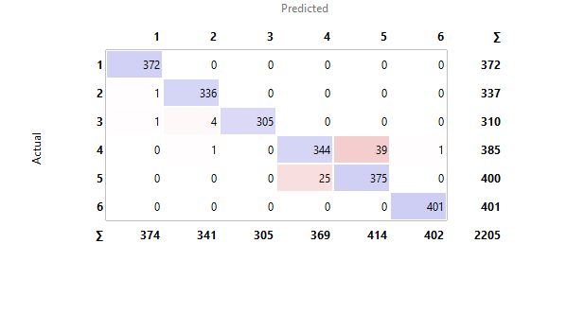
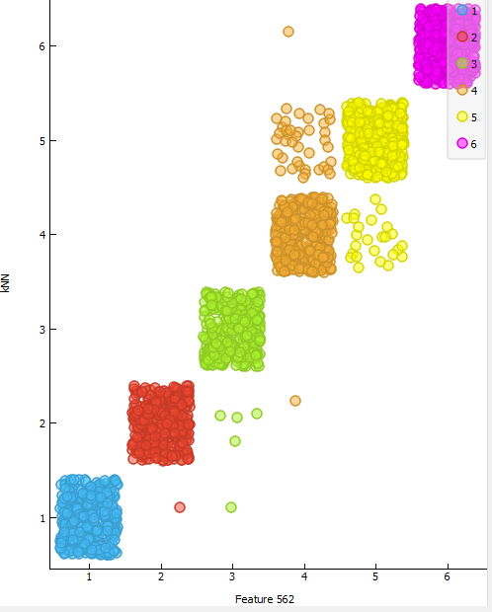

ACCURACY = 96.73%

2: NN(NUERAL NETWORK):

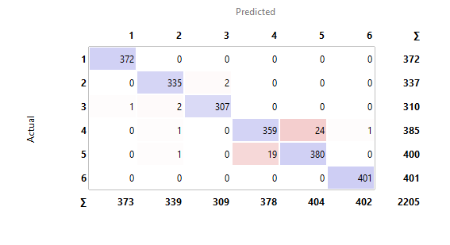

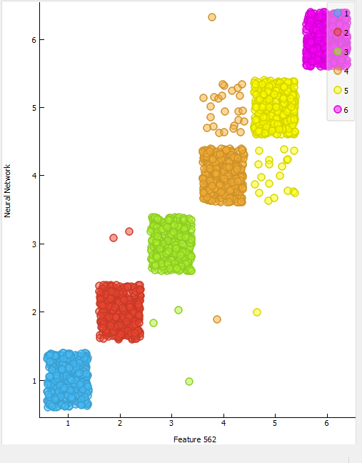

ACCURACY: 97.68%

3: SVM (SUPPORT VECTOR MACHINE)

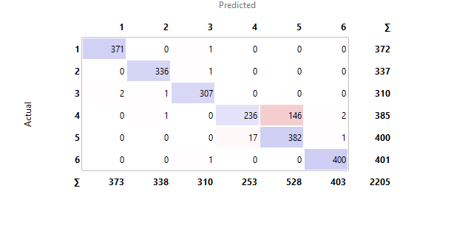
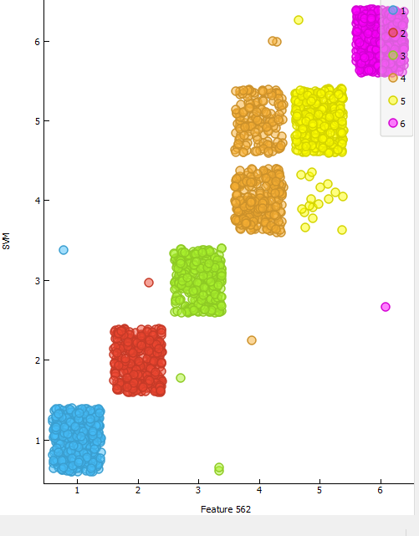

ACCURACY : 92.15%

PROJECT 2

FINDING INDOOR
LOCATION USING WLAN

Introduction

Many real world applications need to know the localization of a user in the world to provide their services. Therefore, automatic user localization has been a hot research topic in the last years. Automatic user localization consists of estimating the position of the user (latitude, longitude and altitude) by using an electronic device, usually a mobile phone. Outdoor localization problem can be solved very accurately thanks to the inclusion of GPS sensors into the mobile devices. However, indoor localization is still an open problem mainly due to the loss of GPS signal in indoor environments. Although, there are some indoor positioning technologies and methodologies, this database is focused on WLAN fingerprint-based ones (also know as WiFi Fingerprinting).

The UJIIndoorLoc database covers three buildings of Universitat Jaume I with 4 or more floors and almost 110.000m2. It can be used for classification, e.g. actual building and floor identification, or regression, e.g. actual longitude and latitude estimation. It was created in 2013 by means of more than 20 different users and 25 Android devices. The database consists of 19937 training/reference records (trainingData.csv file) and 1111 validation/test records (validationData.csv file).
The 529 attributes contain the WiFi fingerprint, the coordinates where it was taken, and other useful information.
Each WiFi fingerprint can be characterized by the detected Wireless Access Points (WAPs) and the corresponding Received Signal Strength Intensity (RSSI). The intensity values are represented as negative integer values ranging -104dBm (extremely poor signal) to 0dbM. The positive value 100 is used to denote when a WAP was not detected. During the database creation, 520 different WAPs were detected. Thus, the WiFi fingerprint is composed by 520 intensity values.
Then the coordinates (latitude, longitude, floor) and Building ID are provided as the attributes to be predicted.
Additional information has been provided.
The particular space (offices, labs, etc.) and the relative position (inside/outside the space) where the capture was taken have been recorded. Outside means that the capture was taken in front of the door of the space.
Information about who (user), how (android device & version) and when (timestamp) WiFi capture was taken is also recorded.

Attribute Information:
Attribute 001 (WAP001): Intensity value for WAP001. Negative integer values from -104 to 0 and +100. Positive value 100 used if WAP001 was not detected.
....
Attribute 520 (WAP520): Intensity value for WAP520. Negative integer values from -104 to 0 and +100. Positive Vvalue 100 used if WAP520 was not detected.
Attribute 521 (Longitude): Longitude. Negative real values from -7695.9387549299299000 to -7299.786516730871000
Attribute 522 (Latitude): Latitude. Positive real values from 4864745.7450159714 to 4865017.3646842018.
Attribute 523 (Floor): Altitude in floors inside the building. Integer values from 0 to 4.
Attribute 524 (BuildingID): ID to identify the building. Measures were taken in three different buildings. Categorical integer values from 0 to 2.
Attribute 525 (SpaceID): Internal ID number to identify the Space (office, corridor, classroom) where the capture was taken. Categorical integer values.
Attribute 526 (RelativePosition): Relative position with respect to the Space (1 - Inside, 2 - Outside in Front of the door). Categorical integer values.
Attribute 527 (UserID): User identifier (see below). Categorical integer values.
Attribute 528 (PhoneID): Android device identifier (see below). Categorical integer values.
Attribute 529 (Timestamp): UNIX Time when the capture was taken. Integer value.
---------------------------------------------
UserID Anonymized user Height (cm)
---------------------------------------------
0 USER0000 (Validation User) N/A
1 USER0001 170
2 USER0002 176
3 USER0003 172
4 USER0004 174
5 USER0005 184
6 USER0006 180
7 USER0007 160
8 USER0008 176
9 USER0009 177
10 USER0010 186
11 USER0011 176
12 USER0012 158
13 USER0013 174
14 USER0014 173
15 USER0015 174
16 USER0016 171
17 USER0017 166
18 USER0018 162
----------------------------------------------
----------------------------------------------
PhoneID Android Device Android Ver. UserID
----------------------------------------------
0 Celkon A27 4.0.4(6577) 0
1 GT-I8160 2.3.6 8
2 GT-I8160 4.1.2 0
3 GT-I9100 4.0.4 5
4 GT-I9300 4.1.2 0
5 GT-I9505 4.2.2 0
6 GT-S5360 2.3.6 7
7 GT-S6500 2.3.6 14
8 Galaxy Nexus 4.2.2 10
9 Galaxy Nexus 4.3 0
10 HTC Desire HD 2.3.5 18
11 HTC One 4.1.2 15
12 HTC One 4.2.2 0
13 HTC Wildfire S 2.3.5 0,11
14 LT22i 4.0.4 0,1,9,16
15 LT22i 4.1.2 0
16 LT26i 4.0.4 3
17 M1005D 4.0.4 13
18 MT11i 2.3.4 4
19 Nexus 4 4.2.2 6
20 Nexus 4 4.3 0
21 Nexus S 4.1.2 0
22 Orange Monte Carlo 2.3.5 17
23 Transformer TF101 4.0.3 2
24 bq Curie 4.1.1 12

PROBLEM TYPE : REGRESSION

TO PREDICT: LONGITUDE AND LATTITUDE

TOOL USED: ORANGE

MODEL : LOGISTIC REGRESSION

RESULT:

FOR LONGITUDE:

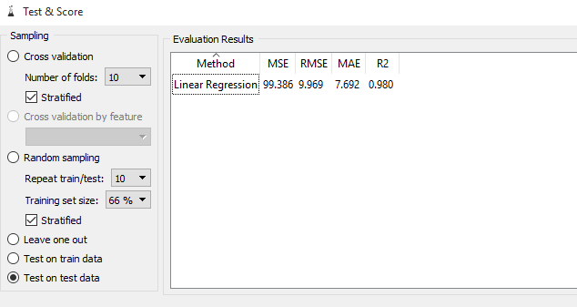

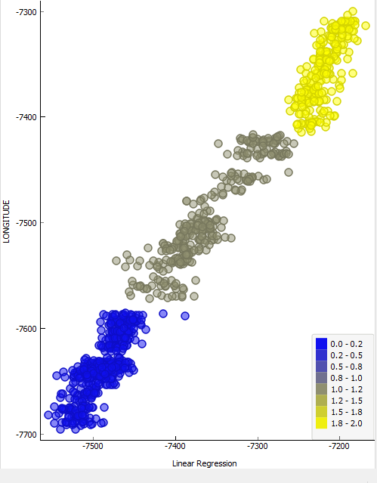

FOR LATTITUDE:

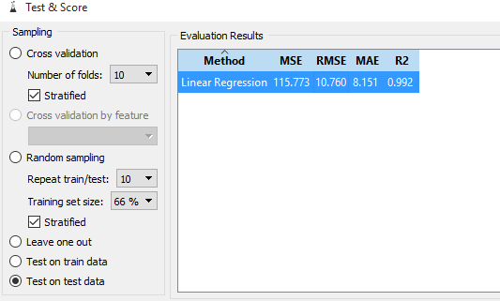

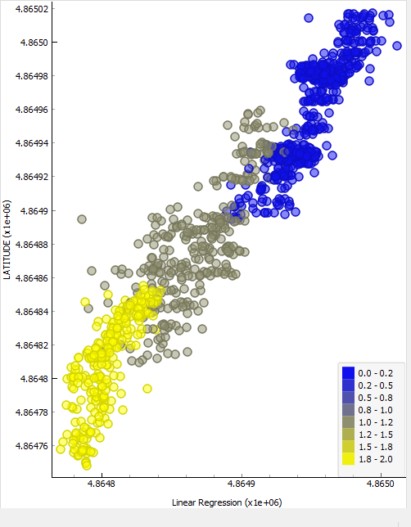

PROJECT 3
CLASSIFICATION OF PHISHING WEBSITES

Introduction
Now a days most of the work is done online or digitally. So, the risk to user data is one of a major concern. And the most easiest way to steal user data is use the method of Phishing, where a hacker creates a similar but fake webpage to a genuine webpage. In order to judge the fakeness of a webpage/website, we classify the website as phishing website or not based some features which were originally gathered by Rami M. Mohammad, Fadi Thabtah and Lee McCluskey.

ABOUT DATASET :

Number of Instances : 11055
Area : Computer Security/ Online frauds
Attribute Charateristics : Integer
Number of Attributes: 31

FEATURES OF THE DATA SET USED:

- IP Address
- URL Length
- Shortening Service
- having_At_Symbol
- double_slash_redirecting
- Prefix_Suffix
- having_Sub_Domain
- SSLfinal_State
- Domain_registeration_length
- Favicon
- port
- HTTPS_token
- Request_URL
- URL_of_Anchor
- Links_in_tags
- SFH
- Submitting_to_email
- Abnormal_URL
- Redirect
- on_mouseover
- RightClick
- popUpWidnow
- Iframe
- age_of_domain
- DNSRecord
- web_traffic
- Page_Rank
- Google_Index
- Links_pointing_to_page
- Statistical_report
- Result (fake or geuine)

PROBLEM TYPE : CLASSIFICATION
TO PREDICT : PHISHING OR NOT PHISIHNG WEBSITE

TOOL USED : WEKA

RESULTS OBTAINED ON DATASET

1. First Result on all the attribute/feature, i.e. without applying any feature selection algorithm:

Classifier Used : J48 -C 0.25 -M 2

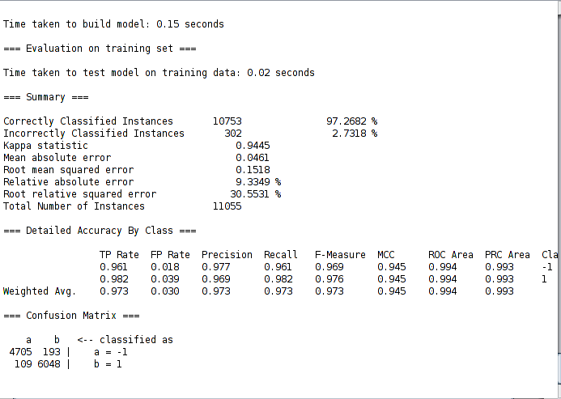

2. Results obtained by applying feature selection:

Attribute Evaluator : GainRatioAttributeEval
Search Method : Best First -D 1 -N 5
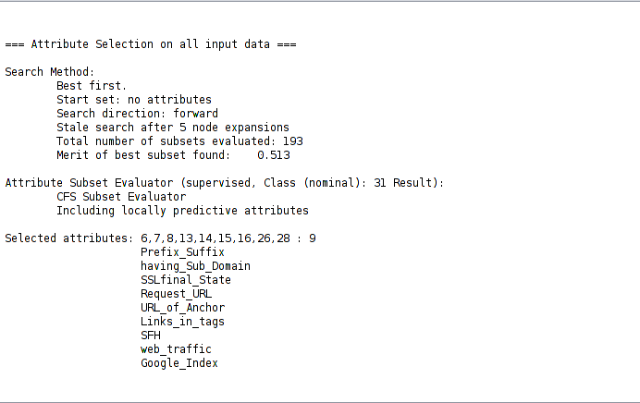

Results based on Feature selected above :

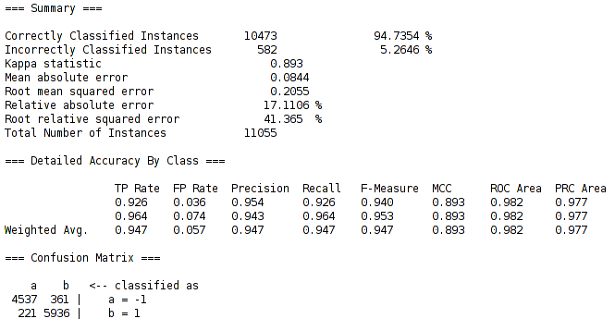

Classification after features selection using 60-40 split percentage of training and datasets:

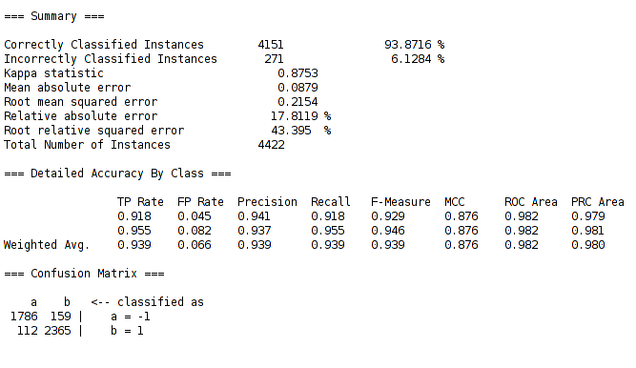

Using 60 percent of dataset as training data, the results are quite good(As the accuracy is above 93 percentage).

CONCLUSION:

After obtaining results from feature selection, we noticed that accuracy percent did not deviate much from original collection of attributes ( deviation was approximately 2% to 2.5 %).

So most of the features were not contributing much to the results. The feature that contributed most to the results are as followed:

- Prefix_Suffix
- having_Sub_Domain
- SSLfinal_State
- Request_URL
- URL_of_Anchor
- Links_in_tags
- SFH
- web_traffic
- Google_Index
To classify a website as fake or genuine, the best features which gives us the result around 94.7%
are mentioned above.

References:
1:https://archive.ics.uci.edu/ml/datasets.html?format=&task=cla&att=&area=&numAtt=&numIns=&type=&sort=nameUp&view=table

2:https://archive.ics.uci.edu/ml/datasets.html?format=&task=reg&att=&area=&numAtt=&numIns=&type=&sort=nameUp&view=table

3:https://www.kaggle.com/uciml/human-activity-recognition-with-smartphones

