**Steps followed**

**Step1:**

1. Start Influxd.exe and influx.exe in your machine

**Step2:**

1. Open a new command Prompt with admin privileges
2. Change your directory to where your influx files are located

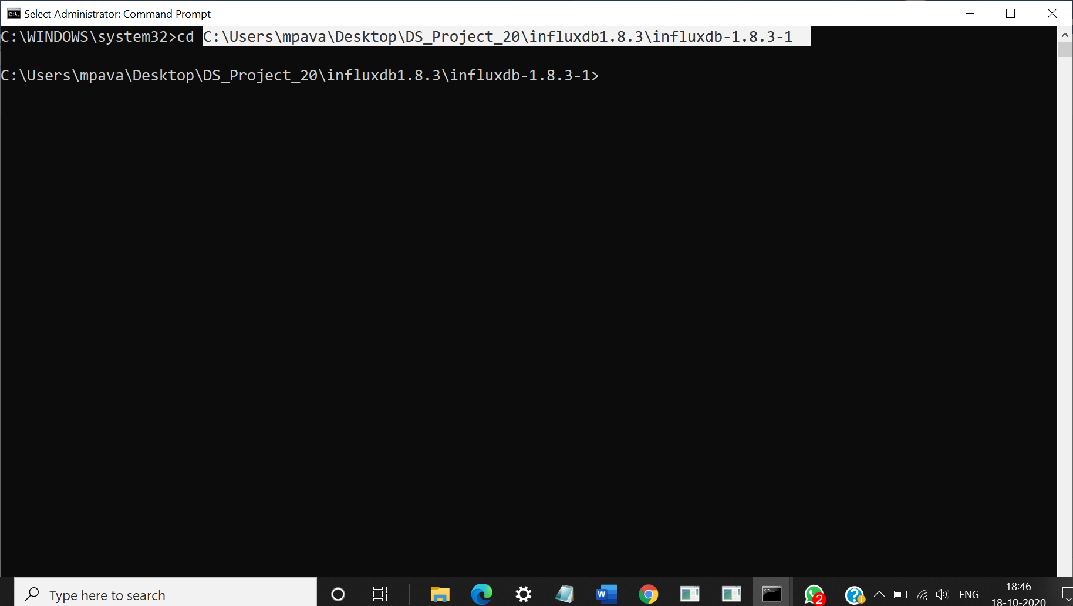

**Step 3:**

1. Type the below command

***influxd restore -portable <path-where-your-manifest-file-is-located>***

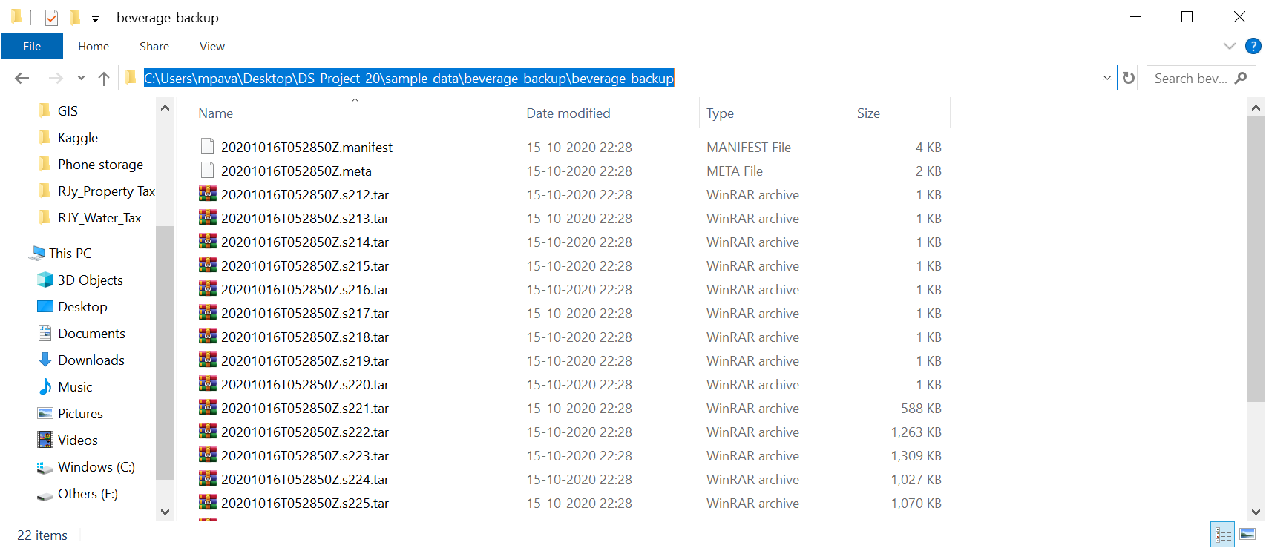

In my case it is;

***influxd restore -portable C:\Users\mpava\Desktop\DS_Project_20\sample_data\beverage_backup\beverage_backup***

It seems to import the .tar.gz files automatically (please see below screenshot)

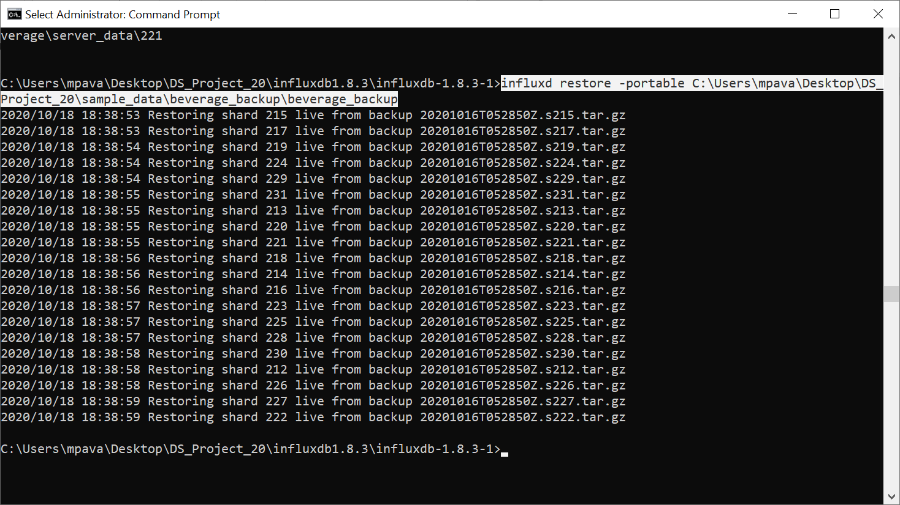

**Step 4:**

1. Now from Influx CLI…. type “SHOW DATABASES”.

It should show some new databases (please see below screenshot)

