SPORTSFB

Sports Facility Booking Platform
Mini Project Report
Web services development and software tool integration
Student name: ______________________________
Student ID: _________________________________
Module / course: _____________________________
Submission: Week 14 | Project start: Week 8
Assessment value: 15 marks

Report guide
This report examines SportsFB, a web service for discovering sports facilities and coordinating bookings between players and facility owners. It explains the case, the development approach, the application architecture, and how a practical CI/CD workflow can be applied. The project begins in Week 8; the report is submitted through the VLE in Week 14. The report is organized to address the assessment rubric.
Assessment area | Marks | Where addressed
Introduction: theme and issues | 2 | Sections 1–2
Case formation: background, case development, methods/process | 3 | Sections 3–5
Content: findings and discussion | 5 | Sections 6–9
Conclusion | 3 | Section 10
References | 2 | Section 11

Project timeline
Period | Activity | Output
Week 8 | Select the case, define users and booking problem, agree project scope. | Problem statement and initial requirements
Weeks 9–10 | Review the workflow and design the service, data model and interfaces. | Architecture and implementation plan
Weeks 11–12 | Build and integrate the web application, database and supporting services. | Working project features
Week 13 | Review outcomes, document limitations, refine report and references. | Final report draft
Week 14 | Submit the mini-project report through the VLE. | Submitted report

The schedule is a suggested work plan aligned to the stated course timeline; it does not claim that every activity has already been completed.

1 Introduction
Sports facilities are often arranged through fragmented channels such as phone calls, messaging, or in-person enquiries. This can make it difficult for players to discover available venues, compare basic details, and confirm a time. Facility owners may also need to manage enquiries, approve bookings, verify payment evidence, and keep availability current.
SportsFB is a web-based booking service designed to connect players, facility owners, and administrators. Players can explore facilities and request a time slot. Owners manage listings and booking requests. An administrator oversees account and listing controls. The case is relevant to web services because it combines a browser interface, server-side APIs, authentication, persistent data, geospatial discovery, and asynchronous booking-expiry processing.

2 Problem statement and objectives
The central problem is the lack of a single, structured process for discovering sports facilities and managing the booking lifecycle. Uncoordinated requests can lead to repeated enquiries, unclear booking status, conflicting reservations, and weak auditability. SportsFB addresses this by centralizing facility information and implementing explicit booking states with role-based actions.
- Provide a searchable catalogue of sports facilities with location and pricing information.
- Support distinct player, owner, and administrator roles.
- Coordinate a booking from request through owner approval, payment-evidence submission, and final verification.
- Protect booking integrity through server-side authorization, time limits, and database constraints.
- Integrate external tools and services where they support identity, mapping, data persistence, and scheduled work.

3 Case formation and scope

3.1 Background and stakeholders
The case models a local sports venue marketplace. A player wants to find and reserve a suitable venue; an owner wants to publish facility details and handle requests; an administrator needs oversight of listings, users, and exceptional cases. The application contains player-facing discovery and booking pages, owner facility and request pages, and administrator management pages.

3.2 Scope
In scope | Outside the demonstrated scope
Facility discovery and details, including map-oriented location data. | Automated live inventory or third-party venue-system synchronization.
Owner facility management and booking request handling. | Integrated card payment gateway; the workflow uses payment proof upload and review.
Booking reservation, approval, payment-evidence review, confirmation or rejection, and expiry. | Native iOS or Android applications.
Google sign-in, role-aware access, administrative controls, audit records, and account settings. | Claims of production-scale performance, independent security certification, or measured user adoption.

4 Methodology
An iterative, case-based development method is appropriate: first understand the service problem and users, then model the workflow, implement the core service, and review the resulting behavior against the requirements. The repository supplies implementation evidence for the case; this report does not claim interviews, surveys, or formal user testing that are not documented.
- Requirements analysis: identify the player, owner, and administrator tasks and the booking states each role can trigger.
- Workflow and data design: represent users, facilities, bookings, receipts, access events, and audit events in PostgreSQL-backed tables.
- Incremental implementation: build pages and API routes in the Next.js application, then connect them to authentication, database, maps, and scheduled jobs.
- Integrity and access review: enforce important conditions in server-side logic and database constraints, including reservation conflicts and payment deadlines.
- Evaluation by traceability: compare implemented routes, schemas, and state transitions with the stated objectives; record gaps as limitations or future work.

5 Technology stack and tools
Layer / tool | Role in SportsFB
TypeScript, React 19 | Typed application code and reusable interactive user-interface components.
Next.js 15 | Web application framework for routing, server-rendered pages, and API route handlers.
NextAuth (Google provider) | Google OAuth sign-in and session handling; application roles are loaded from persisted user records.
Neon PostgreSQL | Serverless PostgreSQL data store for users, facilities, bookings, payment receipts, blocks, subscriptions, and audit events.
Drizzle ORM / Drizzle Kit | Type-aware database access and schema management.
Leaflet | Map visualization for facility locations.
Upstash QStash | Delayed jobs that trigger booking expiration processing.
Upstash Redis / Ratelimit | Rate-limiting support in the application.
Zod | Input validation for service requests.
Sharp | Image processing used to sanitize and resize uploaded payment evidence.
Node.js 20.9+ / npm | Runtime and package management, as declared by the project.

The stack above is read from the project package manifest and source code (Meta, n.d.; Next.js, n.d.; Drizzle Team, n.d.; Neon, n.d.; Auth.js, n.d.; Upstash, n.d.; Leaflet, n.d.). Hosting provider, automated test framework, and continuous-integration configuration were not identified in the repository inspected for this report.

6 Architecture and service design
SportsFB is organized as a web application with a presentation layer, server-side application/API layer, data layer, and supporting external services. Browser requests reach Next.js pages and route handlers. Server-side logic checks user identity and role, validates input, and invokes booking services and database operations. Neon PostgreSQL stores persistent records. QStash and a scheduled sweep endpoint support delayed expiry processing (Upstash, n.d.); Google OAuth and map tiles provide external identity and map capabilities (Auth.js, n.d.; Leaflet, n.d.).
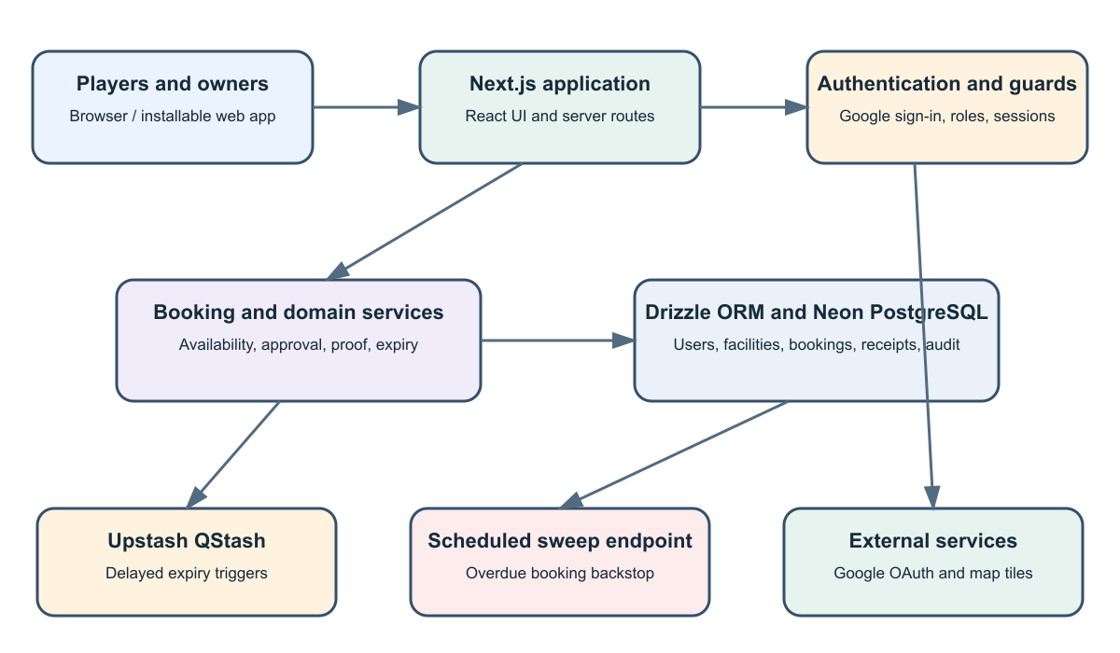
Figure 1. Logical architecture inferred from the project dependencies and source structure.
Security and consistency controls include role-aware route guards, server-side authorization, request validation, rate limiting, a session version that can invalidate prior sessions, and database-level integrity constraints. Payment evidence is stored as a sanitized image and retrieved through authorized routes. Bank details are exposed only to the relevant player during an eligible pending-payment state.

7 Booking workflow
The booking state model makes responsibilities and decision points explicit. A request is not confirmed when first created: the owner approves it, the player submits proof within the payment window, and the owner verifies that evidence. Expiry jobs act as triggers; database deadlines remain authoritative.
Step | Actor / system | Action and resulting state
1 | Player | Selects a facility and time; requests a reservation. State: PENDING_APPROVAL.
2 | Owner | Approves the request. State: PENDING_PAYMENT; a payment deadline is set.
3 | Player | Views eligible payment details and submits payment evidence before the deadline. State: PENDING_VERIFICATION.
4 | Owner | Reviews evidence and approves or rejects it. State: CONFIRMED or REJECTED.
5 | System | Expires overdue unapproved or unpaid bookings; background triggers and a sweep provide cleanup paths.
6 | System / owner | Records exceptional fraud decisions in the audit log and applies account controls.

8 Findings and discussion

Structured lifecycle
The booking code implements explicit states and restricts transitions, reducing ambiguity about who acts next. Database operations support reservation conflict handling and expiry by deadlines.

Role-aware service
Player, owner, and admin pages and API routes map the main business roles to distinct responsibilities. Authorization is applied in server-side logic rather than relying only on hidden interface controls.

Integration of tools
The project combines a web framework, OAuth provider, relational database, ORM, mapping library, image processing, rate limiting, and delayed job service. This demonstrates how a web service depends on integrated tools rather than a front end alone.

Operational safeguards
Audit logs, login events, account lock or suspension fields, and time-limited payment actions support traceability and abuse controls. The code also treats QStash as a trigger while the database deadline remains authoritative.

Limitations
The reviewed repository does not include an automated CI workflow or test scripts in its package manifest. The payment process relies on uploaded evidence and manual verification rather than a payment gateway. Usability, performance, and deployment outcomes require separate testing and measurement.

9 Proposed CI/CD pipeline
No CI/CD workflow file or deployment configuration was found in the main project during report preparation. The pipeline below is therefore a recommended design for the project, not a claim about an existing automated deployment. It demonstrates practical integration of software tools across version control, validation, build, and release.
Stage | Suggested automated work | Gate / outcome
Code change | Developer pushes a branch and opens a pull request. | Changes are reviewed before merge.
Install | Use the lockfile and declared Node.js engine to install dependencies reproducibly. | Fail if dependency installation fails.
Quality checks | Run linting and TypeScript checks; add unit and API tests for booking transitions and authorization. | Block merge on failures.
Build | Run the Next.js production build with safe placeholder configuration where supported. | Block release if build fails.
Database review | Validate schema changes and apply migrations to a staging database first. Keep secrets in the CI secret store. | Require migration review and successful staging check.
Deploy preview | Publish a preview environment for review with isolated credentials and data. | Confirm key player and owner journeys.
Production release | Deploy the reviewed commit to the selected hosting platform; run a smoke check and monitor errors. | Promote only after successful build and staging review; support rollback.

Recommended pipeline flow: Commit → Pull request → Install dependencies → Static checks and tests → Production build → Staging deployment and smoke checks → Approval → Production deployment → Monitor / rollback.

10 Conclusion
SportsFB is a suitable case study of a web service because it combines role-based user journeys, persistent data, server-side APIs, external identity and mapping services, and asynchronous processing. Its booking lifecycle illustrates how service rules must be represented in both application logic and database operations to protect availability and manage payment review.
The project scope is clearest when limited to facility discovery and the request-to-confirmation workflow. The inspected implementation includes meaningful safeguards and integrations, while automated testing and CI/CD remain areas to formalize. A pipeline that validates changes, builds the application, checks staging behavior, and then deploys with monitoring would strengthen repeatability and operational confidence.
This mini-project starts in Week 8 and is due through the VLE in Week 14. The report addresses the assessment rubric through an introduction to the case, case formation and methodology, technical findings and discussion, a conclusion, and references.

11 References
- SportsFB project repository. (2026). Source code, package manifest, database schema, booking service, API routes and SQL integrity scripts. Local project files.
- Drizzle Team. (n.d.). Drizzle ORM documentation. https://orm.drizzle.team/
- Meta. (n.d.). React documentation. https://react.dev/
- Neon. (n.d.). Neon documentation. https://neon.tech/docs
- Next.js. (n.d.). Next.js documentation. https://nextjs.org/docs
- Auth.js. (n.d.). Auth.js documentation. https://authjs.dev/
- Upstash. (n.d.). QStash documentation. https://upstash.com/docs/qstash/
- Leaflet. (n.d.). Leaflet documentation. https://leafletjs.com/reference.html
References follow a consistent author-date format. Add access dates if required by the module’s referencing guide.

Assessment checklist
Rubric criterion | Marks | Report coverage
Introduction: theme and issues | 2 | Sections 1–2
Case formation: background, case development, methods/process | 3 | Sections 3–4
Content: findings and discussion | 5 | Sections 5–9
Conclusion | 3 | Section 10
References: appropriate citation style | 2 | Section 11
Total | 15

