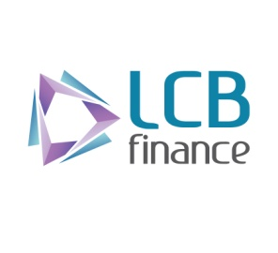

**INTERNAL OFFICE MEMORANDUM**

**From- CEO/ EXECUTIVE DIRECTOR**

**To- Branch Managers, Assistant Managers & Gold Loan Officers**

**Subject- GRANTING GOLD LOANS**

**Copy DGMs. AGM, Manager Audit, Manager Human Resources**

**Date 19th August 2022.**

1. Branch Managers have been provided with the Board Approved Version II of the Gold **Loans Policies and Procedures Manual** under cover of the CEO/ Executive Director’s Internal Memorandum dated 9th August 2022.This Manual contains in detail the procedure to adopted in assaying articles and related activities. If any staff member needs training on this subject Branch Managers are required to contact the Manger Human Resources immediately, with a view to providing appropriate training to them.
2. Since we have decided to enhance our Gold Loan Portfolio, we will be increasing the Limits of authority delegated to Branch Managers for approval of Gold Loans based on their performance in marketing this product, the quality of Loans granted at the Branches and Internal Audit Findings.
3. The grant of gold loans should be in strict compliance with the requirements in the aforesaid manual and the loan to value ratios conveyed to branch managers by credit circulars in relation to market value of Gold, from time to time.
4. Branch Managers, Assistant Managers. Gold Loan Officers and other staff members involved in granting Gold Loans at branches will be held jointly and severally responsible to ensure compliance with the requirements stated herein.
5. **Assaying, Approving and disbursing of Gold Loans in violation of the above requirements will be considered as an act of misconducted warranting disciplinary action against all those involved in such transaction (s) irrespective of their position or grade.**
6. Branch Mangers should bring the contents of this memorandum to the notice of all staff members and ensure compliance.6

**CEO/ Executive Director**