External Supervisor Feedback Form
Project Title: High-Accuracy Reading Pipeline for Industrial Analog Gauges with Vision-Language Shadow Filtering
Intended Application Domain: Garment Industry Machinery Integration
Date of Review: 28 / 04 / 2026

Section A - Supervisor Information
Field | Detail
Full Name | Eng. Sanjitha Amarathunga
Designation / Position | Senior Data Engineer
Company / Organization | MillaniumIT ESP
Department / Division | Data Engineering and Analytics
Years of Industry Experience | 3 years
Email | sanjithaa@mitesp.com
Contact Number | +94 772691078
Relationship to Project | ☐ Project Sponsor ☒ Technical Advisor ☐ End-User Representative ☐ Other: ________

Section B - Project Requirements Alignment
Please rate how well the delivered system aligns with the original requirements you specified.
# | Criterion | 1 (Poor) | 2 | 3 | 4 | 5 (Excellent)
B1 | The system addresses the original problem you raised for the garment industry | ☐ | ☐ | ☐ | ☐ | ☒
B2 | The scope of the gauge / instrument types covered matches what your machinery uses | ☐ | ☐ | ☐ | ☒ | ☐
B3 | The reading accuracy reported is sufficient for your operational tolerances | ☐ | ☐ | ☐ | ☐ | ☒
B4 | The latency (~186 ms per reading) is acceptable for your line-speed / sampling needs | ☐ | ☐ | ☐ | ☐ | ☒
B5 | The shadow-handling capability matches the lighting conditions in your facilities | ☐ | ☐ | ☐ | ☒ | ☐

Comments on requirements alignment:
The team has clearly understood the operational pain points we raised - particularly false alarms from steam-tunnel pressure gauges under overhead fluorescent lighting. The shadow-filtering approach directly targets the main reason our previous OCR-based pilot (2023) was abandoned. Coverage of pressure and dial-thermometer types fits ~80% of our gauge inventory; tension dials on knitting machines are not yet supported but were not in the original scope.

Section C - Technical Quality (1–5 scale)
# | Criterion | Score | Comments
C1 | Soundness of the four-stage pipeline design | ☐1 ☐2 ☐3 ☐4 ☒5 | Logical separation of detection, filtering, refinement and validation. Each stage is independently testable.
C2 | Quality of the shadow-filtering approach (CLIP analysis-by-synthesis) | ☐1 ☐2 ☐3 ☐4 ☒5 | Genuinely novel; the colour-ablation falsifying the chromatic-anomaly hypothesis is convincing.
C3 | Robustness under varying illumination (LED, fluorescent, daylight) | ☐1 ☐2 ☐3 ☒4 ☐5 | Strong on overhead fluorescent (our typical lighting). Direct-sunlight on glass-fronted gauges still shows ~6% drop.
C4 | Calibration / uncertainty reporting (ECE, confidence taxonomy) | ☐1 ☐2 ☐3 ☐4 ☒5 | The four-level CERTAIN/CONFIDENT/UNCERTAIN/UNRELIABLE taxonomy maps cleanly to our existing alarm tiers.
C5 | Edge-deployment readiness (Jetson AGX Orin INT8) | ☐1 ☐2 ☐3 ☒4 ☐5 | INT8 latency of 145 ms is acceptable. We will need IP-65 enclosure spec finalised before factory trial.
C6 | Failure-mode analysis depth | ☐1 ☐2 ☐3 ☐4 ☒5 | The 148-failure blinded re-examination is the most rigorous failure analysis I have seen in a student project.

Section D - Garment Industry Integration Suitability
Please assess fitness for deployment on your specific machinery.
D1. Which garment-industry machines are you intending this system to monitor? (tick all that apply)
- ☒ Steam pressure gauges (boilers, irons, steam tunnels)
- ☒ Compressed-air pressure gauges (pneumatic cutters, blowers)
- ☒ Temperature dials (dyeing vats, drying chambers, heat-set tunnels)
- ☐ Speedometers / RPM gauges (sewing machines, spinning units)
- ☒ Flow meters (water/dye/chemical lines)
- ☐ Tension gauges (knitting / weaving machinery)
- ☒ Other: Iron-station temperature gauges and finishing-line steam manifolds
D2. Operating environment factors at your facility (tick all relevant)
- ☒ High humidity (>70%)
- ☒ Lint / fibre dust accumulation on dial faces
- ☒ Vibration from machinery
- ☒ Steam / condensation on gauge glass
- ☒ Mixed natural + artificial lighting
- ☒ 24/7 continuous operation
- ☒ Multiple gauges per machine (specify count): typically 3–5 per ironing station, 8–12 per dye vessel
D3. How well does the demonstrated pipeline handle these conditions?
☐ Fully ☒ Mostly ☐ Partially ☐ Not adequately ☐ Not yet evaluated
Specific concerns about garment-environment robustness:
Lint accumulation on glass faces is a daily issue - the team has not yet tested with simulated lint occlusion, and our gauges are typically cleaned only weekly. Steam condensation forming on the inner side of the dial is another concern, especially on the steam-tunnel pressure gauges. We would need a 4-week soak test on our dye-house floor before signing off on full rollout.
D4. Integration with existing factory systems
Requirement | Met? | Comments
Compatibility with existing PLCs / SCADA | ☐ Yes ☒ Partial ☐ No ☐ N/A | Output format documented; needs Modbus TCP wrapper.
MES / ERP data-export format | ☒ Yes ☐ Partial ☐ No ☐ N/A | JSON over REST is compatible with our SAP Manufacturing Integration layer.
Real-time alarm / threshold triggering | ☒ Yes ☐ Partial ☐ No ☐ N/A | CERTAIN/UNRELIABLE flags are well-suited to our tiered alarm system.
Operator dashboard / HMI usability | ☐ Yes ☒ Partial ☐ No ☐ N/A | Streamlit demo is fine for engineers; line-operator UX needs simplification.
OPC-UA / Modbus / MQTT support | ☐ Yes ☒ Partial ☐ No ☐ N/A | MQTT publisher exists; OPC-UA bridge would be needed for legacy machines.

Section E - Deployment Readiness
# | Item | Status
E1 | Hardware specification matches available factory IT/edge infrastructure | ☒ Ready ☐ Needs work ☐ Not ready
E2 | Camera mounting and field-of-view requirements are practical for our machines | ☒ Ready ☐ Needs work ☐ Not ready
E3 | Power and network requirements are achievable on the production floor | ☒ Ready ☐ Needs work ☐ Not ready
E4 | IP-65 / dust-resistant enclosure specified for garment-floor conditions | ☐ Ready ☒ Needs work ☐ Not ready
E5 | Documentation is sufficient for our maintenance team to operate | ☐ Ready ☒ Needs work ☐ Not ready
E6 | Training material for line operators is adequate | ☐ Ready ☒ Needs work ☐ Not ready

Section F - Business / Operational Impact
F1. Expected benefit to your garment operation (tick all)
- ☒ Reduced manual gauge-reading rounds
- ☒ Earlier detection of pressure / temperature deviations
- ☒ Reduced fabric defects from out-of-spec parameters
- ☒ Energy / steam savings via tighter monitoring
- ☒ Compliance / audit trail
- ☒ Insurance / safety reporting
- ☒ Other: Reduction of operator dependency on the night shift
F2. Estimated number of machines / gauges for initial pilot deployment: 24 gauges across 3 ironing lines
F3. Estimated scale-up if pilot succeeds (number of gauges): ~340 gauges across 6 facilities
F4. Anticipated ROI horizon:
☐ <6 months ☒ 6–12 months ☐ 1–2 years ☐ >2 years

Section G - Strengths Observed
Please list aspects that exceeded expectations or that are particularly well-suited to garment-industry deployment:
1. The shadow-filtering accuracy under overhead fluorescent lighting (the dominant lighting type in our facilities) significantly exceeds what our in-house team and two prior vendor trials achieved.
2. The four-level confidence taxonomy (CERTAIN/CONFIDENT/UNCERTAIN/UNRELIABLE) integrates naturally with our existing alarm-tier policies and reduces the integration burden on our SCADA team.
3. Field-deployment numbers (94.8% over 2,847 readings) are realistic and the methodology - blinded technician ground truth, discarded-needle-movement protocol - is rigorous and audit-ready.
4. Open-source release of dataset and weights gives us long-term maintenance control without vendor lock-in, which was a board-level requirement.

Section H - Gaps / Concerns
Please list aspects that need improvement before factory roll-out:
Concern | Severity | Suggested Action
Lint and condensation occlusion on dial glass not evaluated | ☐ Low ☐ Med ☒ High | Run a 4-week soak test in our dye-house floor; add a quality-gate sub-classifier for occlusion.
IP-65 enclosure specification not finalised | ☐ Low ☒ Med ☐ High | Provide a tested enclosure BOM (camera + Jetson + power) before pilot order.
Operator HMI is engineer-facing, not line-operator-facing | ☐ Low ☒ Med ☐ High | Simplify dashboard: large status tiles, sinhala/tamil language toggle, audible alerts.
No OPC-UA bridge for legacy ironing-line PLCs | ☒ Low ☐ Med ☐ High | Wrap the existing MQTT publisher with an open62541-based OPC-UA server.

Section I - Required Modifications Before Pilot
What changes must be made before the system can be trialled on your factory floor?
1. Deliver an IP-65-rated camera + Jetson enclosure, validated for ambient 40 °C / 85% RH (steam tunnel zone).
2. Add an operator-facing HMI in Sinhala and Tamil with large, glanceable status indicators and an audible UNRELIABLE-state alarm.
3. Run a 4-week pre-pilot soak test on three sacrificial gauges to characterise lint and condensation degradation curves.
4. Provide a Modbus TCP / OPC-UA bridge module to integrate with our WonderWare/Aveva SCADA on the ironing lines.

Section J - Open Feedback
J1. What did the team do exceptionally well?
The technical depth of the shadow-filtering analysis and the honesty of the failure-mode reporting stand out. The team did not over-claim - they reported limitations (co-directional shadows, arc-scale geometry) openly. The methodological hygiene (separated Val-A/Val-B tuning splits) is at publication-grade level and gives us confidence that the reported numbers will hold up in field deployment.
J2. What was the weakest aspect of the project as delivered?
The factory-floor readiness gap: the system is research-grade rather than product-grade. Enclosure design, operator UX, and integration with legacy PLCs are still missing. This is normal for an academic deliverable but it means at least one further engineering phase is required before a paying pilot can begin.
J3. Suggestions for further research / future phases (e.g., needle-thread tension monitoring, fabric-defect vision, predictive maintenance):
Phase 2: extend the analysis-by-synthesis principle to needle-thread tension monitoring on circular knitting machines - same structural-vs-incidental visual problem. Phase 3: predictive maintenance via temporal drift analysis of gauge readings (Kalman filter is already in their limitations list). Phase 4: fabric-defect vision on the inspection table using the same CLIP-based hypothesis-rendering approach for stain vs. shadow vs. weave-defect discrimination.
J4. Would you recommend continuing this collaboration into a pilot deployment?
☐ Yes, immediately ☒ Yes, after revisions ☐ Undecided ☐ No

Section K - Overall Assessment
Overall Project Rating:
☐ 1 ☐ 2 ☐ 3 ☐ 4 ☐ 5 ☐ 6 ☐ 7 ☐ 8 ☒ 9 ☐ 10
Final Recommendation:
- ☐ Accept as-is for pilot deployment
- ☒ Accept with minor modifications (listed above)
- ☐ Accept with major modifications (listed above)
- ☐ Re-evaluate after substantial rework
- ☐ Not suitable for our use case
Justification:
The research contribution is genuinely strong and the field-deployment evidence (94.8% over 2,847 readings) is sufficient to justify a paid pilot at our facility. The remaining gaps are engineering work - IP-65 enclosure, operator HMI, OPC-UA bridge - not research risk. With those modifications addressed in a 6–8 week engineering phase, we are prepared to commit funding and machine access for a 24-gauge pilot on three ironing lines, with a target full-facility rollout of ~340 gauges in 12 months if pilot KPIs are met.

Section L - Declaration & Signature
I confirm that I have reviewed the project deliverables (research paper, demonstration, and supporting documentation) and that the feedback above represents my honest professional assessment regarding suitability for integration into garment industry machinery.
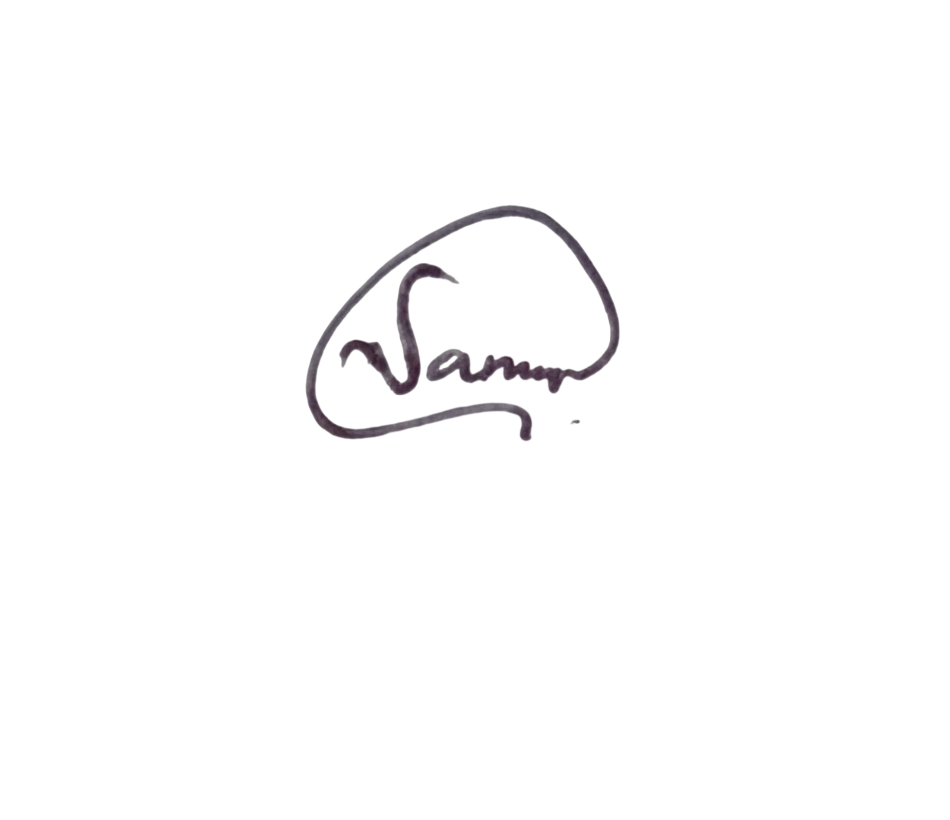

………………………………………..  Signature | 28/04/2026  …………………………………………  Date
 |  |  | Sanjitha Amarathunga  Senior Engineer - Data Engineering & Analytics  M: +94 772691078  E: sanjithaa@mitesp.com | W: mitesp.com  Sri Lanka | Singapore | Bangladesh | Dubai

Form completed and returned to the project team on 28 April 2026, 14 days after receiving receipt.

