**SOFTWARE TESTING ASSIGNMENT**

**Module-1(Fundamental)**

**1.What is SDLC?**

SDLC is a Systematic Process for building software that ensures the quality and correctness of the software built.

**2.What is software testing?**

Software testing is a process used to identify the correctness, completeness and quality of developed computer software.

**3.What is agile methodology?**

It is a combination iterative and incremental model.

It divides the software into small incremental builds, this build are provided in iteration, that means the project are divided into small chunks. (iteration)

**4.What is SRS?**

Software requirement specification.

SRS is a complete description of an application which is to be developed.

SRS contains use case diagram that describes all the interaction use will have with the software application.

**5.What is oops?**

Object oriented programming is way of written the programs in organized way.

**6. Write basic concepts of oops.**

* Object
* Class
* Inheritance
* Polymorphism

-Over ridding

-Over loading

* Encapsulation
* Abstraction

**7.What is Object?**

Object gives the permission to access functionality of class.

**8. What is Class?**

Class is a collection of data members and members function.

**9. What is encapsulation?**

The process wrapping the data in single unit to secure the data from outside world.

**10. What is inheritance?**

Making a class from an existing class deriving the attribute of some other class.

**11. What is polymorphism?**

One name Multiple form.

Type: **Over ridding**

Same name of function with same parameter but definition will be different.

**Over loading**

Same function name but different parameter.

**12. Draw use case on online book shopping.**

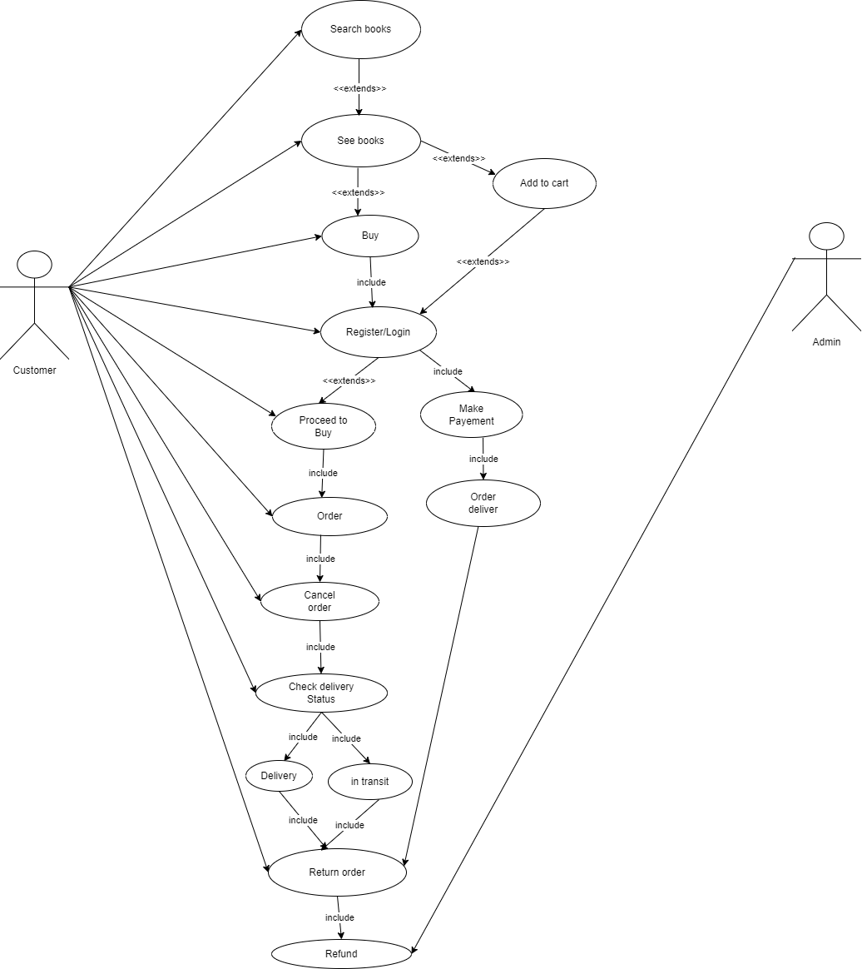

**13. Draw use case on online bill payment system(paytm)**

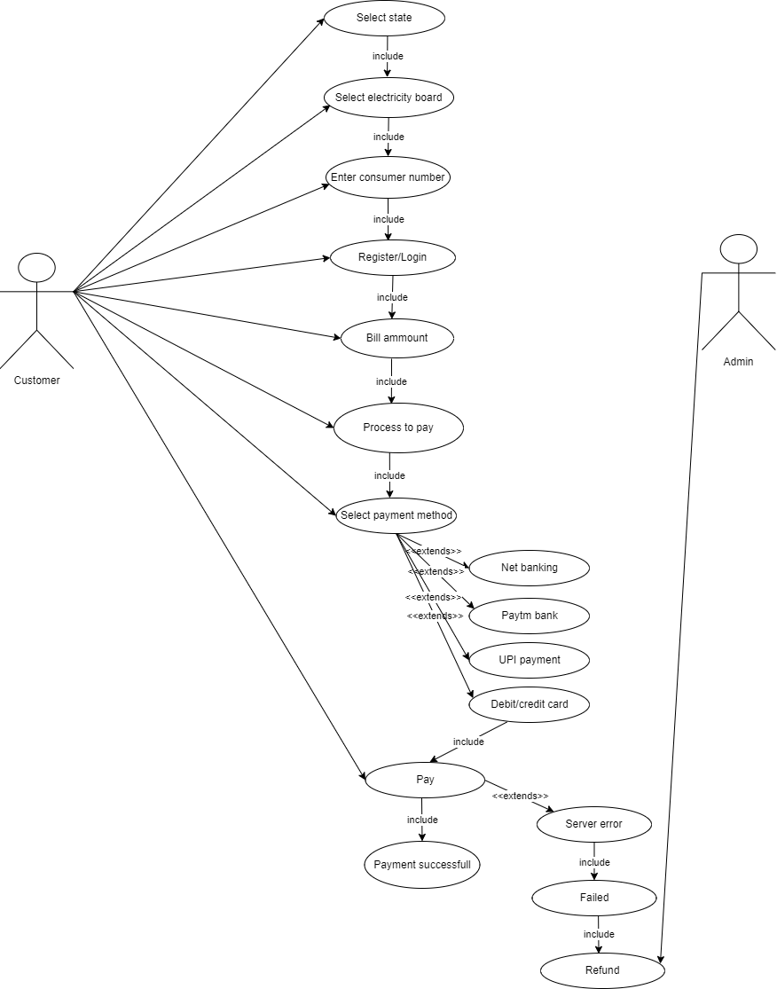

**14. Write SDLC phases with basic introduction.**

1. Requirements collection/gathering

Requirements Definitions usually consist of natural language supplemented by (eg. UML) diagrams and tables.

Types of requirements

1. functional requirements Describe system services or function

2. non-functional requirement are constraint on the system or development process.

1. Analysis

Details on computer programming languages and environments, machines, packages, application architecture, distributed architectures layering, memory size, platform, algorithms, data structures, global type definition, interfaces and many other engineering details are established.

1. Design

Implementation plan

Critical priority analysis

Performance analysis

Test plan

1. Implementation

In the Implementation phase the team builds the component either from scratch or by composition.

Implementation-code

Critical error removal

1. Testing

Testing phase is a separate phase which is performed by different team after the implementation is completed.

1. Maintenance

Maintenance is the process of changing a system after it been deployed.

There are three type of maintenance.

1. Corrective maintenance

Identifying and repairing defects.

2. Adaptive maintenance

Adapting the existing solution to the new platforms.

3. Perfective Maintenance

Implementing the new requirement in spiral lifecycle everything after the delivering and deployment the first prototype can be considered “maintenance”

**15. Explain Phases of the waterfall model.**

The waterfall is unrealistic for many reason, especially requirement must be “frozen” to early in the lifecycle

-        Requirement

-        Analysis

-        Design

-        Implementation

-        Testing

-        Maintenance

**16. Write phases of spiral model.**

 - Planning : Determination of objective, alternatives and constraints initial

requirements completion

-  Risk Analysis: Analysis of alternatives and identification/resolution of risk

-  Customer Evaluation: Assessment for result engineering

-  Engineering : Development of the “next level” product

**17. Write agile manifesto principles.**

* **Individuals and interactions** - in agile development, self-organization and motivation are important, as are interactions like co-location and pair programming.
* **Working software** - Demo working software is considered the best means of communication with the customer to understand their requirement, instead of just depending on documentation.
* **Customer collaboration** - As the requirements cannot be gathered completely in the
* Beginning of the project due to various factors, continuous customer interaction is very important to get proper product requirements..
* **Responding to change** - agile development is focused on quick responses to change and continuous development.

**18. Explain working methodology of agile model and also write pros and cons.**

It is a combination iterative and incremental model.

It divides the software into small incremental builds, this build are provided

in iteration, that means the project are divided into small chunks. (iteration)

Each iteration last about one to three weeks.

Each iteration involves all team member working simultaneously on areas

like planning, requirement, analysis, design, codding, unit testing and

acceptance testing.

At the end of the iteration the working product is displayed to the customer

or the important stake holder and it is released in the market.

After the release we check for the feedback of the deployed software.

If any enhancement is needed in the project then its done and its re-released.

**Advantage of Agile method**

* Frequent delivery
* Face to face communication with the customer.
* less time
* Adaptability

**Disadvantages**

* Less documentation
* Maintenance problem.

**19. Draw usecase on Online shopping product using COD.**

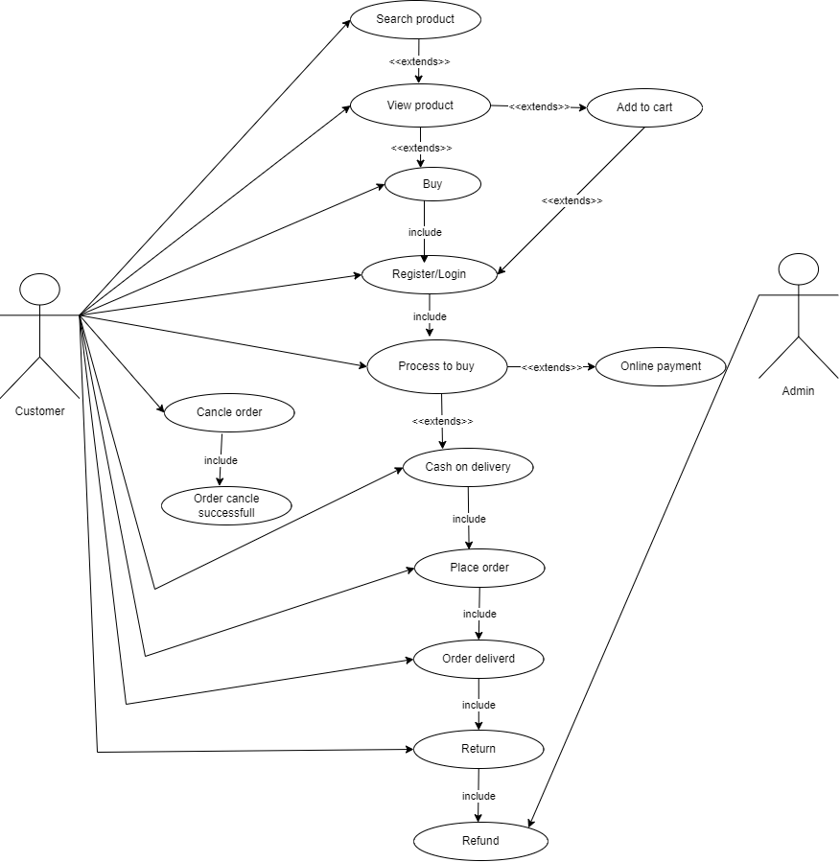

**20. Draw usecase on online shopping product using payment gateway.**

