Name- Jay S Maniyar

GR No- 1710982

Class- TY D

Roll No -7

**HA 6 Family Tree using *Prolog* Programming**

Code-

Simulation using SWI Prolog Programmer

Family Tree:-

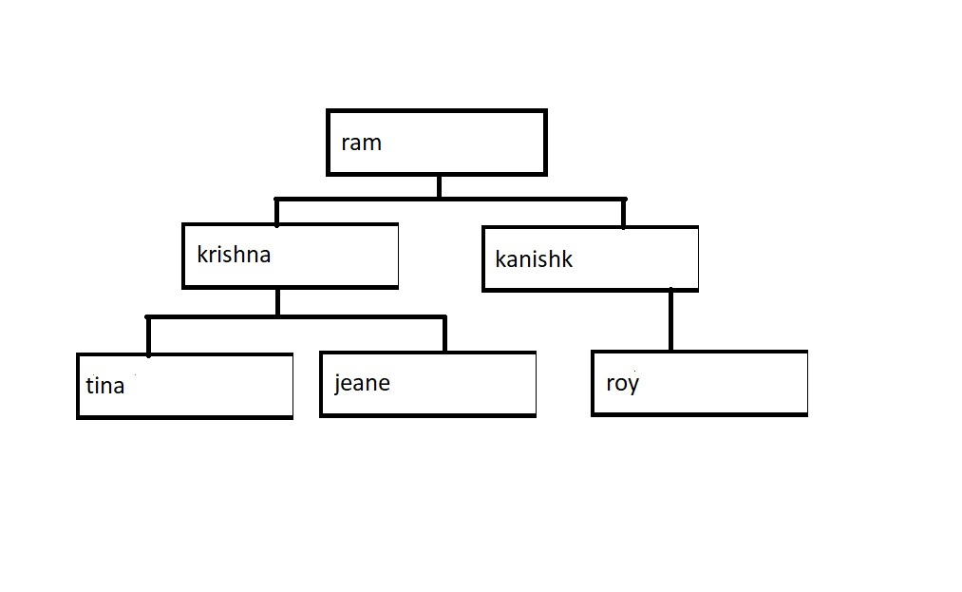

male(ram).

male(krishna).

male(kanishk).

male(roy).

female(tina).

female(jeane).

parent(ram,krishna).

parent(ram,kanishk).

parent(krishna,tina).

parent(krishna,jeane).

parent(kanishk,roy).

son(X,Y):-

male(X),parent(Y,X).

daughter(X,Y):-

female(X),parent(Y,X).

sibling(X,Y):-

parent(Z,X),

parent(Z,Y),

X \= Y.

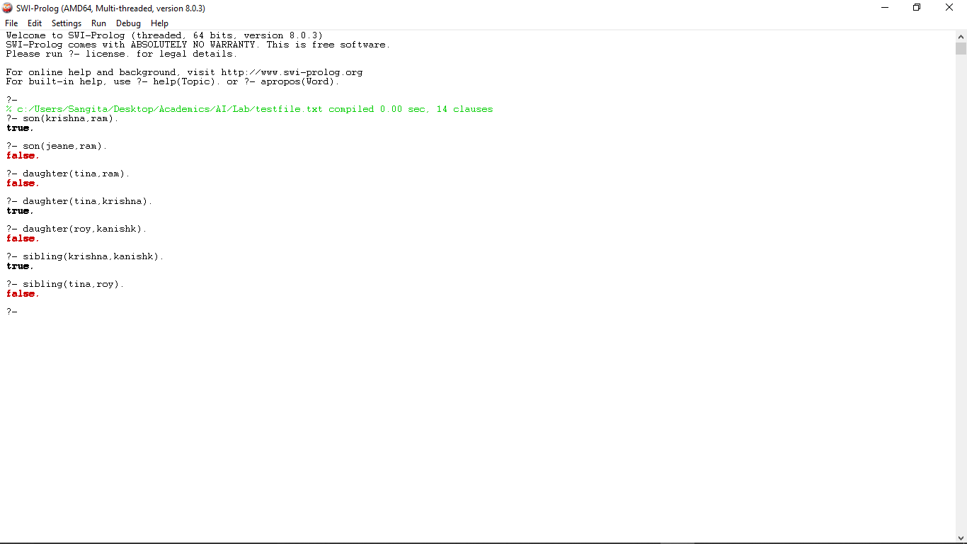Output-