1. **What are the Advantages and Disadvantages Of Artificial Neural Networks?**

Answer:

Advantages:

1. **Linear and nonlinear models**: An artificial neural network can perform tasks that a linear program cannot. Complex linear and nonlinear relationships can be derived using neural networks.
2. **Noise**: Neural networks are less sensitive to noise than statistical regression models. When an element of the neural network fails, it can continue without any problem by their parallel nature. Information such as in traditional programming is stored on the entire network, not on a database. The disappearance of a few pieces of information in one place does not restrict the network from functioning.
3. **Having a distributed memory**: For ANN to be able to learn, it is necessary to determine the examples and to teach the network according to the desired output by showing these examples to the network. The network's progress is directly proportional to the selected instances, and if the event cannot be shown to the network in all its aspects, the network can produce incorrect output
4. **Flexible input/output**: Neural networks can operate using one or more descriptors and/or response variables. They can also be used with categorical and continuous data.
5. **Fault-tolerant**: Corruption of one or more cells of ANN does not prevent it from generating output. This feature makes the networks fault tolerant.

Disadvantages:

1. **Effect of larger number of neuron**s :More neurons can make the process of classification over trained and can make it too good for training set but too bad for new – unknown data.
2. **The duration of the network is unknown**: The network is reduced to a certain value of the error on the sample means that the training has been completed. This value does not give us optimum results.
3. **Optimizing parameters:** There are many parameters to be set in a neural network and optimizing the network can be challenging, especially to avoid over training.
4. **Unexplained functioning of the network**: It is not possible to explain how the results were calculated in any meaningful way. Unexplained functioning of the network.
5. **Conversion of problem to numeric (input to ANN):**  ANNs can work with numerical information. Problems have to be translated into numerical values before being introduced to ANN. The display mechanism to be determined here will directly influence the performance of the network. This depends on the user's ability.
6. **Enlist and mention importance of each evaluation metrics for classifier model.**

**Answer:**

1. **Confusion Matrix:**
2. **tool for analyzing how well your classifier can recognize tuples of different classes.**
3. ***TP* and *TN* tell us when the classifier is getting things right,**
4. **while *FP* and *FN* tell us when the classifier is getting things wrong**



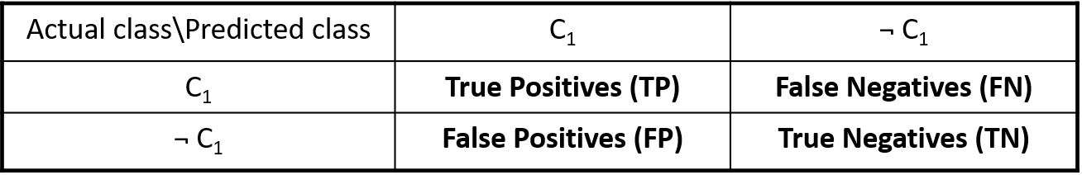

**Confusion Matrix:**

* **Precision**: exactness – what % of tuples that the classifier labeled as positive are actually positive