**Title: - E-Commerce Website**

Group Members :

Roll Number Name

57 Aditya Holkar

69 Upendra Kadre

**Abstract of the project: -**

The project is a complete online e-commerce website named ‘Lifestyle Store’.

Our project is a application of HTML5, Bootstrap, PHP, MySQL together.

The core idea of our project is to design an e-commerce website of a lifestyle retail store which has an inventory of many fashion products. These fashion products consists of products like watches, cameras, shirts from various brands. The user can browse through the website anytime and make a purchase of the products of his choice.

In the front-end, we have implemented the User Interface for the website using HTML & Bootstrap. The front-end of the website includes several forms, these forms consists of a Registration form for registering new user and Login form for already registered user login. We have also added the “Insert into Cart” feature, replicating the same visual features & text boxes which are characteristics of other online sites like Amazon, Flipkart etc. A input field for card details and CVV ,for online transactions has been included.

A clear minimilistic user interface makes our website user friendly .Some major technical aspects and highlights of our project are

**Simple UI**

* For UI designing we have made use of bootstrap .
* All the pages are responsive i.e. they can be viewed from screens of various sizes including mobiles.
* We have made extensive use various bootstrap classes for designing of background, forms, and even images.
* We have used CSS styling for colour optimizations.

1. Home Page

The screenshot below represents the home page of the website. It consists of header and footer with the content present in the center of the screen. The header consists of a navigation bar with links to the Signup and Login Page.



1. Signup for users
2. Since it is a E-Commerce website each user should have a account so we have provided the provision for registration a new user as well as for login.
3. This page allows users to create their new account. We have taken input of various parameters such as name , email, password, address,city etc. All the input data is stored in the database and the user is automatically logged in once he registers to the website. 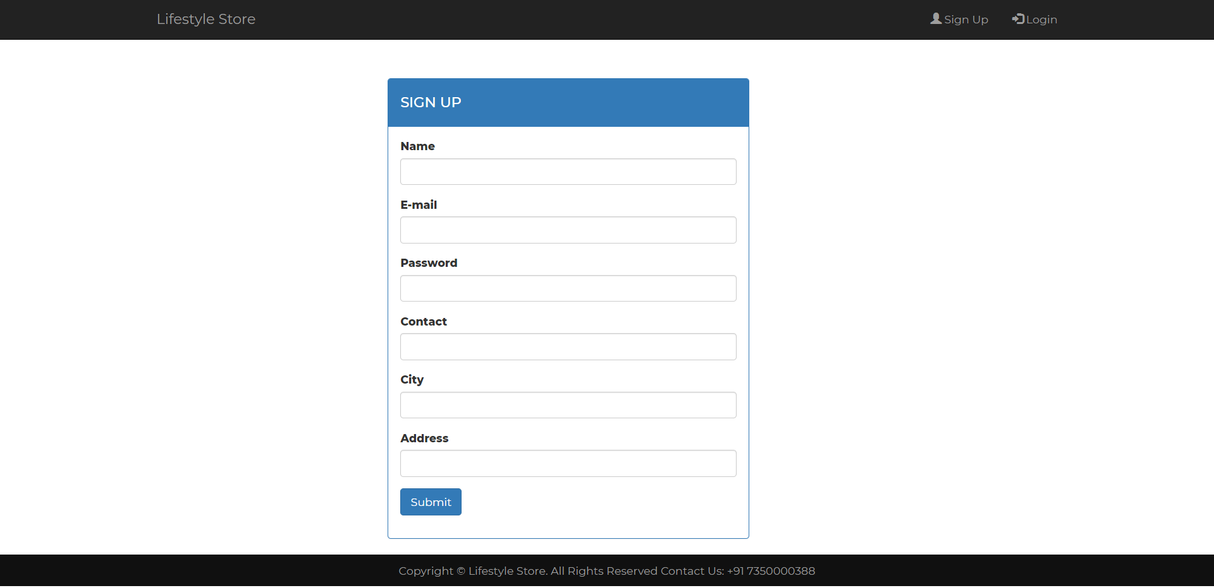
4. Login page :

This page allows previously registered users to log in and purchase products. The username or email-id of the user will always be available at the top of the website on navigation bar once the user log into the website.

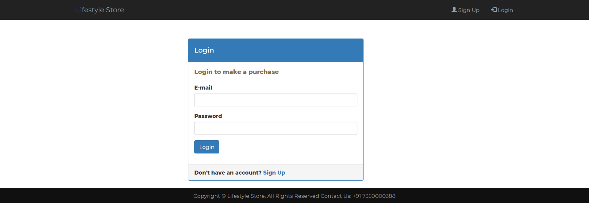

1. Change password:

If user wishes to change his login password he can reset his password through this page. The user has to just type his old password and the new password which he wishes to set. 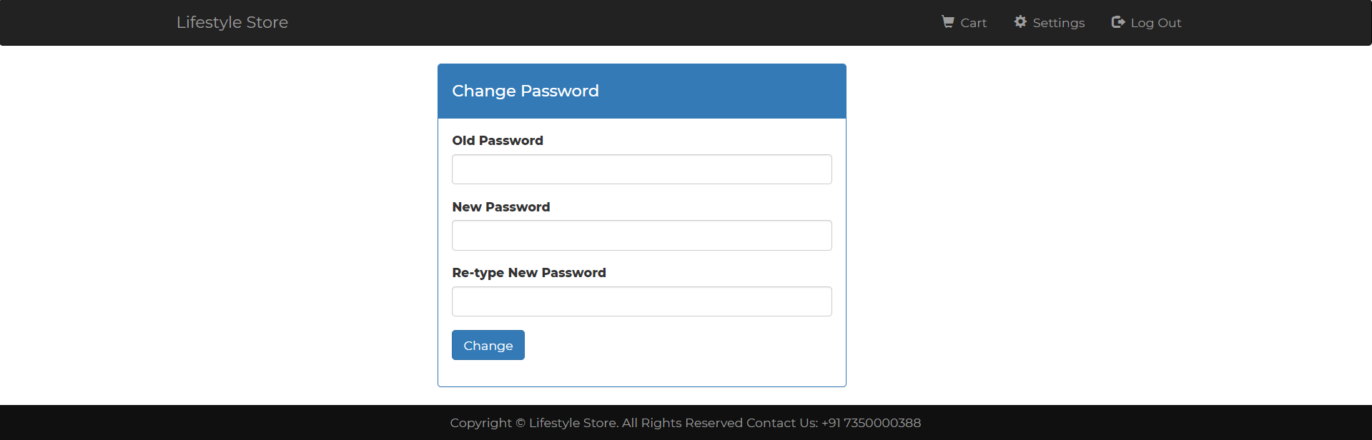

1. Products page :

This page displays all the products available it has mainly two options which are

1. Buy now/add to cart option:

Logged in users will see a option for adding that item to cart where as non logged users can see option for buy now. So on clicking button item gets added to cart.



1. Cart :

When the user adds items from products page the item gets added to cart which can be viewed from this page.The page even calculates total amount to be paid by user and displays the amount on the page. It has the facility to remove item from cart.

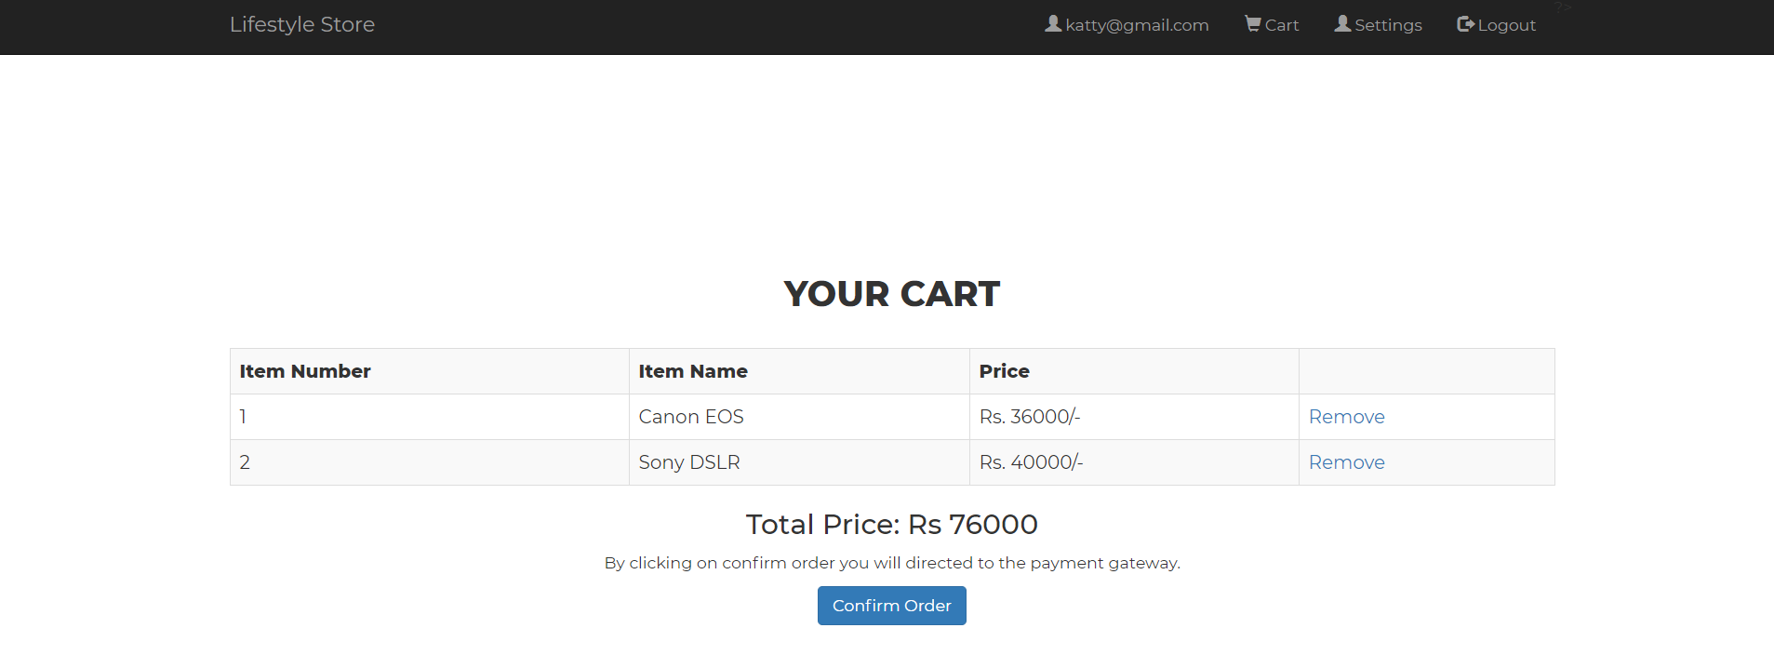

1. Confirmation page:

When the user confirms the purchase from the cart, the website will ask for the card details of the users.

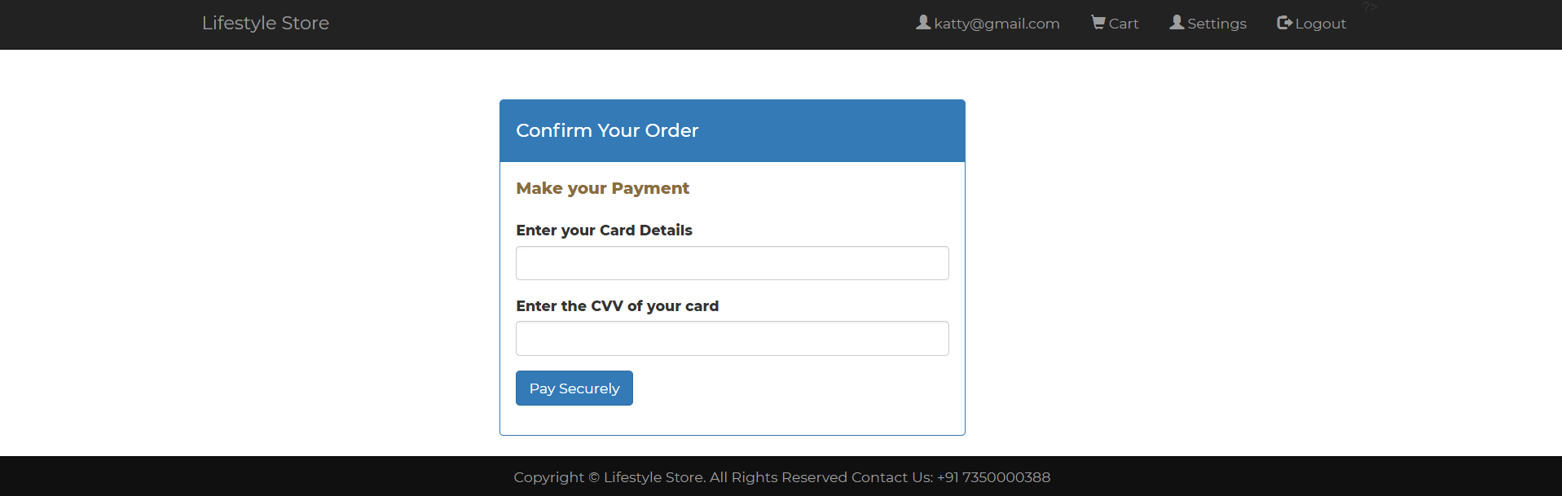

1. Users Page

The purchase history of users is displayed on the users page. The user will be able to see all the purchases that he has made in the history. 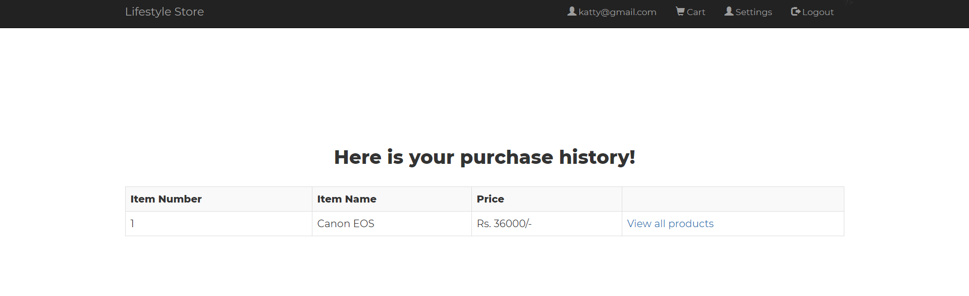

1. Logout page:

This page will destroy session for particular user and redirect the website to home page. This will destroy the session variable of PHP and thus, the user will be redirected to the home page.

1. Admin login:

The admin shall always be able to view the products added to cart and the products purchased by the users over the website. The admin has to login through a special login id and password.

