**Assignment 2**

**Name: Upendra Sunil Kadre**

**Div.: C Roll No: 69**

**GR NO: 1710505**

**Q. Write an HTML snippet with CSS for following effects:**

**a)      Link: after visited red colour and before visited blue colour**

*Code: linkColour.html*

*<!DOCTYPE html>*

*<html>*

*<head>*

*<style>*

*a:link {*

*color: red;*

*}*

*a:visited {*

*color: green;*

*}*

*</style>*

*</head>*

*<body>*

*<h1>Assignment 2</h1>*

*<p>This link changes colour after visiting GOOGLE</p>*

*<p><a href="https://www.google.in">GOOGLE</a></p>*

*</body>*

*</html>*

**b)      table with odd rows pink and even rows blue colour.**

*Code: table.html*

*<!DOCTYPE html>*

*<html>*

*<head>*

*<style>*

*table {*

*border-collapse: collapse;*

*width: 100%;*

*}*

*th, td {*

*text-align: left;*

*padding: 8px;*

*}*

*tr:nth-child(even) {background-color: blue;}*

*tr:nth-child(odd) {background-color: pink;}*

*</style>*

*</head>*

*<body>*

*<h2>Blue-Pink Table</h2>*

*<p>Background colour of even rows is blue and odd is pink:</p>*

*<table>*

*<tr>*

*<th>First Name</th>*

*<th>Last Name</th>*

*<th>Points</th>*

*</tr>*

*<tr>*

*<td>Upendra</td>*

*<td>kadre</td>*

*<td>$100</td>*

*</tr>*

*<tr>*

*<td>Swapnil</td>*

*<td>Katti</td>*

*<td>$150</td>*

*</tr>*

*<tr>*

*<td>Atharva</td>*

*<td>Dixit</td>*

*<td>$300</td>*

*</tr>*

*<tr>*

*<td>Aditya</td>*

*<td>Holkar</td>*

*<td>$250</td>*

*</tr>*

*</table>*

*</body>*

*</html>*

**OUTPUT:**

A)

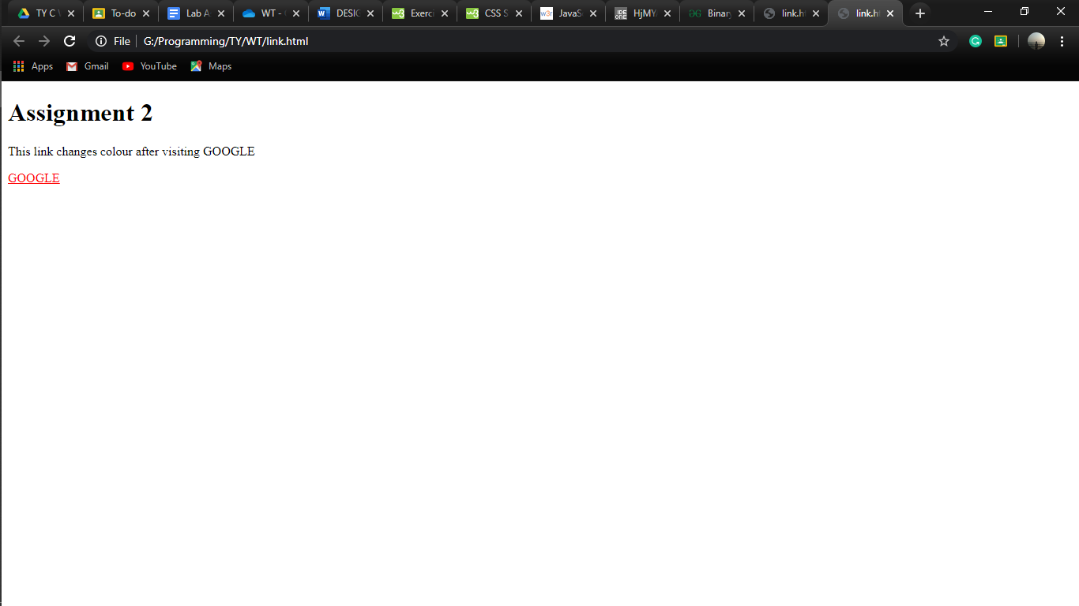

*B)*

