**Title: - E-Commerce Website**

Group Members :

Roll Number Name

57 Aditya Holkar

69 Upendra Kadre

**Abstract of the project: -**

The project is a complete online e-commerce website named ‘Lifestyle Store’.

Our project is a application of HTML5, Bootstrap, PHP, MySQL together.

The core idea of our project is to design an e-commerce website of a lifestyle retail store which has an inventory of many fashion products. These fashion products consists of products like watches, cameras, shirts from various brands. The user can browse through the website anytime and make a purchase of the products of his choice.

**Backend Technologies:**

The technologies of PHP & MySQL are used for backend of the website. The use of PHP is to connect the frontend i.e. the HTML pages to the databases. It includes storing the inputs enterd by the user into the database and fetching the data from database to display it on web pages.

**Relational Diagram of the Database:**

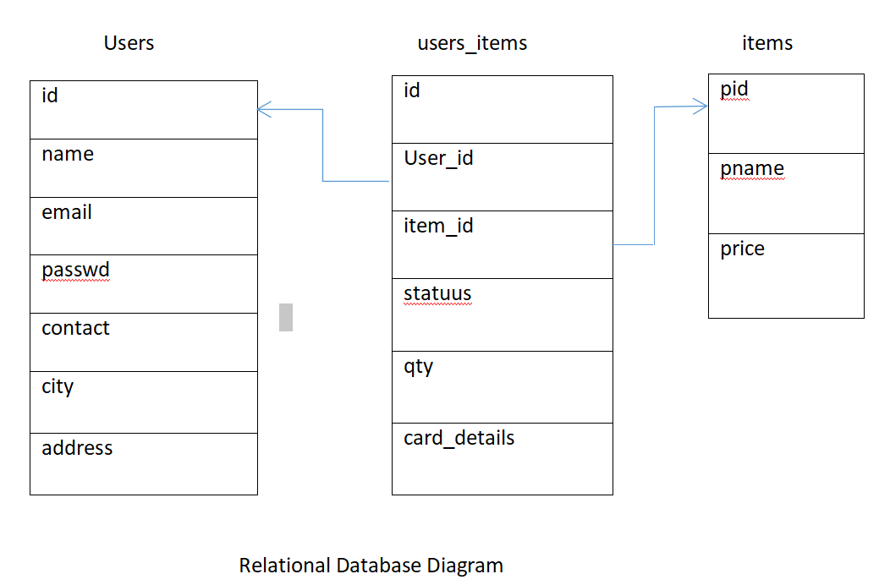

1. The diagram above gives an idea about the database used for the system.
2. The database consists of 3 tables namely- users, items, users_items.
3. The **users** table consists of the details about the users. It has attributes of id(auto-generated when a new user registers), name, email, passwd, contact, city, address.
4. The **items** table consists of the details about the products that are available for sale on the website. It has attributes of product id(pid), product name(pname) and price of the product. Whenever you have to launch a new product on your site, you have to add it into this table of the database.
5. The **user_items** table is a normalized table that consists of the details about each purchase that is made on the website. It has attributes of transaction id(id), user_id(foreign key the id of user who has made purchase), item_id(the product id of item from items table), statuus(The status of the product which a enum value consisting of ‘added to card’ and ‘purchased’), quantity of the product ordered and the card_details used for the transaction.

**Database Structure:**

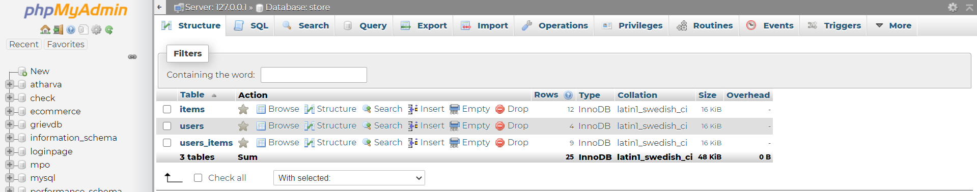

**Users Table Structure:**

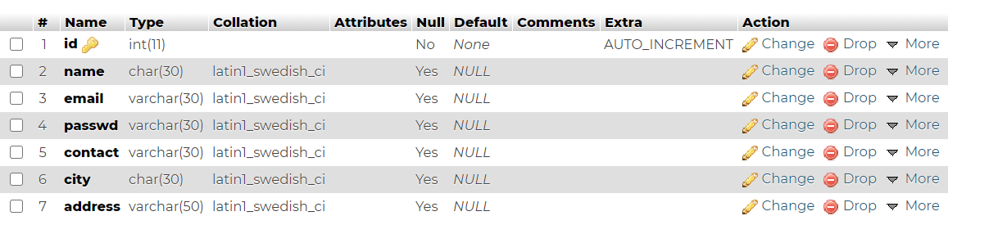

**Items Table Structure:**

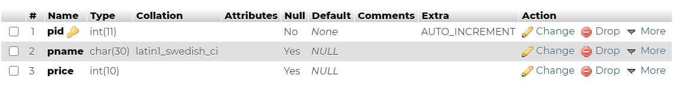

**Users_items Table Structure:**

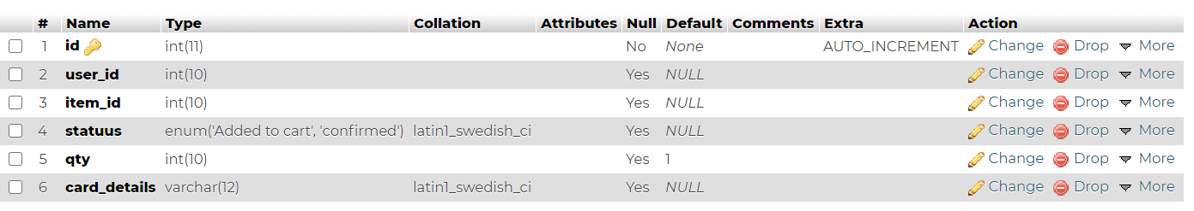

**Role of PHP:**

1. PHP is used for connecting the frontend to the database. It is also used for form validations.
2. The basic PHP commands which are used extensively are:

* Mysqli_connect : for database connection
* Mysqli_query. : For execution of query
* Mysqli_fetch_array:to fetch the result in the form of array

**Explanation about use of PHP & Database at various pages:**

1. The very first use of PHP is made while registering the user to the website.
2. The details entered by the user are fetched by PHP using POST method. These details are then stored into the database by the query:

insert into users (name, email, passwd, contact, city, address) values('$name', '$email', '$password', '$contact', '$city', '$address')"

1. A new user is added into the database after the successful execution of the query.
2. At login page, a session is setup with the existing email-id of the logged in user. A user is logged in only if he has already registered into the database. This is checked by PHP using the following way.

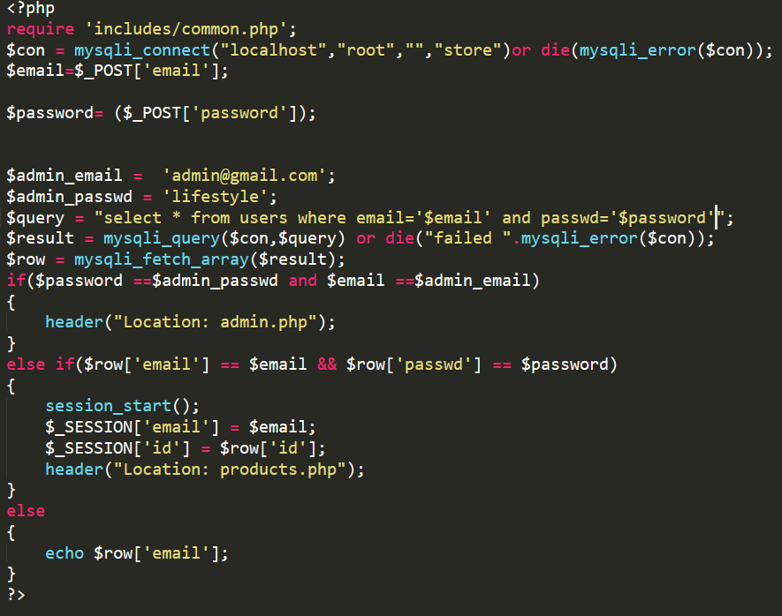

1. On the change password page, the **update** query of SQL is used to make changes into the users table.
2. Whenever the user adds the product to the cart, the **statuus** attribute of the users_items is set to ‘added to cart’.
3. Whenever the user purchases the product, from the confirmation page the **statuus** attribute of the users_items is set to ‘purchased’. This is done by using select query and update query from the SQL syntax.

UPDATE `users_items` SET `statuus` = 'confirmed' WHERE `users_items`.`item_id` = '$a' and `users_items`.`user_id` = '$id' ;

1. To display the products added to cart we use the select query from the users_items table. Similarly the purchase history of the users is displayed. SQL joins are used to execute this query.

SELECT * FROM users_items INNER JOIN items ON users_items.item_id = items.pid and user_id='$id' where statuus='Added to cart'