final-project-skeleton
Team Number: 18
Team Name: Poet of post office
Team Member Name | Email Address
Lige Tan | ligtan@seas.upenn.edu
Tao Yu | taoyu106@seas.upenn.edu
Mutian Yuan | yuanmu@seas.upenn.edu

GitHub Repository URL https://github.com/upenn-embedded/final-project-f25-poet-of-post-office
GitHub Pages Website URL: [for final submission]*

Final Project Proposal

1. Abstract
In a few sentences, describe your final project.
We will design a healthy version of Iron Man gloves. When the palm is opened, the circular LED on the palm will light up. When the hand forms a fist, the laser rays on the back of the hand will be activated. These functions are mainly determined by the states of three fingers equipped with flex sensors. Of course, the three 0/1 signals can result in 8 different states. Accordingly, we will add more functions. For example, when the "victory" gesture is made by hand, the LCD will display "victory". Meanwhile, the sensors that monitor the health of the hands will be connected to the LCD and mobile phone via WIFI, and the health status will be displayed in real time.

2. Motivation
What is the problem that you are trying to solve? Why is this project interesting? What is the intended purpose?
Jokingly speaking, Iron Man can check his own health status at any time through it.
This is more of a toy-like product aimed at teenagers who enjoy science fiction. They can experience the pleasure of wearing Iron Man gloves, and experience the various changes brought about by different gestures to the gloves.At the same time, health information such as heart rate can also be detected in real time and displayed.

3. System Block Diagram
Show your high level design, as done in WS1 and WS2. What are the critical components in your system? How do they communicate (I2C?, interrupts, ADC, etc.)? What power regulation do you need?
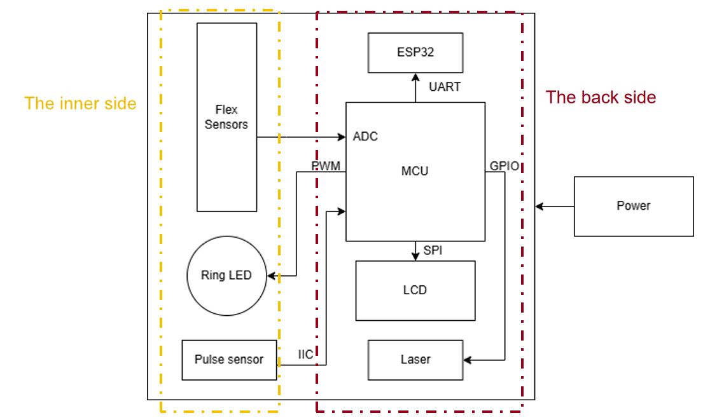

4. Design Sketches
What will your project look like? Do you have any critical design features? Will you need any special manufacturing techniques to achieve your vision, like power tools, laser cutting, or 3D printing? Submit drawings for this section.

In our plan, there are no specific manufacturing techniques required now. All that is needed is to connect all the components together.

5. Software Requirements Specification (SRS)
Formulate key software requirements here. Think deeply on the design: What must your device do? How will you measure this during validation testing? Create 4 to 8 critical system requirements.
These must be testable! See the Final Project Manual Appendix for details. Refer to the table below; replace these examples with your own.
5.1 Definitions, Abbreviations
ESP32-connect WiFi and display http webpage on cell phone. I will use ESP-IDF to program.
5.2 Functionality
ID | Description
WiFi connection | ESP32 start using AP mode to provide user interface to key in the WiFi credentials, then attempt to connect.
Webpage | After connected to WiFi, it switches to STA mode, use a http webpage to display heart rate and gesture.
Decode sensors | Decode heart rate and flex sensor to identify real time gesture and heart rate
Actuation | Provide control signal\data to the output devices.

6. Hardware Requirements Specification (HRS)
Formulate key hardware requirements here. Think deeply on the design: What must your device do? How will you measure this during validation testing? Create 4 to 8 critical system requirements.
These must be testable! See the Final Project Manual Appendix for details. Refer to the table below; replace these examples with your own.
6.1 Definitions, Abbreviations
Here, you will define any special terms, acronyms, or abbreviations you plan to use for hardware
- Ring-shaped LED: WS2812B
- Flex Sensor: 744-FS-L-0055-253-ST
- Heart rate sensor: MAXREFDES117#
- Laser: 1054 LASER DIODE 650NM 5MW 10MM DIA
- MCU: STM32F103C8T6
- WIFI: ESP32-S3
- LCD:ST7735R
6.2 Functionality
ID | Description
Ring-shaped LED | When all the flex sensors have low resistance values, the LED lights up, and the flashing mode can be changed through the button, such as constant on or flashing
Flex Sensor | The resistance value changes with the degree of bending. It will be connected to the ADC port of the MCU.
Heart rate sensor | Detecting real-time heart rate.
Laser | When all the flex sensors have low resistance values, the laser starts lasing.
ESP32-S3 | WIFI connection
STM32F103C8T6 | Microcontroller
LCD | Display heart rate and various expressions corresponding to different gestures

7. Bill of Materials (BOM)
What major components do you need and why? Try to be as specific as possible. Your Hardware & Software Requirements Specifications should inform your component choices.
In addition to this written response, copy the Final Project BOM Google Sheet and fill it out with your critical components (think: processors, sensors, actuators). Include the link to your BOM in this section.
- Ring-shaped LED: WS2812B
- Flex Sensor: 744-FS-L-0055-253-ST
- Heart rate sensor: 426-SEN0203
- Laser: 1054 LASER DIODE 650NM 5MW 10MM DIA
- MCU: STM32F103C8T6
- WIFI: ESP32-S3
- LCD: ST7735R

8. Final Demo Goals
How will you demonstrate your device on demo day? Will it be strapped to a person, mounted on a bicycle, require outdoor space? Think of any physical, temporal, and other constraints that could affect your planning.
On the final demonstration day, we will have one person wearing the glove on his right hand. We will firstly show the WiFi connection module, with the ESP-32 working in SoftAP mode to provide a interface for using to select the scanned WiFi around and then key in the password. The ESP-32 will then switch to STA mode and connect to the corresponding wifi using the saved credentials. Then we will show the LCD display of heart rate and words generated by the gesture. The information on LCD will also be posted on the ESP-32 http page. Different gestures identified by the flex sensor would generate corresponding laser, LED and LCD display effect, we will show them one by one.
The light condition would be a constraint, to demonstrate the LCD, LED and laser, we'd prefer to present them in a dimmer place, otherwise it might not be as visible as we wish.

9. Sprint Planning
You've got limited time to get this project done! How will you plan your sprint milestones? How will you distribute the work within your team? Review the schedule in the final project manual for exact dates.
Milestone | Functionality Achieved | Distribution of Work
Sprint #1 | Finish developing the drivers of input sensors | Together
Sprint #2 | Finish developing the drivers of output sensors. | Together
MVP Demo | Put everything together, show all the functionality | Together
Final Demo | Finalize the wearable external design | Together

This is the end of the Project Proposal section. The remaining sections will be filled out based on the milestone schedule.

Sprint Review #1

Last week's progress11.14
1). Hardware: The realization of LED Strip function in the back side.
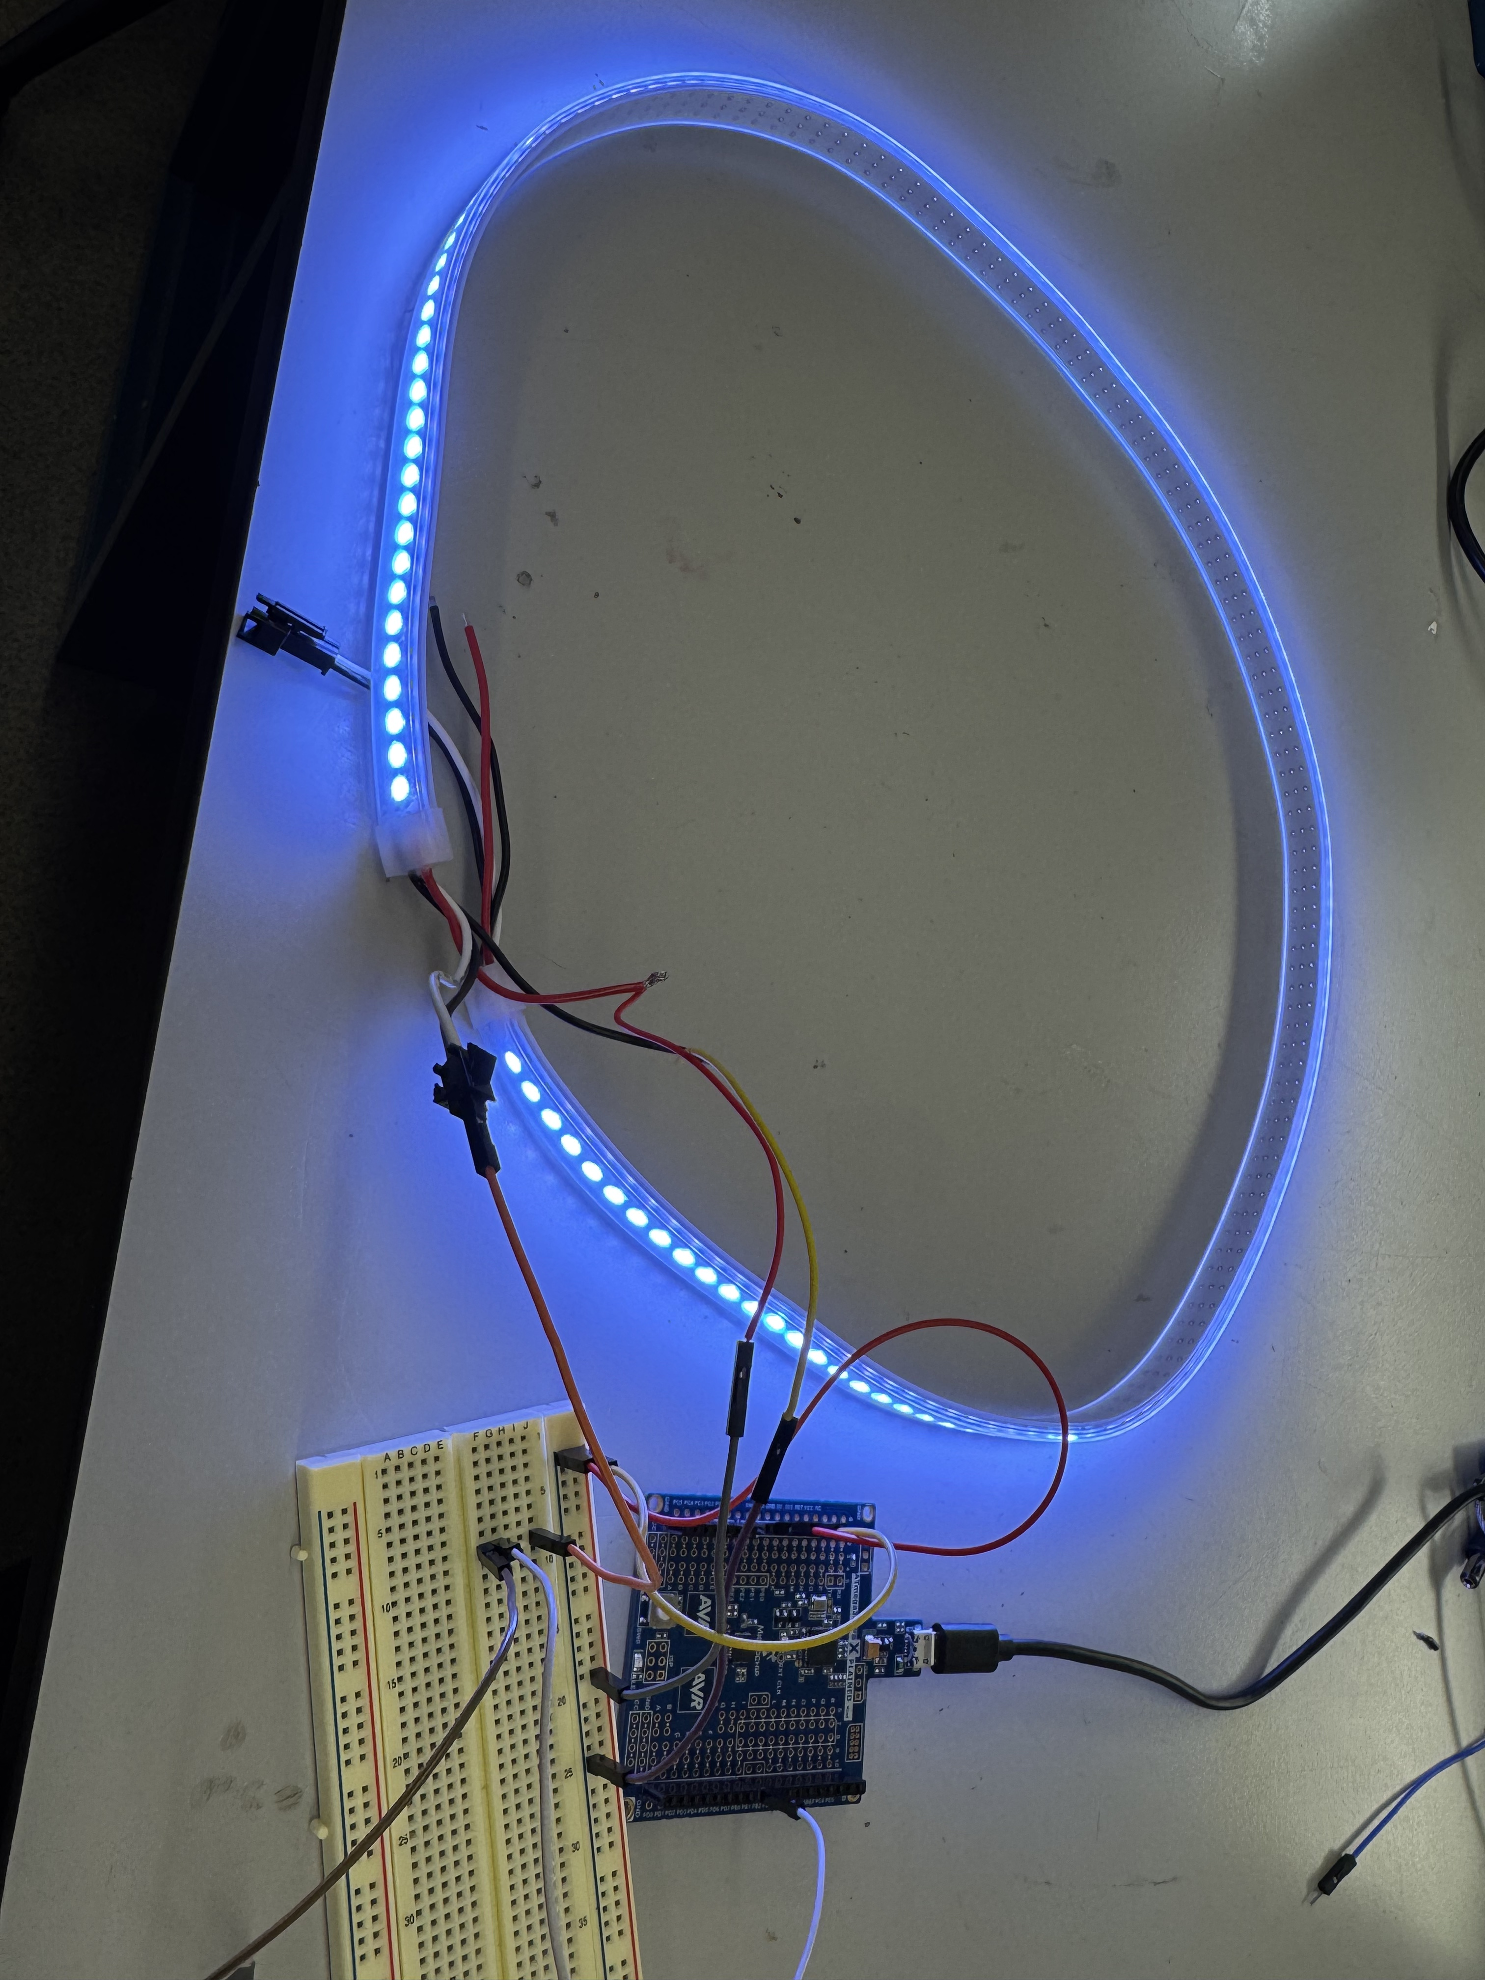
2). Synchronous display on LCD screen
LCD Display
As shown in the video, of course we will place all these components on the gloves later. When the hand makes a fist, the LED strip on the back of the hand will light up and the LCD will display "BIST". When the palm is opened, the LED strip on the back of the hand will turn off and the LCD will display "PALM". The code can be view in
3). Wifi connection module on ESP32.
We have completed the WiFi-connection framework for the system, the device will automatically detect Wi-Fi and connect to stored Wi-Fi credentials, or give a AP configuration page if none is found. On top of this, I have added a status server module to automatically update the status, including current gesture, detected words, and other info like heart rate and power level to the HTTP webpage.
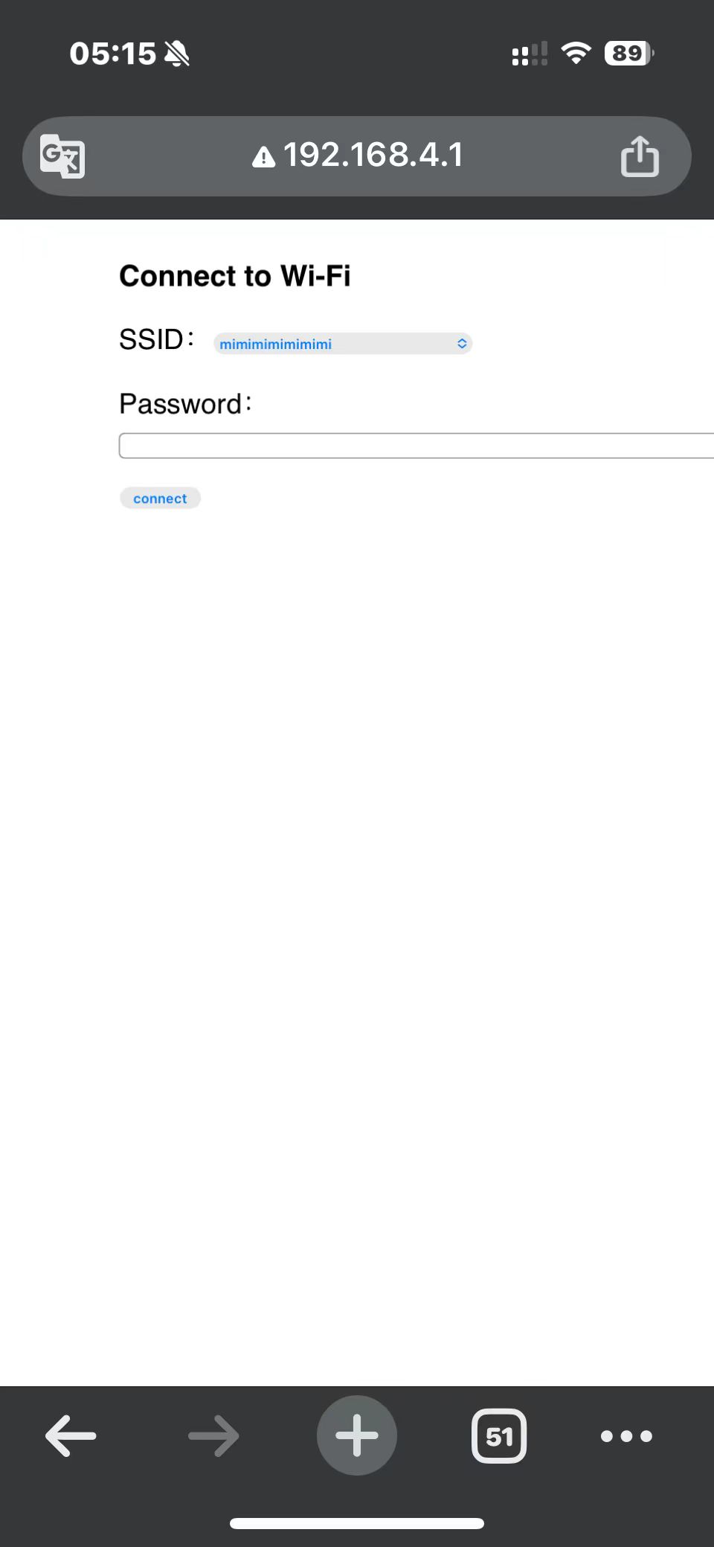
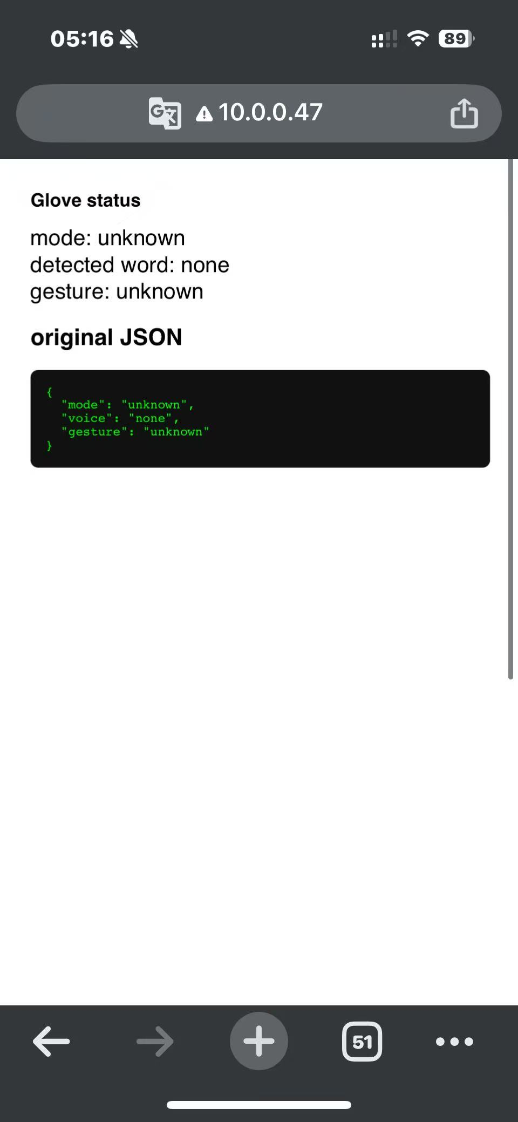

Current state of project
We have made progress on both the software and hardware aspects of the project and have completed components including the dorsal hand LED strip, LCD display, Wi-Fi module integration, and the preliminary training of the speech recognition model. These are all important components of the final project.
However, since not all of the components have arrived yet, some tasks cannot be carried out at this stage.

Next week's plan
1). Complete the connection of the palm-side ring-shaped LED and its interaction with the LCD.
2). Complete the connection of the heart rate sensor and its interaction with the LCD, Wi-Fi, and other modules
3). Finish recording the trainning set for the speech recognition module (Jarvis).

Sprint Review #2

Last week's progress

Current state of project

Next week's plan

MVP Demo
- Show a system block diagram & explain the hardware implementation.
- Explain your firmware implementation, including application logic and critical drivers you've written.
- Demo your device.
- Have you achieved some or all of your Software Requirements Specification (SRS)?
  - Show how you collected data and the outcomes.
- Have you achieved some or all of your Hardware Requirements Specification (HRS)?
  - Show how you collected data and the outcomes.
- Show off the remaining elements that will make your project whole: mechanical casework, supporting graphical user interface (GUI), web portal, etc.
- What is the riskiest part remaining of your project?
  - How do you plan to de-risk this?
- What questions or help do you need from the teaching team?

Final Project Report
Don't forget to make the GitHub pages public website! If you’ve never made a GitHub pages website before, you can follow this webpage (though, substitute your final project repository for the GitHub username one in the quickstart guide): https://docs.github.com/en/pages/quickstart

1. Video
[Insert final project video here]
- The video must demonstrate your key functionality.
- The video must be 5 minutes or less.
- Ensure your video link is accessible to the teaching team. Unlisted YouTube videos or Google Drive uploads with SEAS account access work well.
- Points will be removed if the audio quality is poor - say, if you filmed your video in a noisy electrical engineering lab.

2. Images
[Insert final project images here]
Include photos of your device from a few angles. If you have a casework, show both the exterior and interior (where the good EE bits are!).

3. Results
What were your results? Namely, what was the final solution/design to your problem?

3.1 Software Requirements Specification (SRS) Results
Based on your quantified system performance, comment on how you achieved or fell short of your expected requirements.
Did your requirements change? If so, why? Failing to meet a requirement is acceptable; understanding the reason why is critical!
Validate at least two requirements, showing how you tested and your proof of work (videos, images, logic analyzer/oscilloscope captures, etc.).
ID | Description | Validation Outcome
SRS-01 | The IMU 3-axis acceleration will be measured with 16-bit depth every 100 milliseconds +/-10 milliseconds. | Confirmed, logged output from the MCU is saved to "validation" folder in GitHub repository.

3.2 Hardware Requirements Specification (HRS) Results
Based on your quantified system performance, comment on how you achieved or fell short of your expected requirements.
Did your requirements change? If so, why? Failing to meet a requirement is acceptable; understanding the reason why is critical!
Validate at least two requirements, showing how you tested and your proof of work (videos, images, logic analyzer/oscilloscope captures, etc.).
ID | Description | Validation Outcome
HRS-01 | A distance sensor shall be used for obstacle detection. The sensor shall detect obstacles at a maximum distance of at least 10 cm. | Confirmed, sensed obstacles up to 15cm. Video in "validation" folder, shows tape measure and logged output to terminal.

4. Conclusion
Reflect on your project. Some questions to address:
- What did you learn from it?
- What went well?
- What accomplishments are you proud of?
- What did you learn/gain from this experience?
- Did you have to change your approach?
- What could have been done differently?
- Did you encounter obstacles that you didn’t anticipate?
- What could be a next step for this project?

References
Fill in your references here as you work on your final project. Describe any libraries used here.

