# **Classroom Vocabulary**

# *Baaria* (Giuseppe Tornatore, 2009)

## **Activity 1.** In this scene from the film *Baaria*, the elementary school students are in class. What’s the difference between “alunni” and “studenti” in Italian? And “maestro/a” e “insegnante”? Read to find out:

In English: “students”; in Italian:





**gli alunni / le alunne / lƏ alunnƏ**

(frequentano le scuole elementari)

**gli studenti” / le studentesse / lƏ student** (frequentano la scuola media, il liceo, l’università)

In English: “teacher”; in Italian:

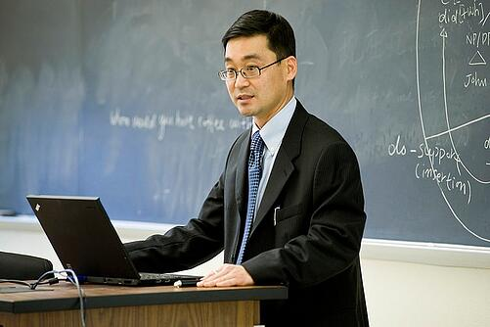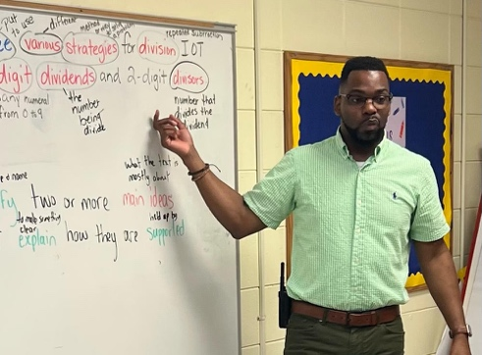

**la maestra / il maestro / lƏ maestrƏ il professore / la professoressa / lƏ professorƏ**

(insegna alle scuole elementari, all’asilo) (insegna all’università, al college)

**l’insegnante**

**l’insegnantƏ**

(insegna alle scuole medie, al liceo)

### Write the appropriate words in the blanks.

le studentesse

1. Chi frequenta il liceo? ____________________, ___________________________, ______________________

2. Chi insegna all’università? ______________________, _______________________, ______________________

3. Chi frequenta le scuole elementari? ___________________, ___________________, ______________________

4. Chi insegna alle scuole elementari? ___________________, ____________________, _____________________

## **Activity 2.**

### C’è = (*there is*), singolare: **C’è un libro.** Ci sono = (*there are*), plurale: **Ci sono tre libri**.

### What’s in this image? Write three objects you see. Use the vocabulary and an indefinite article.

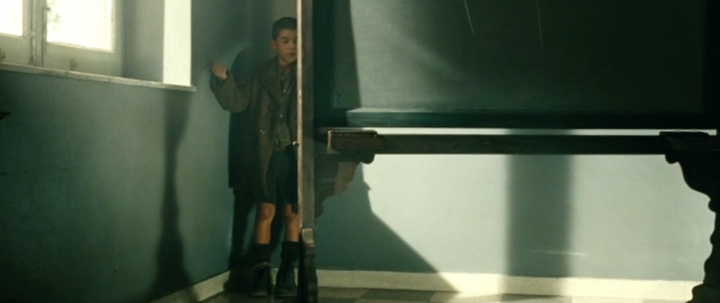

C’è ______________________. C’è ________________________. C’è _______________________.

What’s in this image? Use the new vocabulary and an article (or number).

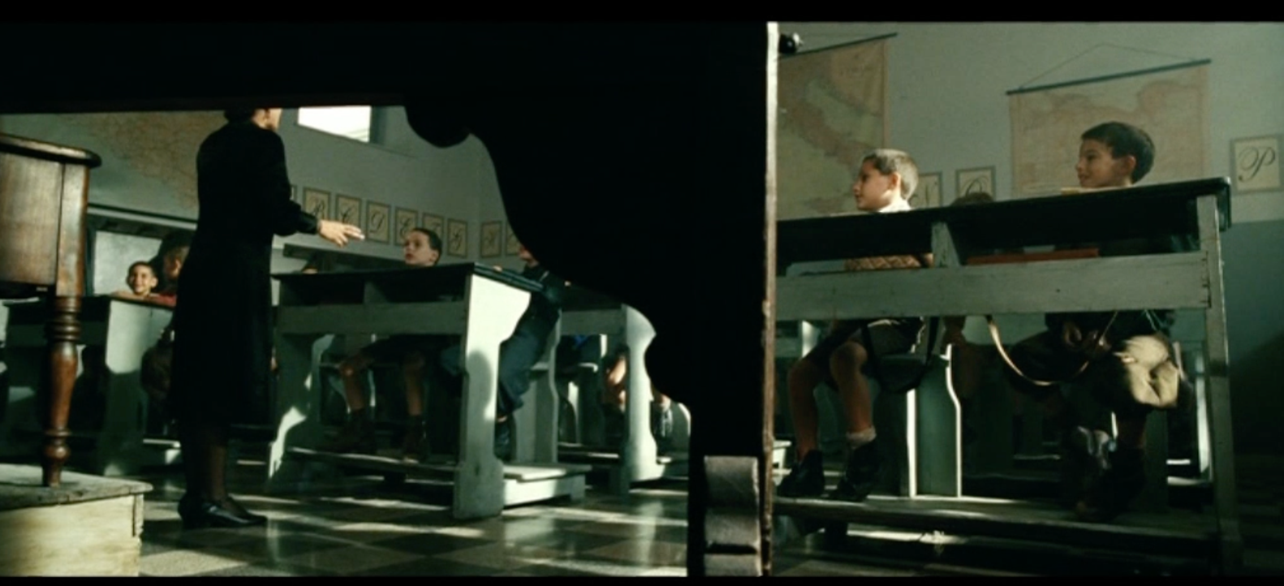

C’è ______________________________. C’è ________________________________.

Ci sono __________________________. Ci sono ______________________________.

C’è ___________________________. Ci sono _____________________________.

## **Activity 3.** What’s your classroom like? Draw a picture of it and present it to a classmate, using vocabulary and “c’è” and “ci sono” to describe the objects featured.

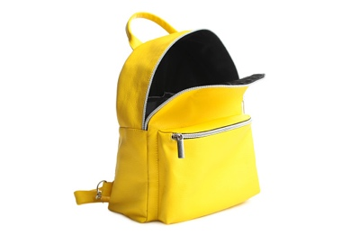



## **Activity 4.** What’s in your backpack? Use the vocabulary, “c’è” or “ci sono,” and an article (or number) to respond to the question.

## Nel mio zaino c’è…. Nel mio zaino ci sono…

__________________________________________________________________________________________________________________________________________________________________________________________________________________________________________

__________________________________________________________________________________________________________________________________________________________________________________________________________________________________________