**Basic Italian with Episode 1 of *Master of None***

**(SEASON 2)\***

* This activity is designed to introduce Italian culture and greetings to students at a novice level as well as to emphasize pronunciation by using a popular American television series (available on Netflix).

Episode’s title: *The Thief* (*Il Ladro*)

Learning goals

* Expose novice students to Italian
* Preliminary vocabulary: greetings and introduction (“hello”, “how do you say,” “sorry”)
* Real situations: how to great formally and informally; how to order in a bar and in a restaurant

Culture

* The thief: Homage to Neorealism
* The city of Modena
* Italian chef Massimo Bottura
* Gastronomy: fresh pasta and Tortellini
* Italian gestures

Culture in context

* What do you say or do when you’re a taking a picture of someone
* The Italian Bar
* Happy Birthday!

Interpersonal Activity

* Reproduce autonomously a basic conversation in Italian

**I. You will hear some preliminary vocabulary in the first scene of the episode. Look at the pictures provided below and then watch the episode to hear how these expressions sound in Italian.**

A. 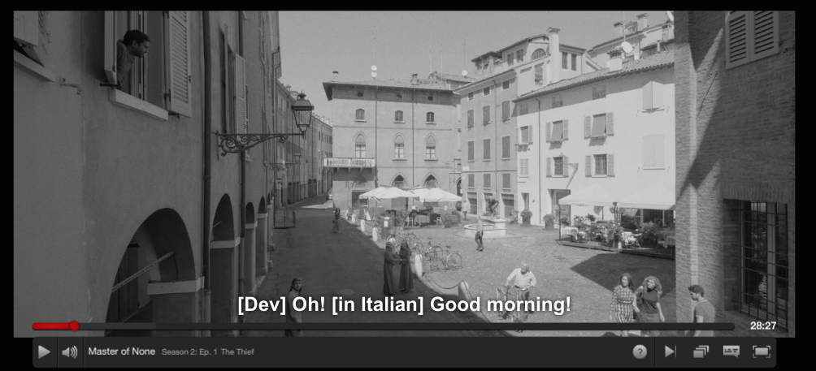

______________ _______________________ ! (It can be either two words or one word)

B. 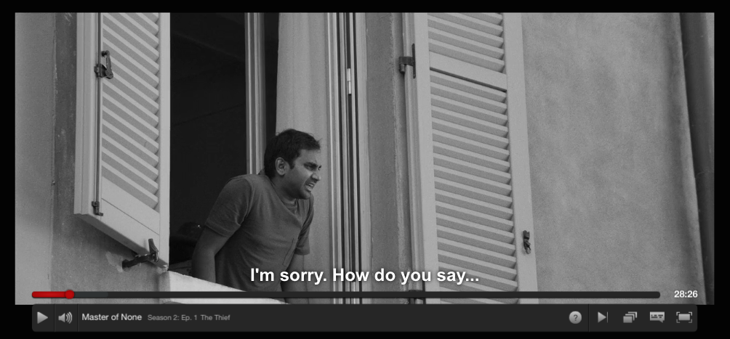

_____________ __________________. Come __________ ________________.....?

C. 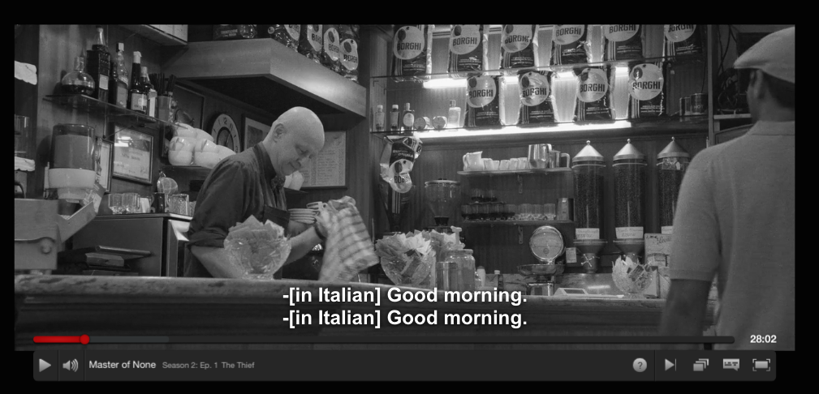

Cameriere (Waiter): ______________ __________!

Dev: ________________________.

**II. Answer the following questions**

1. What did Dev order in the bar:

a. un cappuccino b. un caffè c. un caffè americano d. un tè

2. What verb did Dev use to order

a. ho (I have) b. voglio (I want) c. prendo (I take/have) d. amo (I love)

3. Can you find an equivalent to say “tutto bene?”

________ ok?

4. Which kind of fresh pasta is Dev preparing?

Singular: ______________________ Plural: _______________________

5. What did the old lady say to judge Dev’s work?

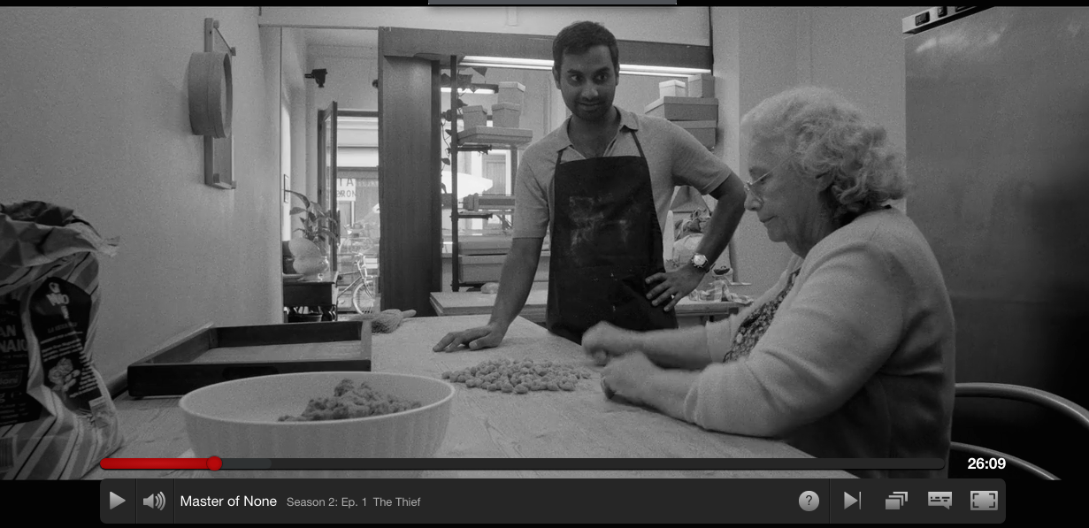

Positivo: * Negativo:

_______________ _______________

* You use this word when someone is talented or skilled. While if you want to say that someone is a good person or that something tastes good you would use ‘BUONO”.

**III. DEV e FRANCESCA**

Francesca: ___________ Dev.

Dev: ___________ Francesca. ________ va?

Francesca: Bene, _____ _________?

Dev: va _______. Posso assaggiare la _______________?

I gesti: Italian gestures. Can you guess which gesture means that ‘someone is smart’, that something is good’ and ‘someone has to go’

1.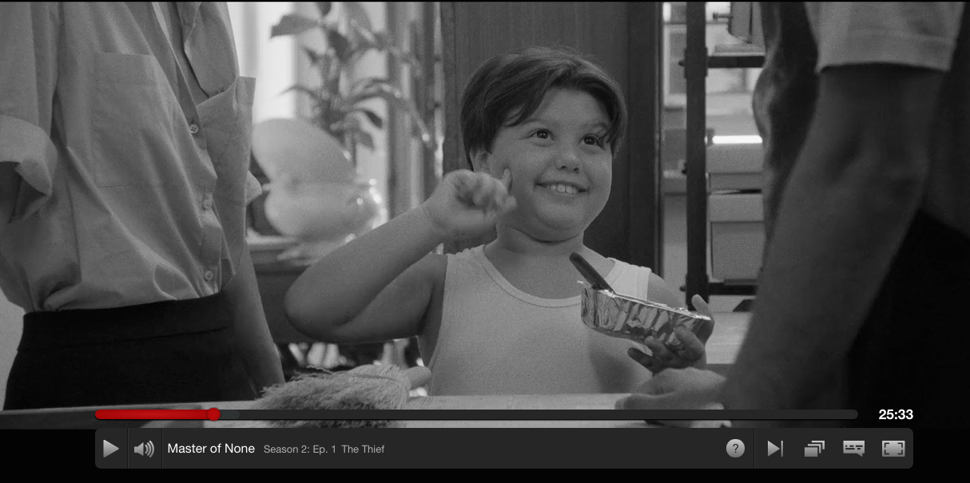 2. 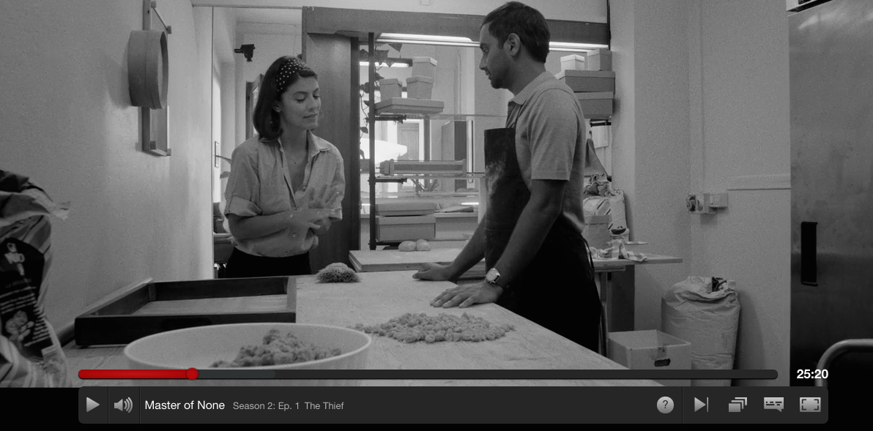 3. 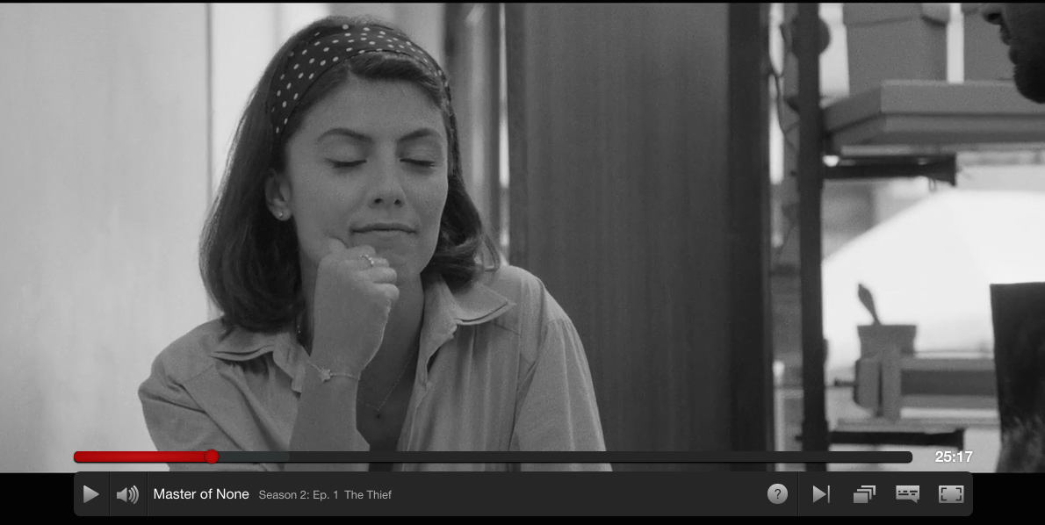

Do you know other hand gestures?

If you are interested in these topics, you can access these links for videos and info:

<https://www.nytimes.com/video/world/europe/100000002309793/the-italian-gesture-.html>

https://www.theguardian.com/world/shortcuts/2013/jul/02/how-speak-italian-with-hand-gestures

Luca Vullo, The Voice of body- Trailer: https://www.youtube.com/watch?v=UXqFTE-zrwI

**IV. “Thank you a Thousand” and “Allora!” (24:17)**

1. How do we say “thank you so much”?

a. grazi b. gracie c. grazie mille

What do Italian respond to that expression? What is Dev suggesting instead?

2. When do Italians use “Allora”?

**V. Dev all’Osteria Giusti (22:00) – Complete the following paragraph with the appropriate definite (IL, LO, LA) or indefinite articles (UN, UNO, UNA)**

_____ sua prenotazione è per _______ mese prossimo non per oggi. Ciao, dimmi… è un problema? ______ signora ha prenotato (*booked*) per _____ persona ma per _____ mese prossimo. E oggi siamo al completo, non la posso fare accomodare….

[….]

1. Circle all the verbs in the above brief paragraph 2. Last time you studied the verb “to be”. Which forms of ‘essere’ appear in the above paragraph?

3. Work with a classmate to complete the chart below:

|  |  |  |  |  |  |
| --- | --- | --- | --- | --- | --- |
| Io sono | Tu sei | **Lui/Lei** | **Noi** | Voi siete | **Loro** |

Fill in the blanks with the appropriate form of “essere” and then check your answer with your classmate/classmates

1. Dev _______ un ragazzo simpatico.
2. Francesca ________ italiana, invece (instead) Dev _______indiano.
3. Voi non _________ italiani.
4. Dev e Francesca __________ in Italia.
5. Master of None _______ una serie televisiva divertente.

**VI: Answer the following questions and then share them with your classmates.** NB: Since this activity isdesigned for elementary students (ideally in their first week of Italian) questions should be in English.

* Have you ever been in Italy?
* Have you ever visited Modena?
* Do you know why this city is famous?
* Do/did you have a bicycle? Do you use it a lot in Philly?
* Do you use an alarm to get up? What kind?
* How often do you use your phone?
* What do you do primarily with your phone?
* In what way do you think (from what you saw in the episode and from your experience) our life is changed “in the smart phone age”?
* Do you like fresh pasta?