**I numeri, 1-30**

*I cento passi* (2000)

**Activity 1.** Peppino and Giovanni are bothers. Listen to their conversation and write the number you hear.

**Peppino:** Sei andato a scuola, sai contare?

**Giovanni:** Come contare?

**Peppino:** Contare, ____**uno**____, ___**due**______, ___**tre**_____,

________**quattro**_____, sai contare?

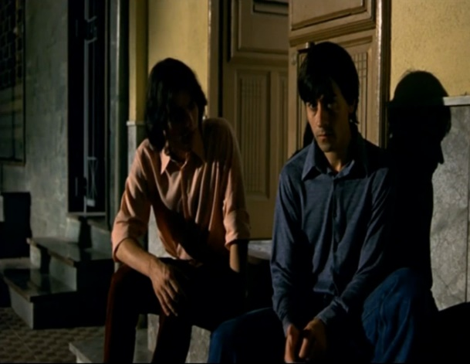

**Giovanni:** Sì, so contare.

**Peppino:** Sai camminare?

**Giovanni:** So camminare.

**Peppino:** Contare e camminare insieme, lo sai fare?

**Giovanni:** Sì, penso di sì.

**Peppino:** Allora, forza. Conta e cammina. Dai.

**Peppino e Giovanni:** ___**uno**_____,

_____**due**____, ____**tre**_____,

______**quattro**_____, ___**cinque**_____, ___**sei**____, ______**sette**______,

_______**otto**_____, nove, dieci...

[...]

Immaginare che la scena continui. Scrivere i numeri nell’ordine giusto. Attenzione allo spelling!

**Peppino:** Dai, continuiamo! Venti, ______**ventuno**_______, ventidue,

_______**ventitré**________, ventiquattro, venticinque, ventisei, ventisette,

________**ventotto**_______, ventinove, _____**trenta**____!

**Activity 2.** Write the number and plural of what you see.

|  |  |
| --- | --- |
| One Step Away | Northstar Church  un passo | Ten Steps to Becoming the Designer You Want to Be - GOOD  _________dieci passi________ |
| A Dad and His Daughter Share a Bond For Life - Her View From Home  un papà | Strollin' with The Homies': 100 dads took their kids for a stroll ...  _______**tre papà**________ |
| Mafia guy* - Models Male & People Background Wallpapers on Desktop ...  un mafioso | C:\Users\Sam's Computer\AppData\Local\Microsoft\Windows\INetCache\Content.MSO\8B0444E8.tmp  ______**sette mafiosi**_______ |
| One Hour for Memory – identitySPECIALIST  un’ora | Purple Clock Timer Time Limit Of Five Hours On Blue Background ...  __________**cinque ore**_________ |
| C:\Users\Sam's Computer\AppData\Local\Microsoft\Windows\INetCache\Content.MSO\54F5CF7B.tmp  una famiglia | Puppets, Puzzles and More :: Set of Four Families / Precut Flannel ...  _______**quattro famiglie**_______ |
| What came first, the Italian bar or coffee? - blog SpecialCoffee  un bar | wcs: Quiet cafés  _______**due bar**______ |
| Portugal map silhouette portugal country isolated Vector Image  un paese | Western Europe - World Music Guide - LibGuides at Appalachian ...  _____**diciotto paesi**_______ |
| Booker Triumph Ushers in New Era for South Korean Writers - Khmer ...  uno scrittore[1] | Eight writers awarded Yale's Windham-Campbell Prizes | YaleNews  ________**otto scrittori**_______ |
| Storie della Domenica - E se la Televisione non fosse sempre ...  una televisione | TV on shelves editorial stock photo. Image of plasma - 32930838  (17 x televisione)  ____**diciassette televisioni**__________ |
| So I'm going to Siena, Italy - Peculiar Porter  una città | (16 x città)  ________**sedici città**________ |

1. Traditionally in Italy, titles like *scrittore* have been masculine and *scrittrice* feminine. While titles have tended to endings *-o* or -*ore* for male and -*ice* or -*essa* for female (ie. *dottore*, *dottoressa* / *attore, attrice*), many women today choose to shed feminize versions of professions and instead opt for what were once masculine titles *professore, avvocato, studente*, etc.