***Beverages and articles***

*Le fate ignoranti* (2001)

**Activity:** Watch the scene and put a checkmark for each item the man offers the woman. Then, write an appropriate article for each option (ex. un, una, il, lo, del, dell’, ecc.). Do you know all of these beverages?



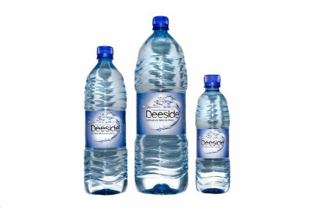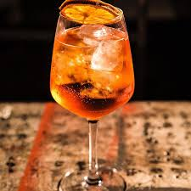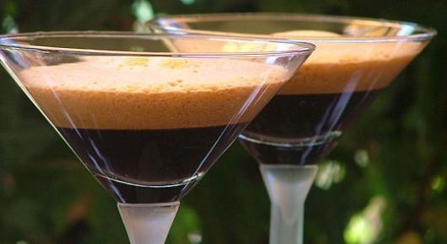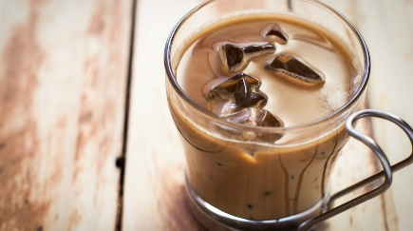



dell’

_________ spritz ________ acqua ________ caffè shakerato ___**il**__ caffè freddo

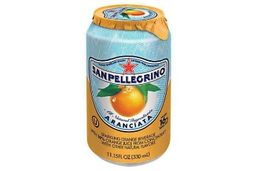

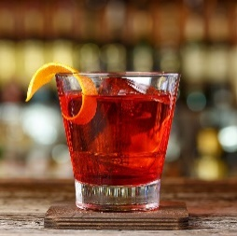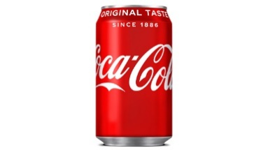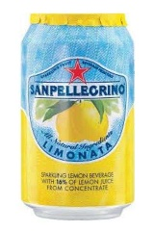



________ aranciata __**una**__ limonata ___**della**__ Coca ___**un**__ Negroni



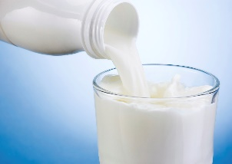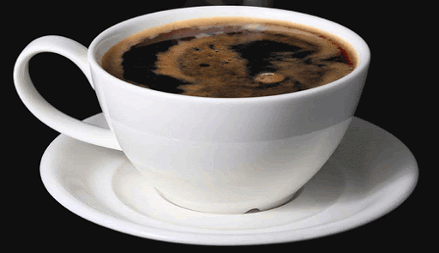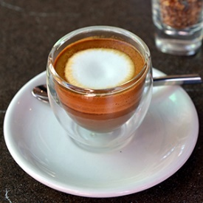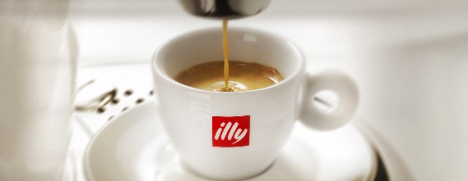



____**il**_ caffè (caldo) _____**il**__ macchiato ___________ americano ________ latte

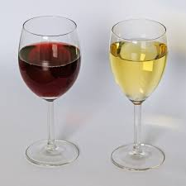

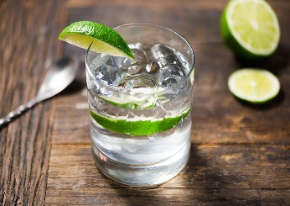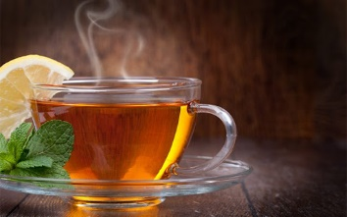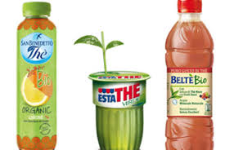



________ tè (caldo) ___**del**_ tè freddo _________ vino _____**un**__ gin e tonic

What else does the man offer the woman? __**Offre uno yogurt e un panino col prosciutto.** ___________

What does the woman end up choosing? ___**Vuole un bicchiere di vino**. __________________________