# *La mia casa è dove sono* (2010)

# a novel by Igiaba Scego

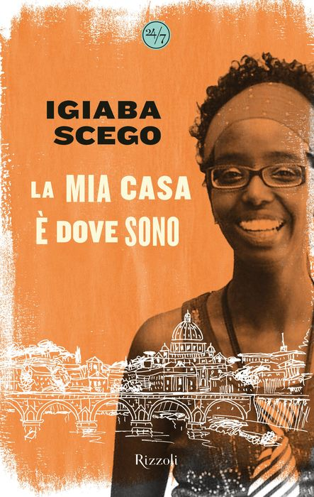

## **Activity 1.** La mia casa è dove sono.

### Igiaba Scego is an Italian writer and activist of Somali origin. Reflect on the following questions:

1) Cosa vuol dire per te la parola “casa”?

2) Questo è il primo libro autobiografico che Scego ha scritto. Cosa vuol dire il titolo, *La mia casa è dove sono*, secondo te?

3) Quali saranno i temi principali del libro? Cosa vorrà comunicare l’autrice?

## **Activity 2A.** Read the text and respond to the following questions:

1. Cosa intende l’autrice quando afferma “la casa ce la portavamo sulle spalle”?
2. Cosa faceva la mamma della narratrice quando era piccola?
3. Come si possono descrivere le fiabe europee e le fiabe somale? Conosci alcune fiabe come quelle della Somalia?

## **Activity 2B.** What are some of the characteristics of the Somali and Euopean fairytales that Scego describes? Write them in the columns below but **don’t copy them directly from the text**—use your own Italian!

|  |  |
| --- | --- |
| Fiabe somale Image result for somalia flag | Fiabe europee Image result for european flag |
|  |  |

## **Activity 3.** Work on small groups. Each student will choose one of the fairytale elements listed in Activity 2B. Together, write a brief fairytale of your own.

Fairytale elements: ______________________________, ___________________________,

__________________________________, _______________________________________, ecc.

Main characters: ________________, ___________________, ____________________, ecc.

Plot: _______________________________________________________________________

C’era una volta… _________________________________________________________

______________________________________________________________________________

______________________________________________________________________________

______________________________________________________________________________

______________________________________________________________________________

______________________________________________________________________________

______________________________________________________________________________

______________________________________________________________________________

______________________________________________________________________________

______________________________________________________________________________

______________________________________________________________________________

______________________________________________________________________________

______________________________________________________________________________

______________________________________________________________________________

______________________________________________________________________________

______________________________________________________________________________