Beverages and articles
Le fate ignoranti (2001)

Activity: Watch the scene and put a checkmark for each item the man offers the woman. Then, write an appropriate article for each option (ex. un, una, il, lo, del, dell’, ecc.). Do you know all of these beverages?





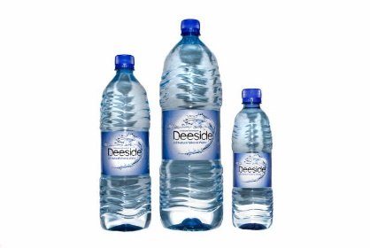
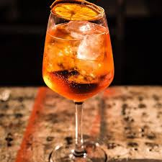
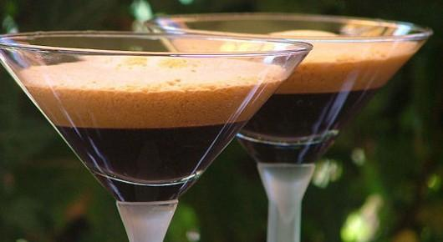
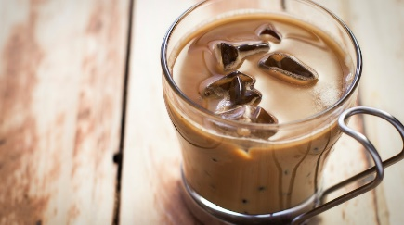

dell’

_________ spritz ________ acqua ________ caffè shakerato ___il__ caffè freddo

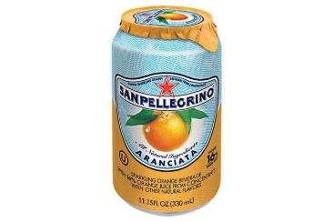



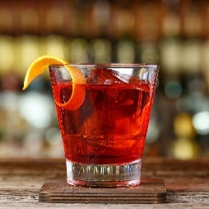
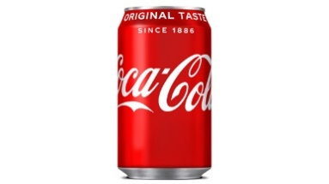
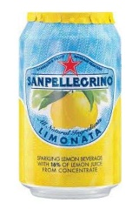

________ aranciata __una__ limonata ___della__ Coca ___un__ Negroni




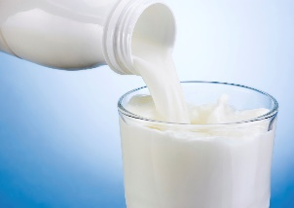
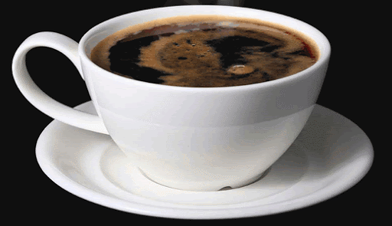
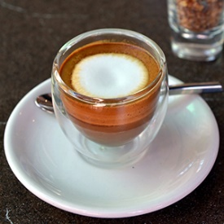
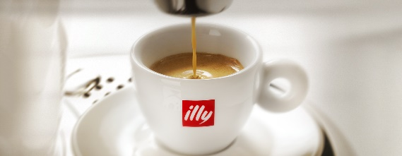

____il_ caffè (caldo) _____il__ macchiato ___________ americano ________ latte
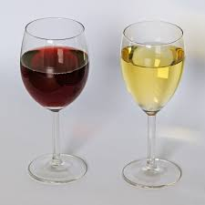



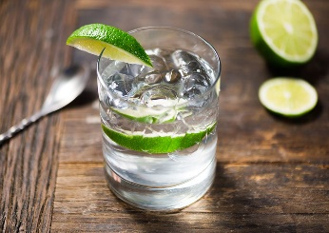
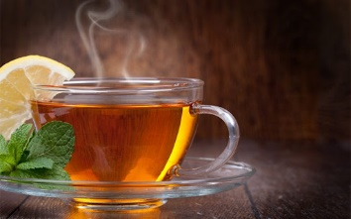

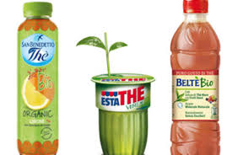

________ tè (caldo) ___del_ tè freddo _________ vino _____un__ gin e tonic

What else does the man offer the woman? __Offre uno yogurt e un panino col prosciutto. ___________

What does the woman end up choosing? ___Vuole un bicchiere di vino. __________________________

