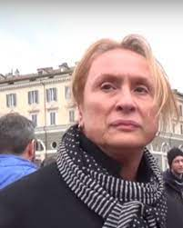
Porpora Marcasciano

Figura simbolo del transfemminismo italiano è sociologa, attivista per i diritti umani e presidente onoraria del Movimento Identità Transessuale di cui ha contribuito a fare la storia. Il suo libro (che comincia con il brano che leggerete qui sotto) AntoloGaia racconta la storia dei movimenti di liberazione sessuale del 1977.
(preso e adatto da: https://www.unadonnalgiorno.it/porpora-favolosa/)

A. Speak with a partner or do a quick Internet search to find responses to these questions.
1. Conosci l’acronimo LGBTQIA+?
2. Quando si parla dei diritti delle persone LGBTQIA+ a che cosa si riferiscono?
3. Cosa conoscete della storia dei movimenti LGBTQIA+ nel tuo paese?
4. Secondo voi la storia è simile o diversa dalla storia dei movimenti LGBTQIA+ in Italia? Perché?

B.1. Watch the video and think about Porpora’s phrases (below). How would you translate them into English? What event/thing is she referring to?

1. “per difendere e sopratutto rivendicare la laicità di questo paese”

_____________________________________________________________________________

2. “è rimasto indietro di secoli”

______________________________________________________________________________

3. “nessuno – i diritti e la liberazione – ce li regala, ce li dobbiamo conquistare con una lotta che è quotidiana”

_____________________________________________________________________________
_____________________________________________________________________________

B2. In your own Italian, how would you summarize Porpora’s message?
_____________________________________________________________________________
_____________________________________________________________________________
_____________________________________________________________________________
_____________________________________________________________________________
_____________________________________________________________________________
C. Read the beginning of Porpora Marcasciano’s book AntoloGaia:

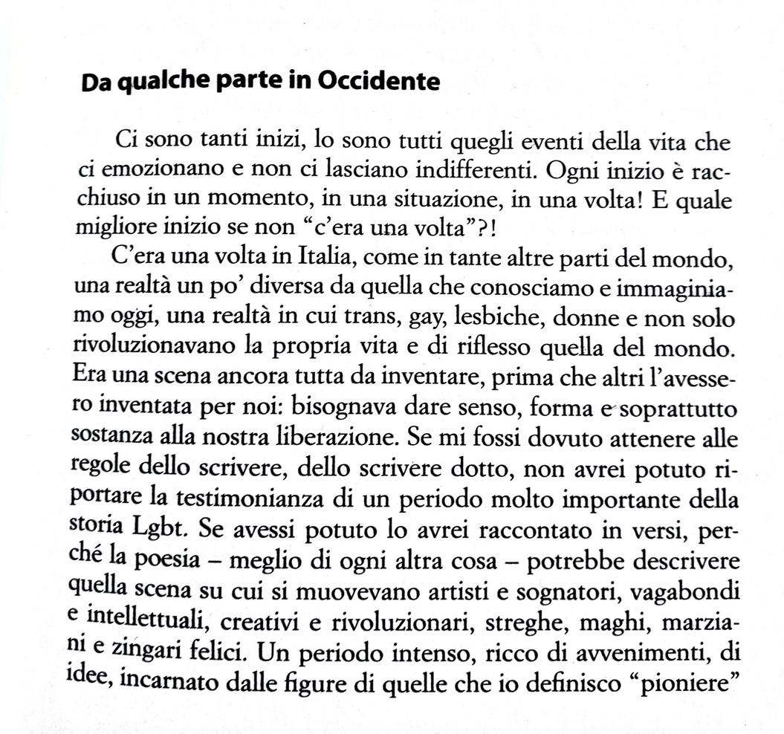

C.1. Comprehension questions:

1. Chi sono i protagonisti di questa storia, e dove si trovano?
____________________________________________________________________________
2. Perché la scrittrice vuole raccontare la storia con la poesia?
____________________________________________________________________________
3. Secondo te qual è il tono di questa storia? Perché?
____________________________________________________________________________
4. Di che cosa parla il libro?
____________________________________________________________________________
C.2. In her text, Porpora uses words like vagabonds (“vagabondi”) and gypsies (“zingare”). While these words might be considered offensive, she chooses to “reappropriate” this language to turn the words into positive terms. Do you know any other words that have been reappropriated? Speak with a partner about the use of offensive words and the power of their reappropriation in your own cultural context. (If necessary, reflect first, write notes, and check a dictionary before beginning the conversation).
C.3. Reread the text and identify all verbs that use the subjunctive mood.

____________________________________________________________________________
____________________________________________________________________________
____________________________________________________________________________

C.4. What type of subjunctives are they? Why are they used?
____________________________________________________________________________
____________________________________________________________________________
____________________________________________________________________________
____________________________________________________________________________
____________________________________________________________________________
____________________________________________________________________________

C.5. Porpora writes:
“Se mi fossi dovuto attenere alle regole dello scrivere… non avrei potuto riportare la testimonianza di un periodo molto importante della storia Lgbt.”
and
“Se avessi potuto lo avrei raccontato in versi”

What kind of statements are they? How are these sentences formed?
____________________________________________________________________________
____________________________________________________________________________
C.6. Write the correct form to create some sentences using the hypothetical period of possibility and impossibility. Don’t forget the agreement when it is necessary!

1. Se gli/le attivisti/e/* non ____________________ (manifestare) durante quell’epoca, gli avanzamenti dei diritti della communità LGBTQIA+ _______________________ (essere) molto più lenti.
2. Se uno _________________ (leggere) il libro Antologaia, _____________________ (capire) di più l’argomento e la storia del movimento in Italia.
3. Se Porpora _________________ (venire) negli Stati Uniti, (lei) ____________________ (potere) presentare il libro agli studenti.
4. Se tutti/e/* noi _________________________ (cercare) di capire gli/le/altri/e/*, (noi) _________________________ (conoscere) meglio le persone.

D. The hypothetical period (impossibility): it is used to describe impossible, past events because other things happened and we cannot go back and change our pasts… however, we can always imagine what might have been.

Think of a moment in which you were involved in something important or something meaningful you took part in. Mimicking the tone and energy of the paragraph written by Porpora Marcasiano, describe what the event was like and how the outcome could have changed if things had been done differently of if you had done something differently.

____________________________________________________________________________
____________________________________________________________________________
____________________________________________________________________________
____________________________________________________________________________
____________________________________________________________________________
____________________________________________________________________________
____________________________________________________________________________
____________________________________________________________________________

