Classroom Vocabulary
Baaria (Giuseppe Tornatore, 2009)

Activity 1. In this scene from the film Baaria, the elementary school students are in class. What’s the difference between “alunni” and “studenti” in Italian? And “maestro/a” e “insegnante”? Read to find out:

In English: “students”; in Italian:



gli alunni / le alunne / lƏ alunnƏ
(frequentano le scuole elementari)
gli studenti” / le studentesse / lƏ studentƏ
(frequentano la scuola media, il liceo, l’università)

In English: “teacher”; in Italian:




la maestra / il maestro / lƏ maestrƏ il professore / la professoressa / lƏ professorƏ
(insegna alle scuole elementari, all’asilo) (insegna all’università, al college)
l’insegnante
l’insegnantƏ
(insegna alle scuole medie, al liceo)

Write the appropriate words in the blanks.
le studentesse

1. Chi frequenta il liceo? ____________________, _____________________________, ______________________

2. Chi insegna all’università? ______________________, ________________________, ______________________

3. Chi frequenta le scuole elementari? ___________________, ___________________, _______________________

4. Chi insegna alle scuole elementari? ___________________, ____________________, ______________________

Activity 2.

C’è = (there is), singolare: C’è un libro. Ci sono = (there are), plurale: Ci sono tre libri.

What’s in this image? Write three objects you see. Use the vocabulary and an indefinite article.

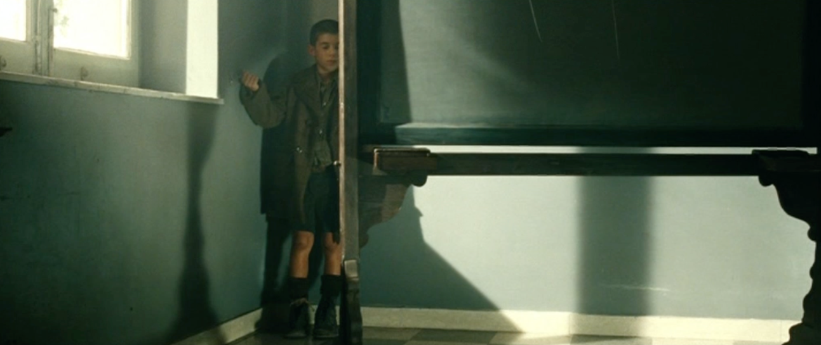

C’è ______________________. C’è ________________________. C’è _______________________.

What’s in this image? Use the new vocabulary and an article (or number).

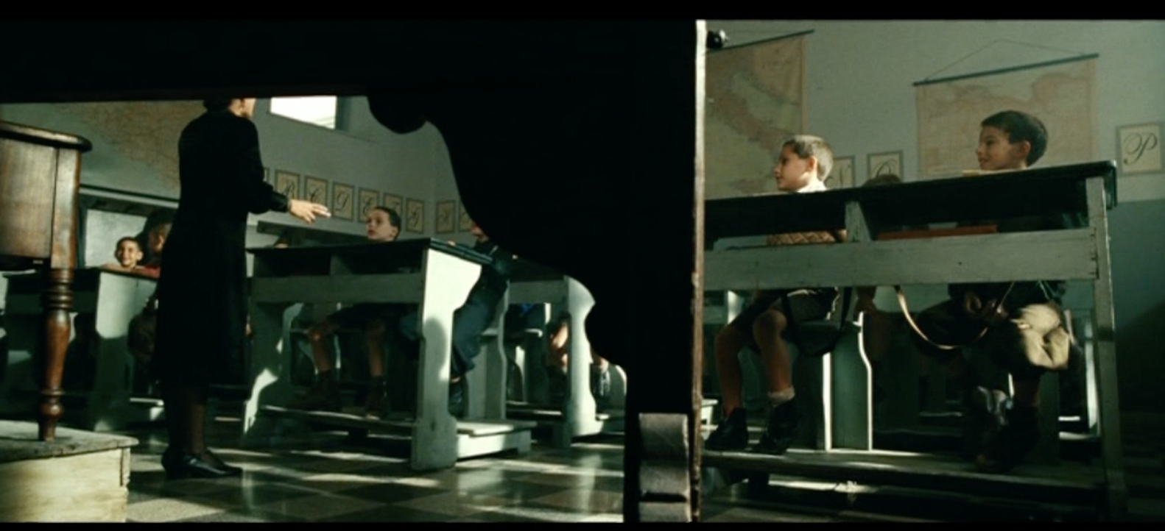

C’è ______________________________. C’è _________________________________.

Ci sono ___________________________. Ci sono ______________________________.

C’è ___________________________. Ci sono ______________________________.
Activity 3. What’s your classroom like? Draw a picture of it and present it to a classmate, using vocabulary and “c’è” and “ci sono” to describe the objects featured.

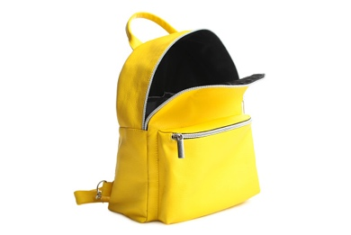

Activity 4. What’s in your backpack? Use the vocabulary, “c’è” or “ci sono,” and an article (or number) to respond to the question.

Nel mio zaino c’è…. Nel mio zaino ci sono…

__________________________________________________________________________________________________________________________________________________________________________________________________________________________________________
__________________________________________________________________________________________________________________________________________________________________________________________________________________________________________

