La mia casa è dove sono (2010)

a novel by Igiaba Scego
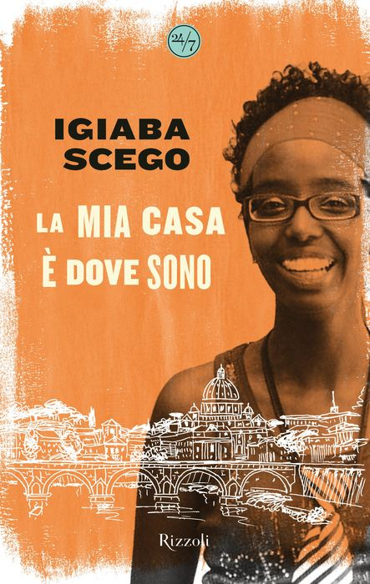

Activity 1. La mia casa è dove sono.

Igiaba Scego is an Italian writer and activist of Somali origin. Reflect on the following questions:

1) Cosa vuol dire per te la parola “casa”?
2) Questo è il primo libro autobiografico che Scego ha scritto. Cosa vuol dire il titolo, La mia casa è dove sono, secondo te?
3) Quali saranno i temi principali del libro? Cosa vorrà comunicare l’autrice?

Activity 2A. Read the text and respond to the following questions:

- Cosa intende l’autrice quando afferma “la casa ce la portavamo sulle spalle”?
- Cosa faceva la mamma della narratrice quando era piccola?
- Come si possono descrivere le fiabe europee e le fiabe somale? Conosci alcune fiabe come quelle della Somalia?

Activity 2B. What are some of the characteristics of the Somali and Euopean fairytales that Scego describes? Write them in the columns below but don’t copy them directly from the text—use your own Italian!

Fiabe somale  | Fiabe europee 

Activity 3. Work on small groups. Each student will choose one of the fairytale elements listed in Activity 2B. Together, write a brief fairytale of your own.

Fairytale elements: ______________________________, ___________________________,

__________________________________, _______________________________________, ecc.

Main characters: ________________, ___________________, ____________________, ecc.

Plot: _______________________________________________________________________

C’era una volta… _________________________________________________________

______________________________________________________________________________

______________________________________________________________________________

______________________________________________________________________________

______________________________________________________________________________

______________________________________________________________________________

______________________________________________________________________________

______________________________________________________________________________

______________________________________________________________________________

______________________________________________________________________________

______________________________________________________________________________

______________________________________________________________________________

______________________________________________________________________________

______________________________________________________________________________

______________________________________________________________________________

______________________________________________________________________________

