1. **Aim:** Create a servlet demonstrating the use of session creation and destruction. Also check whether the user has visited this page first time or has visited earlier also using sessions.

**Program Code:**

**index.html**

<html>

<head><title>Session Demo</title></head>

<form action="Page1" method="get" >

Enter User ID <input type="text" name="txtName"><br>

<input type="reset" ><input type="submit" >

</form>

</html>

**Page1.java**

package mypack;

import java.io.IOException;

import java.io.PrintWriter;

import javax.servlet.ServletException;

import javax.servlet.http.HttpServlet;

import javax.servlet.http.HttpServletRequest;

import javax.servlet.http.HttpServletResponse;

import javax.servlet.http.HttpSession;

public class Page1 extends HttpServlet {

public void doGet(HttpServletRequest request, HttpServletResponse response)

throws ServletException, IOException {

response.setContentType("text/html;charset=UTF-8");

PrintWriter out = response.getWriter();

out.println("<html><head><title>Servlet Page1</title></head>");

HttpSession hs = request.getSession(true);

if(hs.isNew()){

out.println("<body bgcolor=yellow>");

String name = request.getParameter("txtName");

hs.setAttribute("uname", name);

hs.setAttribute("visit", "1");

out.println("<h1>Welcome First Time</h1>");

}

else{

out.println("<h1>Welcome Again</h1>");

int visit = Integer.parseInt((String)hs.getAttribute("visit"))+1;

out.println("<h1>You Visited "+visit+"Times</h1>");

hs.setAttribute("visit", ""+visit);

}

out.println("<h1>Your Session ID "+hs.getId()+"</h1>");

out.println("<h1>You Logged in at "+new java.util.Date(hs.getCreationTime())+"</h1>");

out.println("<h1><a href=Page2>Click for Page 2 </a></h1>");

out.println("<h1><a href=Page3>Click for Page 3 </a></h1>");

out.println("<h1><a href=Page4>Click for Page 4 </a></h1>");

out.println("<h1><a href=LogoutServlet>Click to Terminate Session </a></h1>");

out.println("</body>");

out.println("</html>");

}

}

**Page2.java**

package mypack;

import java.io.IOException;

import java.io.PrintWriter;

import javax.servlet.ServletException;

import javax.servlet.http.HttpServlet;

import javax.servlet.http.HttpServletRequest;

import javax.servlet.http.HttpServletResponse;

import javax.servlet.http.HttpSession;

public class Page2 extends HttpServlet {

public void doGet(HttpServletRequest request, HttpServletResponse response)

throws ServletException, IOException {

response.setContentType("text/html;charset=UTF-8");

PrintWriter out = response.getWriter();

out.println("<html><head><title>Servlet Page2</title></head>");

HttpSession hs = request.getSession(false);

out.println("<h1>Welcome Again on Page No. 2</h1>");

int visit = Integer.parseInt((String)hs.getAttribute("visit"))+1;

out.println("<h1>You Visited "+visit+"Times</h1>");

hs.setAttribute("visit", ""+visit);

out.println("<h1>Your Session ID "+hs.getId()+"</h1>");

out.println("<h1>You Logged in at "+new java.util.Date(hs.getCreationTime())+"</h1>");

out.println("<h1><a href=Page1>Click for Page 1 </a></h1>");

out.println("<h1><a href=Page3>Click for Page 3 </a></h1>");

out.println("<h1><a href=Page4>Click for Page 4 </a></h1>");

out.println("<h1><a href=LogoutServlet>Click for Terminate Session </a></h1>");

out.println("</body>");

out.println("</html>");

}

}

**Page3.java**

package mypack;

import java.io.IOException;

import java.io.PrintWriter;

import javax.servlet.ServletException;

import javax.servlet.http.HttpServlet;

import javax.servlet.http.HttpServletRequest;

import javax.servlet.http.HttpServletResponse;

import javax.servlet.http.HttpSession;

public class Page3 extends HttpServlet {

public void doGet(HttpServletRequest request, HttpServletResponse response)

throws ServletException, IOException {

response.setContentType("text/html;charset=UTF-8");

PrintWriter out = response.getWriter();

out.println("<html><head><title>Servlet Page3</title></head>");

HttpSession hs = request.getSession(false);

out.println("<h1>Welcome Again on Page 3</h1>");

int visit = Integer.parseInt((String)hs.getAttribute("visit"))+1;

out.println("<h1>You Visited "+visit+"Times</h1>");

hs.setAttribute("visit", ""+visit);

out.println("<h1>Your Session ID "+hs.getId()+"</h1>");

out.println("<h1>You Logged in at "+new java.util.Date(hs.getCreationTime())+"</h1>");

out.println("<h1><a href=Page1>Click for Page 1 </a></h1>");

out.println("<h1><a href=Page2>Click for Page 2 </a></h1>");

out.println("<h1><a href=Page4>Click for Page 4 </a></h1>");

out.println("<h1><a href=LogoutServlet>Click for Terminate Session </a></h1>");

out.println("</body>");

out.println("</html>");

}

}

**Page4.java**

package mypack;

import java.io.IOException;

import java.io.PrintWriter;

import javax.servlet.ServletException;

import javax.servlet.http.HttpServlet;

import javax.servlet.http.HttpServletRequest;

import javax.servlet.http.HttpServletResponse;

import javax.servlet.http.HttpSession;

public class Page4 extends HttpServlet {

public void doGet(HttpServletRequest request, HttpServletResponse response)

throws ServletException, IOException {

response.setContentType("text/html;charset=UTF-8");

PrintWriter out = response.getWriter();

out.println("<html><head><title>Servlet Page2</title></head>");

HttpSession hs = request.getSession(false);

out.println("<h1>Welcome Again on Page No. 4</h1>");

int visit = Integer.parseInt((String)hs.getAttribute("visit"))+1;

out.println("<h1>You Visited "+visit+"Times</h1>");

hs.setAttribute("visit", ""+visit);

out.println("<h1>Your Session ID "+hs.getId()+"</h1>");

out.println("<h1>You Logged in at "+new java.util.Date(hs.getCreationTime())+"</h1>");

out.println("<h1><a href=Page1>Click for Page 1 </a></h1>");

out.println("<h1><a href=Page2>Click for Page 2 </a></h1>");

out.println("<h1><a href=Page3>Click for Page 3 </a></h1>");

out.println("<h1><a href=LogoutServlet>Click for Terminate Session </a></h1>");

out.println("</body>");

out.println("</html>");

}

}

**LogoutServlet.java**

package mypack;

import java.io.IOException;

import java.io.PrintWriter;

import javax.servlet.ServletException;

import javax.servlet.http.HttpServlet;

import javax.servlet.http.HttpServletRequest;

import javax.servlet.http.HttpServletResponse;

public class LogoutServlet extends HttpServlet {

public void doGet(HttpServletRequest request, HttpServletResponse response)

throws ServletException, IOException {

response.setContentType("text/html;charset=UTF-8");

PrintWriter out = response.getWriter();

out.println("<html>");

out.println("<head>");

out.println("<title>Servlet LogoutServlet</title>");

out.println("</head>");

out.println("<body>");

javax.servlet.http.HttpSession hs = request.getSession();

if(hs != null) hs.invalidate();

out.println("<h1>You are Logged out now........</h1>");

out.println("</body>");

out.println("</html>");

}

}

**Output:**

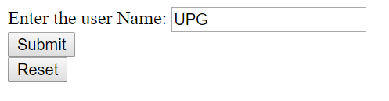

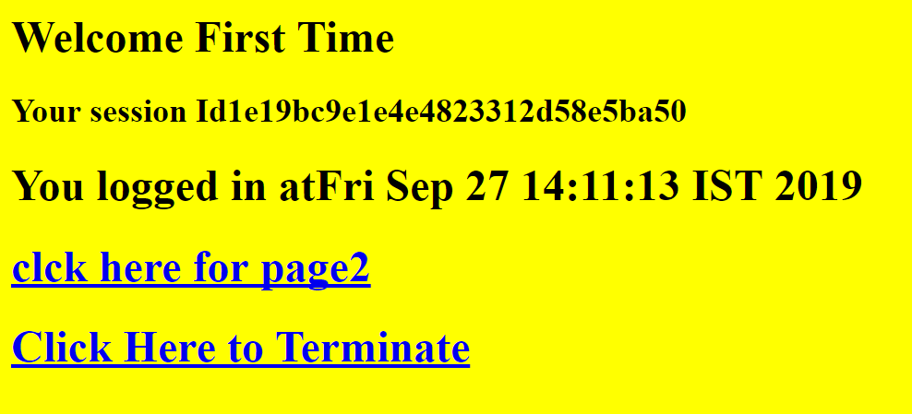

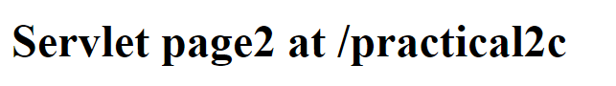

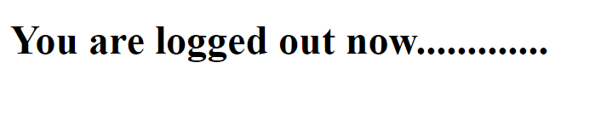

**Practical-3**

1. **Aim:** Create a servlet application to upload and download a file.

**Program Code:**

**index.html**

<!DOCTYPE html>

<!--

To change this license header, choose License Headers in Project Properties.

To change this template file, choose Tools | Templates

and open the template in the editor.

-->

<html>

<body>

<form action="FileUploadServlet" method="post" enctype="multipart/form-data">

Select File to Upload:<input type="file" name="file" id="file"><br>

<br>

Destination <input type="text" value="/tmp" name="destination">

<br>

<br>

<input type="submit" value="Upload file" name="upload" id="upload">

</form>

<br><br>

<h1>File Download Application</h1>

Click <a href="FileDownloadServlet?filename=Cyber.txt">Cyber</a>

<br/><br/>

Click <a href="FileDownloadServlet?filename=CyberSecurity.txt">Cyber Security</a>

</body> </html>

**FileDownloadServlet.java**

package mypack;

import java.io.IOException;

import java.io.InputStream;

import java.io.PrintWriter;

import javax.servlet.ServletContext;

import javax.servlet.ServletException;

import javax.servlet.ServletOutputStream;

import javax.servlet.annotation.WebServlet;

import javax.servlet.http.HttpServlet;

import javax.servlet.http.HttpServletRequest;

import javax.servlet.http.HttpServletResponse;

@WebServlet(name = "FileDownloadServlet", urlPatterns={"/FileDownloadServlet"})

public class FileDownloadServlet extends HttpServlet {

protected void processRequest(HttpServletRequest request, HttpServletResponse response)

throws ServletException, IOException {

response.setContentType("text/html;charset=UTF-8");

String fileToDownload = request.getParameter("filename");

System.err.println("Downloading file now...");

downloadFile(request,response,fileToDownload);

}

private void downloadFile(HttpServletRequest request, HttpServletResponse response, String fileName ) throws ServletException, IOException{

int length = 0;

try(ServletOutputStream outputStream = response.getOutputStream()){

ServletContext context = getServletConfig().getServletContext();

response.setContentType((context.getMimeType(fileName) !=null) ?

context.getMimeType(fileName) : "application/pdf");

response.setHeader("Content-Disposition", "attachment; filename=\""+

fileName);

InputStream inputStream = context.getResourceAsStream("/"+

fileName);

byte[] bytes = new byte[1024];

while((inputStream !=null) && ((length = inputStream.read(bytes)) != -1)){

outputStream.write(bytes,0,length);

}

outputStream.flush();

}

}

**FileUploadServlet.java**

package myPack;

import java.io.File;

import java.io.FileNotFoundException;

import java.io.FileOutputStream;

import java.io.IOException;

import java.io.InputStream;

import java.io.OutputStream;

import java.io.PrintWriter;

import javax.servlet.ServletException;

import javax.servlet.annotation.MultipartConfig;

import javax.servlet.http.HttpServlet;

import javax.servlet.http.HttpServletRequest;

import javax.servlet.http.HttpServletResponse;

import javax.servlet.http.Part;

@MultipartConfig

public class FileUploadServlet extends HttpServlet {

protected void processRequest(HttpServletRequest req, HttpServletResponse res)

throws ServletException, IOException {

res.setContentType("text/html;charset=UTF-8");

PrintWriter out = res.getWriter();

String path = req.getParameter("destination");

Part filePart = req.getPart("file");

String filename = filePart.getSubmittedFileName().toString();

out.print("<br><br><hr> file name: "+filename);

OutputStream os = null;

InputStream is = null;

try {

os = new FileOutputStream(new File(path+File.separator+filename));

is = filePart.getInputStream();

int read=0;

while ((read = is.read()) != -1) {

os.write(read);

}

out.println("<br>file uploaded sucessfully...!!!");

}

catch(FileNotFoundException e){out.print(e);}

}

}

**Output:**

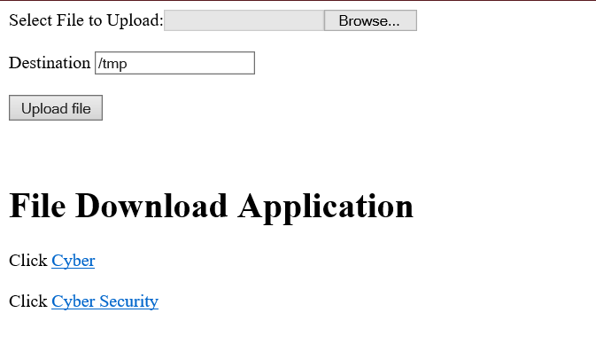

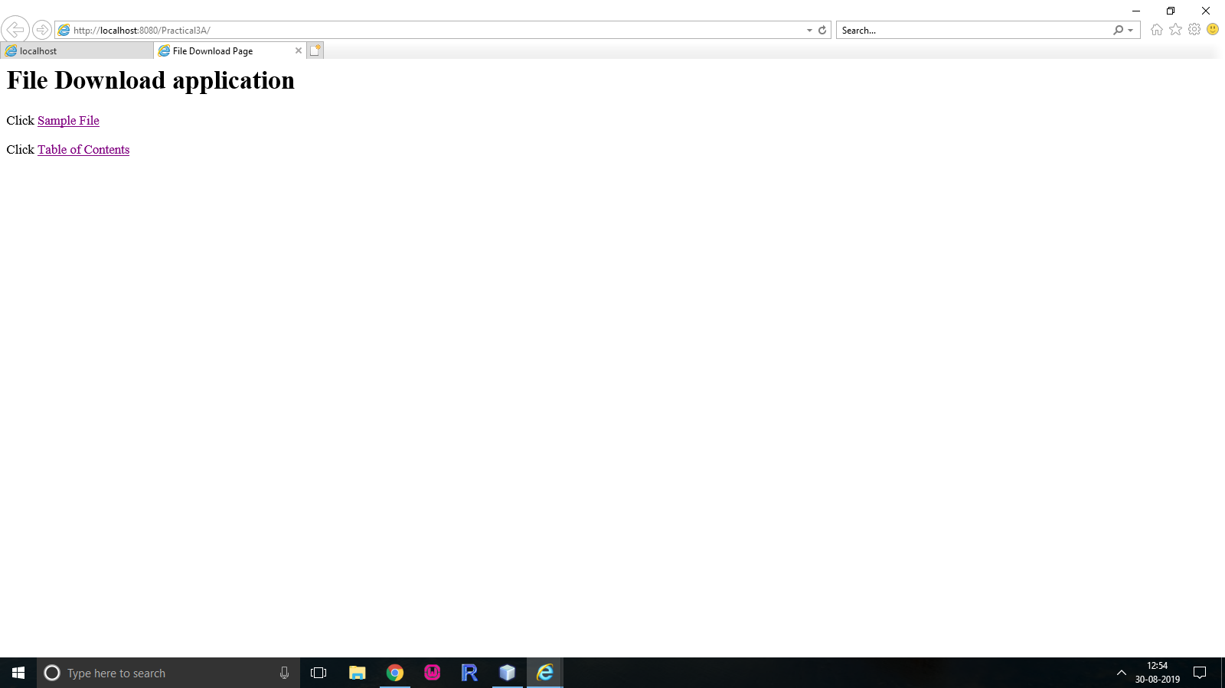

1. **Aim:** Develop Simple Servlet Question Answer Application using Database.

**Program Code:**

**index.html**

<html> <head><title>Quiz Application</title></head>

<body>

<h1>Welcome to Quiz Servlet </h1>

<h1><a href="QuizServlet" >CLICK TO START QUIZ</a></h1>

</body>

</html>

**QuizServlet.java**

package mypack;

import java.io.*;

import java.sql.*;

import javax.servlet.*;

import javax.servlet.http.*;

public class QuizServlet extends HttpServlet {

public void doGet(HttpServletRequest request, HttpServletResponse response)

throws ServletException, IOException {

response.setContentType("text/html;charset=UTF-8");

PrintWriter out = response.getWriter();

out.println("<form action=ShowResult >");

try {

Class.forName("com.mysql.jdbc.Driver");

Connection con = DriverManager.getConnection("jdbc:mysql://localhost:3306/qadb","root","root");

Statement stmt = con.createStatement();

ResultSet res = stmt.executeQuery("select * from quiz");

out.println("<table border=1 >");

int qno=0;

while(res.next()){

qno++;

out.println("<tr><td>"+res.getString(1)+"</td>");

out.println("<td>"+res.getString(2)+"</td></tr>");

out.println("<tr><td><input type=radio name="+qno+" value="+res.getString(3)+"></td><td>"+res.getString(3)+"</td></tr>");

out.println("<tr><td><input type=radio name="+qno+" value="+res.getString(4)+"></td><td>"+res.getString(4)+"</td></tr>");

out.println("<tr><td><input type=radio name="+qno+" value="+res.getString(5)+"></td><td>"+res.getString(5)+"</td></tr>");

out.println("<tr><td><input type=radio name="+qno+" value="+res.getString(6)+"></td><td>"+res.getString(6)+"</td></tr>");

}

}catch(Exception e){out.println(e);}

out.println("</table>");

out.println("<input type=reset >");

out.println("<input type=submit value=SUBMIT >");

out.println("</form>");

}

}

**ShowResult.java**

package mypack;

import java.io.*;

import java.sql.*;

import javax.servlet.*;

import javax.servlet.http.*;

public class ShowResult extends HttpServlet {

public void doGet(HttpServletRequest request, HttpServletResponse response)

throws ServletException, IOException {

response.setContentType("text/html;charset=UTF-8");

PrintWriter out = response.getWriter();

try {

Class.forName("com.mysql.jdbc.Driver");

Connection con = DriverManager.getConnection("jdbc:mysql://localhost:3306/qadb","root","root");

Statement stmt = con.createStatement();

ResultSet res = stmt.executeQuery("select ans from quiz");

int count =0, qno=0;

while(res.next()){

if(res.getString(1).equals(request.getParameter(""+(++qno))))

{ count++;

out.println("<h1>Correct </h1>");

}

else {

out.println("<h1>Incorrect </h1>");

}

}

out.println("<h1>Your Score is "+count+" </h1>");

}catch(Exception e){out.println(e);}

} }

**Output:**

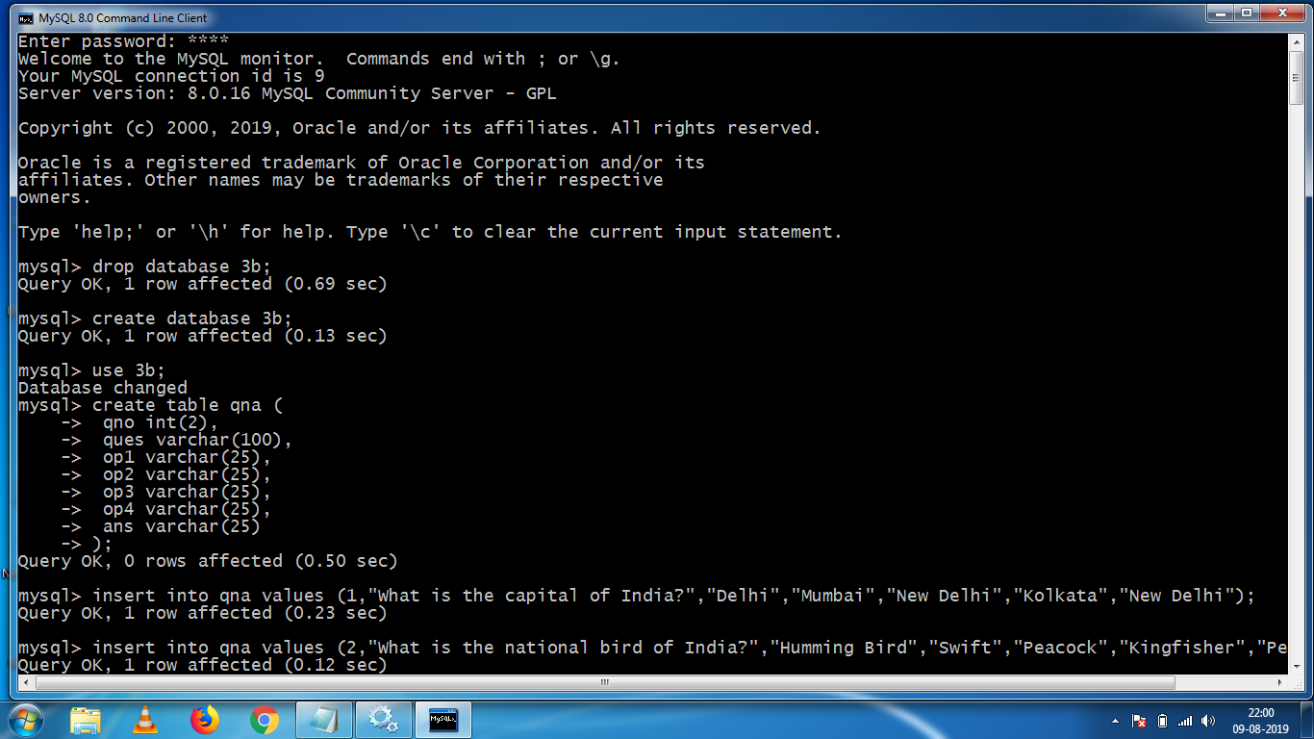

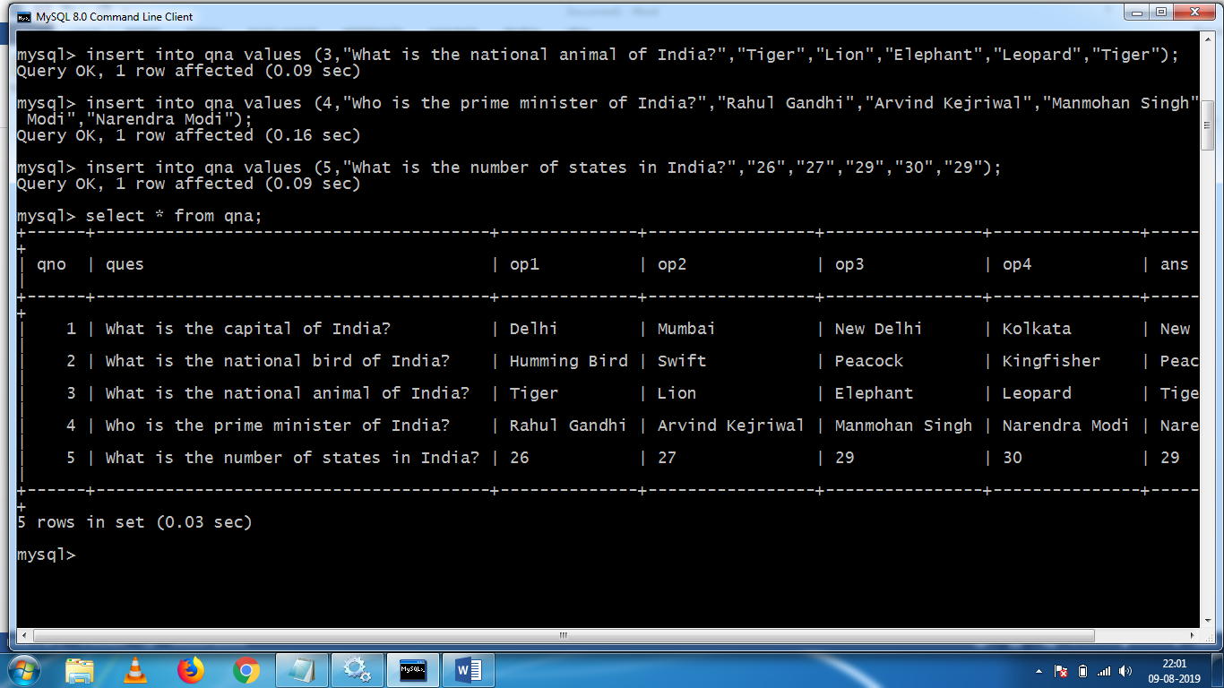

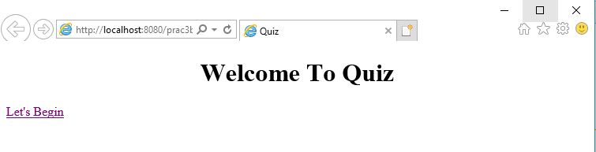

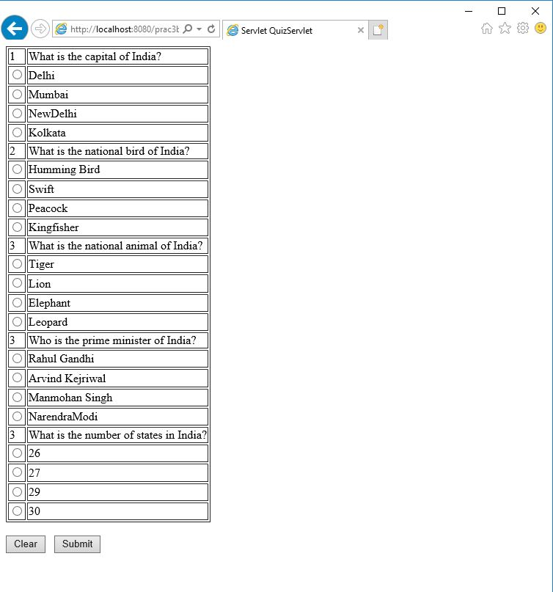

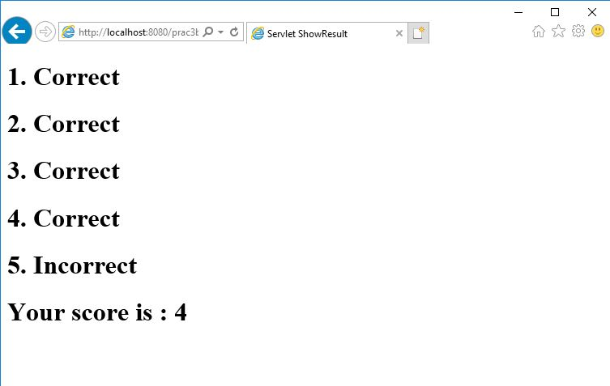

1. **Aim:** Create simple Servlet application to demonstrate Non-Blocking Read Operation.

**Program Code:**

**index.html**

<html>

<head>

<title>Non Blocking IO</title>

<meta charset="UTF-8">

<meta http-equiv="Refresh" content="0; URL=NonBlockingServlet">

</head>

<body>

</body>

</html>

**NonBlockingServlet.java**

package nonblkapp;

import java.io.*;

import java.net.*;

import javax.servlet.*;

import javax.servlet.http.*;

public class NonBlockingServlet extends HttpServlet {

protected void service(HttpServletRequest request, HttpServletResponse response)

throws ServletException, IOException {

response.setContentType("text/html;charset=UTF-8");

try (PrintWriter out = response.getWriter()) {

/* TODO output your page here. You may use following sample code. */

out.println("<h1>FileReader</h1>");

String filename="/booklist.txt";

ServletContext c=getServletContext();

InputStream in=c.getResourceAsStream(filename);

String path="http://"+request.getServerName()+":"+request.getServerPort()+request.getContextPath()+"/ReadingNonBloclingServlet";

URL url=new URL(path);

HttpURLConnection conn=(HttpURLConnection)url.openConnection();

conn.setChunkedStreamingMode(2); //number of bytes to write in each chunk.

conn.setDoOutput(true);

conn.connect();

if(in!=null)

{

InputStreamReader inr=new InputStreamReader(in);

BufferedReader br = new BufferedReader(inr);

String text="";

System.out.println("Reading started....");

BufferedWriter bw=new BufferedWriter(new OutputStreamWriter(conn.getOutputStream()));

while((text=br.readLine())!=null){

out.print("<hr>"+text);

try{

Thread.sleep(1000);

out.flush();

}catch(Exception ex){ out.println(ex); }

}out.print("reading completed....");

bw.flush();

bw.close();

}

}

}

}

**ReadingListener.java**

package nonblkapp;

import java.io.IOException;

import java.util.logging.Level;

import java.util.logging.Logger;

import javax.servlet.AsyncContext;

import javax.servlet.ReadListener;

import javax.servlet.ServletInputStream;

public class ReadingListener implements ReadListener

{

private ServletInputStream input = null;

private AsyncContext ac = null;

ReadingListener(ServletInputStream in, AsyncContext c) {

input = in;

ac = c;

}

@Override

public void onDataAvailable() throws IOException {

}

public void onAllDataRead() throws IOException {

ac.complete();

}

public void onError(final Throwable t) {

ac.complete();

t.printStackTrace();

}

}

**ReadingNonBlocingServlet.java**

package nonblkapp;

import java.io.IOException;

import java.io.PrintWriter;

import javax.servlet.AsyncContext;

import javax.servlet.ServletException;

import javax.servlet.ServletInputStream;

import javax.servlet.annotation.WebServlet;

import javax.servlet.http.HttpServlet;

import javax.servlet.http.HttpServletRequest;

import javax.servlet.http.HttpServletResponse;

/**

*

* @author Beena Kapadia

*/

@WebServlet (name = "ReadingNonBlockingServlet", urlPatterns = {"/ReadingNonBlockingServlet"},asyncSupported = true )

public class ReadingNonBlockingServlet extends HttpServlet {

@Override

protected void service(HttpServletRequest request, HttpServletResponse response)

throws ServletException, IOException {

response.setContentType("text/html");

AsyncContext ac = request.startAsync();

ServletInputStream in=request.getInputStream();

in.setReadListener(new ReadingListener(in,ac));

}

}

**Output:**

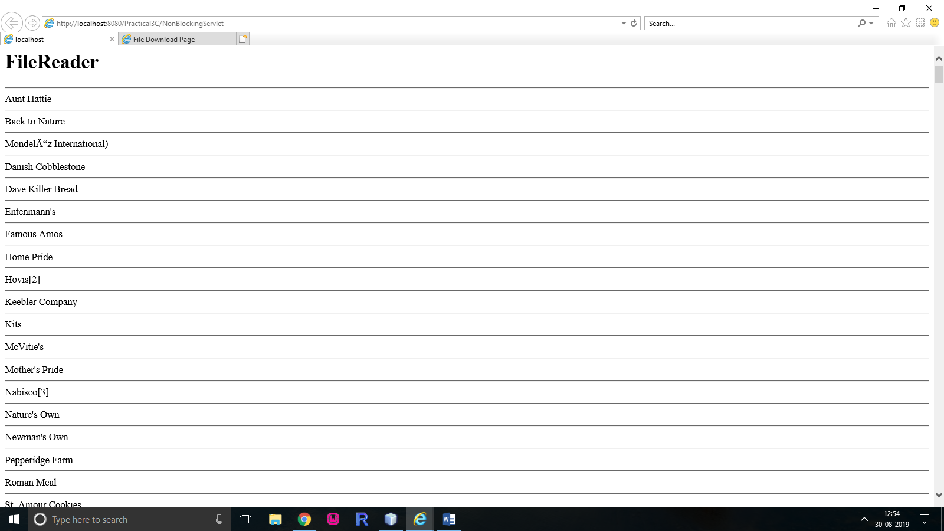

**Practical-4**

1. **Aim:** Develop a simple JSP application to display values obtained from the use of intrinsic objects of various types.

**Program Code:**

**index.html**

<!DOCTYPE html>

<!--

To change this license header, choose License Headers in Project Properties.

To change this template file, choose Tools | Templates

and open the template in the editor.

-->

<html>

<head>

<title>TODO supply a title</title>

<meta charset="UTF-8">

<meta name="viewport" content="width=device-width, initial-scale=1.0">

</head>

<body>

<div>TODO write content</div>

<a href="Prac_4A.jsp">Click Here</a>

</body>

</html>

**Prac_4A.jsp**

<%@page contentType="text/html" pageEncoding="UTF-8"%>

<html><head><title>JSP Page</title></head>

<body>

<h1>Use of Intrinsic Objects in JSP</h1>

<h1>Request Object </h1>

Query String <%=request.getQueryString() %><br>

Context Path <%=request.getContextPath() %><br>

Remote Host <%=request.getRemoteHost() %><br>

<h1>Response Object </h1>

Character Encoding Type <%=response.getCharacterEncoding() %><br>

Content Type <%=response.getContentType() %><br>

Locale <%=response.getLocale() %><br>

<h1>Session Object </h1>

ID <%=session.getId() %><br>

Creation Time <%=new java.util.Date(session.getCreationTime()) %><br>

Last Access Time<%=new java.util.Date(session.getLastAccessedTime()) %><br>

</body>

</html>

**Output:**

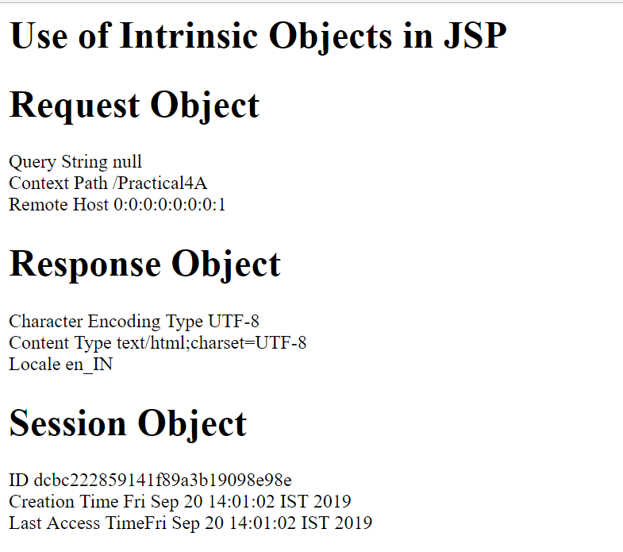

1. **Aim:** Develop a simple JSP application to pass values from one page to another with validations. (Name-txt, age-txt, hobbies-checkbox, email-txt,gender-radio button).

**Program Code:**

**index.html**

<html><head><title>User Information Paage</title>

</head>

<body>

<form action="Validate.jsp">

Enter Your Name<input type="text" name="name" ><br>

Enter Your Age<input type="text" name="age" ><br>

Select Hobbies

<input type="checkbox" name="hob" value="Singing">Singing

<input type="checkbox" name="hob" value="Reading">Reading Books

<input type="checkbox" name="hob" value="Football">Playing Football<br>

Enter E-mail<input type="text" name="email" ><br>

Select Gender

<input type="radio" name="gender" value="male">Male

<input type="radio" name="gender" value="female">Female

<input type="radio" name="gender" value="other">Other<br>

<input type="hidden" name="error" value="">

<input type="submit" value="Submit Form">

<br>

</form>

</body>

</html>

**Validate.jsp**

<%@page contentType="text/html" pageEncoding="UTF-8" import="mypack.*" %>

<html><head><title>JSP Page</title></head>

<body>

<h1>Validation Page</h1>

<jsp:useBean id="obj" scope="request"

class="mypack.CheckerBean" >

<jsp:setProperty name="obj" property="*"/>

</jsp:useBean>

<%

if (obj.validate())

{

%>

<jsp:forward page="successful.jsp"/>

<% }

else {

%>

<jsp:include page="index.html"/>

<%}%>

<%=obj.getError() %>

</body>

</html>

**CheckerBean.java**

package mypack;

public class CheckerBean {

private String name, age, hob, email, gender,error;

public CheckerBean(){error="";}

public void setName(String n){name=n;}

public void setAge(String a){age=a;}

public void setHob(String h){hob=h;}

public void setEmail(String e){email=e;}

public void setGender(String g){gender=g;}

public void setError(String e){error=e;}

public String getName(){return name;}

public String getAge(){return age;}

public String getHob(){return hob;}

public String getEmail(){return email;}

public String getGender(){return gender;}

public String getError(){return error;}

public boolean validate(){

boolean res=true;

if(name.trim().equals("")) {error+="<br>Enter First Name";res=false;}

if(age.length() > 2 )

{error+="<br>Age Invalid";res=false;}

return res;

}

}

**successful.jsp**

<html>

<head>

<meta http-equiv="Content-Type" content="text/html; charset=UTF-8">

<title>JSP Page</title>

</head>

<body>

<h1>DATA VALIDATED SUCCESSFULLY </h1>

</body>

</html>

**Output:**

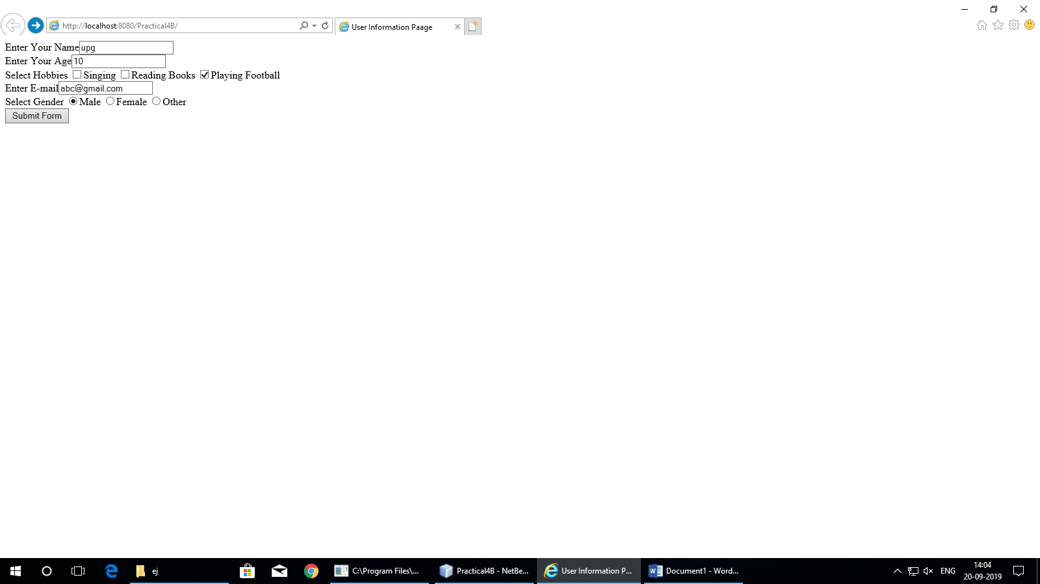

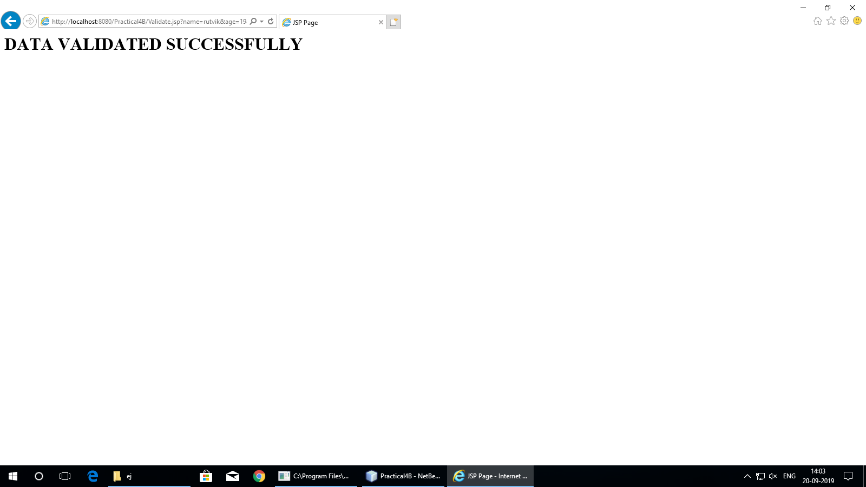

1. **Aim:** Create a registration and login JSP application to register and authenticate the user based on username and password using JDBC.

**Program Code:**

**index.html**

<html>

<head><title>JSP With JDBC</title></head>

<body>

<h1><a href="Register.html" >New User Register Here</a></h1>

<h1><a href="Login.html" >Click Here to Login</a></h1>

</body>

</html>

**Regsiter.html**

<html><head><title>New User Registration Page</title></head>

<body>

<form action="Register.jsp" >

<h1> New User Registration Page</h1>

Enter User Name <input type="text" name="txtName" ><br>

Enter Password <input type="password" name="txtPass1" ><br>

Re-Enter Password<input type="password" name="txtPass2" ><br>

Enter Email<input type="text" name="txtEmail" ><br>

Enter Country Name <input type="text" name="txtCon" ><br>

<input type="reset" ><input type="submit" value="REGISTER" >

</form>

</body>

</html>

**Register.jsp**

<%@page contentType="text/html" import="java.sql.*"%>

<html><body>

<h1>Registration JSP Page</h1>

<%

String uname=request.getParameter("txtName");

String pass1 = request.getParameter("txtPass1");

String pass2 = request.getParameter("txtPass2");

String email = request.getParameter("txtEmail");

String ctry = request.getParameter("txtCon");

if(pass1.equals(pass2)){

try{

Class.forName("com.mysql.jdbc.Driver");

Connection con = DriverManager.getConnection("jdbc:mysql://localhost:3306/4c");

PreparedStatement stmt = con.prepareStatement("insert into user values (?,?,?,?)");

stmt.setString(1, uname); stmt.setString(2, pass1);

stmt.setString(3, email); stmt.setString(4, ctry);

int row = stmt.executeUpdate();

if(row==1) { out.println("Registration Successful"); }

else {

out.println("Registration FFFFFAAAIIILLLL !!!!");

%>

<jsp:include page="Register.html" ></jsp:include>

<%

}

}catch(Exception e){out.println(e);}

}

else

{

out.println("<h1>Password Mismatch</h1>");

%>

<jsp:include page="Register.html" ></jsp:include>

<% }

%>

</body>

</html>

**Login.html**

<html>

<body>

<h1>Login Page</h1>

<form action="Login.jsp" >

Enter User Name <input type="text" name="txtName" ><br>

Enter Password <input type="password" name="txtPass" ><br>

<input type="reset" ><input type="submit" value="~~~LOGIN~~" >

</form>

</body>

</html>

**Login.jsp**

<%@page contentType="text/html" import="java.sql.*"%>

<html><body>

<h1>Registration JSP Page</h1>

<%

String uname=request.getParameter("txtName");

String pass = request.getParameter("txtPass");

try{

Class.forName("com.mysql.jdbc.Driver");

Connection con = DriverManager.getConnection("jdbc:mysql://localhost:3306/4c");

PreparedStatement stmt = con.prepareStatement("select password from user where username=?");

stmt.setString(1, uname);

ResultSet rs = stmt.executeQuery();

if(rs.next()){

if(pass.equals(rs.getString(1)))

{

out.println("<h1>~~~ LOGIN SUCCESSFULLL ~~~ </h1>");

}

}

else{

out.println("<h1>User Name not exist !!!!!</h1>");

%>

<jsp:include page="Register.html" ></jsp:include>

<%

}

}catch(Exception e){out.println(e);}

%>

</body>

</html>

**Output:**

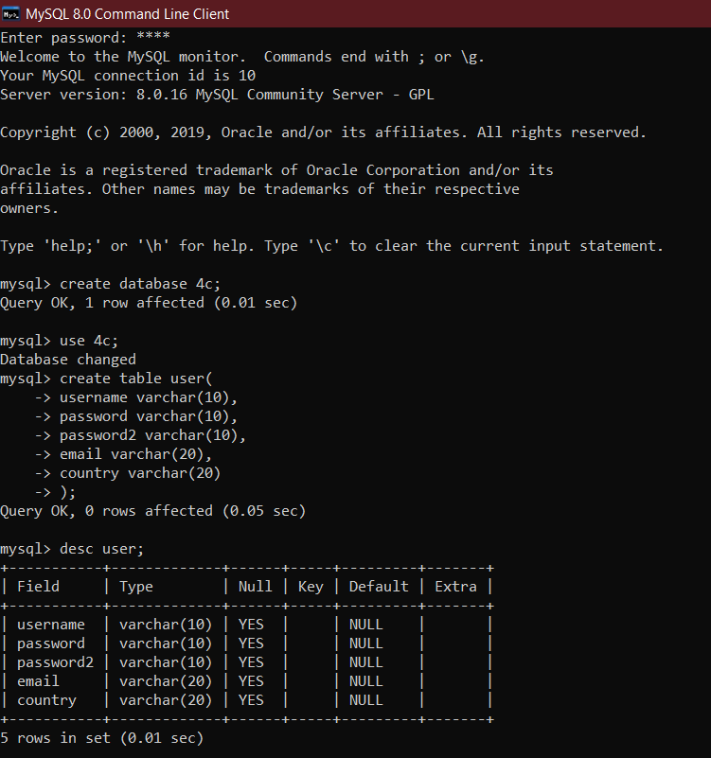

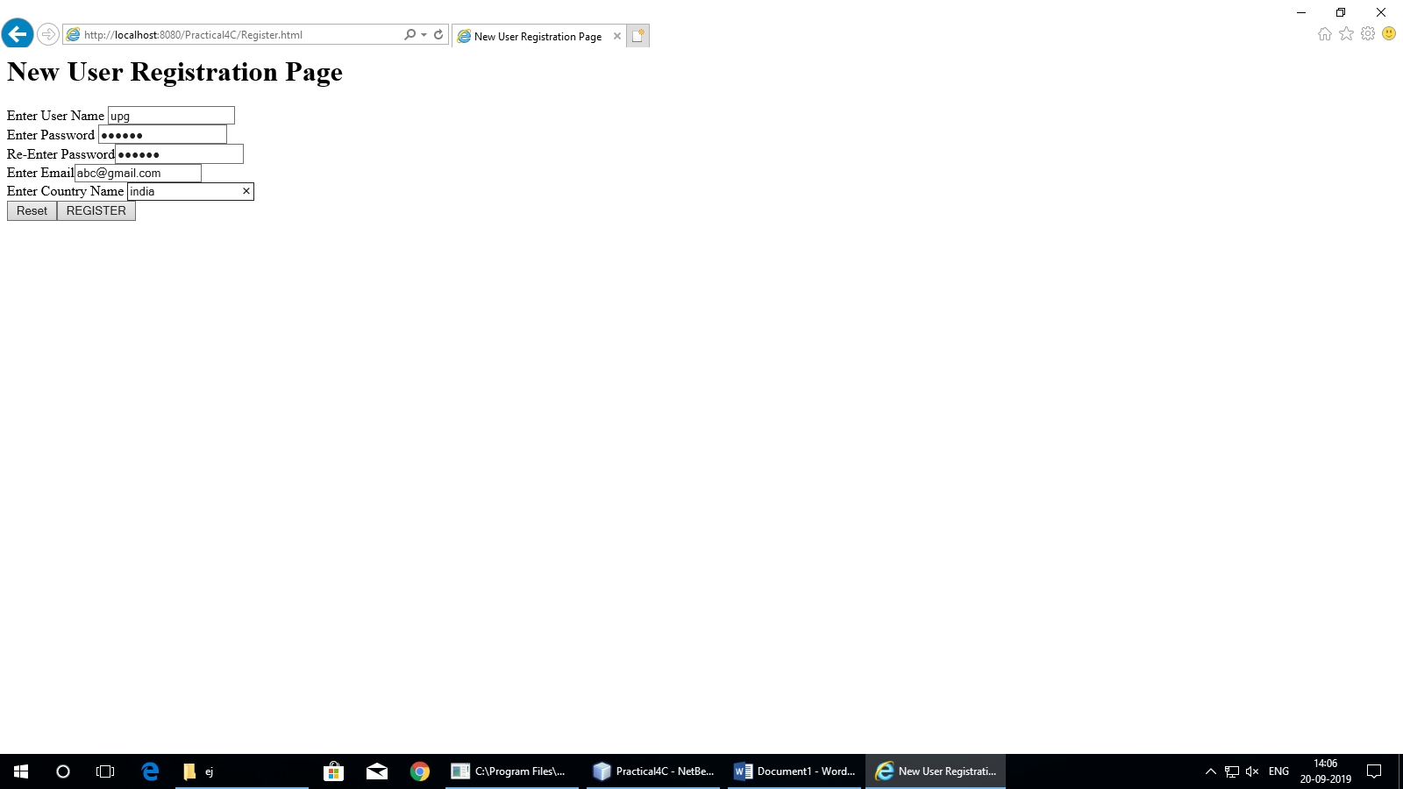

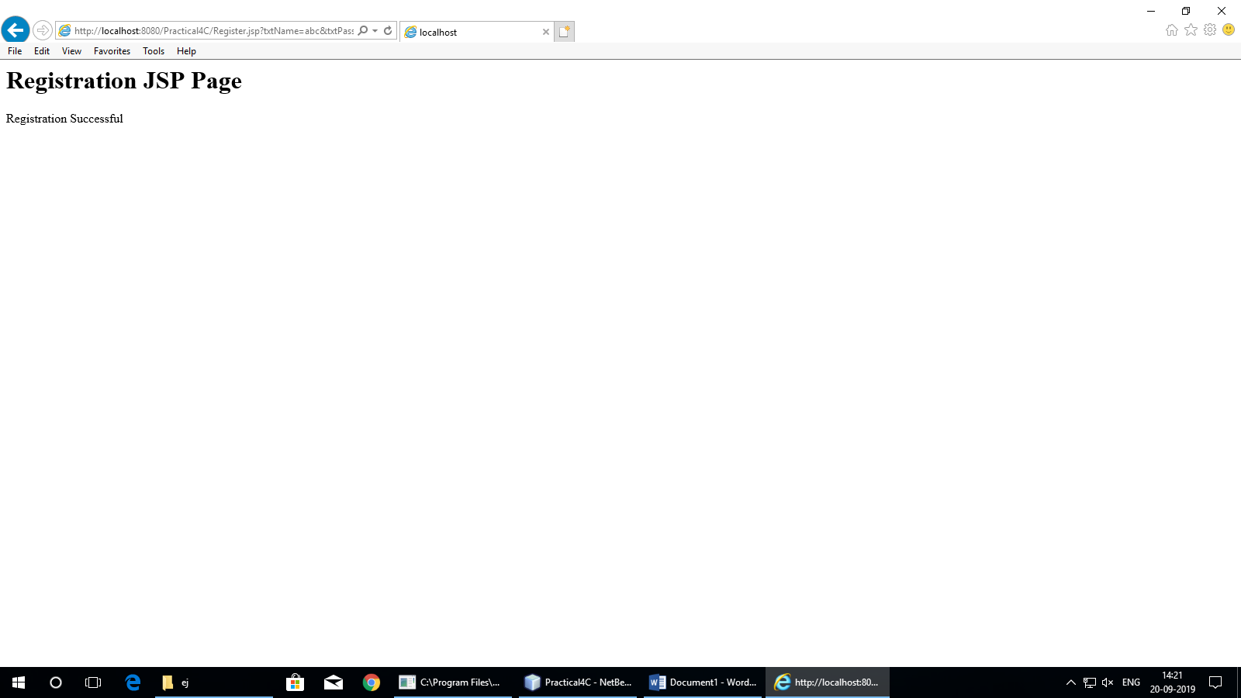

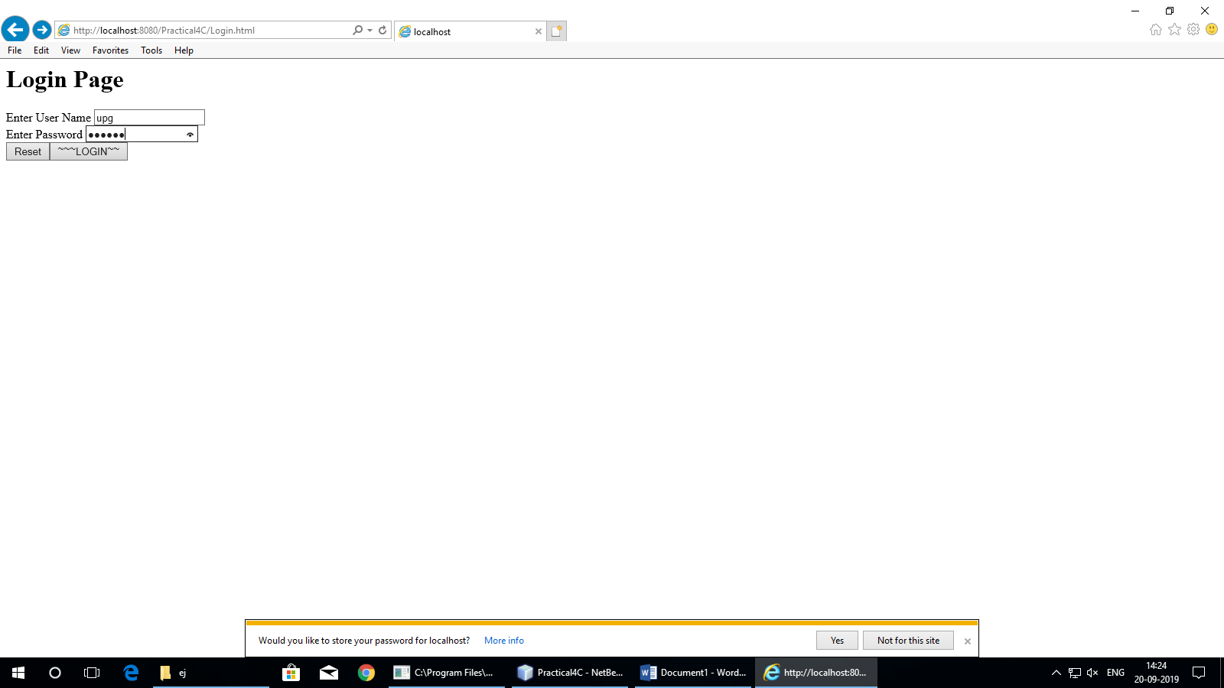

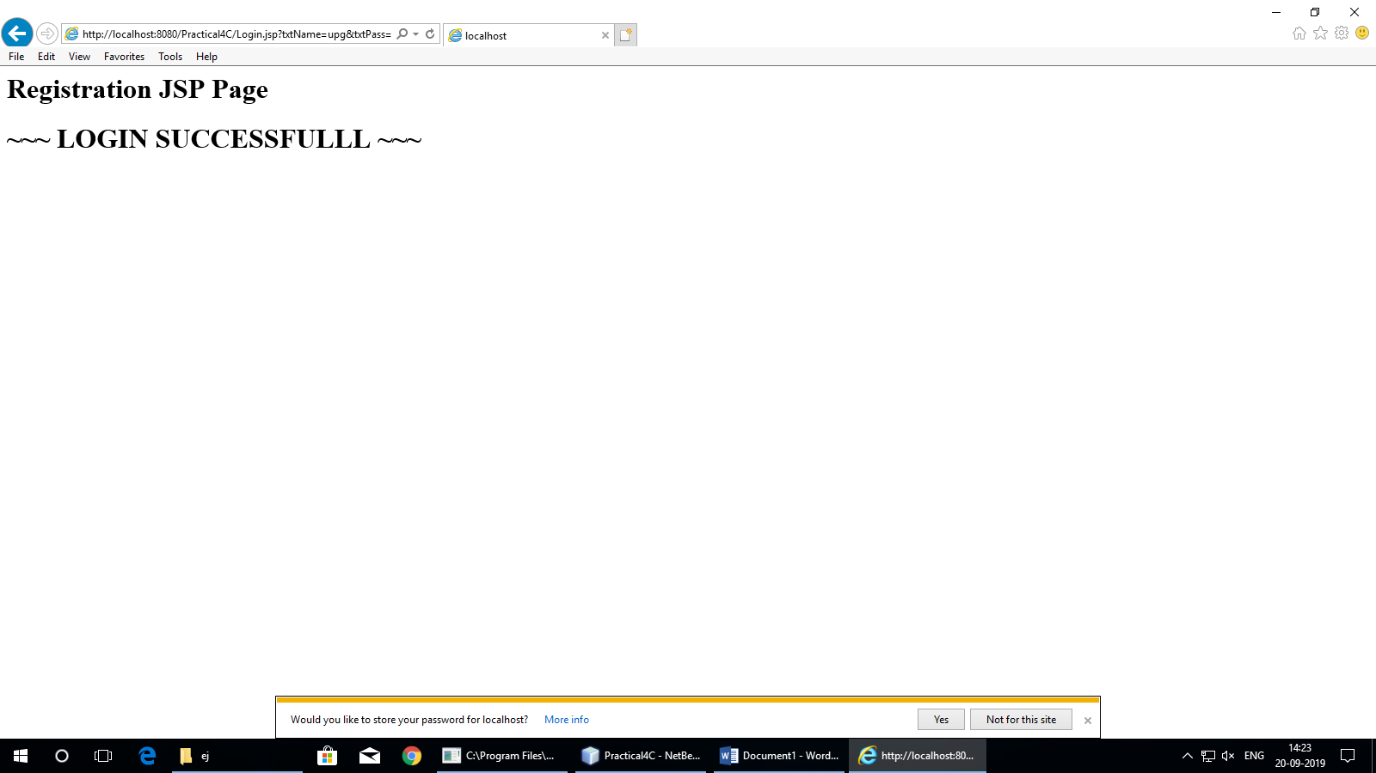

**Practical-5**

1. **Aim:** Create an html page with fields, eno, name, age, desg, salary. Now on submit this data to a JSP page which will update the employee table of database with matching eno.

**Program Code:**

**index.html**

<html>

<body>

<form action="UpdateEmp.jsp" >

Enter Employee Number<input type="text" name="txtEno" ><br>

Enter Name<input type="text" name="txtName" ><br>

Enter age<input type="text" name="txtAge" ><br>

Enter Salary<input type="text" name="txtSal" ><br>

<input type="reset" ><input type="submit">

</form>

</body>

</html>

**UpdateEmp.jsp**

<%@page contentType="text/html" import="java.sql.*" %>

<html>

<body>

<h1>Employee Record Update</h1>

<%

String eno=request.getParameter("txtEno");

String name=request.getParameter("txtName");

String age = request.getParameter("txtAge");

String sal = request.getParameter("txtSal");

try{

Class.forName("com.mysql.jdbc.Driver");

Connection con = DriverManager.getConnection("jdbc:mysql://localhost:3306/empdb");

PreparedStatement stmt = con.prepareStatement("select * from emp where empid=?");

stmt.setString(1, eno);

ResultSet rs = stmt.executeQuery();

if(rs.next()){

out.println("<h1>~~~ Employee "+name+" Exist ~~~ </h1>");

PreparedStatement pst1= con.prepareStatement("update emp set salary=? where empid=?");

PreparedStatement pst2= con.prepareStatement("update emp set age=? where empid=?");

pst1.setString(1, sal); pst1.setString(2, eno);

pst2.setString(1, age); pst2.setString(2, eno);

pst1.executeUpdate(); pst2.executeUpdate();

}

else{

out.println("<h1>Employee Record not exist !!!!!</h1>");

}

}catch(Exception e){out.println(e);}

%>

</body>

</html>

**Output:**

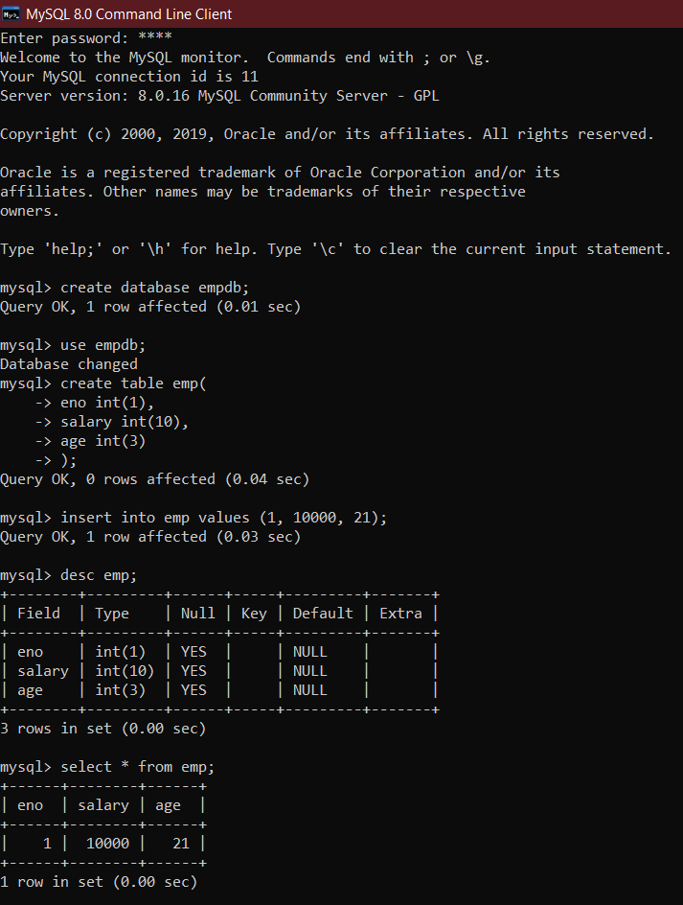

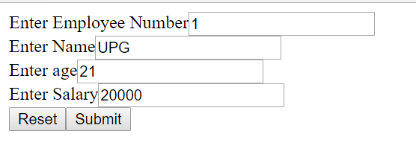

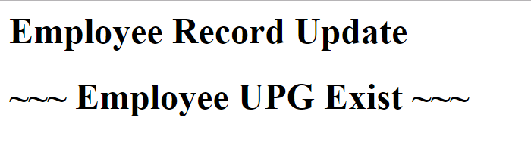

1. **Aim:** Create a JSP page to demonstrate the use of Expression language.

**Program Code:**

**index.html**

<!DOCTYPE html>

<!--

To change this license header, choose License Headers in Project Properties.

To change this template file, choose Tools | Templates

and open the template in the editor.

-->

<html>

<head>

<title>TODO supply a title</title>

<meta charset="UTF-8">

<meta name="viewport" content="width=device-width, initial-scale=1.0">

</head>

<body>

<div>TODO write content</div>

<a href="Bill.jsp">Click Here</a>

</body>

</html>

**Bill.jsp**

<%@page contentType="text/html" pageEncoding="UTF-8"%>

<html><head><title>JSP Page</title></head>

<body>

<h1>Expression Language Demo</h1>

<%! java.util.Date dt = new java.util.Date(); %>

<%! int val1 = 10, val2=20, result =0; %>

<% application.setAttribute("val1",10); %>

<% application.setAttribute("val2",20); %>

<% application.setAttribute("result",0); %>

<% application.setAttribute("dt",new java.util.Date()); %>

<h1>First Number is ${val1}</h1>

<h1>Second Number is ${val2}</h1>

<h1>Sum is ${val1+val2}</h1>

<h1>Today is ${dt}</h1>

</body>

</html>

**Output:**

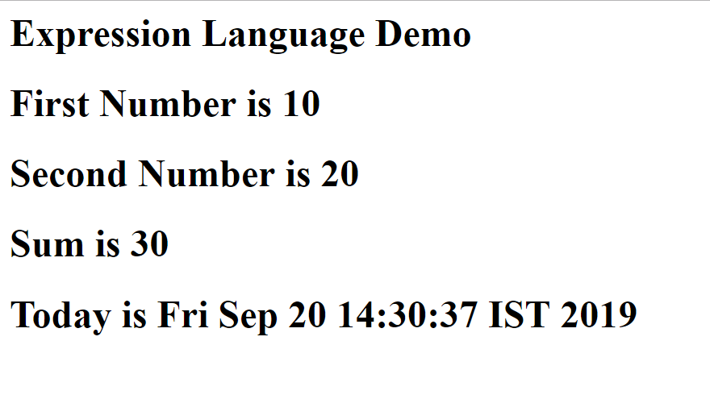

1. **Aim:** Create a JSP application to demonstrate the use of JSTL.

**Program Code:**

**index.html**

<!DOCTYPE html>

<!--

To change this license header, choose License Headers in Project Properties.

To change this template file, choose Tools | Templates

and open the template in the editor.

-->

<html>

<head>

<title>TODO supply a title</title>

<meta charset="UTF-8">

<meta name="viewport" content="width=device-width, initial-scale=1.0">

</head>

<body>

<a href='Table.jsp' >Click to open program</a>

</body>

</html>

**Table.jsp**

<%@taglib uri="http://java.sun.com/jsp/jstl/core" prefix="c" %>

<html>

<body>

<table border="1">

<th>Number </th>

<c:forEach var="i" begin="1" end="100" step="2" >

<tr><td> <c:out value="${i}" /> <br /> </td></tr>

</c:forEach>

</table>

</body>

</html>

**Output:**

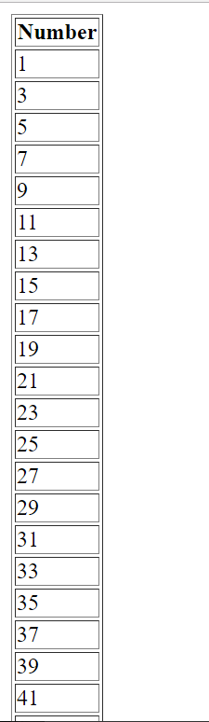

**Practical-6**

1. **Aim:** Create a Currency Converter application using EJB.

**Program Code:**

**index.html**

<html><head><title>Currency Converter</title></head>

<body>

<form action="CCServlet" >

Enter Amount <input type="text" name="amt"><br>

Select Conversion Type

<input type="radio" name="type" value="r2d" checked>Rupees to Dollar

<input type="radio" name="type" value="d2r" >Dollor to Rupees<br>

<input type="reset" ><input type="submit" value="CONVERT" >

</form>

</body>

</html>

**CCServlet.java**

package mypack;

import java.io.*;

import javax.servlet.*;

import javax.servlet.http.*;

import javax.ejb.EJB;

import mybeans.CCBean;

public class CCServlet extends HttpServlet {

@EJB CCBean obj;

public void doGet(HttpServletRequest request, HttpServletResponse response)

throws ServletException, IOException {

response.setContentType("text/html;charset=UTF-8");

PrintWriter out = response.getWriter();

double amt = Double.parseDouble(request.getParameter("amt"));

if(request.getParameter("type").equals("r2d"))

{

out.println("<h1>"+amt+ " Rupees = "+obj.r2Dollor(amt)+" Dollors</h1>");

}

if(request.getParameter("type").equals("d2r"))

{

out.println("<h1>"+amt+ " Dollors = "+obj.d2Rupees(amt)+" Rupees</h1>");

}

}}

**CCBean.java**

package mybeans;

import javax.ejb.Stateless;

@Stateless

public class CCBean {

public CCBean(){}

public double r2Dollor(double r){ return r/65.65; }

public double d2Rupees(double d){ return d*65.65; }

}

**Output:**

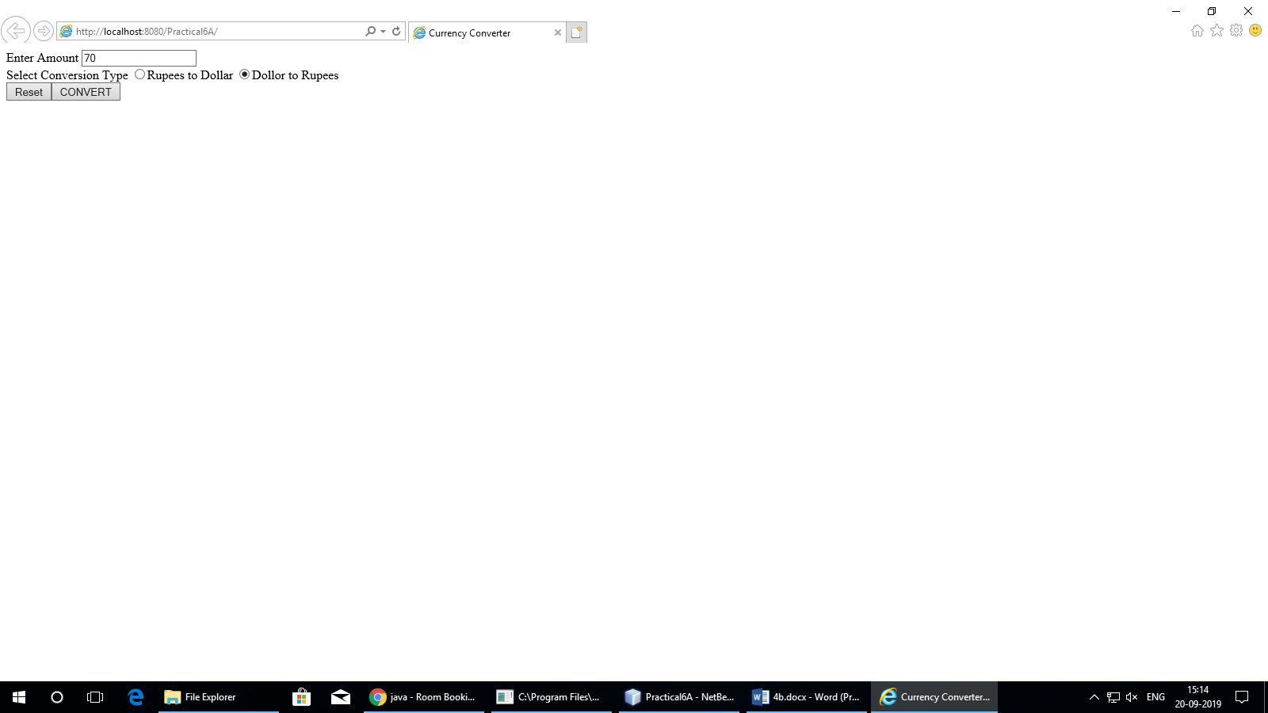

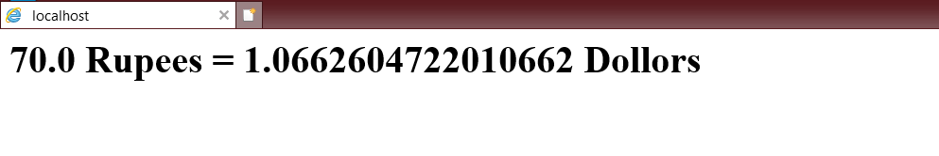

1. **Aim:** Develop a Simple Room Reservation System Application Using EJB.

**Program Code:**

**index.html**

<html><head><title>Room Reservation System</title></head>

<body>

<h1><a href="Book.html" >Click to Book a Room</a></h1>

<h1><a href="Cancle.html" >Click to Cancle a Room</a></h1>

</body>

</html>

**Book.html**

<form action="RBServlet" >

Select a room Type

<input type="radio" name="txtType" value="Delux">Delux

<input type="radio" name="txtType" value="Super Delux">Super Delux

<input type="radio" name="txtType" value="Suit">Suit<br>

Enter Your Name<input type="text" name="txtCust" ><br>

Enter Mobile No.<input type="text" name="txtMob" ><br>

<input type="reset" ><input type="submit" value="Book Room">

</form>

**RBServlet.java**

package mypack;

import java.io.*;

import javax.servlet.*;

import javax.servlet.http.*;

import javax.ejb.EJB;

import mybeans.RRBean;

public class RBServlet extends HttpServlet {

@EJB RRBean obj;

public void doGet(HttpServletRequest request, HttpServletResponse response)

throws ServletException, IOException{

PrintWriter out=response.getWriter();

String rt=request.getParameter("txtType");

String cn=request.getParameter("txtCust");

String cm=request.getParameter("txtMob");

String msg = obj.roomBook(rt, cn, cm);

out.println(msg);

}

}

**RRBean.java**

package mybeans;

import javax.ejb.Stateless;

import java.sql.*;

@Stateless

public class RRBean {

public RRBean(){}

public String roomBook(String rt, String cn, String cm){

String msg="";

try{

Class.forName("com.mysql.jdbc.Driver");

Connection con = DriverManager.getConnection("jdbc:mysql://localhost:3306/rrdb","root","root");

String query="select * from roombook where RoomType=? and status='Not Booked'";

PreparedStatement pst = con.prepareStatement(query);

pst.setString(1,rt);

ResultSet rs= pst.executeQuery();

if(rs.next()){

String rno=rs.getString(1);

PreparedStatement stm1 = con.prepareStatement("update roombook set cust=? where RoomId=? ");

PreparedStatement stm2 = con.prepareStatement("update roombook set mobile=? where RoomId=? ");

PreparedStatement stm3 = con.prepareStatement("update roombook set status=? where RoomId=? ");

stm1.setString(1,cn); stm1.setString(2,rno);

stm2.setString(1,cm); stm2.setString(2,rno);

stm3.setString(1, "Booked"); stm3.setString(2,rno);

stm1.executeUpdate();

stm2.executeUpdate();

stm3.executeUpdate();

msg = "Room "+rno+ " Booked <br> Charges = "+rs.getString(3);

}

else

{

msg = "Room "+rt+ " currently Not available";

}

}catch(Exception e){msg=""+e;}

return msg;

}

}

**Output:**

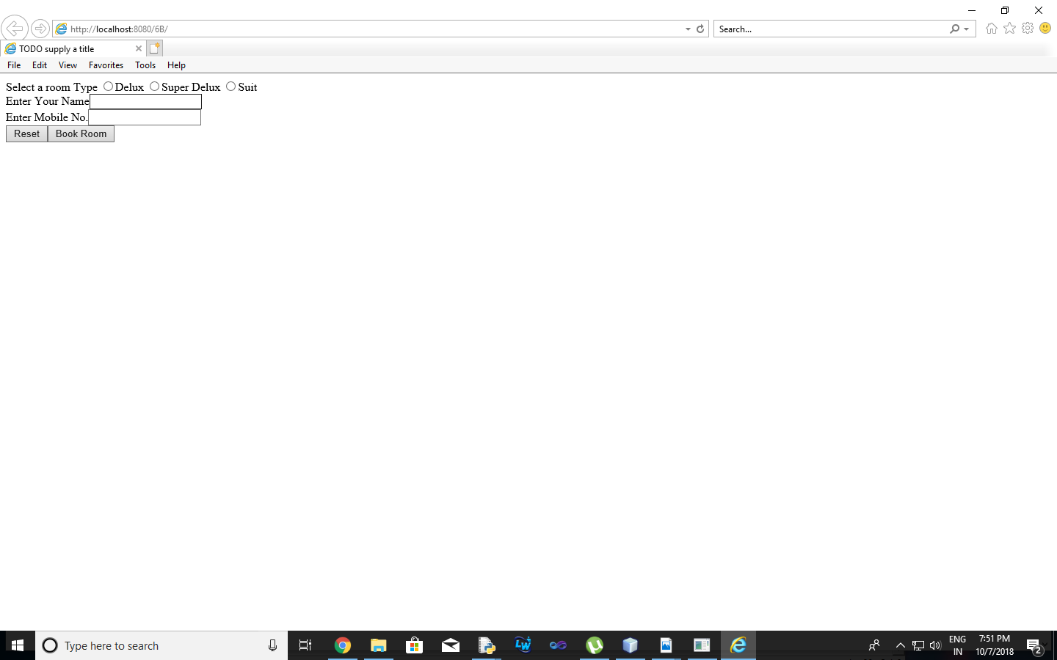

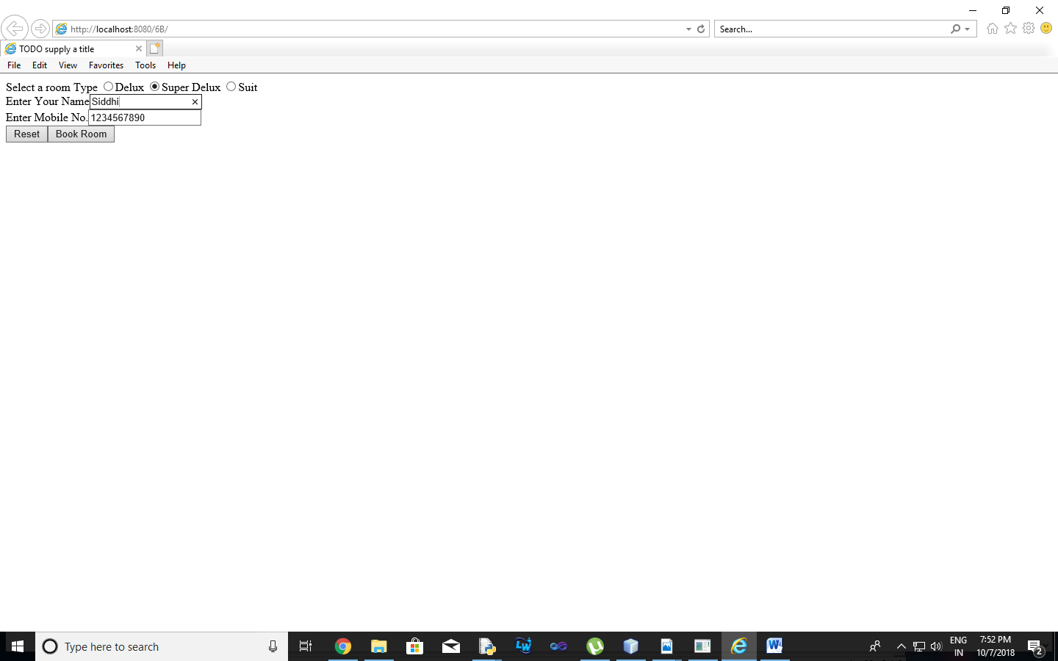

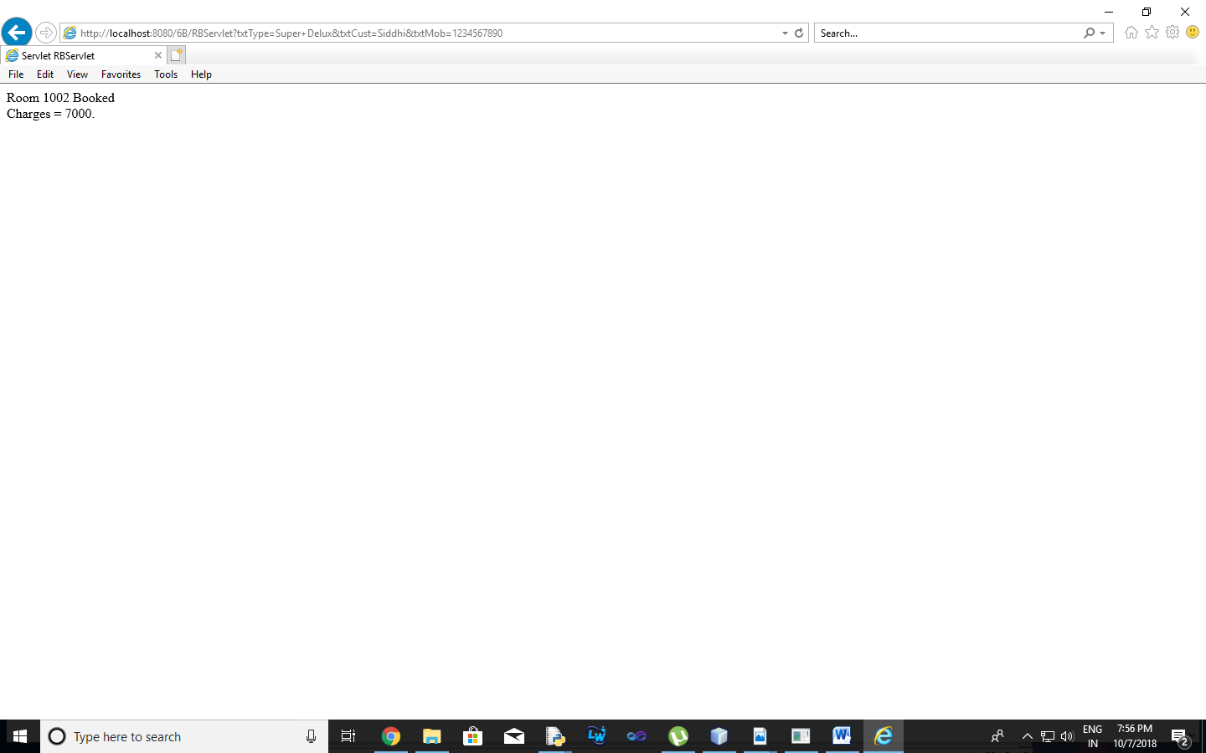

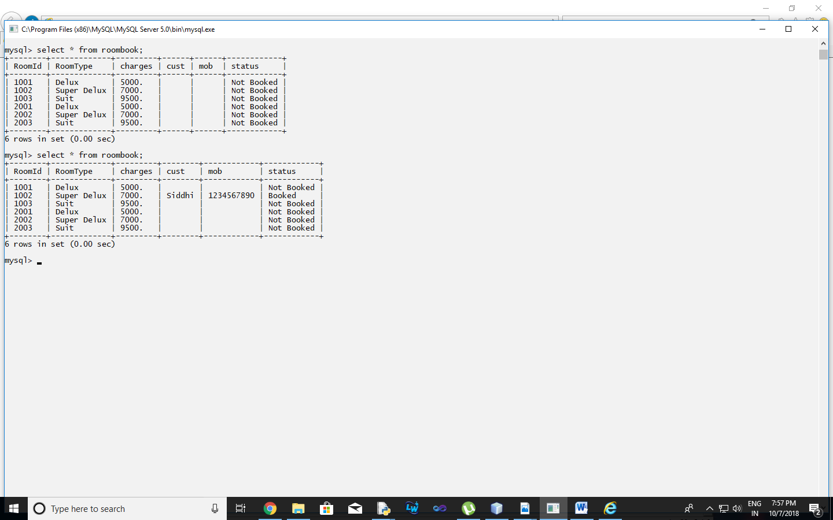

1. **Aim:** Develop simple shopping cart application using EJB [Stateful Session Bean].

**Program Code:**

**index.jsp**

<%@page import="java.util.Iterator, java.util.List, javax.naming.InitialContext, ejb.ShoppingCart"%>

<%@page contentType="text/html" pageEncoding="UTF-8"%>

<!DOCTYPE html>

<%!

private static ShoppingCart cart;

public void jspInit() {

try {

InitialContext ic = new InitialContext();

cart = (ShoppingCart) ic.lookup("java:global/ShoppingCart/ShoppingCart");

} catch (Exception ex) {

System.out.println("Could not create cart bean." + ex.getMessage());

}

}

%>

<%

if(request.getParameter("txtCustomerName") != null) {

cart.initialize(request.getParameter("txtCustomerName"));

} else {

cart.initialize("Guest");

}

if (request.getParameter("btnRmvBook") != null) {

String books[] = request.getParameterValues("chkBook");

if (books != null) {

for (int i=0; i<books.length; i++) {

cart.removeBook(books[i]);

}

}

}

if (request.getParameter("btnAddBook") != null) {

String books[] = request.getParameterValues("chkBook");

if (books != null) {

for (int i=0; i<books.length; i++) {

cart.addBook(books[i]);

}

}

}

%>

<html>

<head>

<meta http-equiv="Content-Type" content="text/html; charset=UTF-8">

<title>Shopping Cart</title>

</head>

<body style="background-color: pink;">

<h1 style="text-align: center;">Books For Sale</h1><br>

<form name="frmBooks" method="post">

<table style="background-color: pink; width: 100%; padding: 1px; border-spacing: 1px;">

<tr style="background-color: pink;">

<td style="width: 70%">

<table style="padding: 1px 1px 1px 1px; border-spacing: 1px; border: 2px solid maroon; width: 400px;">

<tr>

<td style="border: 2px solid maroon;">Customer</td>

<td style="border: 2px solid maroon;">

<input type="text" name="txtCustomerName" value=<%= request.getParameter("txtCustomerName")%> />

</td>

</tr>

<tr style="background-color: maroon;">

<th style="text-align: left; width: 340px; color: white; border: 2px solid maroon;" colspan="2">

<b>Book Titles</b>

</th>

</tr>

<tr>

<td style="border: 2px solid maroon;">

<input type="checkbox" name="chkBook" value="Struts 2.0 For Beginners">

</td>

<td style="width: 340px; border: 2px solid maroon;">Struts 2.0 For Beginners</td>

</tr>

<tr>

<td style="border: 2px solid maroon;">

<input type="checkbox" name="chkBook" value="Oracle 11g For Professionals">

</td>

<td style="width: 340px; border: 2px solid maroon;">Oracle 11g For Professionals</td>

</tr>

<tr>

<td style="border: 2px solid maroon;">

<input type="checkbox" name="chkBook" value="Hibernate 3 For Beginners">

</td>

<td style="width: 340px; border: 2px solid maroon;">Hibernate 3 For Beginners</td>

</tr>

<tr>

<td style="border: 2px solid maroon;">

<input type="checkbox" name="chkBook" value="Java Persistence API In EJB 3 For Beginners">

</td>

<td style="width: 340px; height: 24px; border: 2px solid maroon;">Java Persistence API In EJB 3 For Beginners</td>

</tr>

<tr>

<td colspan="4" style="border: 2px solid maroon;">

<table style="background-color: pink; text-align: center;">

<tr>

<td style="text-align: center;">

<input type='submit' value='Add To My Basket' name='btnAddBook'>

</td>

<td style="text-align: center;">

<input type='submit' value='Remove From My Basket' name='btnRmvBook'>

</td>

</tr>

</table>

</td>

</tr>

</table>

</td>

<td>

<table style="border: 1px solid blue; width: 300px; height: 180px; text-align: right;">

<tr>

<td style="text-align: center; background-color: lightblue; border: 1px solid blue; height: 20px;">Basket</td>

</tr>

<%

if(cart!=null){

List<String> bookList = cart.getContents();

Iterator iterator = bookList.iterator();

while (iterator.hasNext()) {

String title = (String) iterator.next();

%>

<tr>

<td style="text-align: left; background-color: lightblue; border: 1px solid blue;"><%= title %></td>

</tr>

<%

}

}

%>

</table>

</td>

</tr>

</table>

</form>

</body>

</html>

**ShoppingCart.java**

package ejb;

import java.sql.Connection;

import java.sql.DriverManager;

import java.sql.ResultSet;

import java.sql.SQLException;

import java.sql.Statement;

import java.util.ArrayList;

import java.util.List;

import javax.ejb.Remove;

import javax.ejb.Stateful;

@Stateful

public class ShoppingCart {

List<String> contents;

String customerName;

private Connection conn = null;

private ResultSet rs;

private Statement stmt = null;

private String query = null;

public void initialize(String person) {

if (person != null) {

customerName = person;

try {

Class.forName("com.mysql.jdbc.Driver").newInstance();

conn = DriverManager.getConnection("jdbc:mysql://localhost:3306/mysql", "root", "root");

} catch(ClassNotFoundException | IllegalAccessException | InstantiationException | SQLException e) {

System.err.println("Sorry failed to connect to the Database." + e.getMessage());

}

}

contents = new ArrayList<>();

}

public void addBook(String title) {

try {

stmt = conn.createStatement();

query = "INSERT INTO cart VALUES('" + customerName + "','" + title + "')";

stmt.executeUpdate(query);

} catch(SQLException e) {

System.err.println("Sorry failed to insert values from the database table. " + e.getMessage());

}

}

public void removeBook(String title) {

try {

stmt = conn.createStatement();

query = "DELETE FROM cart WHERE uname='" + customerName + "' AND itemname='" + title + "'";

stmt.executeUpdate(query);

} catch(SQLException e) {

System.err.println("Sorry failed to delete values from the database table. " + e.getMessage());

}

}

public List<String> getContents() {

try {

stmt = conn.createStatement();

query = "SELECT * FROM cart WHERE uname='" + customerName + "'";

rs = stmt.executeQuery(query);

while(rs.next()) {

contents.add(rs.getString("itemname"));

}

} catch(SQLException e) {

System.err.println("Sorry failed to select values from the database table. " + e.getMessage());

}

return contents;

}

@Remove()

public void remove() {

contents = null;

}

}

**Output:**

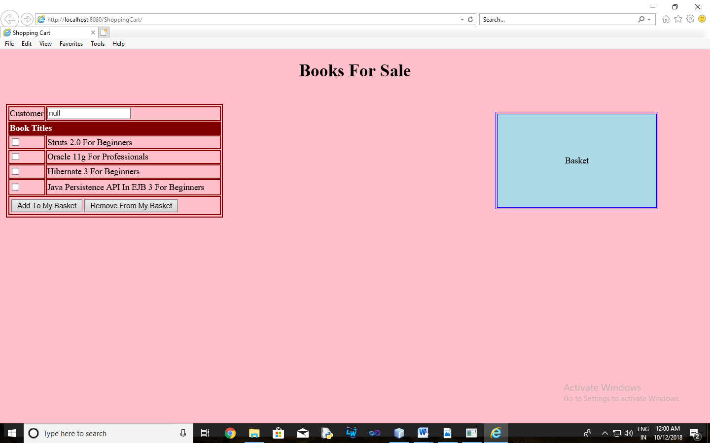

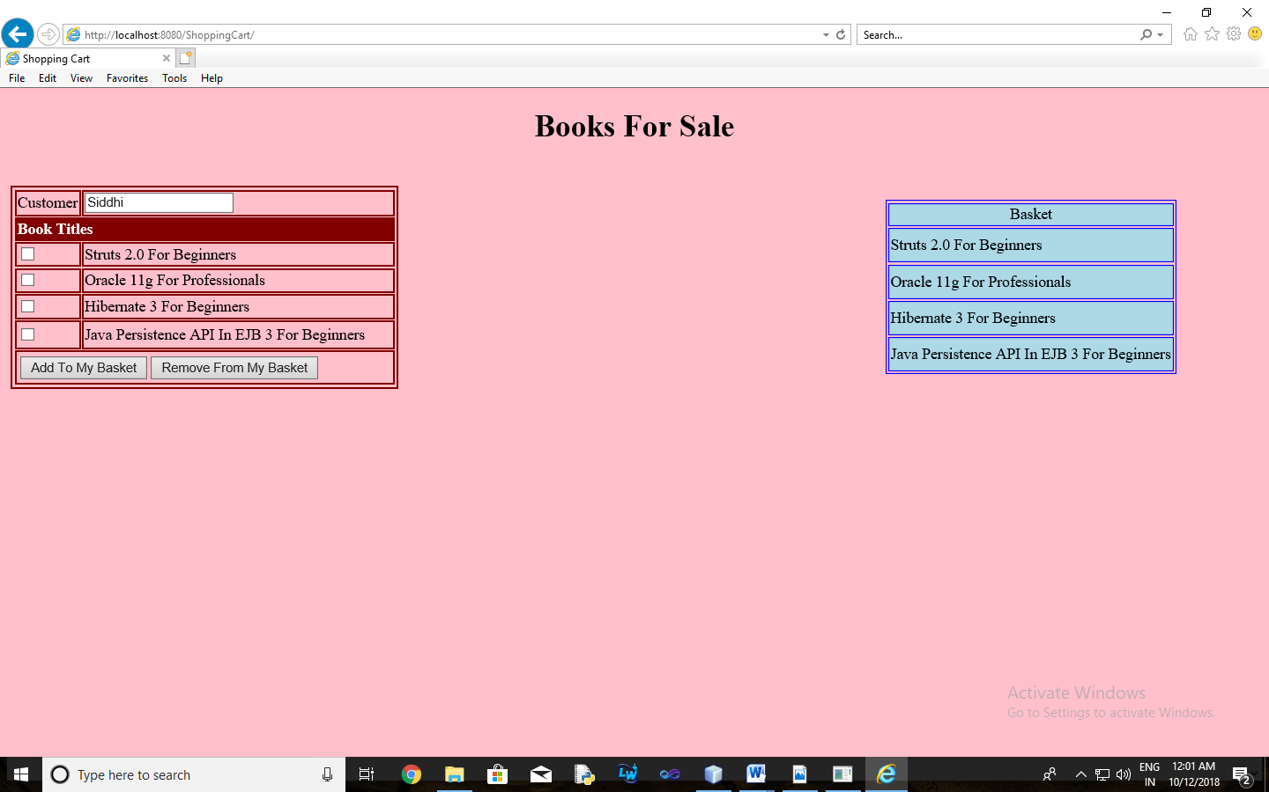

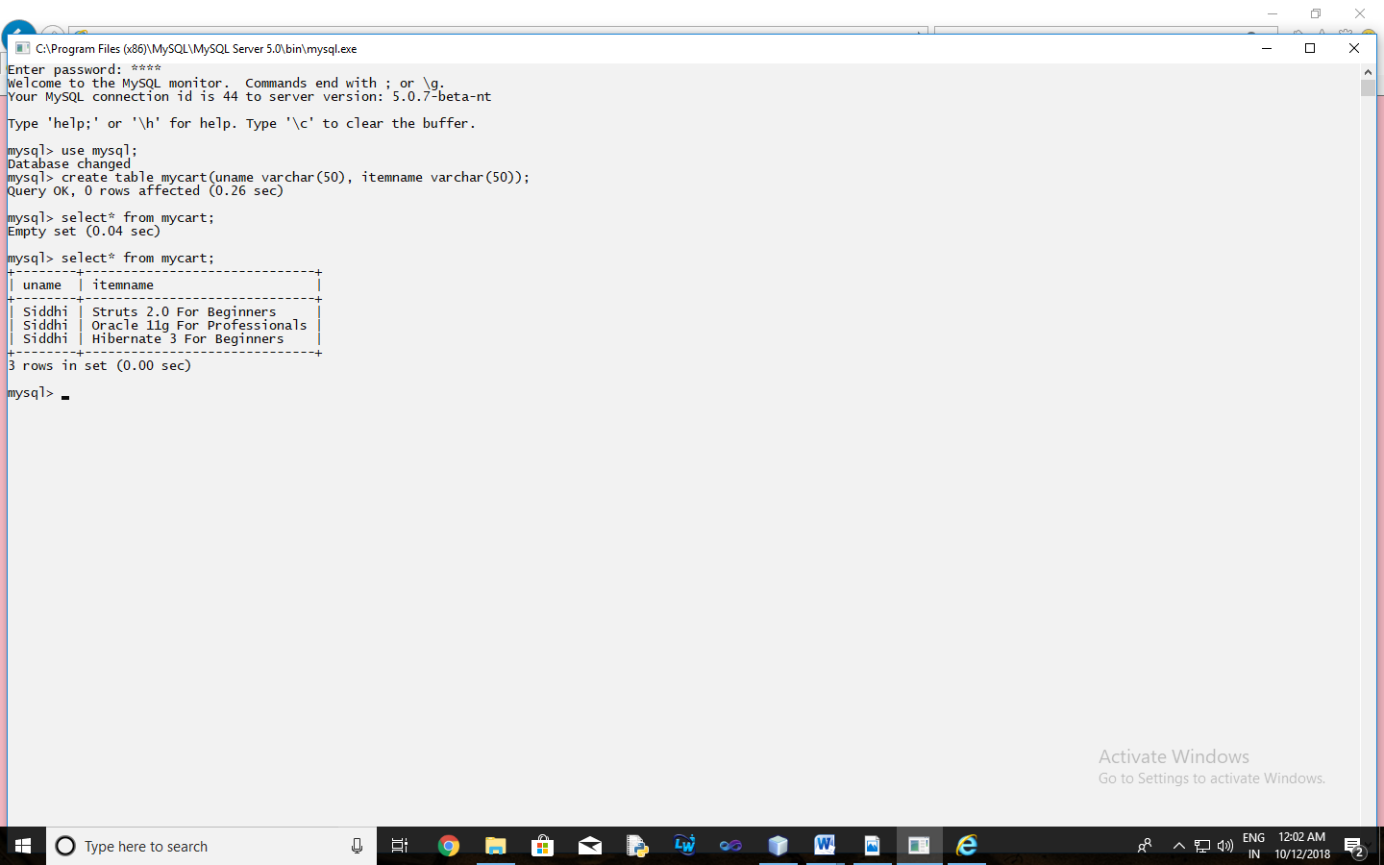

**Practical-7**

1. **Aim:** Develop simple EJB application to demonstrate Servlet Hit count using Singleton Session Beans.

**Program Code:**

**index.xhtml**

<?xml version='1.0' encoding='UTF-8' ?>

<!DOCTYPE html PUBLIC "-//W3C//DTD XHTML 1.0 Transitional//EN" "http://www.w3.org/TR/xhtml1/DTD/xhtml1-transitional.dtd">

<html xmlns="http://www.w3.org/1999/xhtml"

xmlns:h="http://xmlns.jcp.org/jsf/html">

<h:head>

<title>Page Hit Counter using Singleton EJB </title>

</h:head>

<h:body>

<h1>Welcome to Hit Count Page</h1>

Page was hit #{count.hitCount} times

</h:body>

</html>

**web.xml**

<?xml version="1.0" encoding="UTF-8"?>

<web-app version="3.1" xmlns="http://xmlns.jcp.org/xml/ns/javaee" xmlns:xsi="http://www.w3.org/2001/XMLSchema-instance" xsi:schemaLocation="http://xmlns.jcp.org/xml/ns/javaee http://xmlns.jcp.org/xml/ns/javaee/web-app_3_1.xsd">

<context-param>

<param-name>javax.faces.PROJECT_STAGE</param-name>

<param-value>Development</param-value>

</context-param>

<servlet>

<servlet-name>Faces Servlet</servlet-name>

<servlet-class>javax.faces.webapp.FacesServlet</servlet-class>

<load-on-startup>1</load-on-startup>

</servlet>

<servlet-mapping>

<servlet-name>Faces Servlet</servlet-name>

<url-pattern>/faces/*</url-pattern>

</servlet-mapping>

<session-config>

<session-timeout>

30

</session-timeout>

</session-config>

<welcome-file-list>

<welcome-file>faces/index.xhtml</welcome-file>

</welcome-file-list>

</web-app>

**Count.java**

package mypack;

import java.io.Serializable;

import javax.ejb.EJB;

import javax.enterprise.context.ConversationScoped;

import javax.inject.Named;

import counter.ejb.CounterBean;

@Named("count")

@ConversationScoped

public class Count implements Serializable {

@EJB

private CounterBean counterBean;

private int hitCount;

public Count() {

this.hitCount = 0;

}

public int getHitCount() {

hitCount = counterBean.getHits();

return hitCount;

}

public void setHitCount(int newHits) {

this.hitCount = newHits;

}

}

**CounterBean.java**

package counter.ejb;

import javax.ejb.Singleton;

@Singleton

public class CounterBean {

private int hits = 1;

// Increment and return the number of hits

public int getHits() {

return hits++;

}

}

**Output:**

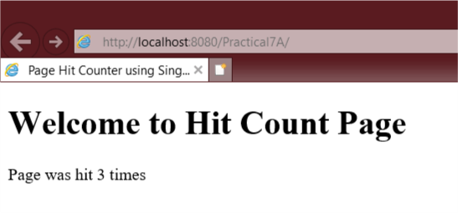

1. **Aim:** Develop simple visitor Statistics application using Message Driven Bean [Stateless Session Bean].

**Program Code:**

**index.jsp**

<%@page import="javax.jms.JMSException, javax.naming.InitialContext, javax.jms.TextMessage, javax.jms.MessageProducer, javax.jms.Session, javax.jms.Connection, javax.jms.Queue, javax.jms.ConnectionFactory" %>

<%@page contentType="text/html" pageEncoding="UTF-8"%>

<!DOCTYPE html>

<%!

private static ConnectionFactory connectionFactory;

private static Queue queue;

Connection connection = null;

Session mysession = null;

MessageProducer messageProducer = null;

TextMessage message = null;

%>

<html>

<head>

<meta http-equiv="Content-Type" content="text/html; charset=UTF-8">

<title>Welcome To Enterprise Java Home Page</title>

</head>

<body style="background-color: pink;">

<h1>Welcome To Enterprise Java Home Page</h1>

<%

try {

InitialContext ctx = new InitialContext();

queue = (Queue) ctx.lookup("jms/Queue");

connectionFactory = (ConnectionFactory) ctx.lookup("jms/QueueFactory");

connection = connectionFactory.createConnection();

mysession = connection.createSession(false, Session.AUTO_ACKNOWLEDGE);

messageProducer = mysession.createProducer(queue);

message = mysession.createTextMessage();

message.setText(request.getRemoteAddr());

messageProducer.send(message);

} catch (JMSException e) {

System.out.println("Exception occurred: " + e.toString());

}

%>

</body>

</html>

**newjsp.jsp**

<%--

Document : newjsp

Created on : Jun 20, 2019, 10:18:39 AM

Author : admin

--%>

<%@page contentType="text/html" pageEncoding="UTF-8"%>

<!DOCTYPE html>

<html>

<head>

<meta http-equiv="Content-Type" content="text/html; charset=UTF-8">

<title>JSP Page</title>

</head>

<body>

<h1>Hello World! Enterprise Java</h1>

<h1><%=new java.util.Date()%></h1>

<h1>3+4 is: <%=3+4%></h1>

</body>

</html>

**BasicMessageBean.java**

package ejb;

import javax.annotation.Resource;

import javax.ejb.ActivationConfigProperty;

import javax.ejb.EJB;

import javax.ejb.MessageDriven;

import javax.ejb.MessageDrivenContext;

import javax.jms.JMSException;

import javax.jms.Message;

import javax.jms.MessageListener;

import javax.jms.TextMessage;

@MessageDriven(activationConfig = {

@ActivationConfigProperty(propertyName = "destinationType", propertyValue = "javax.jms.Queue"),

@ActivationConfigProperty(propertyName = "destinationLookup", propertyValue = "jms/Queue")

})

public class BasicMessageBean implements MessageListener {

@EJB

VisitorStatBean vs;

@Resource

private MessageDrivenContext mdc;

public BasicMessageBean() {

}

@Override

public void onMessage(Message message) {

try {

if (message instanceof TextMessage) {

TextMessage msg = (TextMessage) message;

vs.addVisitor(msg.getText());

}

} catch (JMSException e) {

mdc.setRollbackOnly();

}

}

}

**VisitorStatBean.java**

package ejb;

import java.sql.Connection;

import java.sql.DriverManager;

import java.sql.ResultSet;

import java.sql.SQLException;

import java.sql.Statement;

import javax.annotation.PostConstruct;

import javax.annotation.PreDestroy;

import javax.ejb.Stateless;

@Stateless

public class VisitorStatBean {

private Connection conn = null;

private ResultSet rs;

private Statement stmt = null;

private String query = null;

@PostConstruct

public void connect() {

try {

Class.forName("com.mysql.jdbc.Driver").newInstance();

conn = DriverManager.getConnection("jdbc:mysql://localhost:3306/visitorstat", "root", "root");

System.out.println("Database connection established successfully.");

} catch(ClassNotFoundException | InstantiationException | IllegalAccessException | SQLException e) {

System.err.println("Sorry failed to connect to the Database.");

}

}

@PreDestroy

public void disconnect() {

try {

conn.close();

System.out.println("Database connection closed successfully.");

} catch(SQLException e) {

System.err.println("Cannot close the database connection: " + e.getMessage());

}

}

public void addVisitor(String host) {

try {

stmt = conn.createStatement();

query = "INSERT INTO UserStat (hostname, visits) VALUES('" + host + "','1')";

stmt.executeUpdate(query);

} catch(SQLException e) {

try {

stmt = conn.createStatement();

query = "UPDATE UserStat SET visits = visits + 1 WHERE hostname = '" + host + "'";

stmt.executeUpdate(query);

} catch(SQLException ex) {

System.err.println("Cannot update: " + ex.getMessage());

}

}

}

}

**Output:**

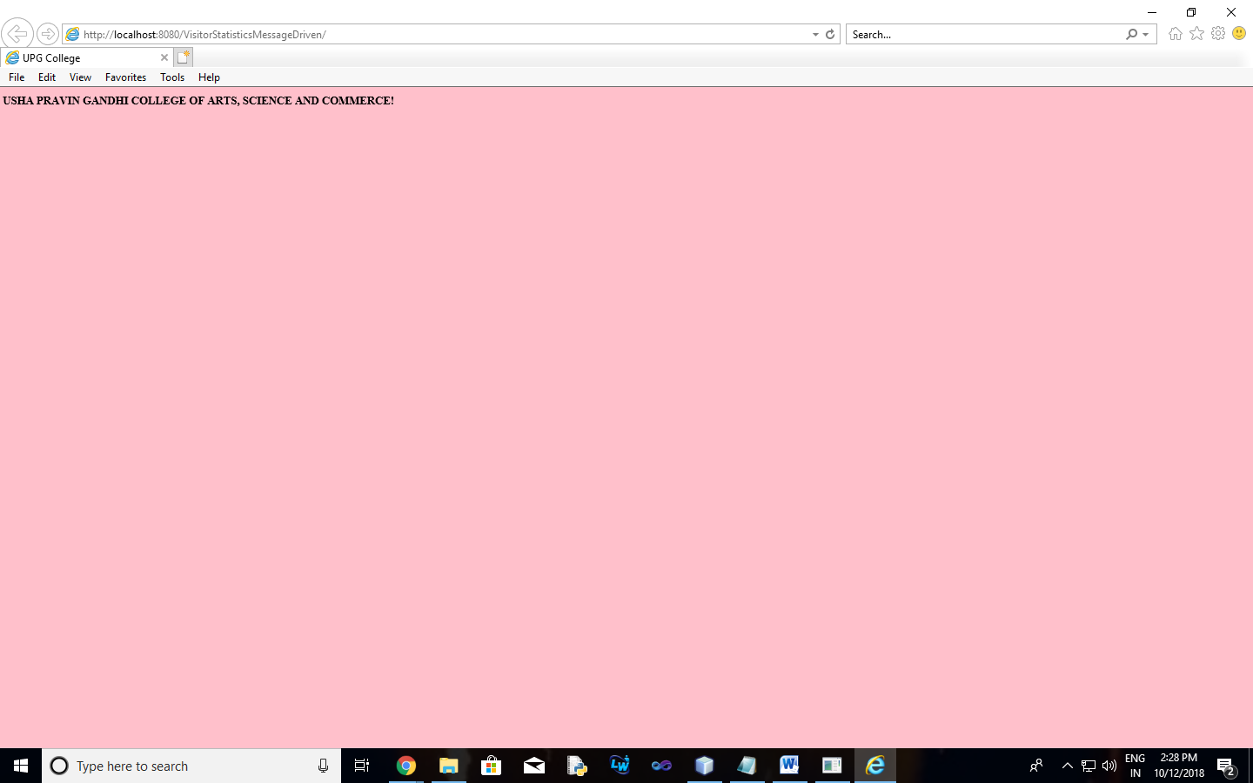

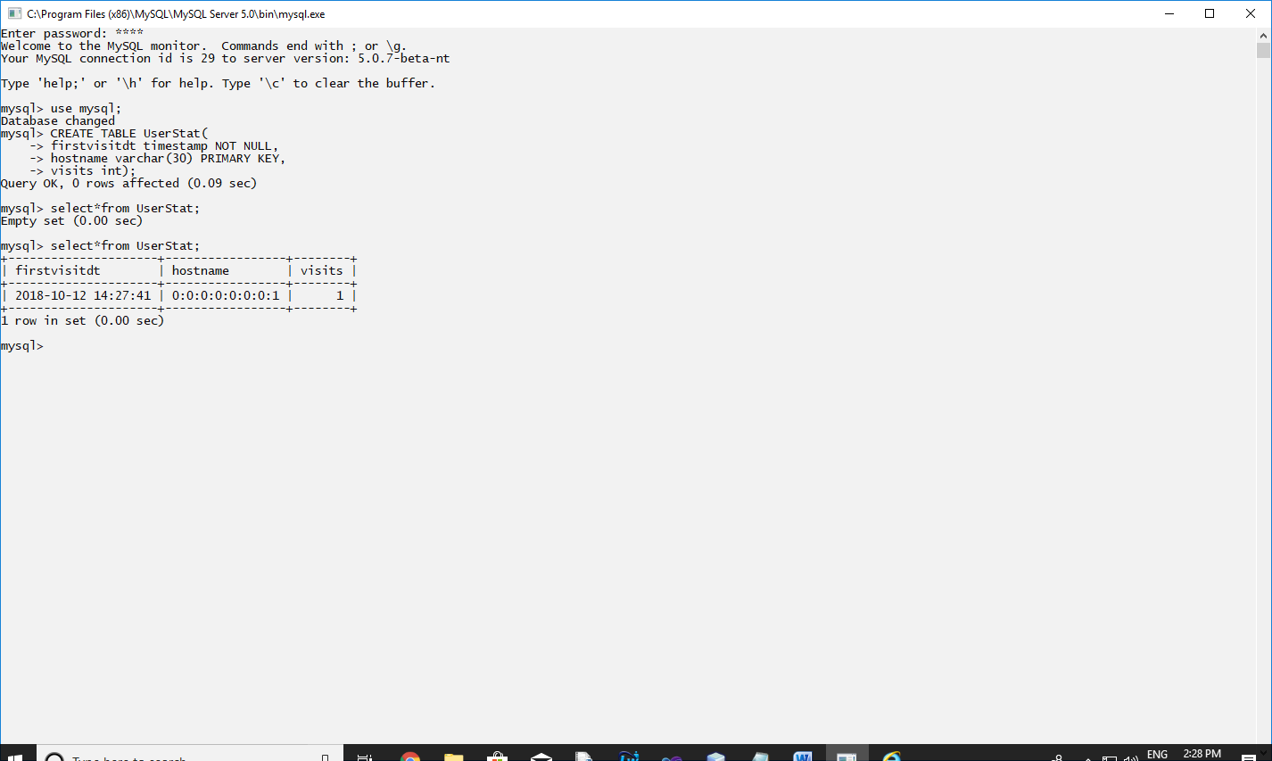

1. **Aim:** Develop simple Marks Entry Application to demonstrate accessing Database using EJB.

**Program Code:**

**index.html**

Top of Form

<html>

<head>

<title>TODO supply a title</title>

<meta charset="UTF-8">

<meta name="viewport" content="width=device-width, initial-scale=1.0">

</head>

<body>

<form action="RBServlet" >

Enter Student Name<input type="text" name="txtCust" ><br>

Enter Subject<input type="text" name="sub"><br>

Enter Marks<input type="text" name="txtMob" ><br>

<input type="reset" value="RE-ENTER"><input type="submit" value="SUBMIT">

</form>

</body>

</html>

**RBServlet.java**

package mypack;

import java.io.IOException;

import java.io.PrintWriter;

import javax.ejb.EJB;

import javax.servlet.ServletException;

import javax.servlet.http.HttpServlet;

import javax.servlet.http.HttpServletRequest;

import javax.servlet.http.HttpServletResponse;

public class RBServlet extends HttpServlet {

@EJB RRBean obj;

protected void processRequest(HttpServletRequest request, HttpServletResponse response)

throws ServletException, IOException {

response.setContentType("text/html;charset=UTF-8");

{

try (PrintWriter out = response.getWriter()) {

String s=request.getParameter("sub");

String n=request.getParameter("txtCust");

String m=request.getParameter("txtMob");

String msg = obj.markenter(n, s, m);

response.setContentType("text/html;charset=UTF-8");

out.println(msg);

out.println("<!DOCTYPE html>");

out.println("<html>");

out.println("<head>");

out.println("<title>Servlet RBServlet</title>");

out.println("</head>");

out.println("<body>");

out.println("<h1>Records Inserted Successfully</h1>");

out.println("</body>");

out.println("</html>");

}

}

}

**RRBean.java**

package mypack;

import javax.ejb.Stateless;

import java.sql.*;

@Stateless

public class RRBean {

public RRBean(){}

public String markenter(String n, String s,String m){

String msg;

try{

Class.forName("com.mysql.jdbc.Driver");

Connection con = DriverManager.getConnection("jdbc:mysql://localhost:3306/rrdb","root","root123");

String query="insert into student1 values(?,?,?)";

PreparedStatement pst = con.prepareStatement(query);

pst.setString(1,n);

pst.setString(2,s);

pst.setString(3,m);

pst.executeUpdate();

msg="Marks entered";

}

catch(Exception e){msg=""+e;}

return msg;

}

}

