OUTPUT:

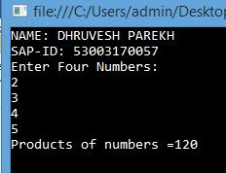

Practical No.1
1A. Create an application that obtains four int values from the user and displays the product.
Code:
using System;
using System.Collections.Generic;
using System.Linq;
using System.Text;

namespace ConsoleApplication1
{
class Program
{
static void Main(string[] args)
{
Console.WriteLine(“#53003170057#\n #Dhruvesh Parekh#\n”);
int[] num = new int[4];
int pro = 1;
Console.WriteLine("Enter 4 numbers:");
for(int i=0;i<4;i++)
{
num[i]=Convert.ToInt32(Console.ReadLine());
pro*=num[i];
}
Console.WriteLine("product is:"+pro);
Console.ReadKey();
}
}
}

OUTPUT:

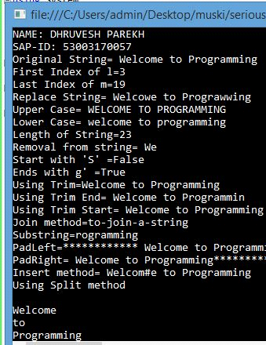

1B. Create an application to demonstrate string operations.
Code:
using System;
using System.Collections.Generic;
using System.Linq;
using System.Text;

namespace StrOperation
{
class StrOperation
{
static void Main(string[] args)
{
string lname, fname;
Console.WriteLine("Enter First name:");
lname = Console.ReadLine();
Console.WriteLine("Enter Last name:");
fname = Console.ReadLine();
Console.WriteLine("trim: "+lname.Trim());
Console.WriteLine("clone: "+fname.Clone());
Console.WriteLine("trimend: "+lname.TrimEnd());
Console.WriteLine("trimstart: "+lname.TrimStart());
Console.WriteLine("padleft: "+fname.PadLeft(8,'*'));
Console.WriteLine("padright: "+fname.PadRight(8,'#'));
Console.WriteLine("insert: "+lname.Insert(2,"abc"));
Console.WriteLine("remove: "+lname.Remove(1,1));
Console.WriteLine("replace: "+lname.Replace("y","a"));
Console.WriteLine("substring: "+fname.Substring(1,4));
Console.WriteLine("toupper: "+fname.ToUpper());
string[] s1={"hello","hie","bye"};
string s3=string.Join("-",s1);
Console.WriteLine(s3);
Console.ReadKey();
}

}
}

OUTPUT:

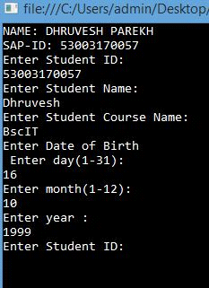

1C. Create an application that receives the (Student Id, Student Name, Course Name, Date of Birth) information from a set of students. The application should also display the information of all the students once the data entered.

Code:
using System;
using System.Collections.Generic;
using System.Linq;
using System.Text;
namespace StudInfo{
class StudInfo{
struct Student{
public string studid, name, cname;
public int day, month, year;
}
static void Main(string[] args)
{
Student[] st= new Student[3];
int i;
Console.WriteLine(“#53003170057#\n #Dhruvesh Parekh#\n”);
for(i=0;i<2;i++)
{
Console.Write("Enter student ID:");
st[i].studid=Console.ReadLine();
Console.Write("Enter student Name:");
st[i].name=Console.ReadLine();
Console.Write("Enter course Name:");
st[i].cname=Console.ReadLine();
Console.Write("Enter date of birth\n Enter day(1-31):");
st[i].day=Convert.ToInt32(Console.ReadLine());
Console.Write("Enter month(1-12):");
st[i].month=Convert.ToInt32(Console.ReadLine());
Console.Write("Enter year:");
st[i].year=Convert.ToInt32(Console.ReadLine());
}
Console.WriteLine("\n\nStudent's List\n");
for(i=0;i<2;i++)
{
Console.WriteLine("\nStudent ID:"+st[i].studid);
Console.WriteLine("\nStudent name:"+st[i].name);
Console.WriteLine("\nCourse name:"+st[i].cname);
Console.WriteLine("\nDate of birth(dd-mm-yy):"+st[i].day+"-"+st[i].month+"-"+st[i].year);
}
Console.ReadKey();

}
}
}

OUTPUT:

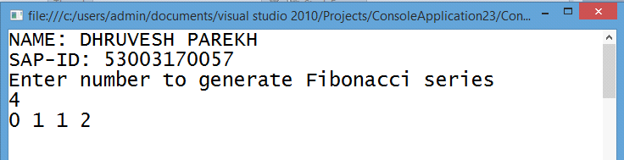

1D. Create an application to demonstrate following operations.
i. Generate Fibonacci series.

Code:

using System;
using System.Collections.Generic;
using System.Linq;
using System.Text;

namespace Fibo
{
class Fibonacci
{
static void Main(string[] args)
{
Console.WriteLine(“#53003170057#\n #Dhruvesh Parekh#\n”);
Console.WriteLine("Enter length");
int n = Convert.ToInt32(Console.ReadLine());
int t1 = 0;
int t2 = 1;
Console.WriteLine("Fibonacci series of given length is");
Console.WriteLine(t1);
Console.WriteLine(t2);
for (int i = 2; i <= n; i++)
{
int sum = t1 + t2;
t1 = t2;
t2 = sum;
Console.WriteLine(sum);
}
Console.ReadKey();
}
}
}

OUTPUT:

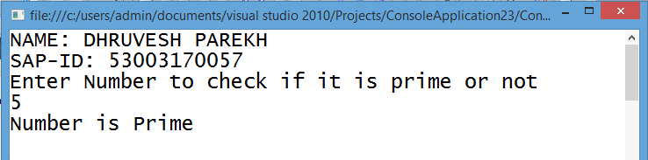

ii. Test for prime numbers
Code:
using System;
using System.Collections.Generic;
using System.Linq;
using System.Text;

namespace Prime
{
class Prime
{
static void Main(string[] args)
{
Console.WriteLine(“#53003170057#\n #Dhruvesh Parekh#\n”);
Console.WriteLine("Enter a number to check it is prime or not");
int n, i;
int flag = 0;
n = Convert.ToInt32(Console.ReadLine());
for (i = 2; i <= n / 2; i++)
{
if (n % i == 0)
{
Console.WriteLine("not prime");
flag = 1;
break;
}
}
if (flag == 0)
{
Console.WriteLine("prime");
}
Console.ReadKey();
}
}
}

OUTPUT:

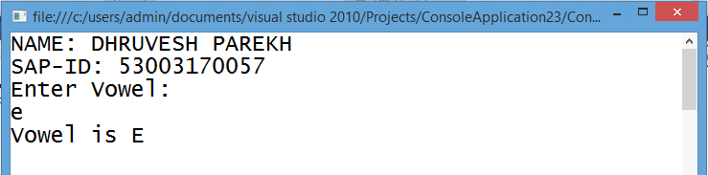

iii. Test for vowels.

Code:
using System;
using System.Collections.Generic;
using System.Linq;
using System.Text;

namespace Vowel
{
class Vowel
{
static void Main(string[] args)
{
char ch;
Console.WriteLine(“#53003170057#\n #Dhruvesh Parekh#\n”);
Console.WriteLine("Enter the alphabet");
ch = Convert.ToChar(Console.ReadLine());
if (ch == 'a' || ch == 'e' || ch == 'i' || ch == 'o' || ch == 'u')
{
Console.WriteLine(ch + "is vowel");
}
else
{
Console.WriteLine(ch + " is a consonant");
}
Console.ReadKey();
}
}
}

OUPUT:

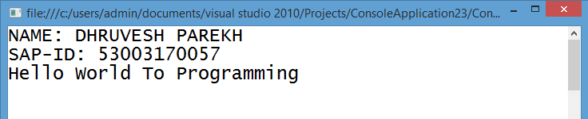

iv. Use of foreach loop with arrays

Code:
using System;
using System.Collections.Generic;
using System.Linq;
using System.Text;

namespace For_each
{
class ForEach
{
static void Main(string[] args)
{
int[] num= {1,2,3,4,5,6,7,8};
Console.WriteLine(“#53003170057#\n #Dhruvesh Parekh#\n”);
Console.WriteLine("Even Numbers:");
foreach(int i in num)
{
if(i%2==0)
{
Console.WriteLine(i);
}

}
Console.ReadKey();
}
}
}

OUTPUT:

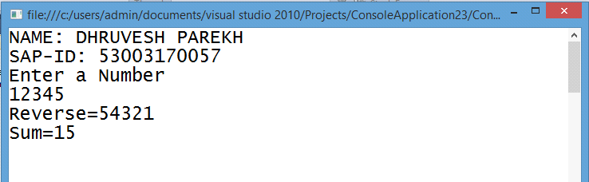

v. Reverse a number and find sum of digits of a number.
Code:
using System;
using System.Collections.Generic;
using System.Linq;
using System.Text;

namespace ReverseNo
{
class Program
{
static void Main(string[] args)
{
Console.WriteLine(“#53003170057#\n #Dhruvesh Parekh#\n”);
Console.WriteLine("Enter a number to reverse");
int Number = Convert.ToInt32(Console.ReadLine());
int Reverse = 0, Sum=0;
while (Number > 0)
{
int remainder = Number % 10;
Sum = Sum+remainder;
Reverse = (Reverse * 10) + remainder;
Number = Number / 10;
}
Console.WriteLine("Reverse No. is {0}", Reverse);
Console.WriteLine("Sum of the number is {0}", Sum);
Console.ReadKey();
}
}
}

Output:

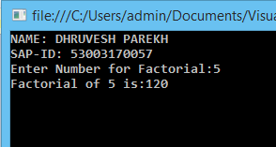

Practical No.2

a. Create simple application to perform following operations
i. Finding factorial Value
Code:
using System;
using System.Collections.Generic;
using System.Linq;
using System.Text;
namespace Factorial{
class Factorial{
int fact(int n)
{
if(n==0||n==1)
{
return 1;
}
else if(n<0)
{
return -1;
}
else
{
return n*fact(n-1);
}
}
static void Main(string[] args)
{
Factorial p = new Factorial();
int m,pr;
Console.WriteLine(“#53003170057#\n #Dhruvesh Parekh#\n”);
Console.WriteLine("enter no");
m=Convert.ToInt32(Console.ReadLine());
pr=p.fact(m);
if(pr==0||pr==1)
{
Console.WriteLine("not negative");
}
else if (pr <0)
{
Console.WriteLine("negative no");
}
else
{
Console.WriteLine("factorial is " + pr);
}
Console.ReadKey();
}
}
}

OUTPUT:

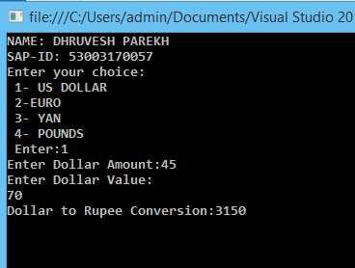

ii. Money Conversion

Code:
using System;
using System.Collections.Generic;
using System.Linq;
using System.Text;

namespace Currency_Conv
{
class Currency_Conv
{
static void Main(string[] args)
{
int choice;
Console.WriteLine(“#53003170057#\n #Dhruvesh Parekh#\n”);
Console.WriteLine("Enter your choice:\n 1.Rupee to dollar\n 2. Rupee to Euro\n 3.Rupee to pound");
choice = Convert.ToInt32(Console.ReadLine());
double rupee, dollar,euro,pound;
switch (choice)
{
case 1:

Console.WriteLine("Enter rupee amount:");
rupee=Convert.ToDouble(Console.ReadLine());
dollar=rupee*0.015;
Console.WriteLine("Dollar:"+dollar);
break;
case 2:

Console.WriteLine("Enter rupee amount:");
rupee=Convert.ToDouble(Console.ReadLine());
euro=rupee*0.013;
Console.WriteLine("Euro:"+euro);
break;
case 3:

Console.WriteLine("Enter rupee amount:");
rupee=Convert.ToDouble(Console.ReadLine());
pound=rupee*0.012;
Console.WriteLine("Pound:" + pound);
break;
}
Console.ReadKey();

}
}
}

OUTPUT:

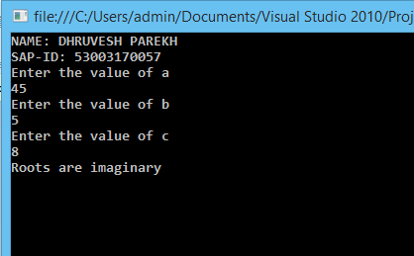

static void Main(string[] args)
{
Console.WriteLine(“#53003170057#\n #Dhruvesh Parekh#\n”);
QuadEqn qe = new QuadEqn();
qe.quadratic();
Console.ReadKey();
}
}
}

iii. Quadratic Equation

Code:
using System;
using System.Collections.Generic;
using System.Linq;
using System.Text;
namespace Quad_eqn {
class QuadEqn {
public void quadratic()
{
int a, b, c, d;
double x, y;
Console.WriteLine("Enter the value of a:");
a=Convert.ToInt32(Console.ReadLine());
Console.WriteLine("Enter the value of b:");
b = Convert.ToInt32(Console.ReadLine());
Console.WriteLine("Enter the value of c:");
c = Convert.ToInt32(Console.ReadLine());
d = (b * b) - (4 * a * c);

if (a == 0)
{
Console.WriteLine("Not a Quadratic Equation");

}
else if (d < 0)
{
d = -1 * d;
Console.WriteLine("Roots are imaginary");
x = -b / (2 * a);
y = (Math.Sqrt(d) / (2 * a));
Console.WriteLine(x + "+i" + y);
Console.WriteLine(x + "-i" + y);
}
else if (d == 0)
{
Console.WriteLine("Roots are real and equal");
Console.WriteLine("Roots are=" + (-b / (2 * a)));
}
else
{
Console.WriteLine("Roots are real and distinct");

Console.WriteLine("Roots are=" + ((-b + Math.Sqrt(d)) / (2 * a)), ((-b - Math.Sqrt(d)) / (2 * a)));

}

}

OUTPUT:

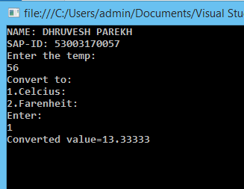

iv. Temperature Conversion

Code:
using System;
using System.Collections.Generic;
using System.Linq;
using System.Text;

namespace TempConvertor
{
class Temprature
{
public double cTof(double celsius)
{
return (celsius * (9 / 5)) + 32;
}
public double fToc(double farhenheit)
{
return (farhenheit - 32) * (5 / 9);
}
}
class Program
{
static void Main(string[] args)
{
Temprature t = new Temprature();
Console.WriteLine(“#53003170057#\n #Dhruvesh Parekh#\n”);
Console.WriteLine( "1. Celsius to Farhenheit\n 2.Farhenheit To Celsius");
double val;
int choice;
choice = Convert.ToInt32(Console.ReadLine());
Console.WriteLine("Enter value:");
val = Convert.ToDouble(Console.ReadLine());
switch (choice)
{
case 1:
Console.WriteLine("Conversion is:" + t.cTof(val));
break;
case 2:
Console.WriteLine("Conversion is:" + t.fToc(val));
break;
}
Console.ReadKey();
}
}
}

OUTPUT:

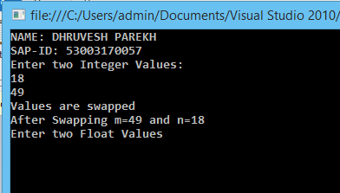

2B.Create simple application to demonstrate use of following concepts

i. Function Overloading
Code:
using System;
using System.Collections.Generic;
using System.Linq;
using System.Text;
namespace Function_Over {
class Overloading {
public void swap(ref int n, ref int m)
{
int temp;
temp = n;
n = m;
m = temp;
Console.WriteLine("Values are swapped");
}
public void swap(ref float p, ref float q)
{
float temp;
temp = p;
p = q;
q = temp;
Console.WriteLine("Values are swapped");
}
}
class Program
{
static void Main(string[] args)
{
Overloading o = new Overloading();
Console.WriteLine(“#53003170057#\n #Dhruvesh Parekh#\n”);
Console.WriteLine("Enter two Integer Values: ");
int m = Convert.ToInt32(Console.ReadLine());
int n = Convert.ToInt32(Console.ReadLine());
o.swap(ref m, ref n);
Console.WriteLine("After Swapping m={0} and n={1}", m, n);
Console.WriteLine("Enter two Float Values");
float p = Convert.ToSingle(Console.ReadLine());
float q = Convert.ToSingle(Console.ReadLine());
o.swap(ref p, ref q);
Console.WriteLine("After Swapping p={0} and q={1}", p, q);
Console.ReadKey();
}
}
}

OUTPUT:

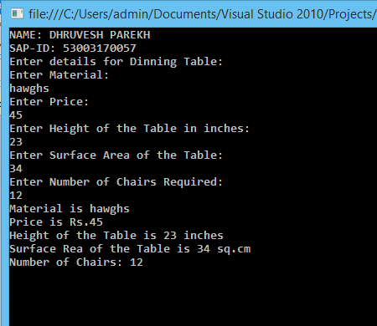

Console.WriteLine("Enter number Of Chairs:");
noOfChairs = Convert.ToInt32(Console.ReadLine());
}
public void setData()
{
base.setData();
Console.WriteLine("Number of Chair is:" + noOfChairs);
}
}
class Program
{
static void Main(string[] args)
{
DinningTable dt=new DinningTable();
Console.WriteLine(“#53003170057#\n #Dhruvesh Parekh#\n”);
Console.WriteLine("Enter details for Dinnng Table");
dt.getData();
dt.setData();
Console.ReadKey();
}
}
}

ii. Inheritance (all types)
1.Single Inheritance and Multilevel Inheritance
Code:
using System;
using System.Collections.Generic;
using System.Linq;
using System.Text;
namespace MultilevelInh {
class Furnitue {
string material;
float price;
public void getData()
{
Console.WriteLine("Enter material:");
material = Console.ReadLine();
Console.WriteLine("Enter price:");
price = Convert.ToSingle(Console.ReadLine());
}
public void setData()
{
Console.WriteLine("Material is:" + material);
Console.WriteLine("Price is:" + price);
}
}
class Table:Furnitue
{
float height;
float surfaceArea;
public void getData()
{
base.getData();
Console.WriteLine("Enter height:");
height = Convert.ToSingle(Console.ReadLine());
Console.WriteLine("Enter SurfaceArea:");
surfaceArea = Convert.ToSingle(Console.ReadLine());
}
public void setData()
{
base.setData();
Console.WriteLine("Height is:" + height);
Console.WriteLine("surfaceArea is:" + surfaceArea);
}
}
class DinningTable:Table
{
int noOfChairs;
public void getData()
{
base.getData();

OUTPUT:

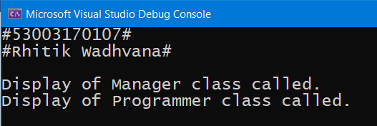

2.Hierarchical Inheritance

Code:
using System;
using System.Collections.Generic;
using System.Linq;
using System.Text;
namespace Hierarchical_Inh
{
class Employee
{
public virtual void display()
{
Console.WriteLine("Display of Employee class called.");
}
}
class Programmer:Employee
{
public void display()
{
Console.WriteLine("Display of Programmer class called.");
}
}
class Manager:Employee
{
public void display()
{
Console.WriteLine("Display of Manager class called.");
}
}
class Program
{
static void Main(string[] args)
{
Manager m = new Manager();
Console.WriteLine(“#53003170057#\n #Dhruvesh Parekh#\n”);
m.display();
Programmer p = new Programmer();
p.display();
Console.ReadKey();
}

}
}

OUTPUT:

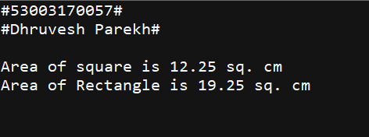

iii. Constructor overloading
Code:
using System;
using System.Collections.Generic;
using System.Linq;
using System.Text;

namespace Constructor_over
{
class Area
{
public Area(float s)
{
Console.WriteLine("Area of Sqaure is "+s*s+" sq. cm.");
}
public Area(float l,float b)
{
Console.WriteLine("Area of Rectangle is " + l * b + " sq. cm.");
}
}
class Program
{
static void Main(string[] args)
{
Console.WriteLine(“#53003170057#\n #Dhruvesh Parekh#\n”);
Area obj = new Area(2.5f);
Area obj1 = new Area(2.5f,5.5f);
Console.ReadKey();
}

}
}

OUTPUT:

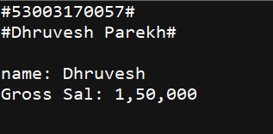

private int S_ta;
public int da
{
get { return S_da; }
set { S_da = value; }
}
private int S_da;
public int GrossSal()
{
int gSal;
gSal = hra + ta + da + BasicSal(15000);
return gSal;
}
public void dispSal()
{
base.ShowData();
Console.WriteLine("Gross Sal:" + GrossSal());
}
}
class Program
{
static void Main(string[] args)
{
Console.WriteLine(“#53003170057#\n #Dhruvesh Parekh#\n”);
Salary s = new Salary("Rhitik", 10000);
s.da = 20000;
s.ta = 30000;
s.dispSal();
Console.ReadKey();
}
}
}

iv. Interfaces
Code:
using System;
using System.Collections.Generic;
using System.Linq;
using System.Text;
namespace Multiple_Inh {
interface Gross
{
int ta
{
get;
set;
}
int da
{
get;
set;
}
int GrossSal();
}
class Employee
{
string name;
public Employee(string name)
{
this.name = name;
}
public int BasicSal(int basicSal)
{
return basicSal;
}
public void ShowData()
{
Console.WriteLine("Name :" + name);
}
}
class Salary:Employee, Gross
{
int hra;
public Salary(string name, int hra) : base(name)
{
this.hra = hra;
}
public int ta
{
get { return S_ta; }
set { S_ta = value; }
}

OUTPUT:

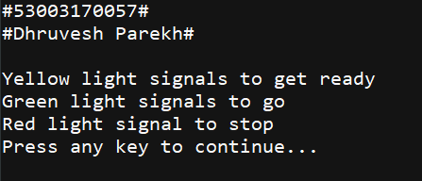

2C. Create simple application to demonstrate use of following concepts.

- Using Delegates and events

CODE:
using System;
using System.Collections.Generic;
using System.Linq;
using System.Text;
namespace TrafficDelegateExample{
public delegate void TrafficDel();
class TrafficSignal
{
public static void Yellow()
{
Console.WriteLine("Yellow light signals to get ready");
}
public static void Green()
{
Console.WriteLine("Green light signals to go");
}
public static void Red()
{
Console.WriteLine("Red light signals to stop");
}
TrafficDel[] td = new TrafficDel[3];
//to initialize an array of delegate with the above methods
public void IdentifySignal()
{
td[0] = new TrafficDel(Yellow);
td[1] = new TrafficDel(Green);
td[2] = new TrafficDel(Red);
}
//to invoke members of the array of delegate
public void display()
{
td[0]();
td[1]();
td[2]();
}
static void Main(string[] args)
{
Console.WriteLine(“#53003170057#\n #Dhruvesh Parekh#\n”);
TrafficSignal ts = new TrafficSignal();
ts.IdentifySignal();
ts.display(); }}}

OUTPUT:

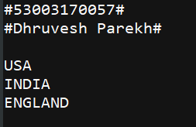

Delegates Events

CODE:
using System;
using System.Collections.Generic;
using System.Linq;
using System.Text;

namespace Delegates
{
public delegate void DelEventHandler();
public class Program
{
//an event to add that is associated to a single delegate DelEventHandler.
public static event DelEventHandler add;

public static void Main(string[] args)
{
//filling the delegate invocation lists with a couple of defined methods using the +=operator
Console.WriteLine(“#53003170057#\n #Dhruvesh Parekh#\n”);
add += new DelEventHandler(USA);
add += new DelEventHandler(India);
add += new DelEventHandler(England);

//invoke the event via the Invoke method
add.Invoke();
Console.ReadLine();
}
static void USA()
{
Console.WriteLine("USA");
}

static void India()
{
Console.WriteLine("India");
}

static void England()
{
Console.WriteLine("England");
}

}
}

OUTPUT:

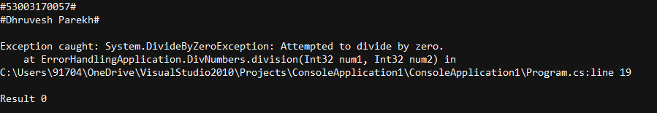

ii. Exception Handling
CODE:
using System;
using System.Collections.Generic;
using System.Linq;
using System.Text;

namespace ErrorHandlingApplication
{
class DivNumbers
{
int result;
DivNumbers()
{
result = 0;
}
public void division(int num1, int num2)
{
try
{
result = num1 / num2;
}
catch (DivideByZeroException e)
{
Console.WriteLine("Exception caught: {0}", e);
}
finally
{
Console.WriteLine("Result: {0}", result);
}
}
static void Main(string[] args)
{
Console.WriteLine(“#53003170057#\n #Dhruvesh Parekh#\n”);
DivNumbers d = new DivNumbers();
d.division(25, 0);
Console.ReadKey();
}
}
}

OUTPUT:

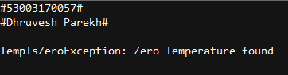

Creating User Defined Exception
CODE:
using System;
using System.Collections.Generic;
using System.Linq;
using System.Text;
namespace UserDefinedException
{
Class TestTemperature
{
static void Main(string[] args)
{
Console.WriteLine(“#53003170057#\n #Dhruvesh Parekh#\n”);
Temperature temp = new Temperature();
try
{
temp.showTemp();
}
catch (TempIsZeroException e)
{
Console.WriteLine("TempIsZeroException: {0}", e.Message);
}
Console.ReadKey();
}
}
}
public class TempIsZeroException : Exception
{
public TempIsZeroException(string message): base(message)
{
}
}
public class Temperature
{
int temperature = 0;
public void showTemp()
{
if (temperature == 0)
{
throw (new TempIsZeroException("Zero Temperature found"));
}
else
{
Console.WriteLine("Temperature: {0}", temperature);
}
} }

OUTPUT:

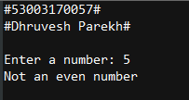

Write a program to accept a number from the user and throw an exception if the number is not an even number.
CODE:
using System;
namespace ExceptionHandlingExample
{
class NotEvenException:Exception
{
public NotEvenException(string msg) : base(msg)
{
}
}
}
namespace ExceptionHandlingExample
{
class Program
{
static void Main(string[] args)
{
Console.WriteLine(“#53003170057#\n #Dhruvesh Parekh#\n”);
int num;
try
{
Console.Write("Enter a number: ");
num = int.Parse(Console.ReadLine());
if ((num % 2) != 0)
throw new NotEvenException("Not an even number ");
else
Console.WriteLine("Its even number ");
}
catch (NotEvenException e)
{
Console.WriteLine(e.Message);
}
}
}
}

OUTPUT:

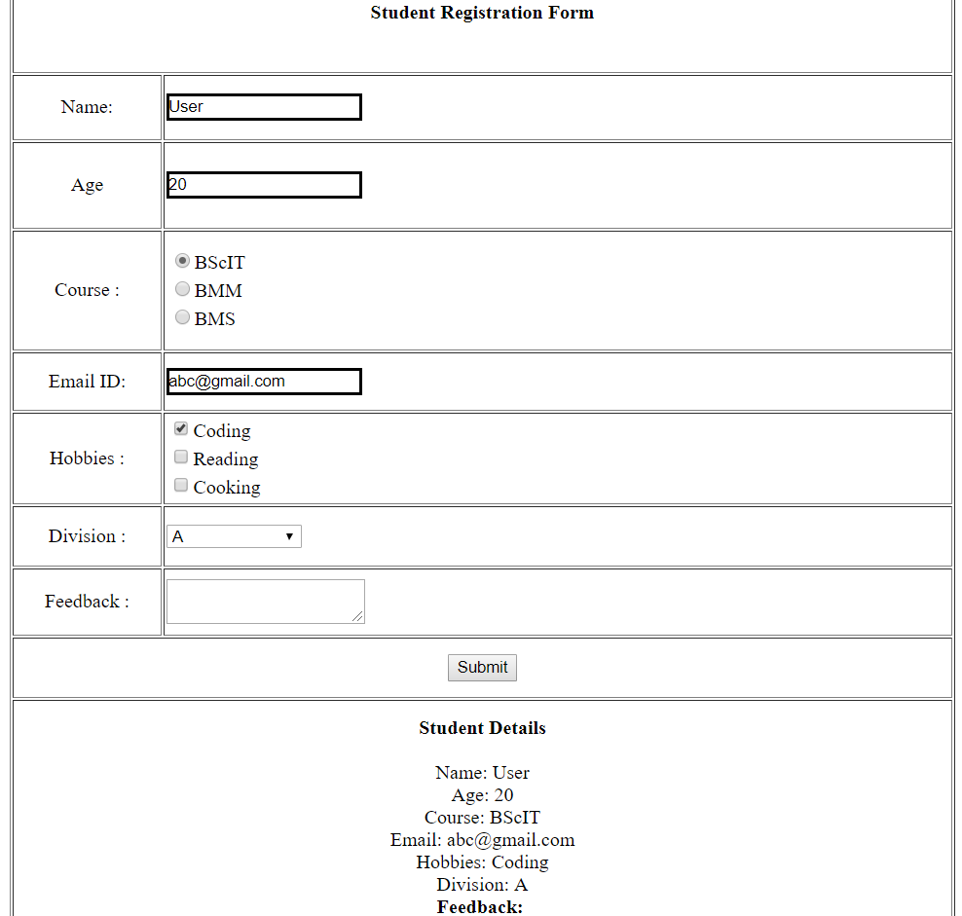

3A. Create a simple web page with various sever controls to demonstrate setting and use of their properties. (Example : AutoPostBack)

CODE:
Default.aspx
<%@ Page Language="C#" AutoEventWireup="true" CodeFile="Default.aspx.cs" Inherits="_Default" %>
<!DOCTYPE html PUBLIC "-//W3C//DTD XHTML 1.0 Transitional//EN" "http://www.w3.org/TR/xhtml1/DTD/xhtml1-transitional.dtd">
<html xmlns="http://www.w3.org/1999/xhtml">
<head runat="server">
<title></title>
<style type="text/css">
.style1
{
width: 119px;
text-align:center;
}
.style3
{
height: 68px;
}
.style4
{
width: 119px;
text-align: center;
height: 68px;
}
.style5
{
width: 119px;
text-align: center;
height: 51px;
}
.style6
{
height: 51px;
}
.style7
{
width: 119px;
text-align: center;
height: 45px;
}
.style8
{
height: 45px;
}
.style9
{
width: 119px;
text-align: center;
height: 47px;
}
.style10
{
height: 47px;
}
.style11
{
width: 119px;
text-align: center;
height: 52px;
}
.style12
{
height: 52px;
}
</style>
</head>
<body>
<form id="form1" runat="server">
<table id="tbl1" text-align:center border="1" style="height: 786px; width: 777px" align="center">
<tr >
<td class="style1" colspan="2"><asp:Label ID="Label1" runat="server"
Text="Student Registration Form" Enabled="False" Font-Bold="True"
Font-Italic="False" Height="45px" Width="501px"></asp:Label></td>
</tr>
<tr>
<td class="style5">
Name:
</td>
<td class="style6">
<asp:TextBox ID="TextBox1" runat="server" BorderColor="Black" ></asp:TextBox>
</td>
</tr>
<tr>
<td class="style4">
Age
</td>
<td class="style3">
<asp:TextBox ID="TextBox2" runat="server" BorderColor="Black"></asp:TextBox>
</td>
</tr>
<tr>
<td class="style1">
Course :
</td>
<td>
<asp:RadioButtonList ID="RadioButtonList1" runat="server">
<asp:ListItem>BScIT</asp:ListItem>
<asp:ListItem>BMM</asp:ListItem>
<asp:ListItem>BMS</asp:ListItem>
</asp:RadioButtonList>
</td>
</tr>
<tr>
<td class="style7">
Email ID:
</td>
<td class="style8">
<asp:TextBox ID="TextBox3" runat="server" BorderColor="Black"></asp:TextBox>
</td>
</tr>
<tr>
<td class="style9">
Hobbies :
</td>
<td class="style10">
<asp:CheckBoxList ID="CheckBoxList1" runat="server">
</asp:CheckBoxList>
</td>
</tr>
<tr>
<td class="style9">
Division :
</td>
<td class="style10">
<asp:DropDownList ID="DropDownList1" runat="server">
<asp:ListItem>Select Division</asp:ListItem>
<asp:ListItem>A</asp:ListItem>
<asp:ListItem>B</asp:ListItem>
</asp:DropDownList>
</td>
</tr>
<tr>
<td class="style11">
Feedback :</td>
<td class="style12">
<asp:TextBox ID="TextBox4" runat="server" TextMode="MultiLine"></asp:TextBox>
</td>
</tr>
<tr>
<td class="style1" colspan="2">
<asp:Button ID="Button1" runat="server" onclick="Button1_Click" Text="Submit" />
</td>
</tr>
<tr>
<td class="style1" colspan="2">
<asp:Label ID="Label2" runat="server"></asp:Label>
</td>
</tr>
</table>
</form>
</body>
</html>
Default.aspx.cs
using System;
using System.Collections.Generic;
using System.Linq;
using System.Web;
using System.Web.UI;
using System.Web.UI.WebControls;
public partial class _Default : System.Web.UI.Page
{
protected void Page_Load(object sender, EventArgs e)
{
if (!this.IsPostBack)
{
CheckBoxList1.Items.Add("Coding");
CheckBoxList1.Items.Add("Reading");
CheckBoxList1.Items.Add("Cooking");
}
}
protected void Button1_Click(object sender, EventArgs e)
{
String str = "<b>Student Details</b><br/><br/>";
str += "Name: " + TextBox1.Text+"<br/>";
str += "Age: " + TextBox2.Text + "<br/>";
str += "Course: " + RadioButtonList1.Items[RadioButtonList1.SelectedIndex].Text+"<br/>";
str += "Email: " + TextBox3.Text + "<br/>";
str+="Hobbies: ";
foreach(ListItem lst in CheckBoxList1.Items)
{
if(lst.Selected==true)
{
str += lst.Text + "<br/>";
}
}
str+="Division: ";
foreach(ListItem lst1 in DropDownList1.Items)
{
if(lst1.Selected==true)
{
str+=lst1.Text;
}
}
str += "<br>";
str += "<b>Feedback: </b>" + TextBox4.Text+"<br/>";
Label2.Text = str;

}

}

OUTPUT:

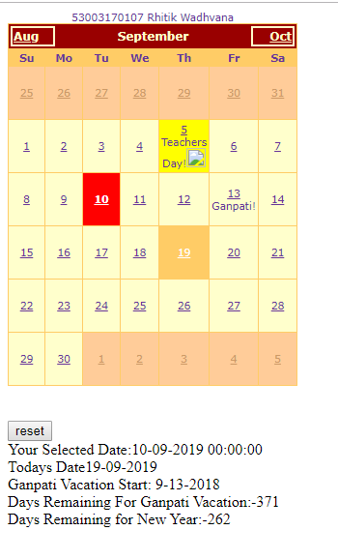

3B. Demonstrate the use of Calendar control to perform following operations.
a) Display messages in a calendar control
b) Display vacation in a calendar control
c) Selected day in a calendar control using style
d) Difference between two calendar dates

CODE:
Default.aspx
<%@ Page Language="C#" AutoEventWireup="true" CodeFile="Default.aspx.cs" Inherits="_Default" %>
<!DOCTYPE html PUBLIC "-//W3C//DTD XHTML 1.0 Transitional//EN" "http://www.w3.org/TR/xhtml1/DTD/xhtml1-transitional.dtd">
<html xmlns="http://www.w3.org/1999/xhtml">
<head runat="server">
<title></title>
</head>
<body>
<form id="form1" runat="server">
<div>
<asp:Calendar ID="Calendar1" runat="server" BackColor="#FFFFCC"
BorderColor="#FFCC66" BorderWidth="1px" DayNameFormat="Shortest"
Font-Names="Verdana" Font-Size="8pt" ForeColor="#663399" Height="200px"
NextPrevFormat="ShortMonth" OnDayRender="Calendar1_DayRender"
ShowGridLines="True" Width="300px" OnSelectionChanged="Calendar1_SelectionChanged" >
<DayHeaderStyle BackColor="#FFCC66" Font-Bold="True" Height="1px" />
<NextPrevStyle BorderStyle="Solid" BorderWidth="2px" Font-Size="9pt"
ForeColor="#FFFFCC" />
<OtherMonthDayStyle BackColor="#FFCC99" BorderStyle="Solid" ForeColor="#CC9966" />
<SelectedDayStyle BackColor="Red" Font-Bold="True" />
<SelectorStyle BackColor="#FFCC66" />
<TitleStyle BackColor="#990000" Font-Bold="True" Font-Size="9pt" ForeColor="#FFFFCC" />
<TodayDayStyle BackColor="#FFCC66" ForeColor="White" />
<WeekendDayStyle Height="50px" />
</asp:Calendar>

</div>
<br />
<br />
<asp:Button ID="btnReset" runat="server" Text="reset"
onclick="btnReset_Click" />
<br />
<asp:Label ID="Label1" runat="server"></asp:Label>
<br />
<asp:Label ID="Label2" runat="server"></asp:Label>
<br />
<asp:Label ID="Label3" runat="server"></asp:Label>
<br />
<asp:Label ID="Label4" runat="server"></asp:Label>
<br />
<asp:Label ID="Label5" runat="server"></asp:Label><br />
</form>
</body>
</html>

Default.aspx.cs
using System;
using System.Collections.Generic;
using System.Linq;
using System.Web;
using System.Web.UI;
using System.Web.UI.WebControls;

public partial class _Default : System.Web.UI.Page
{
protected void Calendar1_DayRender(object sender, System.Web.UI.WebControls.DayRenderEventArgs e)
{
if (e.Day.Date.Day == 5 && e.Day.Date.Month == 9)
{
e.Cell.BackColor = System.Drawing.Color.Yellow;
Label lbl = new Label();
lbl.Text = "<br>Teachers Day!";
e.Cell.Controls.Add(lbl);
Image g1 = new Image();
g1.ImageUrl = "td.jpg";
g1.Height = 20;
g1.Width = 20;
e.Cell.Controls.Add(g1);
}
if (e.Day.Date.Day == 13 && e.Day.Date.Month == 9)
{
Calendar1.SelectedDate = new DateTime(2018, 9, 12);
Calendar1.SelectedDates.SelectRange(Calendar1.SelectedDate, Calendar1.SelectedDate.AddDays(10));
Label lbl1 = new Label();
lbl1.Text = "<br>Ganpati!";
e.Cell.Controls.Add(lbl1);
}
}
protected void btnReset_Click(object sender, EventArgs e)
{
Label1.Text = "";
Label2.Text = "";
Label3.Text = "";
Label4.Text = "";
Label5.Text = "";
Calendar1.SelectedDates.Clear();
}
protected void Calendar1_SelectionChanged(object sender, EventArgs e)
{
Label1.Text = "Your Selected Date:" + Calendar1.SelectedDate.Date.ToString();
Calendar1.Caption = "Title ";
Calendar1.FirstDayOfWeek = FirstDayOfWeek.Sunday;
Calendar1.NextPrevFormat = NextPrevFormat.ShortMonth;
Calendar1.TitleFormat = TitleFormat.Month;
Label2.Text = "Todays Date" + Calendar1.TodaysDate.ToShortDateString();
Label3.Text = "Ganpati Vacation Start: 9-13-2018";

TimeSpan d = new DateTime(2018, 9, 13) - DateTime.Now;
Label4.Text = "Days Remaining For Ganpati Vacation:" + d.Days.ToString();
TimeSpan d1 = new DateTime(2018, 12, 31) - DateTime.Now;
Label5.Text = "Days Remaining for New Year:" + d1.Days.ToString();

if(Calendar1.SelectedDate.ToShortDateString() == "9/13/2018")
Label3.Text = "<b>Ganpati Festival Startss</b>";
if(Calendar1.SelectedDate.ToShortDateString() == "9/23/2018")
Label3.Text = "<b>Ganpati Festival End</b>";
}

}

OUTPUT:

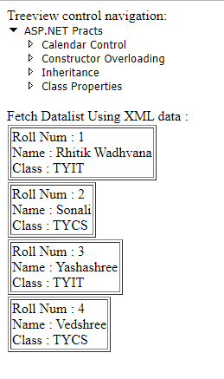

3C. Demonstrate the use of Treeview control perform following operations. A)Treeview control and datalist b)Treeview operations.

CODE:

Default.aspx
<%@ Page Language="C#" AutoEventWireup="true" CodeFile="Default.aspx.cs" Inherits="_Default" %>

<!DOCTYPE html PUBLIC "-//W3C//DTD XHTML 1.0 Transitional//EN" "http://www.w3.org/TR/xhtml1/DTD/xhtml1-transitional.dtd">

<html xmlns="http://www.w3.org/1999/xhtml">
<head id="Head1" runat="server">
<title></title>
</head>
<body>
<form id="form1" runat="server">
<div>
Treeview control navigation:
<asp:TreeView ID = "TreeView1" runat = "server" Width =
"150px" ImageSet="Arrows">
<HoverNodeStyle Font-Underline="True" ForeColor="#5555DD" />
<Nodes>
<asp:TreeNode Text = "ASP.NET Practs" Value = "New Node">
<asp:TreeNode Text = "Calendar Control" Value = "RED" NavigateUrl="~/calndrCtrl.aspx">
</asp:TreeNode>
<asp:TreeNode Text = "Constructor Overloading" Value = "GREEN"
NavigateUrl="~/clsconstrc.aspx"> </asp:TreeNode>
<asp:TreeNode NavigateUrl="~/singleInh.aspx" Text="Inheritance"
Value="BLUE"></asp:TreeNode>
<asp:TreeNode NavigateUrl="~/clsProp.aspx" Text="Class Properties" Value="Class
Properties"></asp:TreeNode>
</asp:TreeNode>
</Nodes>
<NodeStyle Font-Names="Tahoma" Font-Size="10pt" ForeColor="Black"
HorizontalPadding="5px" NodeSpacing="0px" VerticalPadding="0px" />
<ParentNodeStyle Font-Bold="False" />
<SelectedNodeStyle Font-Underline="True" ForeColor="#5555DD"
HorizontalPadding="0px" VerticalPadding="0px" />
</asp:TreeView>
<br />
Fetch Datalist Using XML data : </div>
<asp:DataList ID="DataList1" runat="server">
<ItemTemplate>
<table class = "table" border="1">
<tr>
<td>Roll Num : <%# Eval("sid") %><br />
Name : <%# Eval("sname") %><br />
Class : <%# Eval("sclass")%>
</td>
</tr>
</table>
</ItemTemplate>
</asp:DataList>

</form>
</body>
</html>

Default.aspx.cs
using System;
using System.Collections.Generic;
using System.Linq;
using System.Web;
using System.Web.UI;
using System.Web.UI.WebControls;

using System.Data;

public partial class _Default : System.Web.UI.Page
{
protected void Page_Load(object sender, EventArgs e)
{
if (!IsPostBack)
{
BindData();
}
}
protected void BindData()
{
DataSet ds = new DataSet();
ds.ReadXml(Server.MapPath("XMLFile.xml"));
if (ds != null && ds.HasChanges())
{
DataList1.DataSource = ds;
DataList1.DataBind();
}
else
{
DataList1.DataBind();
}
}
}

XMFile.xml
<?xml version="1.0" encoding="utf-8" ?>
<studentdetail>
<student>
<sid>1</sid>
<sname>Tushar</sname>
<sclass>TYIT</sclass>
</student>
<student>
<sid>2</sid>
<sname>Sonali</sname>
<sclass>TYCS</sclass>
</student>
<student>
<sid>3</sid>
<sname>Yashashree</sname>
<sclass>TYIT</sclass>
</student>
<student>
<sid>4</sid>
<sname>Vedshree</sname>
<sclass>TYCS</sclass>
</student>
</studentdetail>

OUTPUT:

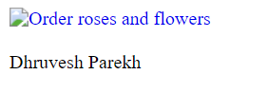

4B. Create Web Form to demonstrate use of Adrotator Control. Add a XML File, name it “adds.xml”.
CODE:

Adds.xml
<Advertisements>
<Ad>
<ImageUrl>rose1.jpg</ImageUrl>
<NavigateUrl>http://www.1800flowers.com</NavigateUrl>
<AlternateText>
Order flowers, roses, gifts and more </AlternateText>
<Impressions>20</Impressions>
<Keyword>flowers</Keyword>
</Ad>
<Ad>
<ImageUrl>rose2.jpg</ImageUrl>
<NavigateUrl>http://www.babybouquets.com.au</NavigateUrl>
<AlternateText>Order roses and flowers</AlternateText>
<Impressions>20</Impressions>
<Keyword>gifts</Keyword>
</Ad>
<Ad>
<ImageUrl>rose3.jpeg</ImageUrl> <NavigateUrl>http://www.flowers2moscow.com</NavigateUrl>
<AlternateText>Send flowers to Russia</AlternateText>
<Impressions>20</Impressions>
<Keyword>russia</Keyword>
</Ad>
</Advertisements>

Default.aspx
<%@ Page Language="C#" AutoEventWireup="true" CodeBehind="WebForm1.aspx.cs" Inherits="WebApplication2.WebForm1" %>

<!DOCTYPE html>

<html xmlns="http://www.w3.org/1999/xhtml">
<head runat="server">
<title></title>
</head>
<body>
<form id="form1" runat="server">
<div>
<asp:AdRotator ID="AdRotator1" runat="server" DataSourceID="XmlDataSource1" />
<asp:XmlDataSource ID="XmlDataSource1" runat="server" DataFile="~/XMLFile1.xml"></asp:XmlDataSource>
</div>
</form>
</body> </html>
OUTPUT:

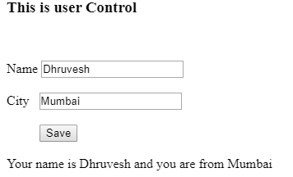

4C. Create Web Form to demonstrate the use of User Controls. Add Web User Control Website -> Add -> Web User Control and name it ‘MyUserControl’.
CODE:
Default.aspx
<%@ Page Language="C#" AutoEventWireup="true" CodeFile="Default.aspx.cs" Inherits="_Default" %>

<%@ Register Src="~/WebUserControl.ascx" TagPrefix="uc"
TagName="Student"%>

<!DOCTYPE html PUBLIC "-//W3C//DTD XHTML 1.0 Transitional//EN" "http://www.w3.org/TR/xhtml1/DTD/xhtml1-transitional.dtd">

<html xmlns="http://www.w3.org/1999/xhtml">
<head runat="server">
<title></title>
</head>
<body>
<form id="form1" runat="server">
<div>

<uc:Student ID="studentcontrol" runat="server" />

</div>
</form>
</body>
</html>

WebUserControl.ascx
<%@ Control Language="C#" AutoEventWireup="true" CodeFile="WebUserControl.ascx.cs" Inherits="WebUserControl" %>
<h3>This is User Contro1 </h3>
<table>

<tr>
<td>Name</td>
<td>

<asp:TextBox ID="txtName" runat="server"></asp:TextBox>
</td>
</tr>
<tr>
<td>City</td>
<td><asp:TextBox ID="txtcity" runat="server"></asp:TextBox></td>
</tr>
<tr>
<td></td>
<td>
</td>
</tr>
<tr>
<td></td>

<td>
<asp:Button ID="txtSave" runat="server" Text="Save" onclick="txtSave_Click" />
</td>
</tr>
</table><br />
<asp:Label ID="Label1" runat="server" Text=" "></asp:Label>

WebUserControl.ascx.cs
using System;
using System.Collections.Generic;
using System.Linq;
using System.Web;
using System.Web.UI;
using System.Web.UI.WebControls;

public partial class WebUserControl : System.Web.UI.UserControl
{
protected void Page_Load(object sender, EventArgs e)
{

}
protected void txtSave_Click(object sender, EventArgs e)
{
Label1.Text = "Your Name is " + txtName.Text + " and you are from " +
txtcity.Text;
}

}

OUTPUT:

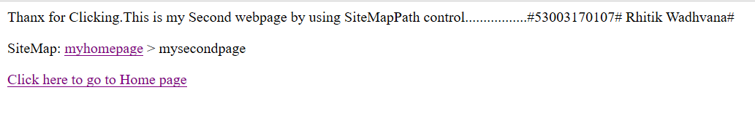

5A. Create Web Form to demonstrate use of Website Navigation controls and Site Map.
CODE:
Default.aspx
<%@ Page Title="" Language="C#" MasterPageFile="~/MasterPage.master" AutoEventWireup="true" CodeFile="Default.aspx.cs" Inherits="Default" %>

<asp:Content ID="Content1" ContentPlaceHolderID="head" Runat="Server">
</asp:Content>
<asp:Content ID="Content2" ContentPlaceHolderID="HeaderContent" Runat="Server">
</asp:Content>
<asp:Content ID="Content3" ContentPlaceHolderID="BodyContent" Runat="Server">

<asp:SiteMapPath ID="SiteMapPath1" runat="server">
</asp:SiteMapPath>
<br />

<asp:HyperLink ID="HyperLink1" runat="server" NavigateUrl="~/myweb1.aspx">Click here to go to first page</asp:HyperLink>
<br />
<asp:HyperLink ID="HyperLink2" runat="server" NavigateUrl="~/myweb2.aspx">Click here to go to second page</asp:HyperLink>

</asp:Content>

MasterPage.master
<%@ Master Language="C#" AutoEventWireup="true" CodeFile="MasterPage.master.cs" Inherits="MasterPage" %>

<!DOCTYPE html PUBLIC "-//W3C//DTD XHTML 1.0 Transitional//EN" "http://www.w3.org/TR/xhtml1/DTD/xhtml1-transitional.dtd">

<html xmlns="http://www.w3.org/1999/xhtml">
<head runat="server">
<title></title>
<asp:ContentPlaceHolder id="head" runat="server">
</asp:ContentPlaceHolder>
</head>
<body>
<form id="form1" runat="server">
<div>
<asp:ContentPlaceHolder id="HeaderContent" runat="server">

</asp:ContentPlaceHolder>

<asp:ContentPlaceHolder id="BodyContent" runat="server">

</asp:ContentPlaceHolder>
</div>
</form>
</body>
</html>

myweb1.aspx
<%@ Page Language="C#" AutoEventWireup="true" CodeFile="myweb1.aspx.cs" Inherits="myweb1" %>

<!DOCTYPE html PUBLIC "-//W3C//DTD XHTML 1.0 Transitional//EN" "http://www.w3.org/TR/xhtml1/DTD/xhtml1-transitional.dtd">

<html xmlns="http://www.w3.org/1999/xhtml">
<head runat="server">
<title></title>
</head>
<body>
<form id="form1" runat="server">
<div>

<asp:Label ID="Label1" runat="server"
Text="Thank you for clicking.This is My First Webpage.............."></asp:Label>
<br />
<br />

<asp:Label ID="Label2" runat="server" Text="SiteMap:"></asp:Label>

<asp:SiteMapPath ID="SiteMapPath1" runat="server">
</asp:SiteMapPath>
<br />
<br />

<asp:HyperLink ID="HyperLink1" runat="server" NavigateUrl="~/myweb2.aspx">click here to go to mywebpage2</asp:HyperLink>
</div>

</form>
</body>
</html>

myweb2.aspx
<%@ Page Language="C#" AutoEventWireup="true" CodeFile="myweb2.aspx.cs" Inherits="myweb2" %>

<!DOCTYPE html PUBLIC "-//W3C//DTD XHTML 1.0 Transitional//EN" "http://www.w3.org/TR/xhtml1/DTD/xhtml1-transitional.dtd">

<html xmlns="http://www.w3.org/1999/xhtml">
<head runat="server">
<title></title>
</head>
<body>
<form id="form1" runat="server">
<div>
<asp:Label ID="Label1" runat="server"
Text="Thanx for Clicking.This is my Second webpage by using SiteMapPath control.................">
</asp:Label>
</div>
<p>
<asp:Label ID="Label2" runat="server" Text="SiteMap: "></asp:Label>

<asp:SiteMapPath ID="SiteMapPath1" runat="server">
</asp:SiteMapPath>
</p>

<asp:HyperLink ID="HyperLink1" runat="server" NavigateUrl="~/Default.aspx">Click here to go to Home page</asp:HyperLink>&nbsp;
</p>
</form>

</body>
</html>

Web.sitemap
<?xml version="1.0" encoding="utf-8" ?>

<siteMap xmlns="http://schemas.microsoft.com/AspNet/SiteMap-File-1.0" >
<siteMapNode url="Default.aspx" title="myhomepage" description="">
<siteMapNode url="myweb1.aspx" title="myfirstpage" description="" />
<siteMapNode url="myweb2.aspx" title="mysecondpage" description="" />
</siteMapNode>
</sitemap>

OUTPUT:

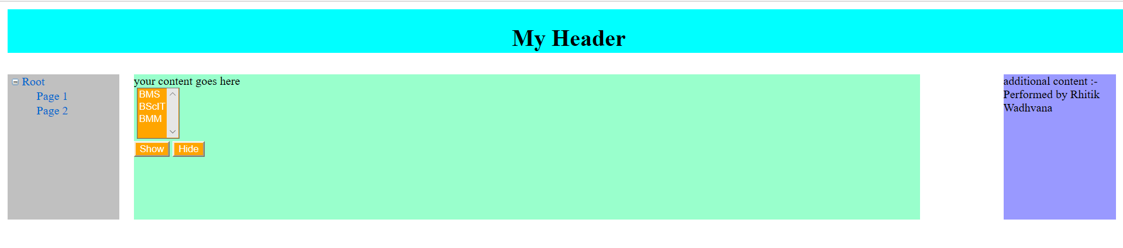

5B. Create a web application to demonstrate use of Master Page with applying Styles and Themes for page beautification.
CODE:
Default.aspx
<%@ Page Title="" Language="C#" MasterPageFile="~/MasterPage5B.master" AutoEventWireup="true" CodeFile="Default.aspx.cs" Inherits="_Default" Theme = "SkinFile" %>

<asp:Content ID="Content1" ContentPlaceHolderID="head" Runat="Server">
</asp:Content>
<asp:Content ID="Content2" ContentPlaceHolderID="MainContent" Runat="Server">
your content goes here<br />
&nbsp;<asp:ListBox ID="ListBox1" runat="server">
<asp:ListItem>BMS</asp:ListItem>
<asp:ListItem>BScIT</asp:ListItem>
<asp:ListItem>BMM</asp:ListItem>
</asp:ListBox>

<br />
<asp:Button ID="Button1" runat="server" onclick="Button1_Click" Text="Show" />
<asp:Button ID="Button2" runat="server" onclick="Button2_Click" Text="Hide" />
<br />
</asp:Content>
<asp:Content ID="Content3" ContentPlaceHolderID="AdditionalContent" Runat="Server">
additional content :- Performed by Jay Modi
</asp:Content>

Default.aspx.cs
using System;
using System.Collections.Generic;
using System.Linq;
using System.Web;
using System.Web.UI;
using System.Web.UI.WebControls;

public partial class _Default : System.Web.UI.Page
{
protected void Page_Load(object sender, EventArgs e)
{

}
protected void Button1_Click(object sender, EventArgs e)
{

MasterPage5B master = (MasterPage5B)this.Master;
master.ShowNavigationControls = true;

}
protected void Button2_Click(object sender, EventArgs e)
{
MasterPage5B master = (MasterPage5B)this.Master;
master.ShowNavigationControls = false;

}
}

MasterPage5B.master
<%@ Master Language="C#" AutoEventWireup="true" CodeFile="MasterPage5B.master.cs" Inherits="MasterPage5B" %>

<!DOCTYPE html PUBLIC "-//W3C//DTD XHTML 1.0 Transitional//EN" "http://www.w3.org/TR/xhtml1/DTD/xhtml1-transitional.dtd">

<html xmlns="http://www.w3.org/1999/xhtml">
<head runat="server">
<title></title>
<asp:ContentPlaceHolder id="head" runat="server">
</asp:ContentPlaceHolder>
<style type="text/css">
body
{
width:80%;

}
.Header
{ position: absolute;
top: 10px;
left: 10px;
height: 60px;
text-align: center;
background-color:Aqua;
width:100%;
text-align:center;
}
.LeftPanel
{
position: absolute;
top: 100px;
left: 10px;
/*width: 160px;*/
background-color: #C0C0C0;
width:10%;
height:200px;
}
.RightPanel
{
position: absolute;
top: 100px;
right: 10px;
/*width: 160px;*/
width:10%;
background-color: #9999FF;
height:200px;
}
.CenterPanel
{
position: absolute;
top: 100px;
margin-left: 175px;
margin-right: 180px;
background-color: #99FFCC;
width:70%;
height:200px;
}

</style>
</head>
<body >

<form id = "form1" runat = "server">
<div class = "Header">
<h1> My Header</h1>
</div>
<div class = "LeftPanel">
<asp:TreeView ID = "TreeView1" runat = "server" Width = "150px">
<Nodes>
<asp:TreeNode Text = "Root" Value = "New Node">
<asp:TreeNode Text = "Page 1" Value = "Page 1"> </asp:TreeNode>
<asp:TreeNode Text = "Page 2" Value = "Page 2"> </asp:TreeNode>
</asp:TreeNode>
</Nodes>
</asp:TreeView>
</div>
<div class = "CenterPanel">
<asp:ContentPlaceHolder id = "MainContent" runat = "server">

</asp:ContentPlaceHolder>
</div>
<div class = "RightPanel">
<asp:ContentPlaceHolder id = "AdditionalContent" runat = "server"> </asp:ContentPlaceHolder>
</div>
</form>
</body>
</html>

MasterPage5B.master.cs
using System;
using System.Collections.Generic;
using System.Linq;
using System.Web;
using System.Web.UI;
using System.Web.UI.WebControls;

public partial class MasterPage5B : System.Web.UI.MasterPage
{
public bool ShowNavigationControls
{
get
{
return TreeView1.Visible;
}
set
{
TreeView1.Visible = value;
}
} protected void Page_Load(object sender, EventArgs e) { }
}

SkinFile.skin
<%--
Default skin template. The following skins are provided as examples only.

1. Named control skin. The SkinId should be uniquely defined because
duplicate SkinId's per control type are not allowed in the same theme.

<asp:GridView runat="server" SkinId="gridviewSkin" BackColor="White" >
<AlternatingRowStyle BackColor="Blue" />
</asp:GridView>

2. Default skin. The SkinId is not defined. Only one default
control skin per control type is allowed in the same theme.

<asp:Image runat="server" ImageUrl="~/images/image1.jpg" />
--%>

<asp:ListBox runat = "server" ForeColor = "White" BackColor = "Orange"/>
<asp:TextBox runat = "server" ForeColor = "White" BackColor = "Orange"/>
<asp:Button runat = "server" ForeColor = "White" BackColor = "Orange"/>

OUTPUT:

Session
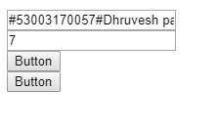
ViewState
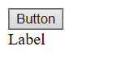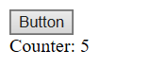
QueryString
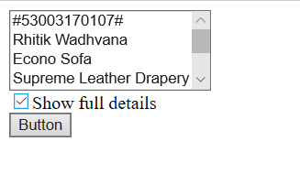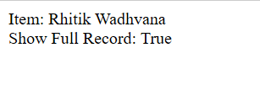
Cookies

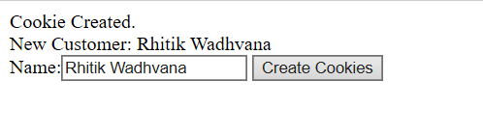

5C. Create a web application to demonstrate various states of ASP.NET Pages.
CODE:
session.aspx
<%@ Page Language="C#" AutoEventWireup="true" CodeFile="session.aspx.cs" Inherits="session" %>

<!DOCTYPE html PUBLIC "-//W3C//DTD XHTML 1.0 Transitional//EN" "http://www.w3.org/TR/xhtml1/DTD/xhtml1-transitional.dtd">

<html xmlns="http://www.w3.org/1999/xhtml">
<head runat="server">
<title></title>
</head>
<body>
<form id="form1" runat="server">
<div>
<asp:TextBox ID="JayModi" runat="server" Text="#53003170050#Jay Modi#"> </asp:TextBox>
<br />

<asp:TextBox ID="TextBox1" runat="server"></asp:TextBox>
<br />
<asp:Button ID="Button1" runat="server" Text="Button" onclick="Button1_Click" />

<br />
<asp:Button ID="Button2" runat="server" onclick="Button2_Click" Text="Button" />
</div>
</form>
</body>
</html>

session.aspx.cs
using System;
using System.Collections.Generic;
using System.Linq;
using System.Web;
using System.Web.UI;
using System.Web.UI.WebControls;

public partial class session : System.Web.UI.Page
{

protected void Page_Load(object sender, EventArgs e)
{
if (!IsPostBack)
{
if (Session["Counter"] == null)
{
Session["Counter"] = 0;
}
TextBox1.Text = Session["Counter"].ToString();

}
}
protected void Button1_Click(object sender, EventArgs e)
{
if (Session["Counter"] != null)
{
int SessionCounter = (int)Session["Counter"] + 1;
TextBox1.Text = SessionCounter.ToString();
Session["Counter"] = SessionCounter;
}
}

protected void Button2_Click(object sender, EventArgs e)
{
Response.Redirect("secondPage.aspx");
}
}

secondPage.aspx
<%@ Page Language="C#" AutoEventWireup="true" CodeFile="secondPage.aspx.cs" Inherits="secondPage" %>

<!DOCTYPE html PUBLIC "-//W3C//DTD XHTML 1.0 Transitional//EN" "http://www.w3.org/TR/xhtml1/DTD/xhtml1-transitional.dtd">

<html xmlns="http://www.w3.org/1999/xhtml">
<head runat="server">
<title></title>
</head>
<body>
<form id="form1" runat="server">
<div>
<asp:Label ID="Label1" runat="server" Text="Label"></asp:Label>
</div>
</form>
</body>
</html>

secondPage.aspx.cs
using System;
using System.Collections.Generic;
using System.Linq;
using System.Web;
using System.Web.UI;
using System.Web.UI.WebControls;

public partial class secondPage : System.Web.UI.Page
{
protected void Page_Load(object sender, EventArgs e)
{
if (Session["Counter"] != null)
{
Label1.Text = Session["Counter"].ToString();
}
}
}

ViewState.aspx

<%@ Page Language="C#" AutoEventWireup="true" CodeFile="ViewState.aspx.cs" Inherits="ViewState" %>

<!DOCTYPE html PUBLIC "-//W3C//DTD XHTML 1.0 Transitional//EN" "http://www.w3.org/TR/xhtml1/DTD/xhtml1-transitional.dtd">

<html xmlns="http://www.w3.org/1999/xhtml">
<head runat="server">
<title></title>
</head>
<body>
<form id="form1" runat="server">
<div>
<asp:Button ID="Button1" runat="server" Text="Button" onclick="Button1_Click" />
<br />
<asp:Label ID="Label1" runat="server" Text="Label"></asp:Label>
</div>
</form>
</body>
</html>

ViewState.aspx.cs

using System;
using System.Collections.Generic;
using System.Linq;
using System.Web;
using System.Web.UI;
using System.Web.UI.WebControls;

public partial class ViewState : System.Web.UI.Page
{
protected void Page_Load(object sender, EventArgs e)
{

}
protected void Button1_Click(object sender, EventArgs e)
{
int counter;
if (ViewState["Counter"] == null)
{
counter = 1;
}
else
{
counter = (int)ViewState["Counter"] + 1;
}
ViewState["Counter"] = counter;
Label1.Text = "Counter: " + counter.ToString();

}
}

QueryString.aspx

<%@ Page Language="C#" AutoEventWireup="true" CodeFile="QueryString.aspx.cs" Inherits="QueryString" %>

<!DOCTYPE html PUBLIC "-//W3C//DTD XHTML 1.0 Transitional//EN" "http://www.w3.org/TR/xhtml1/DTD/xhtml1-transitional.dtd">

<html xmlns="http://www.w3.org/1999/xhtml">
<head runat="server">
<title></title>
</head>
<body>
<form id="form1" runat="server">
<div>
<asp:ListBox ID="lstItems" runat="server"></asp:ListBox>

<br />
<asp:CheckBox ID="chkDetails" runat="server" Text="Show full details" />

<br />
<asp:Button ID="Button1" runat="server" Text="Button" onclick="Button1_Click" />
<br />
<asp:Label ID="lblError" runat="server" ></asp:Label>
</div>
</form>
</body>
</html>

QueryString.aspx.cs

using System;
using System.Collections.Generic;
using System.Linq;
using System.Web;
using System.Web.UI;
using System.Web.UI.WebControls;

public partial class QueryString : System.Web.UI.Page
{
protected void Page_Load(object sender, EventArgs e)
{
if (!this.IsPostBack)
{
// Add sample values.
lstItems.Items.Add("#53003170057#");
lstItems.Items.Add("Dhruvesh Parekh");
lstItems.Items.Add("Econo Sofa");
lstItems.Items.Add("Supreme Leather Drapery");
lstItems.Items.Add("Threadbare Carpet");
lstItems.Items.Add("Antique Lamp");
lstItems.Items.Add("Retro-Finish Jacuzzi");
}

}
protected void Button1_Click(object sender, EventArgs e)
{
if (lstItems.SelectedIndex == -1)
{
lblError.Text = "You must select an item.";
}
else
{ // Forward the user to the information page,
// with the query string data.
string url = "QueryString2.aspx?";
url += "Item=" + lstItems.SelectedItem.Text + "&";
url += "Mode=" + chkDetails.Checked.ToString();
Response.Redirect(url);
}
}
}

QueryString2.aspx

<%@ Page Language="C#" AutoEventWireup="true" CodeFile="QueryString2.aspx.cs" Inherits="QueryString2" %>

<!DOCTYPE html PUBLIC "-//W3C//DTD XHTML 1.0 Transitional//EN" "http://www.w3.org/TR/xhtml1/DTD/xhtml1-transitional.dtd">

<html xmlns="http://www.w3.org/1999/xhtml">
<head runat="server">
<title></title>
</head>
<body>
<form id="form1" runat="server">
<div>
<asp:Label ID="lblInfo" runat="server" ></asp:Label>
</div>
</form>
</body>
</html>

QueryString2.aspx.cs
using System;
using System.Collections.Generic;
using System.Linq;
using System.Web;
using System.Web.UI;
using System.Web.UI.WebControls;

public partial class QueryString2 : System.Web.UI.Page
{
protected void Page_Load(object sender, EventArgs e)
{
lblInfo.Text = "Item: " + Request.QueryString["Item"];
lblInfo.Text += "<br/>Show Full Record: ";
lblInfo.Text += Request.QueryString["Mode"];

}
}

cookies.aspx

<%@ Page Language="C#" AutoEventWireup="true" CodeFile="cookies.aspx.cs" Inherits="cookies" %>

<!DOCTYPE html PUBLIC "-//W3C//DTD XHTML 1.0 Transitional//EN" "http://www.w3.org/TR/xhtml1/DTD/xhtml1-transitional.dtd">

<html xmlns="http://www.w3.org/1999/xhtml">
<head runat="server">
<title></title>
</head>
<body>
<form id="form1" runat="server">
<div>
<asp:Label ID="lblWelcome" runat="server" ></asp:Label>
<br />
Name:<asp:TextBox ID="txtName" runat="server"></asp:TextBox>
<asp:Button ID="Button1" runat="server" onclick="Button1_Click"
Text="Create Cookies" />
<br />

</div>
</form>
</body>
</html>

cookies.aspx.cs

using System;
using System.Collections.Generic;
using System.Linq;
using System.Web;
using System.Web.UI;
using System.Web.UI.WebControls;
using System.Net;

public partial class cookies : System.Web.UI.Page
{
protected void Page_Load(object sender, EventArgs e)
{
HttpCookie cookie = Request.Cookies["Preferences"];
if (cookie == null)
{
lblWelcome.Text = "Unknown Customer <br/>";
}
else
{
lblWelcome.Text = "Cookie Found. <br/>";
lblWelcome.Text += "Welcome, " + cookie["Name"];
}
}
protected void Button1_Click(object sender, EventArgs e)
{
// Check for a cookie, and create a new one only if one doesn’t already exist.
// retrieve the cookie, which is named Preferences
HttpCookie cookie = Request.Cookies["Preferences"];
if (cookie == null)
{ cookie = new HttpCookie("Preferences"); }

cookie["Name"] = txtName.Text;
cookie.Expires = DateTime.Now.AddYears(1);
Response.Cookies.Add(cookie);
lblWelcome.Text = "Cookie Created.<br/>";
lblWelcome.Text += "New Customer: " + cookie["Name"];
}
}

OUTPUT:

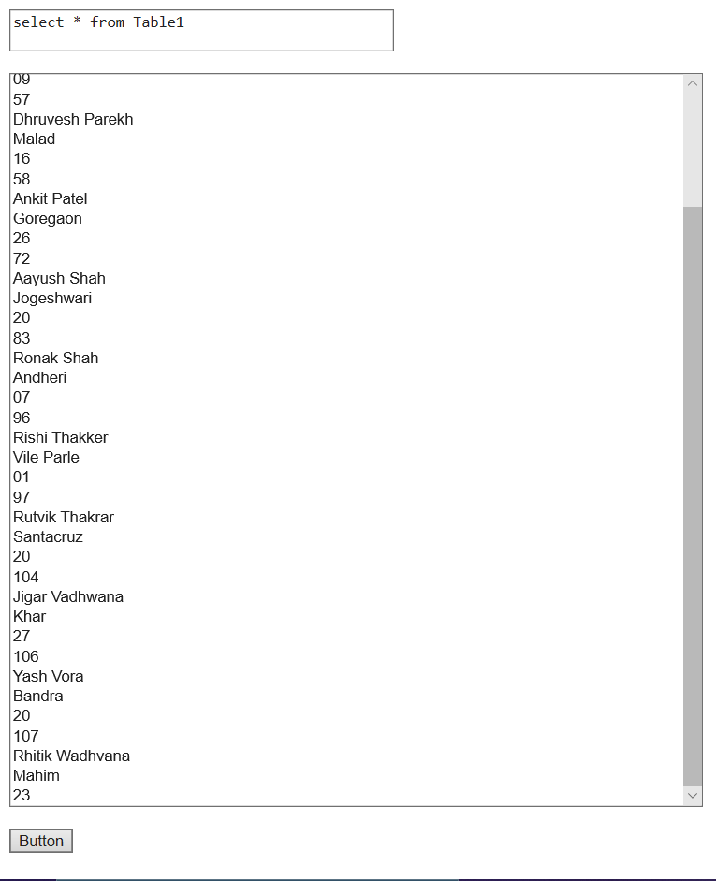

6A. Create a web application bind data in a multiline textbox by querying in another textbox.
CODE:
Default.aspx

<%@ Page Language="C#" AutoEventWireup="true" CodeFile="Default.aspx.cs" Inherits="_Default" %>
<!DOCTYPE html PUBLIC "-//W3C//DTD XHTML 1.0 Transitional//EN" "http://www.w3.org/TR/xhtml1/DTD/xhtml1-transitional.dtd">
<html xmlns="http://www.w3.org/1999/xhtml">
<head runat="server">
<title></title>
</head>
<body>
<form id="form1" runat="server">
<div>
<asp:TextBox ID="TextBox1" runat="server" Height="91px" TextMode="MultiLine"
Width="323px"></asp:TextBox>
<br />
<br />
<asp:ListBox ID="ListBox1" runat="server"></asp:ListBox>
<br />
<br />
<asp:Button ID="Button1" runat="server" onclick="Button1_Click" Text="Button" />
</div>
</form>
</body>
</html>

Default.aspx.cs
using System;
using System.Collections.Generic;
using System.Linq;
using System.Web;
using System.Web.UI;
using System.Web.UI.WebControls;
using System.Data;
using System.Data.SqlClient;
using System.Configuration;
public partial class _Default : System.Web.UI.Page
{
protected void Page_Load(object sender, EventArgs e)
{
}
protected void Button1_Click(object sender, EventArgs e)
{
string connStr =
ConfigurationManager.ConnectionStrings["connStr"].ConnectionString;
SqlConnection con = new SqlConnection(connStr);
con.Open();
SqlCommand cmd = new SqlCommand(TextBox1.Text, con);
SqlDataReader reader = cmd.ExecuteReader();
ListBox1.Items.Clear();
while (reader.Read())
{
//To add new blank line in the text area
int j = reader.FieldCount;
for (int i = 0; i < j; i++)
{
ListBox1.Items.Add(reader[i].ToString());
}
}
reader.Close();
con.Close();
}
}
Web.config

<?xml version="1.0"?>
<!--
For more information on how to configure your ASP.NET application, please visit
http://go.microsoft.com/fwlink/?LinkId=169433
-->
<configuration>
<system.web>
<compilation debug="false" targetFramework="4.0" />
</system.web>
<connectionStrings>
<add name="connStr" connectionString="Data Source=.\SQLEXPRESS;AttachDbFilename='C:\Users\admin\Documents\Visual Studio 2010\WebSites\WebSite13\App_Data\Database.mdf';Integrated Security=True;User Instance=True" />

</connectionString>
</configuration>

OUTPUT:

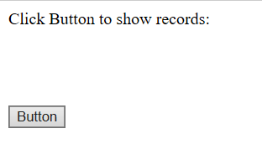

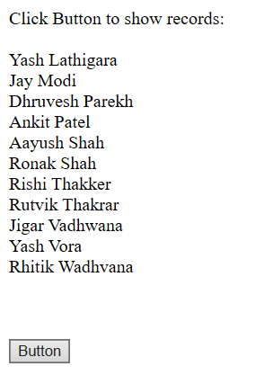

6B. Create a web application to display records by using database.
CODE:
Default.aspx
<%@ Page Language="C#" AutoEventWireup="true" CodeFile="Default.aspx.cs" Inherits="_Default" %>
<!DOCTYPE html PUBLIC "-//W3C//DTD XHTML 1.0 Transitional//EN" "http://www.w3.org/TR/xhtml1/DTD/xhtml1-transitional.dtd">
<html xmlns="http://www.w3.org/1999/xhtml">
<head id="Head1" runat="server">
<title></title>
</head>
<body>
<form id="form1" runat="server">
<div>
Click Button to show records:<br />
<br />
<asp:Label ID="Label1" runat="server" Text=""></asp:Label>
<br />
<br />
<br />
<asp:Button ID="Button1" runat="server" onclick="Button1_Click" Text="Button" />
</div>
</form>
</body>
</html>

Default.aspx.cs
using System;
using System.Collections.Generic;
using System.Linq;
using System.Web;
using System.Web.UI;
using System.Web.UI.WebControls;
using System.Data;
using System.Data.SqlClient;
using System.Configuration;
public partial class _Default : System.Web.UI.Page
{
protected void Page_Load(object sender, EventArgs e)
{
}
protected void Button1_Click(object sender, EventArgs e)
{
string connStr = ConfigurationManager.ConnectionStrings["connStr"].ConnectionString; SqlConnection con = new SqlConnection(connStr); SqlCommand cmd = new SqlCommand("Select City, State from Customer", con);
con.Open();
SqlDataReader reader = cmd.ExecuteReader();
while (reader.Read()) { Label1.Text += reader["City"].ToString() + " " + reader["State"].ToString() + "<br>";
}
reader.Close(); con.Close();
}

Web.config

<?xml version="1.0"?>
<!--
For more information on how to configure your ASP.NET application, please visit
http://go.microsoft.com/fwlink/?LinkId=169433
-->
<configuration>
<system.web>
<compilation debug="false" targetFramework="4.0" />
</system.web>
<connectionStrings>
<add name="connStr" connectionString="Data Source=.\SQLEXPRESS;AttachDbFilename='C:\Users\admin\Documents\Visual Studio 2010\WebSites\WebSite13\App_Data\Database.mdf';Integrated Security=True;User Instance=True" />

</connectionString>
</configuration>

OUTPUT:

6C. Create a web application to display records using database.

OUTPUT:

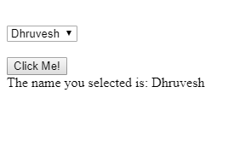

7A. Create a web application to display Databinding using Dropdownlist control.
CODE:
Default.aspx
<%@ Page Language="C#" AutoEventWireup="true" CodeFile="Default.aspx.cs" Inherits="_Default" %>

<!DOCTYPE html PUBLIC "-//W3C//DTD XHTML 1.0 Transitional//EN" "http://www.w3.org/TR/xhtml1/DTD/xhtml1-transitional.dtd">

<html xmlns="http://www.w3.org/1999/xhtml">
<head runat="server">
<title></title>
</head>
<body>
<form id="form1" runat="server">
<div>

<asp:DropDownList ID="DropDownList1" runat="server">
</asp:DropDownList>

</div>
<p>
<asp:Button ID="Button1" runat="server" Text="Click Me !" onclick=”Button1_Click” />
</p>
<p>
&nbsp;</p>
<p>
<asp:Label ID="Label1" runat="server" Text=""></asp:Label>
</p>
</form>
</body>
</html>

Default.aspx.cs
using System;
using System.Collections.Generic;
using System.Linq;
using System.Web;
using System.Web.UI;
using System.Web.UI.WebControls;
using System.Data;
using System.Data.SqlClient;
using System.Configuration;
public partial class _Default : System.Web.UI.Page
{
protected void Page_Load(object sender, EventArgs e)
{
if (IsPostBack == false)
{
string connStr = ConfigurationManager.ConnectionStrings["connStr"].ConnectionString;
SqlConnection con = new SqlConnection(connStr);
SqlCommand cmd = new SqlCommand("Select Distinct City from Customer", con);
con.Open();
SqlDataReader reader = cmd.ExecuteReader();
DropDownList1.DataSource = reader;
DropDownList1.DataTextField = "City";
DropDownList1.DataBind();
reader.Close();
con.Close();
}
}
protected void Button1_Click(object sender, EventArgs e)
{
Label1.Text = "The Country You Have Selected Is: " + DropDownList1.SelectedValue;
}
}

OUTPUT:

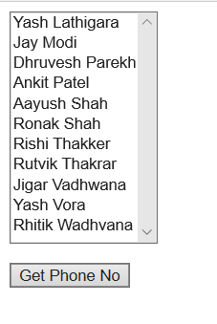

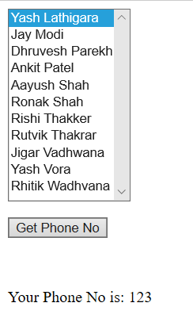

7B. Create a web application to display the postal code no of customer using database.
CODE:
Default.aspx
<%@ Page Language="C#" AutoEventWireup="true" CodeFile="Default.aspx.cs" Inherits="_Default" %>

<!DOCTYPE html PUBLIC "-//W3C//DTD XHTML 1.0 Transitional//EN" "http://www.w3.org/TR/xhtml1/DTD/xhtml1-transitional.dtd">

<html xmlns="http://www.w3.org/1999/xhtml">
<head runat="server">
<title></title>
</head>
<body>
<form id="form1" runat="server">
<div>

<asp:ListBox ID="ListBox1" runat="server" Height="185px" Width="121px"></asp:ListBox>
<br />

</div>
<p>
<asp:Button ID="Button1" runat="server" Text="Get Phone No" />
</p>
<p>
&nbsp;</p>
<p>
<asp:Label ID="Label1" runat="server" Text=""></asp:Label>
</p>
</form>
</body>
</html>

Default.aspx.cs
using System;
using System.Collections.Generic;
using System.Linq;
using System.Web;
using System.Web.UI;
using System.Web.UI.WebControls;
using System.Data;
using System.Data.SqlClient;
using System.Configuration;
public partial class _Default : System.Web.UI.Page
{
protected void Button1_Click(object sender, EventArgs e)
{
Label1.Text = "Your Postal Code is: " + ListBox1.SelectedValue;
}
protected void Page_Load(object sender, EventArgs e)
{
if (IsPostBack == false)
{
string connStr = ConfigurationManager.ConnectionStrings["connStr"].ConnectionString;
SqlConnection con = new SqlConnection(connStr);
SqlCommand cmd = new SqlCommand("Select Distinct POSTAL_CODE from Customer", con);
con.Open();
SqlDataReader reader = cmd.ExecuteReader();
ListBox1.DataSource = reader;
ListBox1.DataTextField = "City";
ListBox1.DataValueField = "POSTAL_CODE";
ListBox1.DataBind();
reader.Close();
con.Close();
}
}
}

OUTPUT:

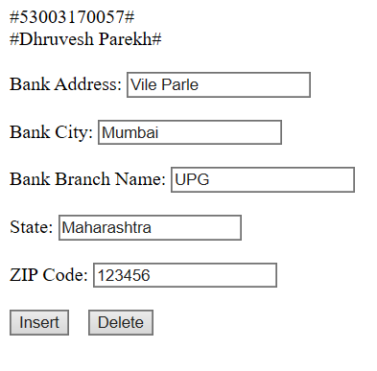
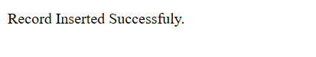

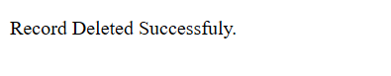

7C. Create a web application for inserting and deleting record from a database. (Using Execute-Non Query)
CODE:
Default.aspx
<%@ Page Language="C#" AutoEventWireup="true" CodeFile="Default.aspx.cs" Inherits="_Default" %>

<!DOCTYPE html PUBLIC "-//W3C//DTD XHTML 1.0 Transitional//EN" "http://www.w3.org/TR/xhtml1/DTD/xhtml1-transitional.dtd">

<html xmlns="http://www.w3.org/1999/xhtml">
<head runat="server">
<title></title>
</head>
<body>
<form id="form1" runat="server">
<div>

#53003170057#<br />
#Dhruvesh Parekh#<br />
<br />

Bank Address:
<asp:TextBox ID="TextBox1" runat="server"></asp:TextBox>
<br />
<br />
Bank City:
<asp:TextBox ID="TextBox2" runat="server"></asp:TextBox>
<br />
<br />
Bank Branch Name:
<asp:TextBox ID="TextBox3" runat="server"></asp:TextBox>
<br />
<br />
State:
<asp:TextBox ID="TextBox4" runat="server"></asp:TextBox>
<br />
<br />
ZIP Code:
<asp:TextBox ID="TextBox5" runat="server"></asp:TextBox>
<br />
<br />
<asp:Button ID="Button1" runat="server" Text="Insert"
onclick="Button1_Click" />
&nbsp;&nbsp;
<asp:Button ID="Button2" runat="server" Text="Delete"
onclick="Button2_Click"/>

<br />
<br />
<asp:Label ID="Label1" runat="server" Text=""></asp:Label>

</div>
</form>
</body>
</html>

Default.aspx.cs
using System;
using System.Collections.Generic;
using System.Linq;
using System.Web;
using System.Web.UI;
using System.Web.UI.WebControls;
using System.Data;
using System.Data.SqlClient;
using System.Configuration;
public partial class _Default : System.Web.UI.Page
{
protected void Button1_Click(object sender, EventArgs e)
{
string connStr = ConfigurationManager.ConnectionStrings["connStr"].ConnectionString;
SqlConnection con = new SqlConnection(connStr);
string InsertQuery = "insert into BRANCH values(@ADDRESS, @CITY, @NAME, @STATE,@ZIP_CODE)";
SqlCommand cmd = new SqlCommand(InsertQuery, con);
cmd.Parameters.AddWithValue("@ADDRESS", TextBox1.Text);
cmd.Parameters.AddWithValue("@CITY", TextBox2.Text);
cmd.Parameters.AddWithValue("@NAME", TextBox3.Text);
cmd.Parameters.AddWithValue("@STATE", TextBox4.Text);
cmd.Parameters.AddWithValue("@ZIP_CODE", TextBox5.Text);
con.Open();
cmd.ExecuteNonQuery();
Label1.Text = "Record Inserted Successfuly.";
con.Close();
}
protected void Button2_Click(object sender, EventArgs e)
{
string connStr = ConfigurationManager.ConnectionStrings["connStr"].ConnectionString;
SqlConnection con = new SqlConnection(connStr);
string InsertQuery = "delete from branch where NAME=@NAME";
SqlCommand cmd = new SqlCommand(InsertQuery, con);
cmd.Parameters.AddWithValue("@NAME", TextBox1.Text);
con.Open();
cmd.ExecuteNonQuery();
Label1.Text = "Record Deleted Successfuly.";
con.Close();
}
}

OUTPUT:

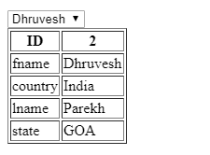

8A. Create a web application to demonstrate various uses and properties of SqlDataSource.
CODE:
Default.aspx
<%@ Page Language="C#" AutoEventWireup="true" CodeFile="Default.aspx.cs" Inherits="_Default" %>
<!DOCTYPE html PUBLIC "-//W3C//DTD XHTML 1.0 Transitional//EN" "http://www.w3.org/TR/xhtml1/DTD/xhtml1-transitional.dtd">
<html xmlns="http://www.w3.org/1999/xhtml">
<head id="Head1" runat="server">
<title></title>
</head>
<body>
<form id="form1" runat="server">
<div>
<asp:DropDownList ID="DropDownList1" runat="server"
DataSourceID="SqlDataSource1" DataTextField="name" DataValueField="name"
onselectedindexchanged="DropDownList1_SelectedIndexChanged"
AutoPostBack="True">
</asp:DropDownList>
<asp:SqlDataSource ID="SqlDataSource1" runat="server"
ConnectionString="Data Source=.\SQLEXPRESS;AttachDbFilename=|DataDirectory|\Database.mdf;Integrated Security=True;User Instance=True"
SelectCommand="SELECT [name] FROM [test2]" ProviderName="System.Data.SqlClient"></asp:SqlDataSource>
<br />
<asp:DetailsView ID="DetailsView1" runat="server" Height="50px" Width="125px"
AutoGenerateRows="False" DataSourceID="SqlDataSource3" >
<Fields>
<asp:BoundField DataField="id" HeaderText="id" SortExpression="id" />
<asp:BoundField DataField="name" HeaderText="name" SortExpression="name" />
<asp:BoundField DataField="country" HeaderText="country"
SortExpression="country" />
<asp:BoundField DataField="lname" HeaderText="lname" SortExpression="lname" />
<asp:BoundField DataField="state" HeaderText="state" SortExpression="state" />
</Fields>
</asp:DetailsView>
<asp:SqlDataSource ID="SqlDataSource3" runat="server"
ConnectionString="Data Source=.\SQLEXPRESS;AttachDbFilename=|DataDirectory|\Database.mdf;Integrated Security=True;User Instance=True"
SelectCommand="SELECT * FROM [test2]" ProviderName="System.Data.SqlClient"></asp:SqlDataSource>
</div>
</form>
</body>
</html>

Default.aspx.cs
using System;
using System.Collections.Generic;
using System.Linq;
using System.Web;
using System.Web.UI;
using System.Web.UI.WebControls;
using System.Data;
using System.Data.SqlClient;
using System.Configuration;
public partial class _Default : System.Web.UI.Page
{
protected void Page_Load(object sender, EventArgs e)
{
}
protected void DropDownList1_SelectedIndexChanged(object sender, EventArgs e)
{
SqlDataSource3.SelectCommand="select * from test2 where name='"+DropDownList1.SelectedValue +"'";
}
}

OUTPUT:

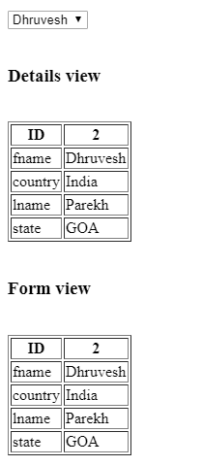

8B. Create a web application to demonstrate data binding using DetailsView and FormView control.
CODE:
Default.aspx
<%@ Page Language="C#" AutoEventWireup="true" CodeFile="Default.aspx.cs" Inherits="_Default" %>
<!DOCTYPE html PUBLIC "-//W3C//DTD XHTML 1.0 Transitional//EN" "http://www.w3.org/TR/xhtml1/DTD/xhtml1-transitional.dtd">
<html xmlns="http://www.w3.org/1999/xhtml">
<head id="Head1" runat="server">
<title></title>
</head>
<body>
<form id="form1" runat="server">
<div>
<asp:DropDownList ID="DropDownList1" runat="server"
DataSourceID="SqlDataSource1" DataTextField="name" DataValueField="name"
onselectedindexchanged="DropDownList1_SelectedIndexChanged"
AutoPostBack="True">
</asp:DropDownList>
<asp:SqlDataSource ID="SqlDataSource1" runat="server"
ConnectionString="Data Source=.\SQLEXPRESS;AttachDbFilename=|DataDirectory|\Database.mdf;Integrated Security=True;User Instance=True"
SelectCommand="SELECT [name] FROM [test2]" ProviderName="System.Data.SqlClient"></asp:SqlDataSource>
<br />

<h3>DetailsView</h3>
<asp:DetailsView ID="DetailsView1" runat="server" Height="50px" Width="125px"
AutoGenerateRows="False" DataSourceID="SqlDataSource3" >
<Fields>
<asp:BoundField DataField="id" HeaderText="id" SortExpression="id" />
<asp:BoundField DataField="name" HeaderText="name" SortExpression="name" />
<asp:BoundField DataField="country" HeaderText="country"
SortExpression="country" />
<asp:BoundField DataField="lname" HeaderText="lname" SortExpression="lname" />
<asp:BoundField DataField="state" HeaderText="state" SortExpression="state" />
</Fields>
</asp:DetailsView>

<h3>FormView</h3>
<asp:FormView ID="FormView1" runat="server" Height="50px" Width="125px"
AutoGenerateRows="False" DataSourceID="SqlDataSource3" >
<ItemTemplate>
<table border="2">
<tr>
<td>id</td>
<td><%# Eval("id") %></td>
</tr>
<tr>
<td>name</td>
<td><%# Eval("name") %></td>
</tr>
<tr>
<td>country</td>
<td><%# Eval("country") %></td>
</tr>
<tr>
<td>lname</td>
<td><%# Eval("lname") %></td>
</tr>
<tr>
<td>state</td>
<td><%# Eval("state") %></td>
</tr>
</table>
</ItemTemplate>
</asp:FormView>
<asp:SqlDataSource ID="SqlDataSource3" runat="server"
ConnectionString="Data Source=.\SQLEXPRESS;AttachDbFilename=|DataDirectory|\Database.mdf;Integrated Security=True;User Instance=True"
SelectCommand="SELECT * FROM [test2]" ProviderName="System.Data.SqlClient"></asp:SqlDataSource>
</div>
</form>
</body>
</html>

Default.aspx.cs
using System;
using System.Collections.Generic;
using System.Linq;
using System.Web;
using System.Web.UI;
using System.Web.UI.WebControls;
using System.Data;
using System.Data.SqlClient;
using System.Configuration;
public partial class _Default : System.Web.UI.Page
{
protected void Page_Load(object sender, EventArgs e)
{
}
protected void DropDownList1_SelectedIndexChanged(object sender, EventArgs e)
{
SqlDataSource3.SelectCommand = "select * from test2 where name='" + DropDownList1.SelectedValue + "'";
}
}

OUTPUT:

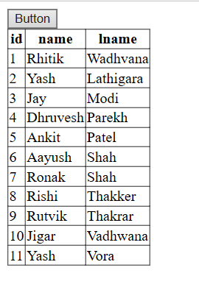

8C. Create a web application to display using disconnected data access and data binding using GridView.
CODE:
Default.aspx
<%@ Page Language="C#" AutoEventWireup="true" CodeFile="Default.aspx.cs" Inherits="_Default" %>
<!DOCTYPE html PUBLIC "-//W3C//DTD XHTML 1.0 Transitional//EN" "http://www.w3.org/TR/xhtml1/DTD/xhtml1-transitional.dtd">
<html xmlns="http://www.w3.org/1999/xhtml">
<head id="Head1" runat="server">
<title></title>
</head>
<body>
<form id="form1" runat="server">
<div>
<asp:Button ID="Button1" runat="server" Text="Button" onclick="Button1_Click" />
<br />
<asp:GridView ID="GridView1" runat="server">
</asp:GridView>
</div>
</form>
</body>
</html>

Default.aspx.cs
using System;
using System.Collections.Generic;
using System.Linq;
using System.Web;
using System.Web.UI;
using System.Web.UI.WebControls;
using System.Data;
using System.Data.SqlClient;
using System.Configuration;
public partial class _Default : System.Web.UI.Page
{
protected void Page_Load(object sender, EventArgs e)
{
}
protected void Button1_Click(object sender, EventArgs e)
{
string connStr = ConfigurationManager.ConnectionStrings["connStr"].ConnectionString;
SqlConnection con = new SqlConnection(connStr);
SqlCommand objCmd = new SqlCommand("select * from test2", con);
SqlDataAdapter objDa = new SqlDataAdapter();
DataSet objDs = new DataSet();
objCmd.CommandType = CommandType.Text;
objDa.SelectCommand = objCmd;
objDa.Fill(objDs, "test2");
GridView1.DataSource = objDs.Tables[0];
GridView1.DataBind();
}
}

OUTPUT:

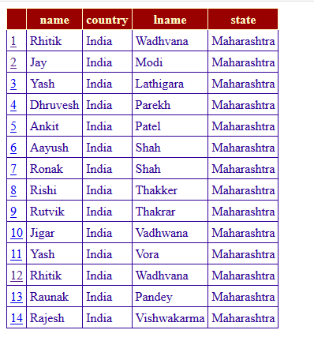

9A. Create a web application to demonstrate use of GridView control template and GridView hyperlink.
CODE:
Default.aspx
<%@ Page Language="C#" AutoEventWireup="true" CodeFile="Default.aspx.cs" Inherits="_Default" %>

<!DOCTYPE html PUBLIC "-//W3C//DTD XHTML 1.0 Transitional//EN" "http://www.w3.org/TR/xhtml1/DTD/xhtml1-transitional.dtd">

<html xmlns="http://www.w3.org/1999/xhtml">
<head runat="server">
<title></title>
</head>
<body>
<form id="form1" runat="server">
<div>

<asp:GridView ID="GridView1" runat="server" AutoGenerateColumns="False"
BackColor="White" BorderColor="#CC9966" BorderStyle="None" BorderWidth="1px"
CellPadding="4" DataSourceID="SqlDataSource1">
<Columns>
<asp:HyperLinkField DataNavigateUrlFields="name"
DataNavigateUrlFormatString="~/Default2.aspx?name={0}" DataTextField="id" />
<asp:BoundField DataField="name" HeaderText="name" SortExpression="name" />
<asp:BoundField DataField="country" HeaderText="country"
SortExpression="country" />
<asp:BoundField DataField="lname" HeaderText="lname" SortExpression="lname" />
<asp:BoundField DataField="state" HeaderText="state" SortExpression="state" />
</Columns>
<FooterStyle BackColor="#FFFFCC" ForeColor="#330099" />
<HeaderStyle BackColor="#990000" Font-Bold="True" ForeColor="#FFFFCC" />
<PagerStyle BackColor="#FFFFCC" ForeColor="#330099" HorizontalAlign="Center" />
<RowStyle BackColor="White" ForeColor="#330099" />
<SelectedRowStyle BackColor="#FFCC66" Font-Bold="True" ForeColor="#663399" />
<SortedAscendingCellStyle BackColor="#FEFCEB" />
<SortedAscendingHeaderStyle BackColor="#AF0101" />
<SortedDescendingCellStyle BackColor="#F6F0C0" />
<SortedDescendingHeaderStyle BackColor="#7E0000" />
</asp:GridView>
<asp:SqlDataSource ID="SqlDataSource1" runat="server"
ConnectionString="<%$ ConnectionStrings:ConnectionString %>"
SelectCommand="SELECT * FROM [test2]"></asp:SqlDataSource>
</div>
</form>
</body>
</html>

Default.aspx.cs
using System;
using System.Collections.Generic;
using System.Linq;
using System.Web;
using System.Web.UI;
using System.Web.UI.WebControls;

public partial class _Default : System.Web.UI.Page
{
protected void Page_Load(object sender, EventArgs e)
{
GridView1.PageIndex = e.NewPageIndex;
methodname();
}
}

OUTPUT:
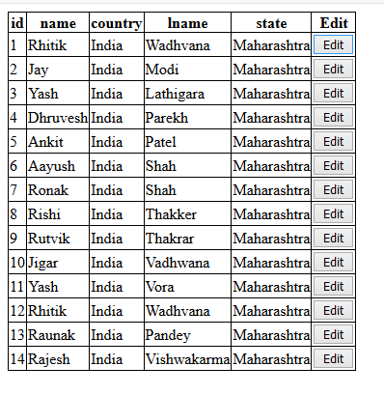

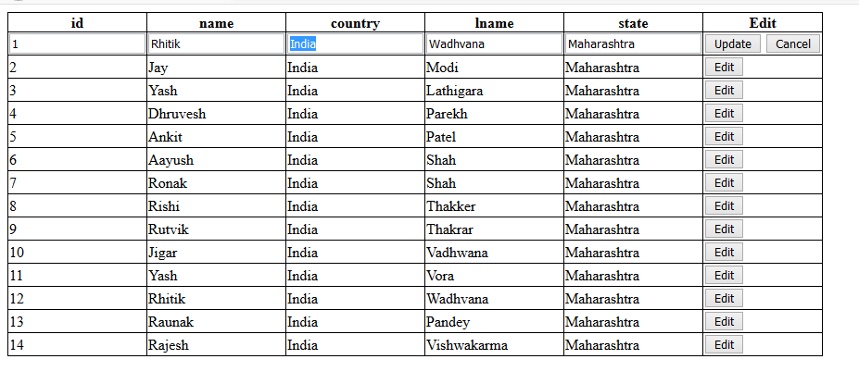

9B. Create a web application to demonstrate use of GridView button column and GridView events.
CODE:
Default.aspx
<%@ Page Language="C#" AutoEventWireup="true" CodeFile="Default.aspx.cs" Inherits="_Default" %>

<!DOCTYPE html PUBLIC "-//W3C//DTD XHTML 1.0 Transitional//EN" "http://www.w3.org/TR/xhtml1/DTD/xhtml1-transitional.dtd">

<html xmlns="http://www.w3.org/1999/xhtml">
<head runat="server">
<title></title>
</head>
<body>
<form id="form1" runat="server">

<asp:GridView ID="GridView1" runat="server" AutoGenerateColumns="False"
DataSourceID="SqlDataSource1">
<Columns>
<asp:BoundField DataField="id" HeaderText="id" SortExpression="id" />
<asp:BoundField DataField="name" HeaderText="name" SortExpression="name" />
<asp:BoundField DataField="country" HeaderText="country"
SortExpression="country" />
<asp:BoundField DataField="lname" HeaderText="lname" SortExpression="lname" />
<asp:BoundField DataField="state" HeaderText="state" SortExpression="state" />
<asp:CommandField ButtonType="Button" HeaderText="Edit" ShowEditButton="True"
ShowHeader="True" />
</Columns>
</asp:GridView>

<asp:SqlDataSource ID="SqlDataSource1" runat="server"
ConnectionString="<%$ ConnectionStrings:ConnectionString %>"
SelectCommand="SELECT * FROM [test2]"></asp:SqlDataSource>

</form>
</body>
</html>

OUTPUT:
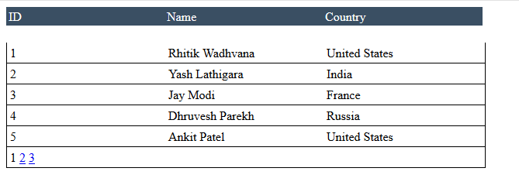

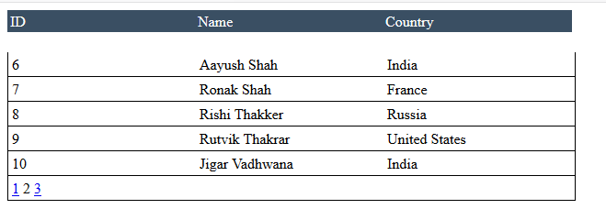

9C. Create a web application to demonstrate use of GridView paging and creating own table format using GridView.
CODE:
Default.aspx
<%@ Page Language="C#" AutoEventWireup="true" CodeFile="Default.aspx.cs" Inherits="_Default" %>
<!DOCTYPE html PUBLIC "-//W3C//DTD XHTML 1.0 Transitional//EN" "http://www.w3.org/TR/xhtml1/DTD/xhtml1-transitional.dtd">
<html xmlns="http://www.w3.org/1999/xhtml">
<head id="Head1" runat="server">
<title></title>
</head>
<body>
<form id="form1" runat="server">
<div>
<table runat="server" style="color: White; background-color: #3A4F63;"
id="headerTable">
<tr>
<td style="width: 200px; background-color: #3A4F63; color: White;">
ID
</td>
<td style="width: 200px;">
Name
</td>
<td style="width: 200px;">
Country
</td>
</tr>
</table>
<!-- These are the actual data items -->
<!-- Bind to your specific properties i.e. Employees. -->
<asp:GridView ID="GridView1" runat="server" HeaderStyle-ForeColor="White"
AutoGenerateColumns="false" AllowPaging="True"
onpageindexchanging="GridView1_PageIndexChanging" PageSize="5">
<columns>
<asp:TemplateField>
<ItemTemplate>
<table>
<tr>
<td style="width: 200px;"> <asp:Label ID="lblid" runat="server" Text='<%#Eval("Id") %>'></asp:Label>
</td>
<td style="width: 200px;"> <asp:Label ID="lblName" runat="server" Text='<%#Eval("Name") %>'></asp:Label>
</td>
<td style="width: 200px;"> <asp:Label ID="Country" runat="server" Text='<%#Eval("Country") %>'></asp:Label>
</td>
</tr>
</table>
</ItemTemplate>
</asp:TemplateField>
</columns>
</asp:GridView>
</div>
</form>
</body>
</html>
Default.aspx.cs
using System;
using System.Collections.Generic;
using System.Linq;
using System.Web;
using System.Web.UI;
using System.Web.UI.WebControls;
using System.Data;
public partial class _Default : System.Web.UI.Page
{
protected void Page_Load(object sender, EventArgs e)
{
if (!this.IsPostBack)
{
methodname();
}
}
public void methodname()
{
DataTable dt = new DataTable();
dt.Columns.AddRange(new DataColumn[3] { new DataColumn("Id", typeof(int)),
new DataColumn("Name", typeof(string)),
new DataColumn("Country",typeof(string)) });
dt.Rows.Add(1, "Rhitik Wadhvana", "United States");
dt.Rows.Add(2, "Yash Lathigara", "India");
dt.Rows.Add(3, "Jay Modi", "France");
dt.Rows.Add(4, "Dhruvesh Parekh", "Russia");
dt.Rows.Add(5, "Ankit Patel", "United States");
dt.Rows.Add(6, "Aayush Shah", "India");
dt.Rows.Add(7, "Ronak Shah", "France");
dt.Rows.Add(8, "Rishi Thakker", "Russia");
dt.Rows.Add(9, "Rutvik Thakrar", "United States");
dt.Rows.Add(10, "Jigar Vadhwana", "India");
dt.Rows.Add(11, "Yash Vora", "France");
dt.Rows.Add(12, "Raunak Pandey", "Russia");
dt.Rows.Add(11, "Rajesh Vishwakarma", "France");
GridView1.DataSource = dt;
GridView1.DataBind();
}
protected void GridView1_PageIndexChanging(object sender, GridViewPageEventArgs e)
{
GridView1.PageIndex = e.NewPageIndex;
methodname();
}
}

OUTPUT:

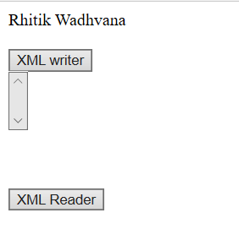

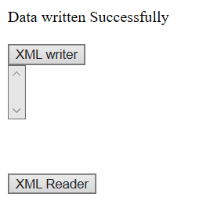

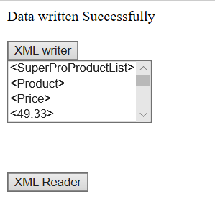

10A. Create a web application to demonstrate reading and writing operation with XML.
CODE:

Default.aspx
<%@ Page Language="C#" AutoEventWireup="true" CodeFile="Default.aspx.cs" Inherits="_Default" %>

<!DOCTYPE html PUBLIC "-//W3C//DTD XHTML 1.0 Transitional//EN" "http://www.w3.org/TR/xhtml1/DTD/xhtml1-transitional.dtd">

<html xmlns="http://www.w3.org/1999/xhtml">
<head id="Head1" runat="server"> <title></title> </head>
<body>
<form id="form1" runat="server">
<div>
<asp:Label ID="Label1" runat="server" Text="Rhitik Wadhvana"></asp:Label> <br /> <br />
<asp:Button ID="Button1" runat="server" Text="XML writer" onclick="Button1_Click" />
<br />
<asp:ListBox ID="ListBox1" runat="server"></asp:ListBox>
<br /> <br /> <br /> <br />

<asp:Button ID="Button2" runat="server" Text="XML Reader" onclick="Button2_Click" />
</div>
</form>
</body>
</html>

Default.aspx.cs
using System;
using System.Collections.Generic;
using System.Linq;
using System.Web;
using System.Web.UI;
using System.Web.UI.WebControls;
using System.Xml;

public partial class _Default : System.Web.UI.Page
{
protected void Page_Load(object sender, EventArgs e)
{

}
protected void Button1_Click(object sender, EventArgs e)
{
String fs = "C:\\Users\\asus\\Documents\\Visual Studio 2010\\WebSites\\WebSite1\\XMLFile.xml";
XmlTextWriter w = new XmlTextWriter(fs, null);
w.WriteStartDocument();
w.WriteStartElement("SuperProProductList");
w.WriteComment("This file generated by the XmlTextWriter class."); // Write the first product.
w.WriteStartElement("Product");
w.WriteAttributeString("ID", "1");
w.WriteAttributeString("Name", "Chair");
w.WriteStartElement("Price");
w.WriteString("49.33");
w.WriteEndElement();
w.WriteEndElement();
// Write the second product.
w.WriteStartElement("Product");
w.WriteAttributeString("ID", "2");
w.WriteAttributeString("Name", "Car");
w.WriteStartElement("Price");
w.WriteString("43399.55");
w.WriteEndElement();
w.WriteEndElement();
// Write the third product.
w.WriteStartElement("Product");
w.WriteAttributeString("ID", "3");
w.WriteAttributeString("Name", "Fresh Fruit Basket");
w.WriteStartElement("Price");
w.WriteString("49.99");
w.WriteEndElement();
w.WriteEndElement();
// Close the root element.
w.WriteEndElement();
w.WriteEndDocument();
w.Close();
Label1.Text = "Data written Successfully";
}
protected void Button2_Click(object sender, EventArgs e)
{
String fs = "C:\\Users\\asus\\Documents\\Visual Studio 2010\\WebSites\\WebSite1\\XMLFile.xml";
XmlTextReader reader = new XmlTextReader(fs); while (reader.Read())
{
switch (reader.NodeType)
{
case XmlNodeType.Element: ListBox1.Items.Add("<" + reader.Name + ">"); break;
case XmlNodeType.Text: ListBox1.Items.Add("<" + reader.Value + ">"); break;
case XmlNodeType.EndElement: ListBox1.Items.Add("<" + reader.Name + ">"); break;
}
}
}
}

OUTPUT:

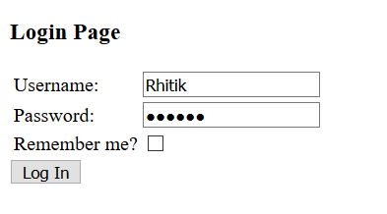



10B. Create a web application to demonstrate Form Security and Windows Security with proper Authentication and Authorization properties.
CODE:

Default.aspx
<%@ Page Language="C#" AutoEventWireup="true" CodeFile="Default.aspx.cs" Inherits="_Default" %>

<!DOCTYPE html PUBLIC "-//W3C//DTD XHTML 1.0 Transitional//EN" "http://www.w3.org/TR/xhtml1/DTD/xhtml1-transitional.dtd">

<html xmlns="http://www.w3.org/1999/xhtml">
<head id="Head1" runat="server"> <title></title> </head>
<body>
<form id="form1" runat="server">
<h3>Login Page</h3>
<table>
<tr>
<td>Username:</td>
<td><asp:TextBox ID="UserName" runat="server" /></td>
<td><asp:RequiredFieldValidator ID="RequiredFieldValidator1" ControlToValidate="UserName" Display="Dynamic" ErrorMessage="Cannot be empty." runat="server" /></td>
</tr>
<tr>
<td>Password:</td>
<td><asp:TextBox ID="UserPass" TextMode="Password" runat="server" /></td>
<td><asp:RequiredFieldValidator ID="RequiredFieldValidator2" ControlToValidate="UserPass" ErrorMessage="Cannot be empty." runat="server" /></td>
</tr>
<tr>
<td>Remember me?</td>
<td><asp:CheckBox ID="chkboxPersist" runat="server" /></td>
</tr>
</table>
<asp:Button ID="Submit1" OnClick="Login_Click" Text="Log In" runat="server" />
<p><asp:Label ID="Msg" ForeColor="red" runat="server" /></p>
</form>
</body>
</html>

Default.aspx.cs
using System;
using System.Collections.Generic;
using System.Linq;
using System.Web;
using System.Web.UI;
using System.Web.UI.WebControls;
using System.Web.Security;
public partial class _Default : System.Web.UI.Page
{
protected void Page_Load(object sender, EventArgs e)
{

}
protected void Login_Click(object sender, EventArgs e)
{
if (FormsAuthentication.Authenticate(UserName.Text, UserPass.Text))
{
FormsAuthentication.RedirectFromLoginPage(UserName.Text, chkboxPersist.Checked);
Session["username"] = UserName.Text; Response.Redirect("Welcome.aspx");
}
else { Msg.Text = "Invalid User Name and/or Password"; }
}
}

Web.config
<?xml version="1.0"?>

<!-- For more information on how to configure your ASP.NET application, please visit http://go.microsoft.com/fwlink/?LinkId=169433 -->

<configuration>
<appSettings>
<add key="ValidationSettings:UnobtrusiveValidationMode" value="None" />
</appSettings>
<system.web>
<compilation debug="false" targetFramework="4.0" />
<authentication mode="Forms">
<forms loginUrl="Default.aspx" defaultUrl="Welcome.aspx">
<credentials passwordFormat="Clear">
<user name="Jay" password="Jay" />
<user name="Yash" password="Yash"/>
<user name="Dhruvesh" password="Dhruvesh"/>
<user name="Ankit" password="Ankit"/>
<user name="Aayush" password="Aayush"/>
<user name="Ronak" password="Ronak"/>
<user name="Rishi" password="Rishi"/>
<user name="Rutvik" password="Rutvik"/>
<user name="Jigar" password="Jigar"/>
<user name="Rhitik" password="Rhitik"/>
</credentials>
</forms>
</authentication>
<authorization>
<deny users="?"/>
</authorization>
</system.web>

</configuration>

Welcome.aspx.cs
using System;
using System.Collections.Generic;
using System.Linq;
using System.Web;
using System.Web.UI;
using System.Web.UI.WebControls;

public partial class Welcome : System.Web.UI.Page
{
protected void Page_Load(object sender, EventArgs e)
{
Response.Write("Welcome " + Session["username"]);
}
}

OUTPUT:

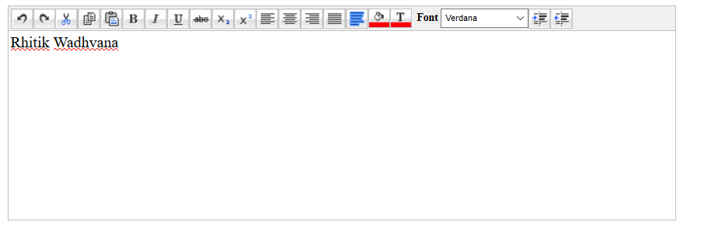

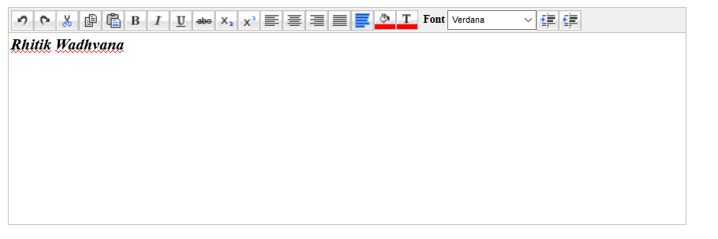

10C(i). Create a web application to demonstrate use of various Ajax controls.
CODE:

Default.aspx
<%@ Page Language="C#" AutoEventWireup="true" CodeFile="Default.aspx.cs" Inherits="_Default" %>

<%@ Register Assembly="AjaxControlToolkit" Namespace="AjaxControlToolkit" TagPrefix="ajaxToolkit" %>

<!DOCTYPE html PUBLIC "-//W3C//DTD XHTML 1.0 Transitional//EN" "http://www.w3.org/TR/xhtml1/DTD/xhtml1-transitional.dtd">

<html xmlns="http://www.w3.org/1999/xhtml">
<head id="Head1" runat="server"> <title></title> </head>
<body>
<form id="form1" runat="server">
<div>
<asp:ScriptManager runat="server" ID="MainScriptManager" />
<asp:TextBox ID="TextBox1" runat="server" Height="210px" TextMode="MultiLine" Width="683px"></asp:TextBox>
<ajaxToolkit:HtmlEditorExtender ID="HtmlEditorExtender1" runat="server" EnableSanitization="False" TargetControlID="TextBox1">
<Toolbar>
<ajaxToolkit:Undo />
<ajaxToolkit:Redo />
<ajaxToolkit:Cut />
<ajaxToolkit:Copy />
<ajaxToolkit:Paste />
<ajaxToolkit:Bold />
<ajaxToolkit:Italic />
<ajaxToolkit:Underline />
<ajaxToolkit:StrikeThrough />
<ajaxToolkit:Subscript />
<ajaxToolkit:Superscript />
<ajaxToolkit:JustifyLeft />
<ajaxToolkit:JustifyCenter />
<ajaxToolkit:JustifyRight />
<ajaxToolkit:JustifyFull />
<ajaxToolkit:SelectAll />
<ajaxToolkit:BackgroundColorSelector />
<ajaxToolkit:ForeColorSelector />
<ajaxToolkit:FontNameSelector />
<ajaxToolkit:Indent />
<ajaxToolkit:Outdent />
</Toolbar>
</ajaxToolkit:HtmlEditorExtender>
</div>
</form>
</body>
</html>

OUTPUT:

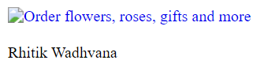

10C(ii). Create a web application to demonstrate dynamic AdRotator.

CODE:

Default.aspx
<%@ Page Language="C#" AutoEventWireup="true" CodeFile="Default.aspx.cs" Inherits="Default" %>

<!DOCTYPE html PUBLIC "-//W3C//DTD XHTML 1.0 Transitional//EN" "http://www.w3.org/TR/xhtml1/DTD/xhtml1-transitional.dtd">

<html xmlns="http://www.w3.org/1999/xhtml">
<head id="Head1" runat="server"> <title></title> </head>
<body>
<form id="form1" runat="server">
<div>
<asp:ScriptManager ID="ScriptManager1" runat="server"> </asp:ScriptManager>
<asp:Timer ID="Timer1" runat="server" Interval="2000"> </asp:Timer>
<asp:UpdatePanel ID="UpdatePanel1" runat="server">
<Triggers>
<asp:AsyncPostBackTrigger ControlID="Timer1" EventName="Tick" />
</Triggers>
<ContentTemplate>
<asp:AdRotator ID="AdRotator1" runat="server" DataSourceID="XmlDataSource1" Height="200px" Width="200px" />
<asp:XmlDataSource ID="XmlDataSource1" runat="server" DataFile="~/XMLFile.xml"> </asp:XmlDataSource>
<br />
<br />
<asp:Label ID="Label1" runat="server" Text="Rhitik Wadhvana"></asp:Label>
</ContentTemplate>
</asp:UpdatePanel>
</div>
</form>
</body>
</html>

XMLFile.xml
<?xml version="1.0" encoding="utf-8" ?>
<Advertisements>
<Ad>
<ImageUrl>rose1.jpg</ImageUrl>
<NavigateUrl>http://www.1800flowers.com</NavigateUrl>
<AlternateText> Order flowers, roses, gifts and more </AlternateText>
<Impressions>20</Impressions>
<Keyword>flowers</Keyword>
</Ad>
<Ad>
<ImageUrl>rose2.jpg</ImageUrl>
<NavigateUrl>http://www.babybouquets.com.au</NavigateUrl>
<AlternateText>Order roses and flowers</AlternateText>
<Impressions>20</Impressions>
<Keyword>gifts</Keyword>
</Ad>
<Ad>
<ImageUrl>rose3.jpg</ImageUrl>
<NavigateUrl>http://www.flowers2moscow.com</NavigateUrl>
<AlternateText>Send flowers to Russia</AlternateText>
<Impressions>20</Impressions>
<Keyword>russia</Keyword>
</Ad>
</Advertisements>

OUTPUT:

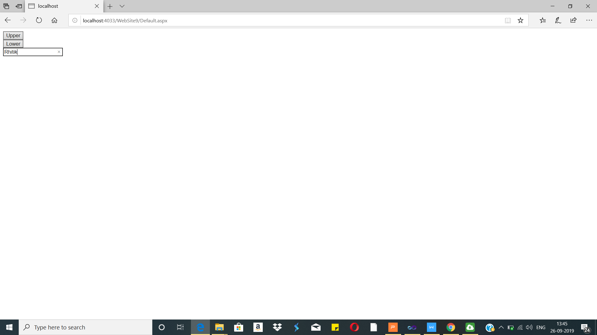

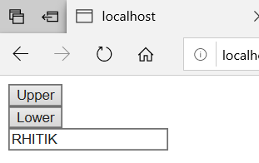

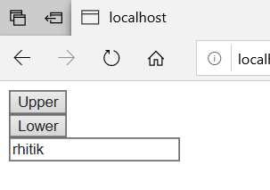

Practical No.11
A. Write a program to create and use DLL.
Code:
AWPClassLib.cs
using System;
using System.Collections.Generic;
using System.Linq;
using System.Text;
namespace AWPClassLib
{
public class AWP
{
public string UpperConvert(string text)
{
return text.ToUpper();
}
public string LowerConvert(string text)
{
return text.ToLower();
}
}
}

Default.aspx
<%@ Page Language="C#" AutoEventWireup="true" CodeFile="Default.aspx.cs" Inherits="_Default" %>
<!DOCTYPE html PUBLIC "-//W3C//DTD XHTML 1.0 Transitional//EN" "http://www.w3.org/TR/xhtml1/DTD/xhtml1-transitional.dtd">
<html xmlns="http://www.w3.org/1999/xhtml">
<head runat="server">
<title></title>
</head>
<body>
<form id="form1" runat="server">
<div>
<asp:Button ID="Button1" runat="server" onclick="Button1_Click" Text="Upper" />
<br />
<asp:Button ID="Button2" runat="server" onclick="Button2_Click" Text="Lower" />
<br />
<asp:TextBox ID="TextBox1" runat="server"></asp:TextBox>
</div>
</form>
</body>
</html>

Default.aspx.cs
using System;
using AWPClassLib;
public partial class _Default : System.Web.UI.Page
{
protected void Page_Load(object sender, EventArgs e)
{
}
protected void Button1_Click(object sender, EventArgs e)
{
AWP c1 = new AWP();
TextBox1.Text = c1.UpperConvert(TextBox1.Text);
}
protected void Button2_Click(object sender, EventArgs e)
{ AWP c1 = new AWP();
TextBox1.Text = c1.LowerConvert(TextBox1.Text);
} }

