📘 Overview of Git
🔹 What is Git?
Git is a distributed version control system (DVCS) used to track changes in source code during software development. It allows multiple developers to work on a project simultaneously without interfering with each other's work.
It was created by Linus Torvalds in 2005 to manage the development of the Linux kernel.

🔹 Why Git is Important
From a DevOps and software engineering perspective, Git is foundational because it:
- Maintains history of code changes
- Enables collaboration across teams
- Supports branching and merging strategies
- Acts as the backbone for CI/CD pipelines
- Provides traceability and rollback capabilities

🔹 Key Concepts in Git
1. Repository (Repo)
A repository is where your project lives. It contains:
- Source code
- Commit history
- Branches
Types:
- Local repository (on your system)
- Remote repository (hosted platforms like GitHub, GitLab)

2. Commit
A commit is a snapshot of your code at a specific point in time.
- Each commit has a unique ID (SHA hash)
- Includes message, author, timestamp

3. Branch
A branch is a parallel version of your codebase.
- Default branch: main (or master)
- Used for:
  - Feature development
  - Bug fixes
  - Experiments

4. Merge
Combining changes from one branch into another.
Example:
- feature/login → merged into main

5. Clone
Creating a copy of a remote repository on your local machine.

6. Pull & Push
- Pull → Fetch and merge changes from remote to local
- Push → Send local commits to remote repository

🔹 Git Architecture (How It Works Internally)
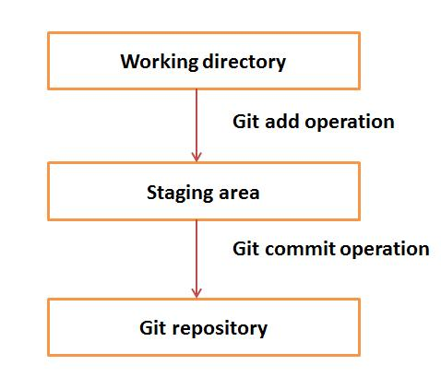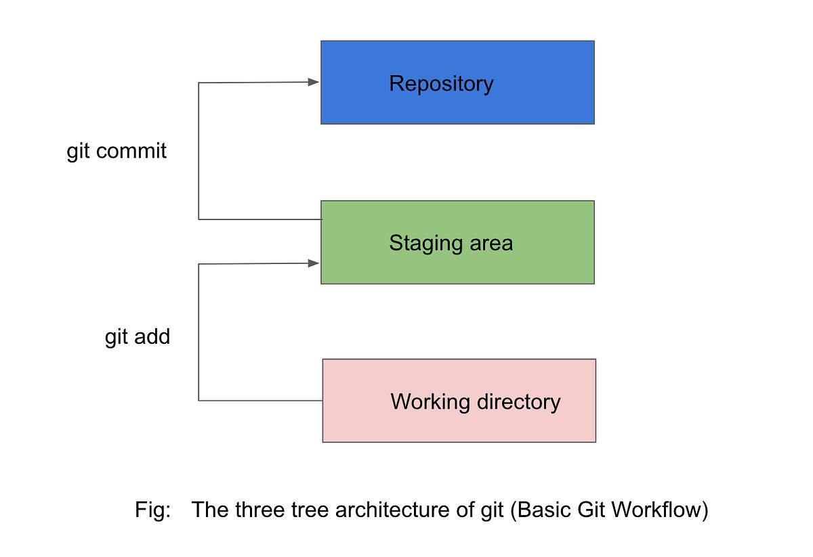
Git has three main areas:
- Working Directory
  - Your actual project files
- Staging Area (Index)
  - Where changes are prepared before commit
- Local Repository
  - Stores committed snapshots
👉 Flow:
Working Directory → Staging Area → Repository
(git add) (git commit)
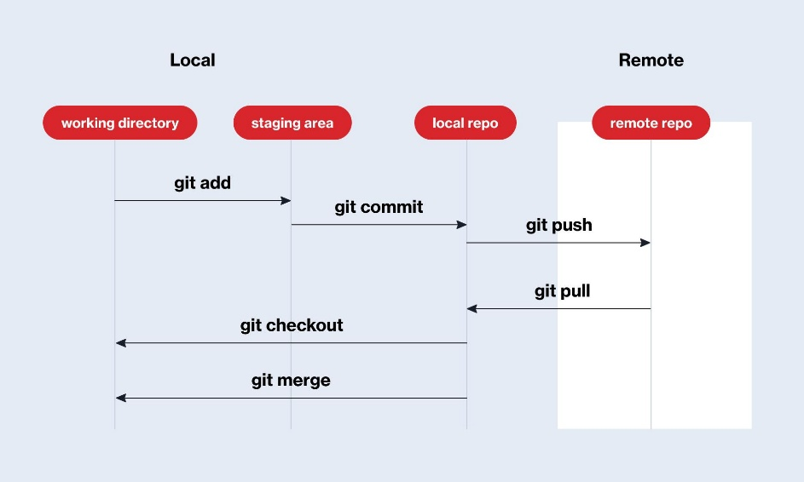

🔹 Basic Git Workflow
Initialize repository:
git init
Add files:
git add .
Commit changes:
git commit -m "Initial commit"
Connect to remote:
git remote add origin <url>
Push code:
git push origin main

🔹 Centralized vs Distributed Version Control
Feature | Centralized (e.g., SVN) | Git (Distributed)
Repository | Single central server | Every developer has full copy
Offline Work | Limited | Fully supported
Speed | Slower | Faster
Branching | Complex | Lightweight & fast

🔹 Advantages of Git
- ✔ Fast and efficient
- ✔ Strong branching model
- ✔ Offline capabilities
- ✔ Distributed collaboration
- ✔ Widely adopted in DevOps pipelines

🔹 Git in DevOps Lifecycle
Git integrates with:
- Build tools (Maven, npm)
- CI/CD tools (Jenkins, Azure DevOps)
- Containerization (Docker)
👉 Example flow:
Developer → Git Commit → CI Pipeline → Build → Test → Deploy

🔹 Common Use Cases
- Source code management
- Version tracking
- Team collaboration
- Open-source contributions

🔹 Summary
Git is not just a tool—it is a core skill for:
- Developers
- DevOps Engineers
- QA Engineers
It provides control, collaboration, and confidence in managing codebases.

