📘 Version Control – Overview
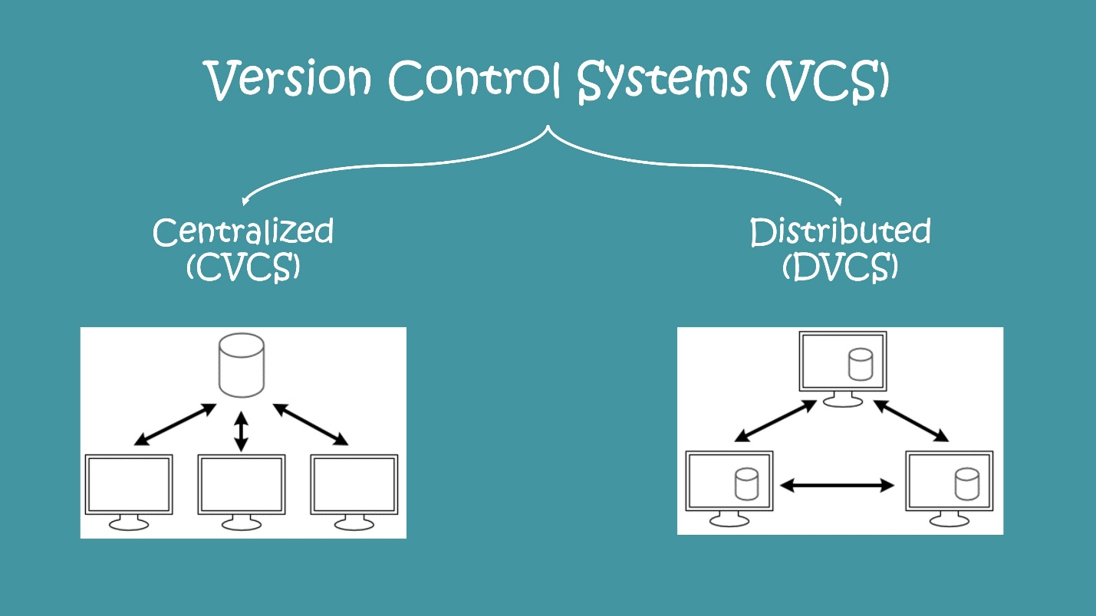
What is Version Control?
Version Control (also called Source Control) is a system that tracks and manages changes to files over time—primarily source code. It enables multiple developers to collaborate without overwriting each other’s work and provides traceability of every change.
Think of it as a time machine for your codebase:
- You can go back to any previous version
- Compare changes (diffs)
- Identify who changed what and why
- Safely experiment using branches

Why Version Control is Critical
- Collaboration → Multiple developers work concurrently
- Traceability → Audit trail of commits
- Backup & Recovery → Restore previous versions
- Branching & Merging → Parallel feature development
- CI/CD Integration → Tools like GitHub, GitLab, and Azure DevOps integrate with pipelines

Core Concepts
- Repository (Repo) → Storage for your project files and history
- Commit → Snapshot of changes
- Branch → Independent line of development
- Merge → Combine changes from different branches
- Clone → Copy repo to local machine
- Pull/Push → Sync changes between local and remote

🔄 Types of Version Control Systems
1. Local Version Control System (LVCS)
How it works:
- Stores versions on a single local machine
- Maintains file changes using patches or snapshots
Example:
- RCS (Revision Control System)
Pros:
- Simple to use
- No network dependency
Cons:
- No collaboration
- High risk of data loss (if system crashes)

2. Centralized Version Control System (CVCS)

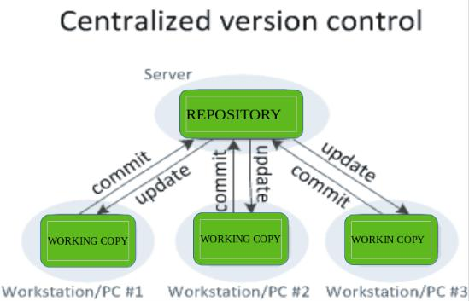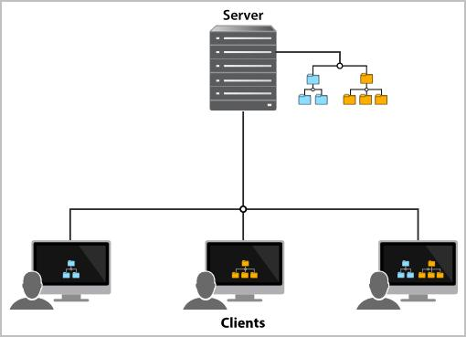
How it works:
- A single central server stores all versions
- Developers checkout files and commit changes back
Examples:
- Apache Subversion
- Perforce
Pros:
- Easy to manage
- Clear access control
Cons:
- Single point of failure
- Requires constant network access
- Slower operations compared to distributed systems

3. Distributed Version Control System (DVCS)

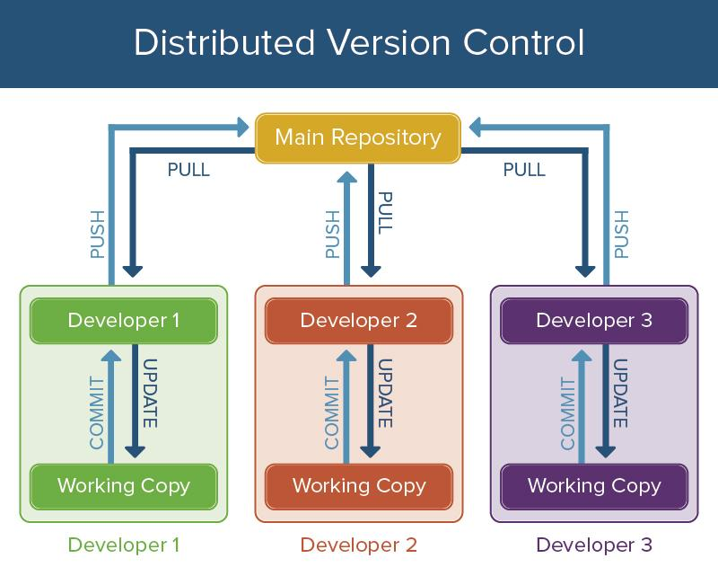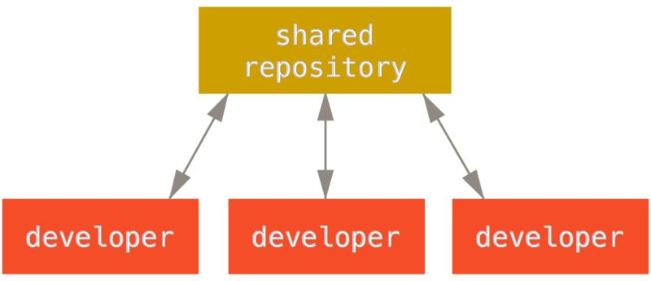

How it works:
- Every developer has a full copy of the repository
- Changes are shared between repositories
Examples:
- Git
- Mercurial
Pros:
- Works offline
- No single point of failure
- Fast operations
- Strong branching/merging support
Cons:
- Slightly steeper learning curve
- Requires understanding of distributed workflows

⚖️ Comparison Summary
Feature | Local VCS | Centralized VCS | Distributed VCS
Collaboration | ❌ No | ✅ Yes | ✅ Yes
Offline Work | ✅ Yes | ❌ No | ✅ Yes
Speed | Fast | Moderate | Very Fast
Risk | High | Medium | Low
Example | RCS | SVN | Git

🚀 Industry Standard
Today, Distributed Version Control Systems dominate—especially Git.
Platforms like:
- GitHub
- GitLab
- Azure DevOps
…extend Git with:
- Code reviews (Pull Requests)
- CI/CD pipelines
- Issue tracking

