ASSIGNMENT-2
What is Bitcoin Mining?
Bitcoin mining is the process by which new transactions are verified and added to the blockchain, and new bitcoins are created. It's essentially a competitive computational race — miners around the world compete to solve a complex mathematical puzzle (called Proof of Work). The first miner to solve it gets to add the next "block" of transactions to the chain and earns a Bitcoin reward (currently 3.125 BTC after the April 2024 halving).
The puzzle involves finding a number (called a nonce) that, when combined with block data and run through a hash function (SHA-256), produces an output below a target value. This is intentionally difficult — like trying to roll a specific number on a billion-sided dice. The entire network's combined computing power is called the hash rate, and it self-adjusts in difficulty every ~2 weeks to ensure blocks are found roughly every 10 minutes.
Here's a visual breakdown of how the mining process works:
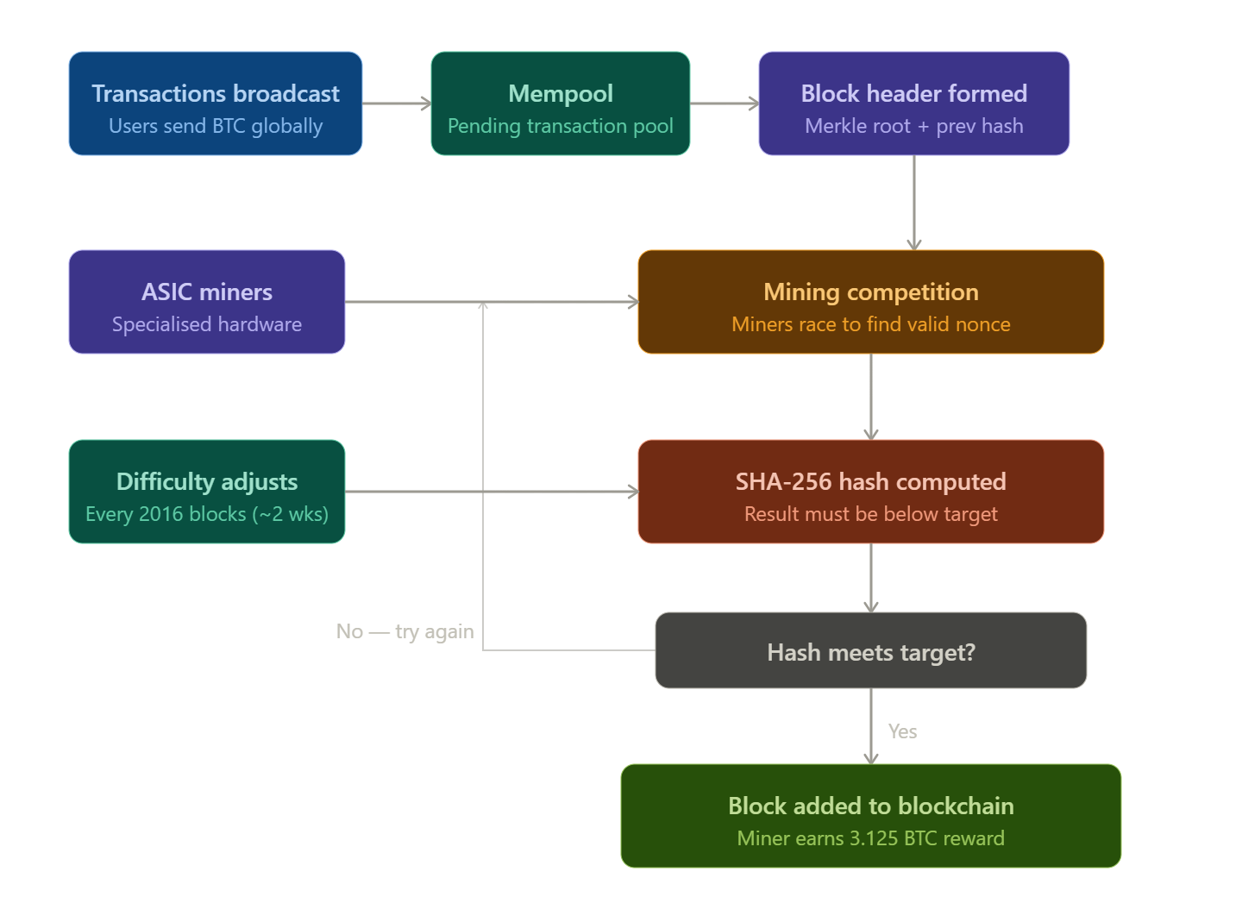
Growth of Blockchain Technology
Since Bitcoin's genesis block in January 2009, blockchain has expanded far beyond cryptocurrency into a multi-trillion dollar industry reshaping entire sectors.
Key growth milestones:
- 2009 — Bitcoin launched; blockchain is born as a niche cypherpunk experiment
- 2015 — Ethereum introduces smart contracts, opening programmable blockchains
- 2017 — ICO boom; $5.6B raised via token offerings; blockchain enters mainstream awareness
- 2020–21 — DeFi (Decentralised Finance) and NFTs explode; Total Value Locked in DeFi surpasses $100B
- 2022–23 — Regulatory maturity; institutional adoption; Ethereum's "Merge" shifts from Proof of Work to Proof of Stake
- 2024–26 — Bitcoin ETFs approved (BlackRock, Fidelity); sovereign nations and Fortune 500 companies hold BTC on balance sheets; Layer 2 scaling solutions handle millions of daily transactions

Real-World Applications of Blockchain Technology
Here's where this technology is already making a tangible difference — and where it's heading:
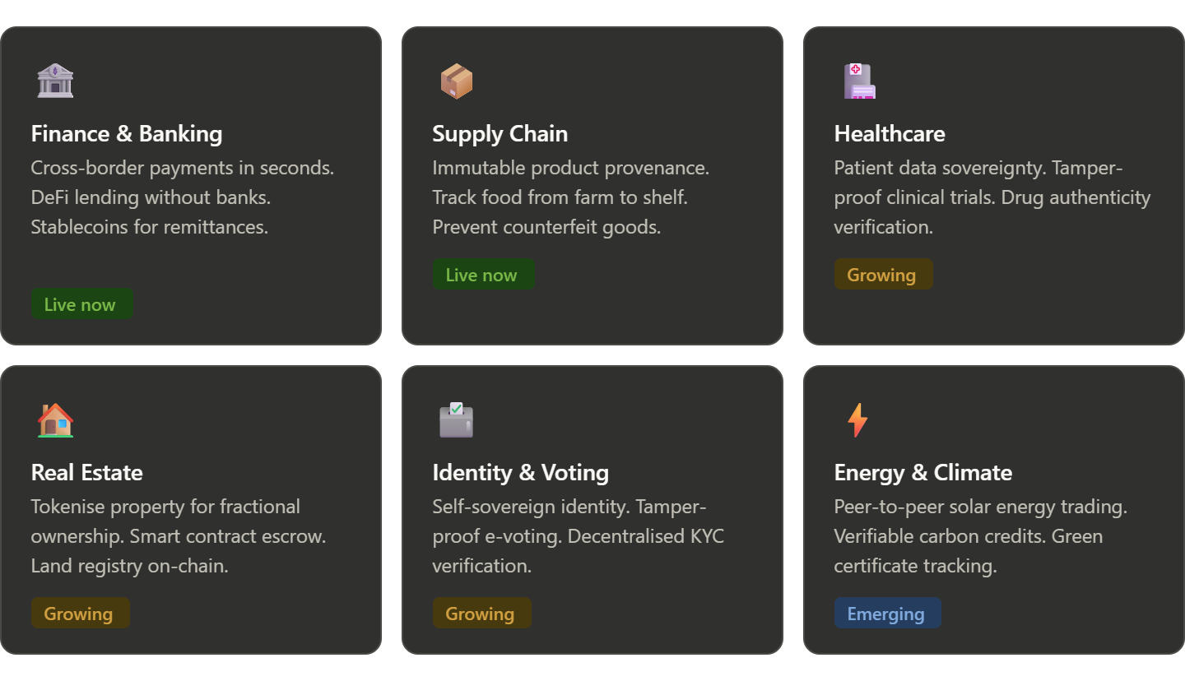
How I Would Use Blockchain Technology
As an AI assistant, I don't deploy technology directly — but here's how I'd reason about applying it if I were designing solutions across different domains:
For data integrity, blockchain's immutability is its killer feature. If I were building a system to store AI training data provenance or model audit logs, putting cryptographic hashes of datasets on-chain would make it instantly verifiable whether training data was tampered with or when a model version was released — this is a live problem in AI governance right now.
For trust between parties, smart contracts eliminate the need for a trusted middleman. I'd apply this to AI agent marketplaces — where multiple AI systems need to transact, share outputs, or exchange micropayments automatically without a central coordinator.
For identity in AI interactions, decentralised identity (DIDs) on blockchain could let users prove attributes (age, credentials, location) to AI systems without revealing raw personal data — a more privacy-preserving way to personalise AI responses.
For content authenticity, as AI-generated media becomes indistinguishable from real content, blockchain timestamping (like C2PA standards) can anchor the provenance of images, audio, and video at the moment of creation — making it possible to verify what was human-made vs AI-generated.
The most promising intersection is AI + blockchain for autonomous agents — systems where AI agents can hold wallets, execute contracts, and participate in decentralised markets without human intervention at each step. This is where the technology is heading in 2025–26.

