Smart Greenhouse RTOS Project
Software architecture and communication protocol
CG2271 · JupiterPluvius auto-watering plant · November 2026

1 System overview
The plant is looked after by two microcontrollers and a cloud dashboard (Figure 1). The MCXC444 runs FreeRTOS and handles everything that must react in real time: it samples the soil, watches the reservoir level and drives the pump, buzzer and grow LED. The ESP32-S2 measures air temperature, humidity and light, exchanges frames with the MCXC444 over UART, and uploads one reading to Supabase every 5 s. A FastAPI and React dashboard on Render shows the data and offers an AI check-up.
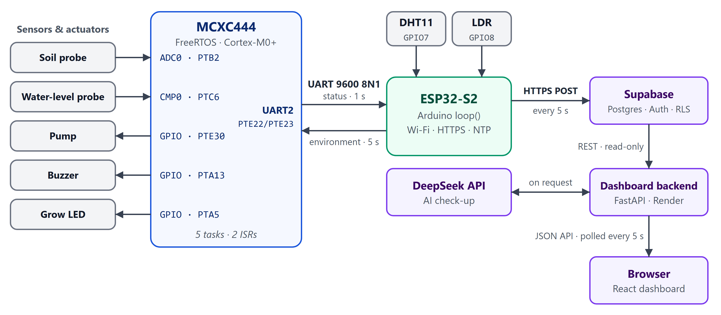
Figure 1. System architecture. The boards exchange UART frames in both directions; only the ESP32-S2 talks to the cloud.
Table 1. Hardware interfaces
Signal | Pin | Peripheral and use
MCXC444
Soil moisture probe | PTB2 | ADC0 channel 12: 12-bit, calibrated at start-up, polled by soil
Reservoir level probe | PTC6 | CMP0 input 0 against its 6-bit DAC at 1.65 V, with hysteresis; interrupt on both edges
Pump driver | PTE30 | GPIO output, driven by pump
Buzzer | PTA13 | GPIO output, driven by water
Grow LED | PTA5 | GPIO output, driven by recv
UART link | PTE22 (TX), PTE23 (RX) | UART2, 9600 baud 8N1, interrupt-driven
Debug console | PTA2 (TX), PTA1 (RX) | LPUART0, 115200 baud, used by PRINTF
ESP32-S2
DHT11 | GPIO7 | Temperature and humidity, read every 3 s
LDR | GPIO8 | 12-bit ADC (11 dB attenuation), median of 9 samples, read every 1 s
UART link | GPIO17 (TX), GPIO16 (RX) | UART1 (Serial1), 9600 baud 8N1

2 Software architecture

2.1 Task structure
The MCXC444 firmware runs FreeRTOS with preemptive scheduling and time slicing, a 200 Hz tick (5 ms) and five priority levels (0–4). main() initialises the clocks and pins, creates every queue, semaphore and mutex, initialises GPIO, ADC0, CMP0 and UART2, creates the five application tasks in Table 2 and starts the scheduler. All RTOS objects are allocated once, from the 10 KB heap_4 heap, before the scheduler starts; nothing is created or deleted at run time.
Table 2. MCXC444 application tasks. Each has a 190-word (760-byte) stack.
Task / function | Priority | Activation | Responsibility
recv  recvTask | 4 | Blocks on queue | Validates each received frame (framing and CRC), parses TEMP, HUM and LIGHT_ADC, switches the grow LED (on when LIGHT_ADC ≥ 1000, i.e. dark) and logs the values.
send  sendTask | 4 | Every 1 s (vTaskDelay) | Formats the status payload SOIL, WATER, LED and passes it to UART2_Send().
soil  soil_moisture_sensor_task | 3 | Every 500 ms | Samples ADC0 into moisture, gives pump_sema when the reading is above 1600 (dry) and logs the value.
water  water_level_sensor_task | 3 | Blocks on reservoir_level_sema | Sets the buzzer from reservoir_level_ok (on while the reservoir is low) at start-up and after every comparator edge; logs the level.
pump  pumpTask | 2 | Blocks on pump_sema | Re-checks moisture, runs the pump for 3 s (4 s at ≥ 30 °C or ≤ 45 % humidity), then waits 30 s before it can water again.
FreeRTOS adds its idle task (priority 0) and timer service task (priority 4); the firmware uses no software timers.
Priorities. The two communication tasks run highest so the UART link is serviced promptly: recv processes a frame as soon as it is queued, and send keeps the 1 s status rate. The sensor tasks come next. The pump task is lowest because its timing tolerance is in seconds and it spends almost all its time asleep. Every task blocks on a queue, a semaphore or vTaskDelay() between short bursts of work, so lower-priority tasks are not starved; the only busy-wait is the ADC conversion in poll_soil_adc(), which takes about 30 µs.
Table 3. Interrupt service routines (both at NVIC priority 2)
ISR | Triggered by | Work done | Hands over to
UART2_FLEXIO_IRQHandler | Byte received (RDRF), receiver overrun (OR), or transmit register empty (TDRE, enabled only while a frame is being sent) | RX: adds the byte to the frame being assembled (Section 3.2). TX: writes the next byte of send_buffer; after the last one, disables the TDRE interrupt. | Frame received: queue → recv  Frame sent: uart_sema → send
CMP0_IRQHandler | Comparator output change: the reservoir level crosses the threshold | Clears the edge flags and stores the comparator output in reservoir_level_ok. | reservoir_level_sema → water
Both handlers do a small, fixed amount of work, never block, call only the …FromISR FreeRTOS functions and end with portYIELD_FROM_ISR(), so a task they wake runs as soon as the interrupt returns.

ESP32-S2
The ESP32-S2 runs one Arduino loop() and creates no tasks of its own. Each job runs once its interval has elapsed on millis() (Table 4), and UART input is drained at the start of every pass, before any job that may wait on the network. Wi-Fi connection changes arrive as event callbacks that only log, and NTP synchronises the clock in the background.
Table 4. ESP32-S2 loop jobs
Job | Interval | Function
Drain UART1 and decode status frames from the MCXC444 | Every pass | receiveFromMCXC444()
Read the LDR (median of 9 samples) | 1 s | readLightSensor()
Read the DHT11 | 3 s | readDHT11()
Send an environment frame to the MCXC444, only while both readings are fresh | 5 s | sendToMCXC444()
Upload one reading to Supabase over HTTPS | 5 s | sendReadingsToSupabase()

2.2 Coordination & synchronisation
Interrupt handlers only capture an event and hand the rest to a task (deferred interrupt processing). Tasks never poll for events: each waits on exactly one RTOS object, or on vTaskDelay() if it is periodic. Figure 2 shows every object with its producer and consumer; Table 5 summarises them.
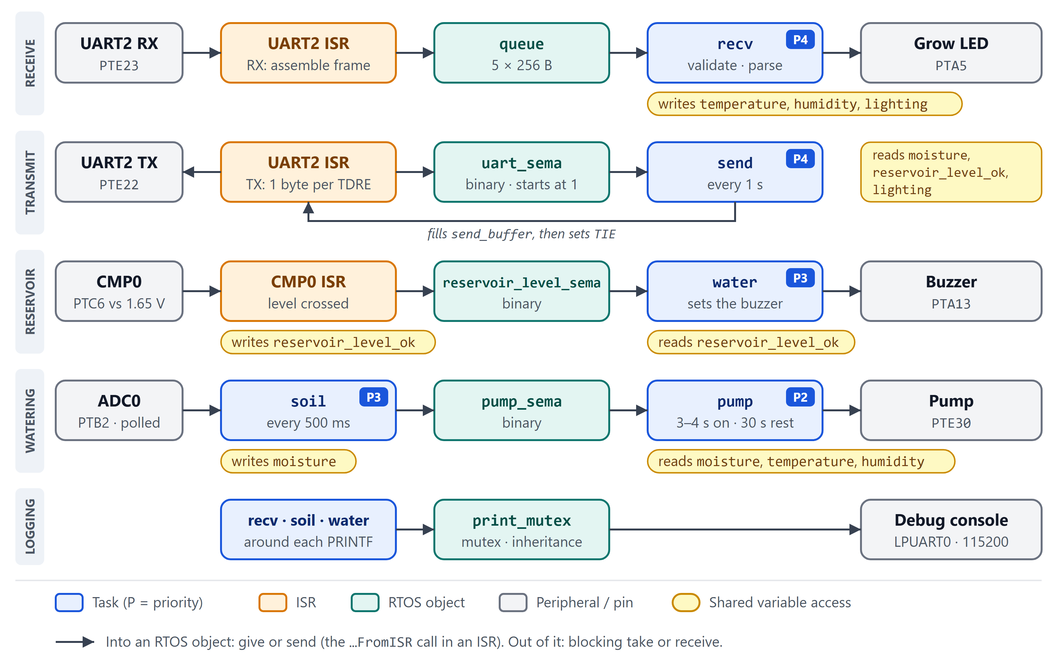
Figure 2. MCXC444 tasks, interrupts and synchronisation objects, one row per data path. Both UART2 ISR boxes are the same handler. The yellow labels show which task or ISR writes or reads each shared variable.
Table 5. Synchronisation objects
Object | Type | Given / sent by | Taken / received by | Purpose
queue | Queue, 5 × 256-byte TMessage | UART2 ISR, when \n completes a frame | recv | Moves each frame out of the ISR by copy, so validation and parsing run in task context. When 5 frames are already waiting, the ISR drops the new one rather than block.
uart_sema | Binary semaphore, given once at start-up | UART2 ISR, after the last byte | send, in UART2_Send() | “Transmitter free” token: one frame in flight at a time (Figure 4, Section 2.3).
reservoir_level_sema | Binary semaphore | CMP0 ISR, on each edge | water | Wakes the water task to update the buzzer when the level crosses the threshold.
pump_sema | Binary semaphore | soil, on each sample above 1600 | pump | Requests watering. Requests made while the pump is busy collapse into one (Figure 3).
print_mutex | Mutex | recv, soil, water | The same tasks | Serialises console output (Section 2.3).

Watering
The soil task gives pump_sema on every dry sample, twice a second. The pump task takes it, re-reads moisture and, if the soil is still dry, runs the pump for 3 s, or 4 s when the latest ESP32-S2 frame reported at least 30 °C or at most 45 % humidity. It then sleeps for a 30 s cooldown so the water can soak in before the probe is trusted again. A binary semaphore holds at most one give, so the requests made in the meantime collapse into a single pending one: after the cooldown the task takes it, re-checks the soil, and either waters again or goes back to waiting (Figure 3).
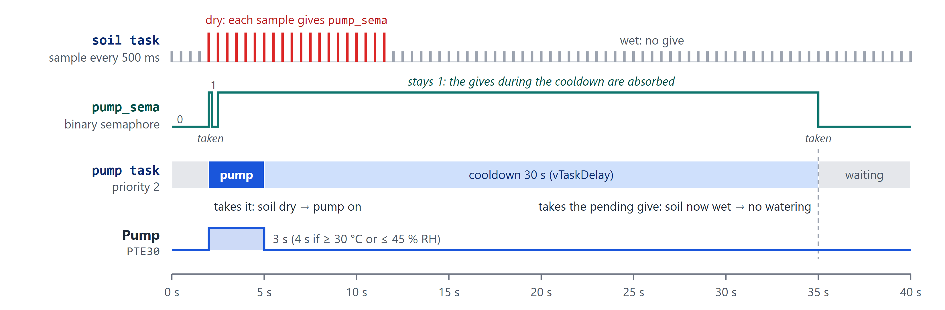
Figure 3. Watering sequence (illustrative). The soil is dry from 2 s to 11.5 s; the pump runs for 3 s and then cools down for 30 s. The gives made meanwhile leave pump_sema at 1, and the one pending request turns out to be stale because the soil is wet by then.

Sending a frame
UART2_Send() never waits for the hardware. It takes uart_sema, builds the frame in send_buffer, enables the transmit interrupt and returns. The ISR then writes one byte per TDRE interrupt; after the last byte it disables the interrupt and gives the semaphore back (Figure 4). A 35-byte status frame occupies the line for 36.5 ms, during which the CPU runs other tasks.
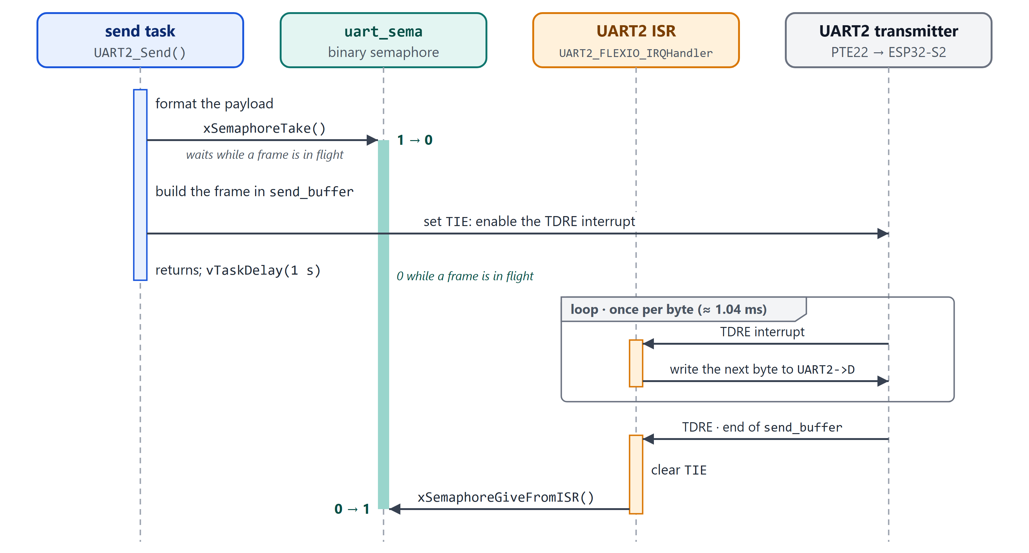
Figure 4. Sending a status frame. uart_sema stays at 0 from the moment the send task starts filling send_buffer until the ISR has sent the last byte.

Between the boards
The boards are loosely coupled: neither waits for the other. Each sends on its own timer (status every 1 s, environment every 5 s) and the receiver keeps the latest valid values. The ESP32-S2 treats the MCXC444’s status as stale after 15 s without a valid frame and then uploads it as missing (Section 3.3); the MCXC444 keeps using the last climate values it received.

2.3 Resource protection
Each shared resource has a single owner or an explicit protection mechanism (Table 6).
Table 6. Shared resources and their protection
Resource | Used by | Protection
UART2 transmitter and send_buffer | send, UART2 ISR | uart_sema. The task writes send_buffer only after taking it, and the ISR gives it back only after the last byte, so a new frame cannot overwrite one still being sent.
Frame being received | UART2 ISR | Owned by the ISR. The queue copies each complete frame, so recv decodes its own copy while the ISR assembles the next one.
Debug console (LPUART0) | recv, soil, water | print_mutex around each PRINTF. The SDK console is built in blocking mode with no locking of its own, so the mutex is what keeps lines from interleaving.
Grow LED, buzzer and pump pins | recv, water, pump | One owning task per pin. Pins are switched through the set and clear registers (PSOR, PCOR), which change only the written bit in one store, so the LED and buzzer tasks, both on port A, cannot undo each other’s writes.
ADC0 | soil | Single owner; calibrated in initADC0() before the scheduler starts.
Shared variables (Table 7) | Tasks, CMP0 ISR | One writer each; see below.

Table 7. Shared variables
Variable | Type | Written by | Read by
moisture | unsigned int | soil | send, pump
reservoir_level_ok | volatile bool | CMP0 ISR (initialised in initCMP0()) | water, send
lighting | bool | recv | send
temperature, humidity | float | recv | pump
Each variable has a single writer, is at most 32 bits wide and is aligned, so on the Cortex-M0+ every access is one indivisible load or store: a reader always sees a complete value, old or new, and no lock is needed. reservoir_level_ok is volatile because an interrupt changes it. The pump task reads temperature and humidity separately and may combine values from consecutive frames; this is harmless because each value only decides whether to add a second of watering.
Why uart_sema is not a mutex. It is taken by a task but given back by the ISR. A FreeRTOS mutex must be released by the task that took it and cannot be given from an interrupt: the kernel’s configASSERT would halt the firmware. A binary semaphore, given once at start-up, serves as the token instead. print_mutex is taken and released by the same task, so it is a real mutex; its priority inheritance limits how long recv (priority 4) can wait behind a lower-priority task’s print.
Start-up order. main() creates the queue, semaphores and mutex before initCMP0() and initUART2() enable their interrupts, so a handler can never use an object that does not exist yet.
On the ESP32-S2, all application code runs in loop(), so its buffers and the MCXC444 status structure have a single user and need no locking.

3 Communication protocol

3.1 UART configuration
Table 8. UART settings
Setting | MCXC444 | ESP32-S2
Peripheral | UART2 | UART1 (Serial1)
Pins | TX PTE22, RX PTE23 (pin mux ALT4) | TX GPIO17, RX GPIO16
Wiring | PTE22 → GPIO16 and GPIO17 → PTE23, plus a common ground; 3.3 V logic on both boards
Baud rate | 9600 (divisor 156 from the 24 MHz bus clock: 9615 baud, +0.16 %) | 9600
Character format | 8 data bits, no parity, 1 stop bit (8N1), no flow control | 8N1, no flow control
Receiving | Interrupt per byte (RDRF) plus an overrun interrupt; frames are assembled in the ISR | Driver receive buffer, drained by loop()
Transmitting | TDRE interrupt, enabled only while a frame is being sent | Serial1.write() of the whole frame
Interrupt priority | NVIC priority 2 | Handled by the driver
Frame buffer | 256 bytes (MAX_MSG_LEN) | 256 bytes
The divisor is SBR = round(f_bus / (16 × 9600)) = round(24 000 000 / 153 600) = 156, which gives 24 MHz / (16 × 156) = 9615 baud. The +0.16 % error is far inside the few per cent a UART tolerates. At 10 bits per character the link carries 960 bytes per second in each direction.

3.2 Packet description
Both directions use the same ASCII frame (Figure 5): it starts with @, carries comma-separated KEY:value pairs, and ends with a CRC-16 in hexadecimal and a line feed.
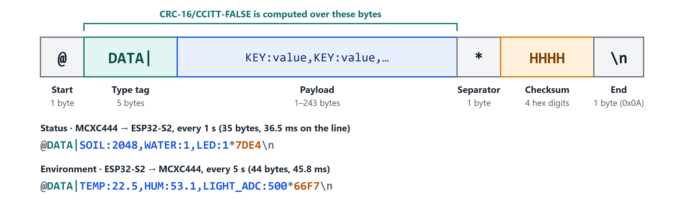
Figure 5. Frame format, with an example in each direction. Lengths and times count every byte up to and including the line feed.
Table 9. Frame fields
Field | Size | Content
Start marker | 1 byte | @. Any @ restarts frame assembly, so a receiver re-synchronises on the next frame after noise or a partial frame.
Type tag | 5 bytes | DATA|
Payload | 1–243 bytes | Comma-separated KEY:value pairs in ASCII; must not contain @, *, CR or LF.
Separator | 1 byte | *
Checksum | 4 bytes | CRC-16 of DATA| and the payload as 4 hexadecimal digits (sent in upper case; either case accepted).
End marker | 1 byte | Line feed (\n, 0x0A).
A frame is 13–255 bytes long, so it fits a 256-byte buffer together with its terminating NUL.
Checksum. CRC-16/CCITT-FALSE: polynomial 0x1021, initial value 0xFFFF, no bit reflection and no final XOR; its check value for the ASCII string “123456789” is 0x29B1. Both boards use the same bitwise routine, packetCRC(). It detects every error burst of up to 16 bits and any odd number of flipped bits.
Table 10. Messages
Message | Sent | Payload format | Example length
Status (MCXC444 → ESP32-S2) | Every 1 s | SOIL:%u,WATER:%d,LED:%d | 35 bytes, 36.5 ms
Environment (ESP32-S2 → MCXC444) | Every 5 s, only while the DHT11 and LDR readings are at most 10 s old | TEMP:%.1f,HUM:%.1f,LIGHT_ADC:%d | 44 bytes, 45.8 ms

Table 11. Payload fields
Key | Range | Meaning | Use at the receiver
SOIL | 0–4095, higher is drier | Raw soil-probe reading | Uploaded as soil_adc_raw; the dashboard converts it to a percentage
WATER | 1 = OK, 0 = low | Reservoir comparator output | Uploaded as reservoir_state
LED | 1 = on, 0 = off | Grow LED state | Uploaded as led_state
TEMP | °C, one decimal | Air temperature (DHT11) | Adds 1 s of watering at 30 °C or more
HUM | % RH, one decimal | Air humidity (DHT11) | Adds 1 s of watering at 45 % or less
LIGHT_ADC | 0–4095, lower is brighter | Raw LDR reading | Turns the grow LED on at 1000 or more (dark)

Receiving a frame
Reception has three stages, the same on both boards (Figure 6):
- Assembly, one byte at a time: in the UART2 ISR on the MCXC444 and in receiveFromMCXC444() on the ESP32-S2. Bytes are ignored until @; @ starts a new frame; bytes are stored until \n. A frame that reaches 255 bytes without \n, or a receiver overrun on the MCXC444, discards the partial frame.
- Validation of the complete frame, by UART2_Decode() in the recv task or decodePacket() on the ESP32-S2: framing, separator position, reserved characters and CRC. A valid frame is reduced to its payload in place.
- Parsing. The MCXC444 accepts new values only if all three fields parse. The ESP32-S2 also requires the whole payload to match the format and checks the ranges: SOIL 0–4095, WATER and LED 0 or 1.
A frame that fails any check is dropped; the ESP32-S2 also logs it. There is no acknowledgement or retransmission: the messages carry periodic state, so the next frame, at most 1 s or 5 s later, replaces a lost one.
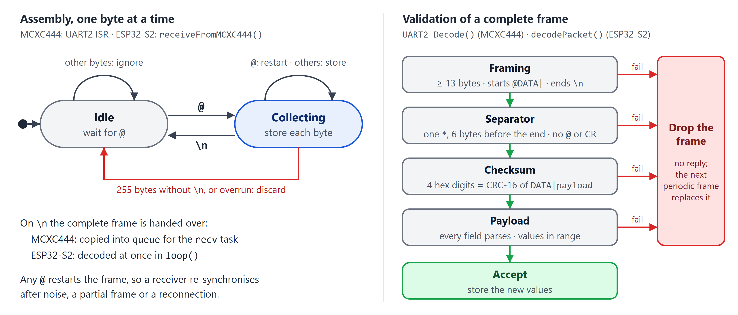
Figure 6. Receiving a frame: byte-by-byte assembly (left) and validation of the complete frame (right).

3.3 Additional features
- Integrity and resynchronisation. Every frame carries a CRC-16 and is checked for exact framing; a corrupted or partial frame is dropped, never acted on, and the next @ re-synchronises the receiver.
- Non-blocking, interrupt-driven UART on the MCXC444. Neither sending nor receiving busy-waits: the ISR moves one byte per interrupt, and decoding runs in a task.
- Data freshness and fault codes. The ESP32-S2 forwards climate data only while it is at most 10 s old, and treats MCXC444 status older than 15 s as missing. Each upload sends missing values as null and lists the cause: DHT11_UNAVAILABLE, LIGHT_SENSOR_UNAVAILABLE or MCXC444_UNAVAILABLE.
- Control across both boards. The pump time depends on the ESP32-S2’s temperature and humidity, and the grow LED on its light reading; both boards use the same threshold (1000) for dark.
- Hardware reservoir alarm. The comparator, with hysteresis, interrupts only when the level crosses the threshold, so the buzzer reacts at once without polling.
- Secure cloud upload. HTTPS with certificate verification against bundled root CAs, NTP time before TLS, and a cached sign-in token for the device account. Supabase row-level security lets the device only insert its own rows and the dashboard backend only read.
- Web dashboard and AI check-up. Live readings, trends over 1 h or 24 h (evenly thinned to about 1,000 points), a log of the latest readings, and an on-demand DeepSeek check-up whose reply is validated and limited to one request per 15 s.

