# Homework Set 1

1. First, I needed to figure out whether the prey or predator was x or y. To do this, I used the method of plugging in 0 for x for dy/dt in system A and for y for dx/dt in system B. When I plugged in 0 for x for dy/dt I got dy/dt=-5y which indicates that when x is extinct, the rate of change of y is negative which indicates the y population is decreasing. This would indicate that x is the food source for y, since without x, y would starve. When I plugged in 0 for y for dx/dt in system B, I got dx/dt=0.3x. This indicates that if population y is extinct, then the x population flourishes which tells me that y was hunting down x. From this, I was able to conclude that x is the prey and y is the predator in both systems. Next, I needed to figure out which system had large prey and small predators and which system had small prey and large predators. Looking at dx/dt in system A and dx/dt in system B, I pulled out the interaction terms. In system A, this was -20xy and in system B this was -xy/100. If y were to increase, meaning the number of predators in both systems increased, this would have a much worse effect on x in system A than on system B. This indicates that in system A, the prey is small and the predators are large since a small increase in y leads to a large decrease in x since there are more prey being eaten more easily. In system B, the prey are large and the predators are small since an increase in y leads to only a small decrease in x. This means that it takes a lot of the small predators to take out a small number of large prey. Looking at dy/dt in system B further confirms this. If the x population, the amount of large prey, increased even by a little bit, this would be really good for the population of y, which is the small predators. The y population would benefit tremendously since they would be able to eat a larger prey which means the small predators would have a lot more food.
2. A. y(t) is increasing when dy/dt is positive. Since dy/dt represents the rate of change of the population, if dy/dt is positive this means that there are more rabbits over time, so the original function counting the amount of rabbits would be increasing. This occurs when y is between -2 and 0, and when y is greater than 8. We only need to consider when y is greater than 8 in this context since time can’t be negative.

B. y(t) is decreasing when dy/dt is negative. This is due to similar reasoning as in part A, except that there would be less rabbits over time resulting in a negative dy/dt. This occurs when y is less than -2, and when y is between 0 and 8. In this context, we only need to consider when y is between 0 and 8.

C. dy/dt is neither positive nor negative when it is equal to zero. This occurs when y=0, y=-2 and y=8. This implies that the solution function has a maximum or minimum at that point since a rate of change of 0 tells us that population is neither increasing or decreasing. There are equilibrium solutions at y=0, y=-2, y=8.

1. The graph depicts the differential equation, dy/dt=2y(1-(y/10)). The horizontal axis is y since we are plugging in values of y into the differential equation and the vertical axis represents dy/dt since that is the result of plugging in y. dy/dt is dependent on y. The graph tells us we have two equilibrium solutions since the differential equation crosses the horizontal axis at two points: y=0 and y=10. It also tells us when y(t) is increasing and decreasing depending on when dy/dt is positive or negative. y(t) is increasing when y is between 0 and 10 and decreasing when y is less than 0 or bigger than 10.
2. A. The person who knows none of the list would be learning more rapidly when time is equal to 0. If we plug in L=1/3 to the differential equation, we would get at time=0, dL/dt=.5(1-1/3)=.5(2/3)=1/3. On the other hand, plugging in L=0 when t=0 to the differential equation yields dL/dt=.5(1-0)=.5. The student who knows less at the beginning starts learning at a higher rate than the student who has 1/3 of the list memorized.

B. The rate of change equation would predict that if someone began with the list completely memorized, that their rate or learning would be equal to 0 since dL/dt=.5(1-1)=0. This would mean that L=1 is an equilibrium solution meaning that their level of knowledge would remain constant; there is nothing left to learn so L(t) can’t increase and they can’t “unmemorize” what they learned so L(t) can’t decrease.

C. There will never be a value of t for which L=1 since no one can know infinitely many things. Instead, the rate of change graph will increase a lot at first but then will begin to level out as time increases. It will slowly still be increasing towards 1, but not enough to be noticeable. It will look almost constant. The amount learned will get very close to 1, but will never actually reach 1 itself.

1. Yes. On the left, dy/dt means that we are taking the derivative with respect to t of the function y(t). On the right, this needs to be interpreted as 0.3 times the function y. Since y is dependent on t, we need to make note that y is actually a function of t rather than an independent variable.
2. The goal of solving an equation such as dx/dt+4x=2 is to find solution functions that have the slope -4x+2 at every point of (t, x(t)). We need to make sure that when we plug in the function x, that the derivative of x(t) with respect to t plus x(t) is equal to 2.
3. A.

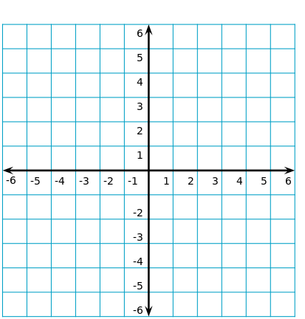

B. I noticed that since dy/dt is only dependent upon y that the slopes would be the same horizontally, so I only computed the slopes vertically and copied them across. I also noticed that dy/dt=1-y2=(1-y)(1+y) so I would have two equilibrium solutions at y=1 and y=-1. In addition, since I am squaring y(t) the graph would be symmetric about the horizontal axis.

C.



1. To me, a mathematical model means finding a function that models some natural phenomenon, such as population growth or virus spread. I don’t have very much experience with mathematical modeling. The only experience I have is with exponential growth models, such as doubling, half-life, and financial interest. For me, mathematical modeling has always been procedural in nature; I have been given the different parameters and just had to plug them in. I have never had to come up with values for the parameters myself. I think the word model when used in the context of mathematics is actually very different for how it is used in day to day life. In terms of fashion model, model airplane, and model student, model is being used as a word for perfect. However, in a mathematical sense, model is being used to say we are sculpting specific values to fit some phenomenon. In a sense, you could say that it means perfect since we are choosing these values to “perfectly” fit what is going on, but in math, I don’t think that anything can be 100% perfect especially for an entire domain of a function. There is always to be give and take in the model.
2. 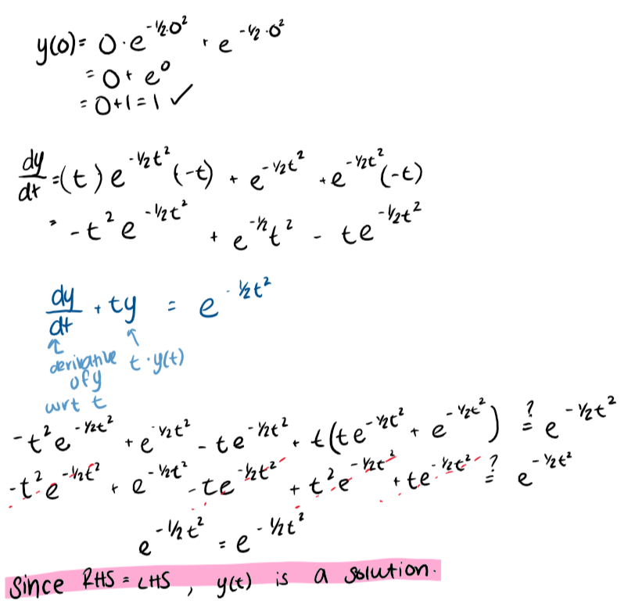
3. A. differential equation, initial condition or initial value, exact solution, slope field, equilibrium solution, qualitative/graphical approach, solution to a differential equation

B. reading a differential equation with meaning