# Homework Set 2

1. 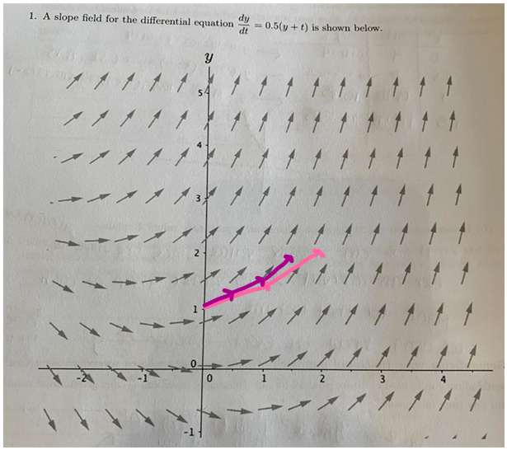
2. in pink
3. in purple
4. 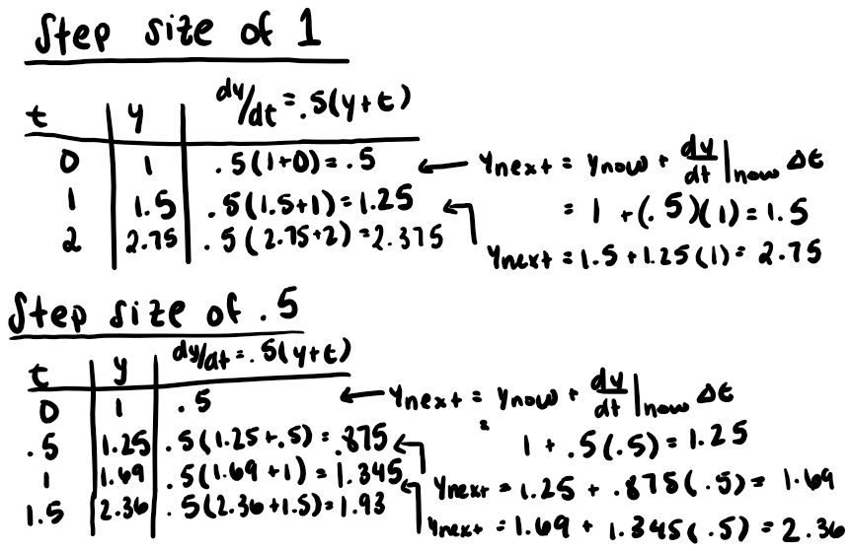

The results we got in part C makes sense with the graphical representations in parts A and B. I predicted that the graph with a step size of .5 should lie above the graph with a step size of 1 since dy/dt=.5(y+t), so dy/dt increases when y and t increase. Since dy/dt increases more often with a smaller step size, the numerical results confirm this. Looking at y(1) on both iterations, the y(1)=1.69 from a step size of .5 is larger than y(1)=1.5 with a step size of 1. In addition, the graph with the smaller step size is smoother looking than the graph with a step size of 1. This indicates that the graph with step size of .5 is more accurate and closer to y(t) than the graph with a step size of 1 since more information is being captured since the steps are smaller.

1. 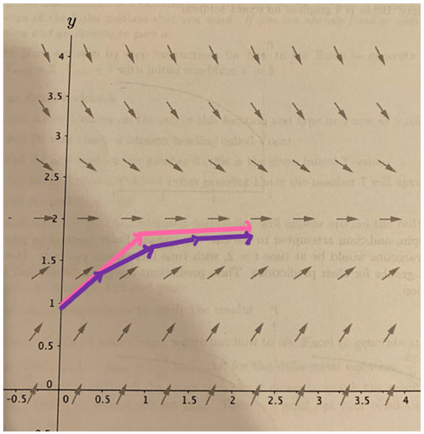A. Since we are starting when t=0 because of the initial condition, y(0)=1 and are trying to get to t=2, we know that the total distance that we need to travel along the t axis is 2. Since we want to only have two steps of Euler’s method, we need to divide the total distance we need to travel, 2, by the number of steps we want, also 2. This gives us a step size of 1. Since the step size would be 1, and we are starting at t=0, one iteration of Euler’s method would get us from t=0 to t=1 since the step size tells us how far we travel. Now, if we do a second iteration of Euler’s method, this would get us from t=1 to t=2 which is what we wanted.

B. in pink

C. in purple

D. Two other things that are different is that the purple curve appears smoother than the pink (i.e. the smaller step size appears smoother than the larger step size) and y(2) on the purple curve appears lower than y(2) than the pink curve.

E. Two things that are similar is that the slope between 0 and .5 of the purple curve is the same as the slope from 0 to 1 on the pink curve and both curves have the same starting point or initial condition which gives them the same slope at that point.

1. Merry’s prediction looks good at first, since it appears that she arrived close to the exact value at t=2. However, looking at the initial slope at t=0, it is not tangent to the curve, meaning that she is using the incorrect dy/dt equation to calculate slope. Since this is incorrect, she is incorrectly carrying out Euler’s method. Pippin’s prediction is the most accurate out of the three in terms of applying Euler’s method. He appears to have the correct slope between t=0 and t=1 and also t=1 and t=2. Although his final value at t=2 is not close to the exact value since the step size is so big, he did correctly carry out Euler’s method by using the correct dy/dt equation. It also makes sense that his approximation would be an overestimate since the curve is concave down. Sam’s prediction is similar to Merry’s prediction in that he used to incorrect dy/dt equation at t=0. This led to him incorrectly carrying out Euler’s method and being off at t=2. In addition, his tip to tail lines should be above the exact solution, not below, since the exact solution is concave down.
2. 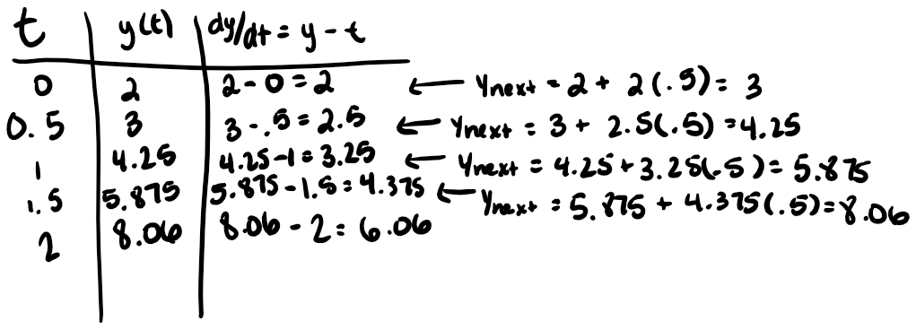Since the solution function is linear, we will get the exact solution. This is because Euler’s method uses a linear approximation, so the step size doesn’t matter since the slope is constant across the entire line.

1. 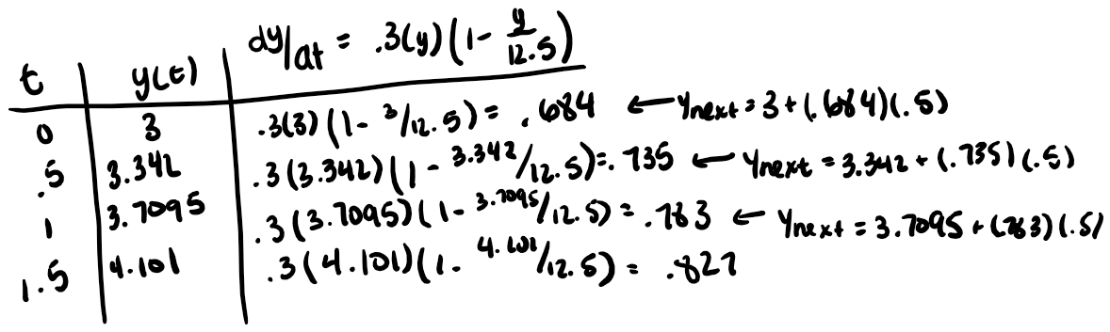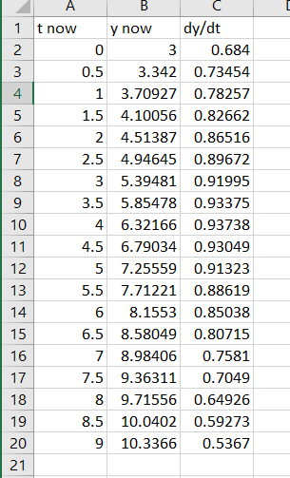A. B.

Besides differences in rounding, the results are the same.

1. I can see it both ways. In the first student’s case, they are not reading it with meaning. They are simply seeing it as plugging in the value P calculated from P(t) into the function to get a resulting dP/dt value. On the other hand, the second student is reading the differential equation with meaning. They say that the derivative of the function P with respect to t must equal 0.5 times the function P times 1 minus the quantity of the function P divided by 100. Here, this student is seeing the dP/dt as a value on the left that must equal the same value on the right. The first student is seeing it as dP/dt=some value. I think I see it more like the first student when we are doing numerical approaches like Euler’s method, but I see it more as the second student when we are using a qualitative approach.
2. A. I would choose t to be greater than 0 and P to be between 0 and 7. t needs to be bigger than 0 since it represents the number of years elapsed which can’t be negative. If we wanted to put a cap on t, we would need to consider the year that we are trying to calculate. I think P should be greater than 0 since P represents population and population can’t be negative. I chose my range to include 5 since this would give me a rate of change of 0. Numbers greater than 5 (i.e. 6 and 7 in this case) would produce a negative slope which would show a decline in population which should be viewable on the graph. Values of P between 0 and 5 would show a positive rate of change which would indicate that population is increasing, but as P gets closer to 5 the rate of change is approaching 0.

B. If P=2, then the rate of change would be positive indicating that the population still has enough resources to increase in size. The population would be able to increase until P=5, where the population would have a rate of change of 0 indicating that there are just enough resources to sustain the same population; the population would not grow or shrink at this point. If P=6 then the rate of change would be negative indicating that there are too many fish for the amount of resources so the population would decrease until P=5.

C. The predictions I made in part B are fairly reasonable. It makes sense that the population should decrease if there are too many fish and not enough resources so they would die out (P=6 situation) and that it should increase if the population is below the carrying capacity meaning that there are still resources to spare (P=2 situation). However, this differential equation doesn’t take into account predators or disease that can occur that could drastically change the population not according to the model. In addition, it’s not likely that if the initial population is P=5 that the population will be in equilibrium forever since there are always fish dying and being born not necessarily at the exact same rate.

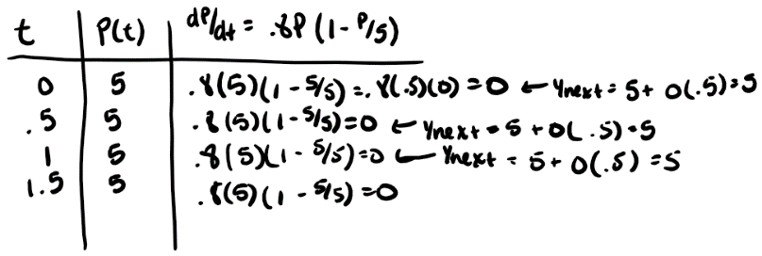D.

1. A. numerical approach, slope field, Euler’s method, equilibrium solution, initial condition, differential equation

B. tip to tail method