# Homework Set 3

1. When we solve a differential equation, we get an infinite amount of solution functions. These functions match the slope of the differential equation at every point along the curve.
2. Parts A-E Both Ways

|  |  |
| --- | --- |
| **Method that preserves meaning** | **Separation of Variables** |
|  |  |
|  |  |
|  |  |
|  |  |
|  |  |

1. Parts A-C

|  |  |
| --- | --- |
|  |  |
|  | |

1. A differential equation that would meet both of the criteria would be dy/dt=y-6. This is because if we plug in the solution function into the differential equation with meaning both sides match up. The differential equation says the derivative of the function y with respect to t is the function y itself minus 6. For y(t)=6, the left side of this would be 0 and the right side would equal 6-6 which is 0. Since the left and right sides agree, we know that this is a solution to the differential equation. For y(t)=8, we can use the same process. The left side would be 0 and the right side would be 8-6=2. Since the left and right sides are not equal y(t)=8 is not a solution.
2. This is a graph of the solution function. The horizontal axis would be t and the vertical axis would be P. I know this since the graph can’t show dP/dt vs P since this would be a straight line according to the differential equation. In class, we learned that when the differential equation is equal to a constant times the function itself, that the solution is of the form ex. Since the graph looks like an exponential function, we can conclude that this is P(t) vs t. Also, looking at the differential equation, as P increases, the slope also increases which is true for an exponential function.
3. A. I would say, the derivative of the function y with respect to t is equal to the function y itself minus t.

B. Cornelia can use a slope field to determine if any of the functions listed in the problem work. She can do this by plotting the differential equation on a slope field. Then she would graph each function on same graph that she graphed the slope field on with the possible initial conditions. If the function lines up with the slopes on the slope field at every point along the curve, then she can conclude that the function is a solution function.

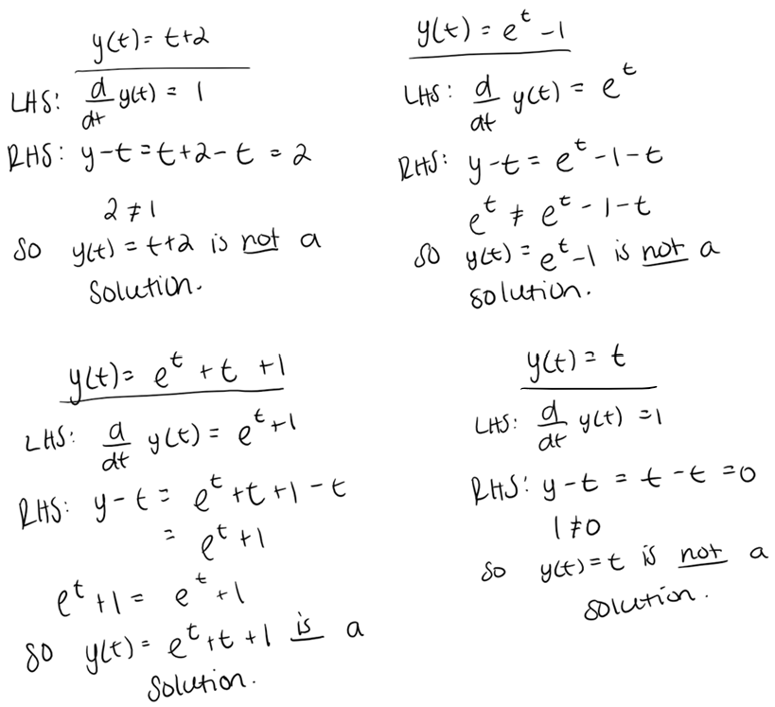C.

1. A. analytic approach, differential equation, Euler’s method, separation of variables, separable differential equation, general solution, initial value problem, particular solution, slope field, graphical approach

B. none